N:N Multi-Select
Developer Guide
How the control, the form library and the names copy plug-in are built, and how to change them
Item | Value
Product | N:N Multi-Select (Power Apps component framework field control), with an optional names copy plug-in
Version | Solution 1.0.0.0, code component 1.0.0, plug-in assembly 1.0.0.0
Publisher | KV, prefix kv
For | Developers who want to understand, fix or adapt the solution, and administrators who want to know what happens behind the scenes
Companion documents | The README and the Technical Reference: installation, every setting, the messages, upgrade, uninstall and troubleshooting
Source | The same guide as docs/developer-guide.md in the repository
Document date | October 10, 2026

Contents
About this guide 8
1. The big picture 10
1.1 What the solution consists of 10
1.2 The two solutions 11
1.3 How the pieces talk to each other 13
1.4 What runs where 14
1.5 Repository tour 14
2. Getting set up 17
2.1 Tools 17
2.2 Get the code 18
2.3 Install the npm packages 18
2.4 Build 18
2.5 Checks before you commit 19
2.6 Prepare a development environment 19
2.7 Import into the development environment 20
2.8 The development loop 21
2.9 The same-version rule 22
3. PCF basics as used in this control 23
3.1 The terms used in this guide 23
3.2 The manifest: ControlManifest.Input.xml 23
3.2.1 The control element 23
3.2.2 The host column (the bound property) 24
3.2.3 The input properties (the settings) 25
3.2.4 Resources 27
3.2.5 Rules for manifest texts 28
3.3 How the platform passes values 28
3.4 The lifecycle 30
3.4.1 init 31
3.4.2 updateView 31
3.4.3 getOutputs 32
3.4.4 destroy 33
3.5 The context objects the control uses 33
3.6 How the CSS gets in: styles.ts 34
3.7 How the bundle is built and registered 34
3.8 Changing the manifest safely 35
4. Control architecture 37
4.1 Module map 37
4.2 index.ts: the controller 39
4.2.1 The token pattern 40
4.2.2 Reacting to setting changes: applyConfig 41
4.2.3 Building what the view shows: render 41
4.2.4 The functions, by job 42
4.3 src/view.ts: the view 43
4.4 src/syncEngine.ts: from picks to requests 45
4.5 src/relatedData.ts: the requests for one relationship 49
4.6 src/dataverse.ts: the Web API client 51
4.7 src/fetchQuery.ts: the list query for views and FetchXML 54
4.8 src/metadata.ts: finding the relationship and the views 55
4.9 src/formBridge.ts: the surrounding form 56
4.10 src/namesCopy.ts: the host column copy 58
4.11 src/strings.ts: the texts 59
4.12 src/styles.ts: the look 59
4.13 src/types.ts: shared types 61
5. Key flows step by step 62
5.1 Opening a record 62
5.2 Opening the list 64
5.2.1 One request decides the mode 64
5.2.2 Searching in server mode 65
5.2.3 Loading more rows 66
5.2.4 When Select all is offered 67
5.3 Picking and removing 68
5.4 The names copy 72
5.4.1 When the copy is written 72
5.4.2 One queue per record 73
5.4.3 Read, then write 74
5.4.4 Errors 77
5.4.5 The link tag and the names copy plug-in 77
5.5 Subgrids on the same form 78
5.5.1 Refresh after a change 78
5.5.2 Following changes made in a subgrid 78
5.5.3 Hiding the subgrids 80
5.6 New records 81
5.7 + New and quick create 82
5.8 Leaving the page while writes are pending 86
5.9 Offline and read-only 88
5.9.1 Offline 88
5.9.2 Read-only 89
6. The view in detail 90
6.1 The elements 90
6.2 Field states 90
6.3 Values, "+N" and "less" 92
6.4 The two keyboard models 93
6.4.1 Focus in the search box (onKeyDown) 93
6.4.2 Focus on the values (onChipsListKey) 94
6.5 The list 95
6.6 Accessibility 97
6.7 Positioning of the floating list 98
6.8 Touch handling 99
6.9 Matching the native look 100
7. The form library 101
7.1 Why it exists 101
7.2 How it loads the bundle 101
7.3 How it re-creates failed controls 102
7.4 The version stamp 102
7.5 The OnLoad handler 103
7.6 Using the loader for another control 106
8. The names copy plug-in 107
8.1 Purpose 107
8.2 Registration 108
8.3 The entry point: Execute 109
8.4 The Associate and Disassociate flow 111
8.5 Finding the configuration in the published forms 112
8.6 Caches and their 2-minute lifetime 113
8.7 Copy plans and routes 114
8.8 The tag protocol with the control 115
8.9 Rebuild: writing the names 118
8.10 The Delete steps 120
8.11 The Update step: following renames 123
8.12 Transactions and error handling 128
8.13 Tracing 129
8.14 Running as SYSTEM, and why 129
8.15 Performance: what each step costs 130
8.16 Turning steps off 132
8.17 The steps page 134
8.17.1 What it is and how to open it 135
8.17.2 How it is packaged 136
8.17.3 Starting: the address check 137
8.17.4 Reading the forms as the plug-in does 138
8.17.5 Reading the steps and their solutions 139
8.17.6 The step ids 140
8.17.7 Creating or updating the steps 141
8.17.8 Where new steps go, and why the page never moves steps 144
8.17.9 Removing steps, and the steps the page did not make 147
8.17.10 Drawing the page: render, the render token and setBusy 148
8.17.11 Security 149
8.17.12 Deploying the steps to test and production 150
9. Building and packaging 151
9.1 What gets packaged 153
9.2 scripts/build.mjs, step by step 153
9.3 scripts/build-with-plugin.mjs, step by step 154
9.4 The strong-name key and the public key token 158
9.5 The solution project 160
9.6 Managed and unmanaged packages 161
10. Customization recipes 162
10.1 Use your own publisher, prefix and namespace instead of KV 162
10.2 Change texts or add a language 164
10.3 Change the look 165
10.4 Add a new setting 166
10.5 Change limits and timings 167
10.6 Change the names format or separator 168
10.7 Add a step of your own to the solution 169
10.8 Create the Delete and Update steps for your tables 170
10.9 Enforce rules on the server 171
11. Testing your changes 172
11.1 States and look 172
11.2 Picking and removing 172
11.3 Keyboard and the native-like behaviours 173
11.4 + New (quick create) 173
11.5 Large lists and search 173
11.6 List settings 174
11.7 Subgrids 174
11.8 New records 174
11.9 Read-only and column security 174
11.10 The names copy, without the plug-in 175
11.11 The names copy, with the plug-in 175
11.12 Deletes and renames 176
11.13 Messages, tabs and slow networks 176
11.14 Checking the plug-in with the Plug-in Trace Log 176
11.15 The steps page 177
12. Debugging and troubleshooting 179
12.1 The browser console 179
12.2 The network requests to look at 179
12.3 Common errors and their causes 180
12.4 The Plug-in Trace Log 181
12.5 The Plugin Registration Tool 182
13. Releasing a new version 183
13.1 Version numbers 183
13.2 Build both solutions 183
13.3 Checksums 184
13.4 What to publish 184
13.5 The same-version caveat 184
Appendix A. Reference tables 186
A.1 Manifest properties 186
A.2 Constants 186
A.3 Web API requests of the control 191
A.4 What the plug-in reads and writes 193
Appendix B. Glossary and plug-in messages 195
B.1 Glossary 195
B.2 Error messages of the names copy plug-in 197

About this guide
This guide explains how N:N Multi-Select is built and how to change it. It covers the field control, the optional form library, the optional names copy plug-in, the build scripts and the solution packages, down to the functions that do the work and the reasons behind each design decision.
Who it is for. Developers who want to understand the code, fix something or adapt the control to their own needs, and administrators who want to know what the control and the plug-in do behind the scenes. To install the control, add it to a form or look up a setting, read the README instead: it covers installation, every setting, the messages users see, upgrades, uninstalling and troubleshooting.
What you need to know.
- Some TypeScript or JavaScript for the control (chapters 3 to 7), and some C# for the plug-in (chapter 8).
- How to use a model-driven app, and how to import a solution and edit a form in the maker portal (make.powerapps.com).
- Nothing about the Power Apps component framework (PCF) or Dataverse plug-ins: the guide explains each term the first time it is used, and Appendix B has a glossary.
How to read it. Read chapters 1 and 2 first: they show the pieces and get a build running. Then go to the chapter you need:
You want to ... | Read
Understand how a PCF control works, with this one as the example | 3
Find which file of the control does what | 4
Follow what happens when a record opens, a value is picked, the list is searched or a new record is saved | 5
Change the look, the keyboard handling or the list | 6 and 10.3
Understand the optional form library | 7
Understand the optional plug-in, create its Delete and Update steps for your tables, or turn steps off | 8, 8.16 and 8.17
Build the packages, or sign the plug-in with your own key | 9
Make a change: your own publisher, another language, a new setting, another names format ... | 10
Check a change before you ship it | 11
Find out why something does not work | 12
Publish a release of your own | 13
Look up a setting, a constant, a request, a term or a plug-in message | Appendix A and Appendix B

Conventions.
- Code excerpts are copied from the source files. The line above each excerpt names the file, the function and the approximate line numbers. Line numbers move when the code changes, so search for the function name. A // ... line (or <!-- ... --> in XML) marks lines left out.
- The recipes in chapter 10 also show new code for you to add; the text always says when code is new.
- Paths are relative to the root of the repository, for example control/NToNMultiSelect/index.ts.
- Names in italics are settings and labels as people see them, for example Copy names into the host column. Bold marks buttons and menu items.
- The guide describes version 1.0.0 of the control (solution version 1.0.0.0), publisher KV, prefix kv.
- The guide exists twice, with the same content: as Markdown, docs/developer-guide.md, and as a Word document, docs/NToNMultiSelect - Developer Guide.docx (also attached to each release).

1. The big picture
This chapter explains what the solution is made of, how its pieces work together, and where each piece lives in the repository. Read it first: every later chapter refers back to it.

1.1 What the solution consists of
N:N Multi-Select edits a many-to-many (N:N) relationship. In Dataverse, an N:N relationship links records of two tables (for example Project and Skill): one project has many skills, and one skill belongs to many projects. Dataverse stores each link as a row in a hidden table of its own, the intersect table. Making a link is called associating two records; removing it is called disassociating them.
The solution has five parts:
Part | What it is | Source | Needed?
The control KV.NToNMultiSelect | A code component: a custom field control built with the Power Apps component framework (PCF). PCF is Microsoft's framework for custom controls in model-driven and canvas apps. A code component is a TypeScript class that the form creates and calls (init, updateView, getOutputs, destroy). It is compiled into one file, bundle.js. | control/ | Always
The form library kv_/NToNMultiSelect/formloader.js | A JavaScript web resource (a file stored in Dataverse) that a form can load. It downloads the control's bundle.js in environments that send the control to the form without its code, and re-creates controls that failed to start. | formloader/ | Only on forms that show "Error loading control"
The names copy plug-in NToNMultiSelect.NamesCopy | A C# plug-in: server code that Dataverse runs when something happens to data. It rewrites the host column after links are made or removed anywhere and, with the Delete and Update steps that its steps page creates for the linked tables, after a linked record is deleted or renamed. | plugin/NamesCopy/, plugin/registration/ | Optional
The steps page kv_/NToNMultiSelect/namescopysteps.html | An HTML web resource for administrators, in the solution with the plug-in. Opened at the environment's address, it creates the plug-in's Delete and Update steps for the linked tables only (the tables whose names are copied), and removes them (8.17). | plugin/steps-page/ | With the plug-in, to follow deletes and renames
The solution packages | The zip files an administrator imports. There are two solutions, each built as managed and unmanaged. | solution/, scripts/ | Always

The control is placed on a text column of the form's table. That column is called the host column. The control only uses it as an anchor: it never sets its value on the form. With the setting Copy names into the host column = Yes, the control writes the selected names ("A; B; C") into the host column with a separate update of the record, so the names can be shown in views, searched and exported.
Where the control runs. On model-driven app forms, in the browser and in the Power Apps mobile app (phone and tablet). It does not run in canvas apps, custom pages, Power Pages, views or editable grids: it needs the model-driven form of a record (5.1, step 2).

1.2 The two solutions
Both solutions have version 1.0.0.0, publisher KV, prefix kv and choice value prefix 72720, and both contain the same control and form library. Import the one you need into an environment. Each is built twice: as an unmanaged package, whose components can be changed (for development), and as a managed package, whose components are locked (for test and production; see 9.6). Two solutions, each managed and unmanaged, make four zip files.
Solution (unique name) | Files | Contents
NToNMultiSelect (display name N:N Multi-Select) | NToNMultiSelect_unmanaged.zip, NToNMultiSelect_managed.zip | The control (kv_KV.NToNMultiSelect) and the form library (kv_/NToNMultiSelect/formloader.js)
NToNMultiSelectWithPlugin (display name N:N Multi-Select) | NToNMultiSelectWithPlugin_unmanaged.zip, NToNMultiSelectWithPlugin_managed.zip | The same control and form library, plus the plug-in assembly NToNMultiSelect.NamesCopy with its Associate and Disassociate steps only (the link steps: no table, PostOperation, synchronous), and the steps page kv_/NToNMultiSelect/namescopysteps.html

The two solutions have the same display name. The unique name and the description tell them apart. The description of NToNMultiSelectWithPlugin (written by scripts/build-with-plugin.mjs, 9.3) is: "Many-to-many multi-select field control, with the plug-in that keeps the names in the host column up to date when records are linked or unlinked. Its steps page creates the Delete and Update steps for the linked tables."
No package contains a Delete or an Update step. The plug-in's Delete and Update steps make the host columns follow deletes and renames of linked records (8.10, 8.11). They are created in the environment, for each linked table, by the steps page (8.17): that is the one supported way to get them. The reason is their cost. A Delete or Update step registered for every table (with no primary table) would run on every delete and every update in the environment: measured, about 15–50 ms more per delete and 15–30 ms more per update, on every table. Limited to a linked table, the steps cost nothing on any other table (8.15).
Which one to take.
- NToNMultiSelect, unless the host column must follow links made outside the form (subgrids on other forms, the other side of the relationship, flows, imports, integrations).
- NToNMultiSelectWithPlugin when it must. When it must also follow deletes and renames of the linked records, create the steps for the linked tables with the steps page. The recommended setup for production is NToNMultiSelectWithPlugin with the steps of your linked tables, created in development and deployed with your own solution (8.17.12).
The plug-in only matters when Copy names into the host column is Yes on at least one form. Without such a form, it returns at once (see section 8).
Adding the plug-in later. Import NToNMultiSelectWithPlugin on top of NToNMultiSelect (the same kind, managed or unmanaged). Both solutions are then installed, and both are named N:N Multi-Select in the list of solutions (the Name column, which shows the unique name, tells them apart). They share the control and the form library: Dataverse keeps a component while any installed managed solution contains it (13.5 explains what that means for removing them).
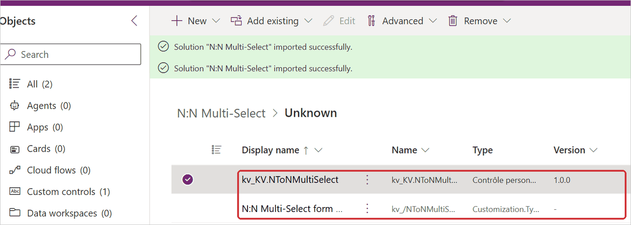
Figure 1. The solution without the plug-in after its import: the code component kv_KV.NToNMultiSelect and the form library web resource. The control comes from the control project that solution/solution.cdsproj references, the web resource from solution/src/WebResources/.
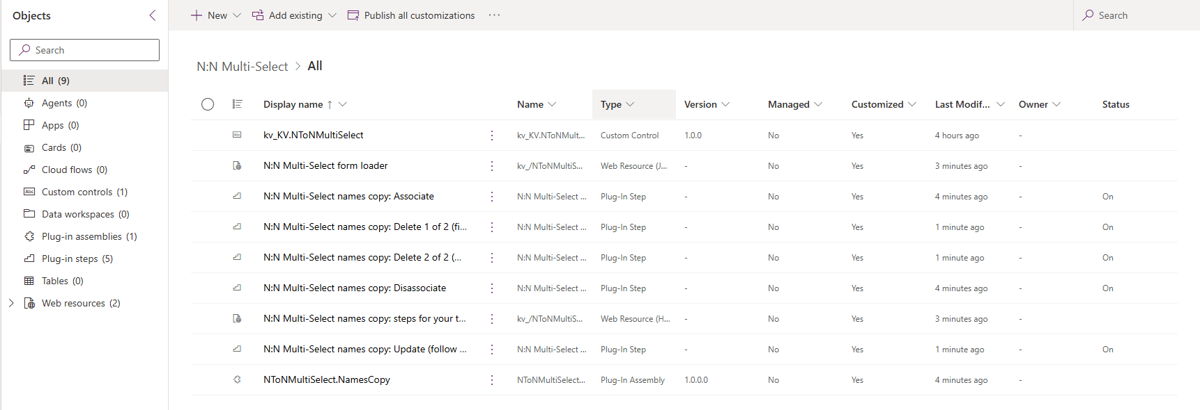
Figure 2. The solution NToNMultiSelectWithPlugin in a development environment, Objects > All (9): the control, the form library web resource (N:N Multi-Select form loader), the web resource of the steps page (N:N Multi-Select names copy: steps for your tables), the plug-in assembly NToNMultiSelect.NamesCopy, the two link steps (Associate and Disassociate) and the three steps that the steps page made for one linked table (Delete 1 of 2, Delete 2 of 2 and Update). scripts/build-with-plugin.mjs adds the assembly and the link steps from plugin/registration/, and the steps page from plugin/steps-page/. A fresh import has six components: the table steps are not in the package, the steps page put them into the installed solution (8.17.8).

1.3 How the pieces talk to each other
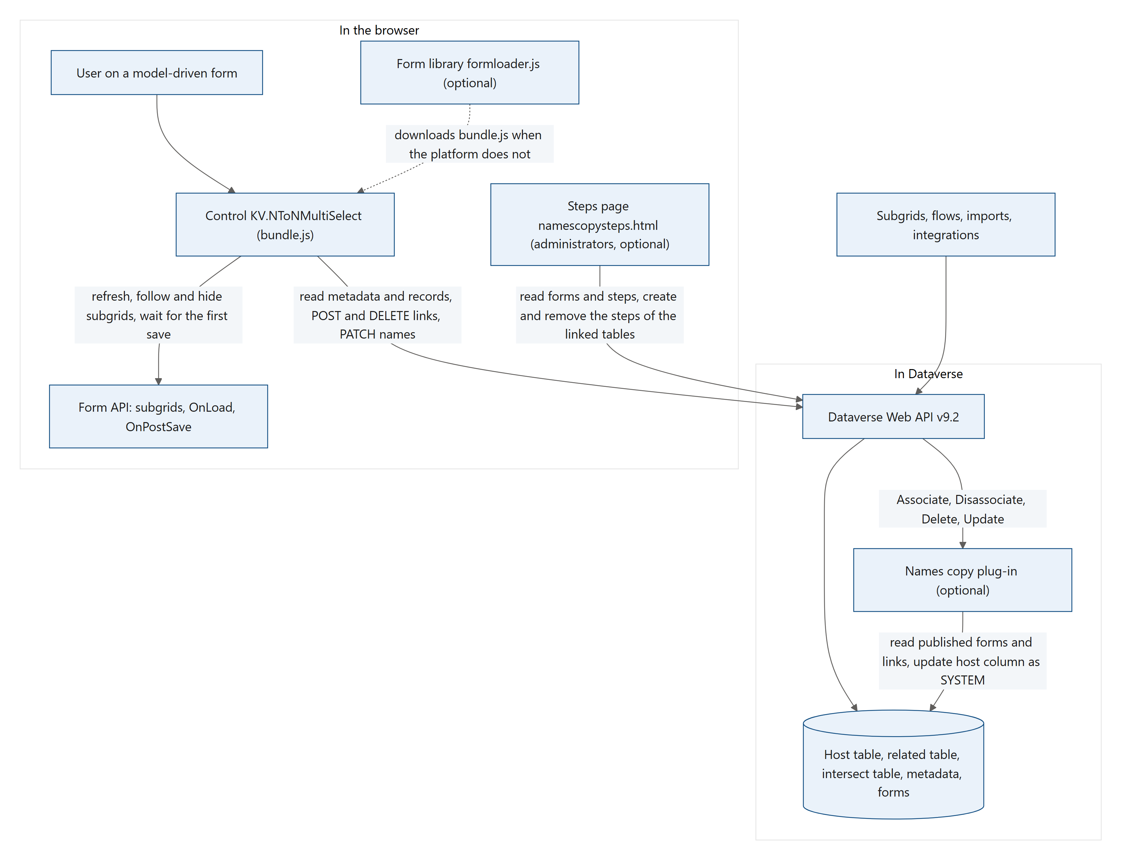
Figure 3. Diagram: 1.3 How the pieces talk to each other
What each arrow means:
- User → control. The form creates the control and passes it the settings typed in the form designer. Every pick is saved at once.
- Control → Web API. The control talks to the Dataverse Web API (the REST/OData interface of Dataverse at <environment URL>/api/data/v9.2) with the browser's fetch, in the user's own session. It reads the relationship's metadata, the saved links and the list of records that can be picked. It makes links with POST .../$ref and removes them with DELETE .../$ref. With Copy names into the host column = Yes, it writes the names with a PATCH of the record. The PCF webAPI object has no associate or disassociate operations, which is why the control calls the Web API directly (see 4.6).
- Control → form API. The control uses the model-driven form API (Xrm.Page) to refresh related subgrids, to follow changes made in them (their OnLoad event), to hide them, and to wait for the first save of a new record (OnPostSave). See 4.9.
- Form library → control. Only where the platform does not download bundle.js itself. See chapter 7.
- Web API → plug-in. Every link made or removed anywhere (the control, subgrids, the other side of the relationship, flows, imports, integrations) goes through the Associate or Disassociate message. Dataverse runs the plug-in's link steps for these messages and, where the steps page created them for a linked table, its steps for Delete (a record of that table is deleted) and Update (a record of that table is renamed).
- Plug-in → tables. The plug-in reads the settings of the published forms, reads the links and writes the host column, as the SYSTEM user.
- Steps page → Web API. An administrator opens the steps page at the environment's address. With that user's session, it reads the forms and the plug-in's steps, and creates or removes the Delete and Update steps of the linked tables (8.17).

1.4 What runs where
Piece | Runs in | Talks to | Runs as
Control | The user's browser, inside the model-driven app | Web API (same origin), form API | The signed-in user, with that user's privileges
Form library | The user's browser (form script) | <environment URL>/webresources/cc_KV.NToNMultiSelect/bundle.js | The signed-in user
Names copy plug-in | The Dataverse sandbox (an isolated process on the server that runs custom plug-ins) | The organization service inside Dataverse | SYSTEM
Steps page | The administrator's browser, at <environment URL>/WebResources/kv_/NToNMultiSelect/namescopysteps.html | Web API (same origin) | The signed-in user, with that user's privileges

1.5 Repository tour
Every folder and file of the repository, with one line each. In the Markdown version on GitHub, the paths are links to the files. Folders and files marked not committed are created by the build and ignored by Git (see .gitignore), so they only appear once you build.
Path | What it is
.gitignore | Files Git ignores: node_modules/, out/, obj/, bin/, **/generated/, *.binlog, .vs/, dist/, solution-with-plugin/, the plug-in's private key plugin/NamesCopy/NamesCopy.snk, the lock files of open Office documents (~$*) and operating system files
LICENSE | The MIT license
README.md | The user and administrator documentation: features, install, settings, messages, troubleshooting
control/ | The PCF project of the control
control/.gitignore | Ignore rules of the PCF project
control/control.pcfproj | MSBuild project of the control. The solution project references it so that dotnet build packages the control
control/package.json | npm scripts (build, lint, refreshTypes, start ...) and development dependencies (pcf-scripts, TypeScript, ESLint)
control/package-lock.json | Exact versions of every npm package, used by npm ci
control/pcfconfig.json | PCF build setting: the output folder ./out/controls
control/tsconfig.json | TypeScript settings (extends the PCF base configuration)
control/eslint.config.mjs | ESLint rules, including the Power Apps rules (@microsoft/eslint-plugin-power-apps)
control/NToNMultiSelect/ControlManifest.Input.xml | The manifest: the control's namespace, name, version and every setting shown in the form designer
control/NToNMultiSelect/index.ts | The controller: the class the form creates. Reads the settings, loads data, saves picks, handles new records, writes the names copy
control/NToNMultiSelect/src/view.ts | Draws the field, the chips and the list with plain DOM; all mouse and keyboard handling
control/NToNMultiSelect/src/styles.ts | The CSS (injected once per page) and the icon code points of the native look
control/NToNMultiSelect/src/syncEngine.ts | Turns picks into associate and disassociate requests, at most 4 at a time, with rollback on failure
control/NToNMultiSelect/src/relatedData.ts | Web API calls that read the list and the links, make and remove links, and update the host column; builds the link tag
control/NToNMultiSelect/src/fetchQuery.ts | Builds the list's FetchXML from Records from view and FetchXML filter; FetchXML paging
control/NToNMultiSelect/src/metadata.ts | Finds the tables, columns and navigation property of the relationship, and the system views; caches them for the page
control/NToNMultiSelect/src/formBridge.ts | Form integration: subgrid refresh, follow and hide; the first save of a new record
control/NToNMultiSelect/src/namesCopy.ts | Copy names into the host column: the text and the ordered updates of the record
control/NToNMultiSelect/src/dataverse.ts | A small Web API client (timeouts, retries, throttling) and the error messages for users
control/NToNMultiSelect/src/strings.ts | Every text the control shows, in English and French
control/NToNMultiSelect/src/types.ts | Shared types (Item, RelationshipInfo) and helpers (id normalisation, name sorting)
control/NToNMultiSelect/generated/ | Not committed. ManifestTypes.d.ts, the TypeScript types of the settings, written from the manifest by the build
control/out/ | Not committed. The built control: bundle.js and ControlManifest.xml
control/obj/ | Not committed. Intermediate files of dotnet build for the control project
control/node_modules/ | Not committed. npm packages installed by npm ci
formloader/ | The optional form library
formloader/formloader.js | Source of the web resource kv_/NToNMultiSelect/formloader.js (the build stamps the version into a copy)
solution/ | The solution project (packages the solution without the plug-in)
solution/.gitignore | Ignore rules of the solution project
solution/solution.cdsproj | MSBuild project that packs src/ into managed and unmanaged zips and references the control project
solution/src/Other/Solution.xml | Solution unique name, display name, description, version, publisher and root components
solution/src/Other/Customizations.xml | The (empty) customizations of the solution, language 1033
solution/src/Other/Relationships.xml | Empty: the solution adds no relationships
solution/src/WebResources/kv_NToNMultiSelectformloaderjs078EAC10-CCC9-489A-8EEB-8FA3FEECD8F8 | The form library as it goes into the package (written by scripts/build.mjs)
solution/src/WebResources/kv_NToNMultiSelectformloaderjs078EAC10-CCC9-489A-8EEB-8FA3FEECD8F8.data.xml | The web resource's name, display name, description and type
solution/bin/, solution/obj/ | Not committed. Build output of the solution project; solution/bin/Release holds the two packages before build.mjs copies them to dist/
plugin/ | The names copy plug-in
plugin/NamesCopy/NamesCopy.csproj | The plug-in project: .NET Framework 4.6.2, assembly NToNMultiSelect.NamesCopy, version 1.0.0.0, signed
plugin/NamesCopy/NamesCopy.snk | Not committed. The strong-name key the assembly is signed with: private, created by the first run of scripts/build-with-plugin.mjs and used by every later build. Keep it (9.4)
plugin/NamesCopy/NamesCopyPlugin.cs | The plug-in: the entry point of every step (Associate, Disassociate, Delete, Update), caches, copy plans, the tag check, rebuilds, the Delete steps and the Update step
plugin/NamesCopy/NamesCopyHelpers.cs | The parts that need no Dataverse: reading form XML, sorting names, the names text
plugin/registration/PluginAssemblies/NToNMultiSelectNamesCopy-02116F62-39C3-F111-B377-7CED8DA4E57C/NToNMultiSelectNamesCopy.dll.data.xml | Registration of the assembly and its plug-in type (ids, friendly name, sandbox isolation)
plugin/registration/SdkMessageProcessingSteps/{05116f62-39c3-f111-b377-7ced8da4e57c}.xml | Step N:N Multi-Select names copy: Associate
plugin/registration/SdkMessageProcessingSteps/{07116f62-39c3-f111-b377-7ced8da4e57c}.xml | Step N:N Multi-Select names copy: Disassociate. There are no other step files: the Delete and Update steps are created in the environment by the steps page
plugin/steps-page/namescopysteps.html | The steps page (8.17): the source of the web resource kv_/NToNMultiSelect/namescopysteps.html of the solution with the plug-in, one HTML file with its style and script. The build writes the web resource name into its copy
plugin/NamesCopy/bin/, plugin/NamesCopy/obj/ | Not committed. Build output of the plug-in
scripts/ | Build scripts (Node.js)
scripts/build.mjs | Builds the control and the solution without the plug-in
scripts/build-with-plugin.mjs | Builds the plug-in (creating its strong-name key at the first run) and the solution with the plug-in: the control and the form library, the plug-in with its Associate and Disassociate steps, and the steps page
solution-with-plugin/ | Not committed. The solution project of NToNMultiSelectWithPlugin, which build-with-plugin.mjs creates again on every run
docs/ | Documentation
docs/NToNMultiSelect - Technical Reference.docx | The Technical Reference: the administrator's guide in Word format
docs/NToNMultiSelect - Developer Guide.docx | This guide as a Word document (the same content)
docs/developer-guide.md | This guide
docs/images/ | Screenshots used by the README and this guide
docs/gallery/ | The demo as GIF and MP4, and a thumbnail
dist/ | Not committed. The built packages; attached to each release

2. Getting set up
This chapter takes you from an empty computer to a working build and a development loop.

2.1 Tools
Tool | Version | What it is used for
Node.js | 22 (LTS) or later | npm, the PCF build (pcf-scripts) and the two build scripts
.NET SDK | 6 or later | dotnet build: packs the solutions and builds the plug-in. The Power Apps build packages, the Dataverse SDK assemblies (Microsoft.CrmSdk.CoreAssemblies) and the .NET Framework 4.6.2 reference assemblies are downloaded from NuGet by the first build
Git | Any recent version | Getting the code and keeping track of your changes
An editor | Visual Studio Code is a good choice for TypeScript; Visual Studio or Visual Studio Code with the C# extension for the plug-in | Editing
A browser | Microsoft Edge or Google Chrome | Testing, with the developer tools (F12)
Power Platform CLI (pac) | Optional | Opening the Plugin Registration Tool (pac tool prt) and unpacking exported solutions (pac solution unpack). Not needed to build
A development environment | A Dataverse environment where you are System Administrator or System Customizer | Importing and testing your build

The repository's package.json does not pin a Node.js version, but some of the locked build packages ask for Node.js 22, and npm ci warns about them with an older version. Visual Studio and the .NET Framework developer pack are not needed.
Other operating systems. The build scripts call only Node.js and dotnet, and the .NET Framework reference assemblies come from NuGet, so the plug-in builds on any operating system the .NET SDK supports. The steps in this guide were checked on Windows only. A few snippets use Windows tools; the guide gives another way where they appear (a new id in 10.1, checksums in 13.3). The plug-in's strong-name key needs no Windows tool: scripts/build-with-plugin.mjs creates it with Node.js at its first run (9.4).
Where the projects come from. The control project has the layout that pac pcf init creates, and the solution project the layout of pac solution init. You do not need either command: both projects are in the repository. To move to newer build tools:
- npm packages. pcf-scripts and pcf-start are allowed as ^1 in control/package.json, and npm ci installs the versions in package-lock.json. To update them, run this in control/, then build, run the checks (2.5), test (chapter 11) and commit package.json and package-lock.json: npm install pcf-scripts@latest pcf-start@latest --save-dev.
- NuGet packages. Microsoft.PowerApps.MSBuild.Pcf (in control/control.pcfproj) and Microsoft.PowerApps.MSBuild.Solution (in solution/solution.cdsproj) are referenced as 1.*, and Microsoft.CrmSdk.CoreAssemblies (in plugin/NamesCopy/NamesCopy.csproj) as 9.0.2.*. A fresh restore takes the newest matching version, so you get updates without a change. Write an exact version in the project file when you need builds that do not change from one day to the next.

2.2 Get the code
git clone https://github.com/<owner>/<repository>.git
cd <repository>

Replace <owner>/<repository> with the address of the repository (or of your fork).
On Windows, clone into a short folder, for example C:\src\NToNMultiSelect: the folder path must stay under about 100 characters. The build creates files with long paths below the repository folder (the plug-in registration files in the project solution-with-plugin/, 9.3). In a deeper folder the full path passes the 260-character Windows limit, and dotnet build stops with MSB3030 "Could not copy the file ... because it was not found", although the file exists. Git can also stop with "Filename too long" for files under plugin/registration/.

2.3 Install the npm packages
cd control
npm ci
cd ..

npm ci installs exactly the versions listed in control/package-lock.json into control/node_modules. Use it rather than npm install, which may pick newer versions.
npm ci may print deprecation warnings and an audit summary about the build tools (development packages; none of them goes into the bundle). Do not run npm audit fix --force: it rewrites package-lock.json with other versions.

2.4 Build
Both scripts find the repository from their own location, so you can run them from any folder.
node scripts/build.mjs
node scripts/build-with-plugin.mjs

Command | What it does | What it produces
npm run build (in control/) | A development build of the control | control/out/controls/NToNMultiSelect/bundle.js and ControlManifest.xml, and control/NToNMultiSelect/generated/ManifestTypes.d.ts
node scripts/build.mjs | The release build of the control and the solution without the plug-in (section 9.2) | dist/NToNMultiSelect_unmanaged.zip and dist/NToNMultiSelect_managed.zip. It also rewrites two committed files: the version in solution/src/Other/Solution.xml and the form library copy in solution/src/WebResources/
node scripts/build-with-plugin.mjs | Builds the control's production bundle, the plug-in and the solution with the plug-in (section 9.3). Run build.mjs first: the version and the form library copy that both solutions take are written by it | At the first run, the strong-name key plugin/NamesCopy/NamesCopy.snk (keep it, 9.4); plugin/NamesCopy/bin/Release/net462/NToNMultiSelect.NamesCopy.dll, the solution project solution-with-plugin/ (created again on every run), and dist/NToNMultiSelectWithPlugin_unmanaged.zip and dist/NToNMultiSelectWithPlugin_managed.zip

The two scripts together write four zips: two for each of the two solutions. A zip in dist/ is replaced only when its package was built. After a failure the zips not yet written are still those of the previous build, so check that the script ended with all its "Wrote dist/..." lines before you import a package.

2.5 Checks before you commit
cd control
npm run refreshTypes
npx tsc --noEmit
npm run lint
cd ..

- npm run refreshTypes writes control/NToNMultiSelect/generated/ManifestTypes.d.ts from the manifest. The type check needs it, and the generated folder is not committed, so run it first in a fresh clone.
- npx tsc --noEmit checks the TypeScript types without writing files.
- npm run lint runs ESLint with the Power Apps rules.
Only npm ci and the build scripts are needed to build; these checks catch mistakes early.

2.6 Prepare a development environment
You need:
- A Dataverse environment for development (never test unfinished code in production).
- A security role that can import solutions and customize forms: System Administrator or System Customizer.
- Two tables with a many-to-many relationship, for example Project and Skill with the relationship new_project_skill. Records in both tables.
- A text column on the form's table that is not Business Required, for example Project skills (new_projectskills), 4,000 characters long if you will test Copy names into the host column.
The privileges users need (useful when you set up test users): Read on both tables; Append and Append To to link records; Create on the related table for + New; Write on the record for Copy names into the host column; and, when column security secures the host column, Update on that column (without it the control is read-only, 5.9.2). The names copy plug-in needs no privileges from the users: it writes as SYSTEM (8.14).

2.7 Import into the development environment
Use the unmanaged package in a development environment. Its components can be changed and removed.
- Go to make.powerapps.com and select the development environment.
- Solutions → Import solution → Browse → select dist/NToNMultiSelect_unmanaged.zip (or dist/NToNMultiSelectWithPlugin_unmanaged.zip to work on the plug-in or the steps page; create the Delete and Update steps of your linked tables with the steps page, recipe 10.8) → Next → Import.
- When the import has finished, select Publish all customizations.
- Add the control to a form as the README describes in Add the control to a form, then Save and publish the form.
The README shows each step of the import with screenshots: Import the solution.

2.8 The development loop
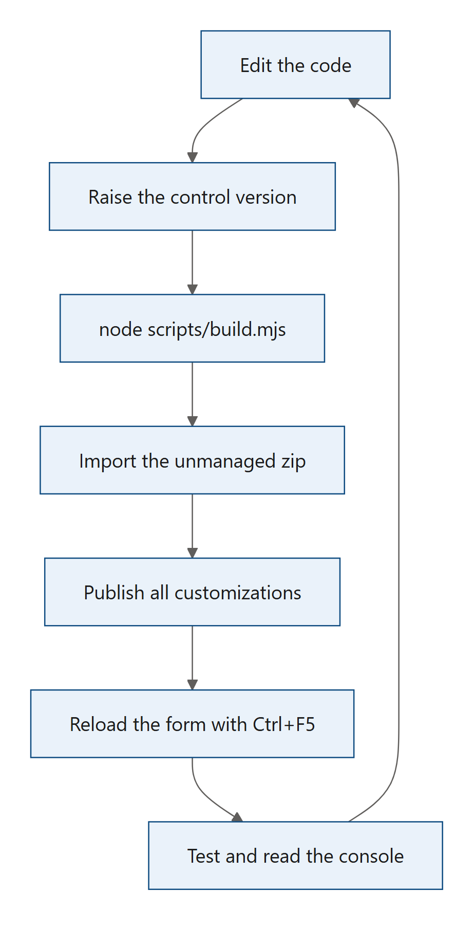
Figure 4. Diagram: 2.8 The development loop
- Edit the code in control/ (or plugin/, formloader/).
- Raise the control version in control/NToNMultiSelect/ControlManifest.Input.xml (see 2.9). Skip this step when you only changed the plug-in.
- Build: node scripts/build.mjs. If you work on the plug-in or use a solution with the plug-in, also run node scripts/build-with-plugin.mjs.
- Import the unmanaged zip you use in the development environment.
- Publish all customizations.
- Reload the app with Ctrl+F5. If the old behaviour still shows, the browser kept the old bundle: press F12 → Application → Storage → Clear site data (this signs you out of that site), then reload.
- Test (chapter 11) and watch the browser console (chapter 12).
To check which bundle the page runs, open the developer tools, Network tab, and look for bundle.js; or search the Sources tab for a text you just changed.
Plug-in only. Dataverse replaces the plug-in assembly and steps with every import, so a plug-in change needs no version change. A faster way during development is the Plugin Registration Tool: select the assembly, Update, and pick the new NToNMultiSelect.NamesCopy.dll (see 12.5).
Faster ways to try a change of the control.
- Serve the bundle from your computer. A tool that redirects web requests (for example the AutoResponder of Fiddler, or the Requestly browser extension) can answer the page's request for cc_KV.NToNMultiSelect/bundle.js with your local control/out/controls/NToNMultiSelect/bundle.js. Run npm run build in control/ and reload the form: no import and no version change. This development build is not minified, so the Sources tab shows readable code. It only replaces the code: a change to the manifest (a new setting) still needs an import.
- pac pcf push. pac pcf push --publisher-prefix kv (Power Platform CLI, signed in to the development environment with pac auth create) builds the control and imports it in a temporary solution of its own, without the form library and the plug-in. Use it only in a development environment, and check in the Sources tab that the new code runs.
Versions raised only for testing. Raise the version as often as you need while you test; those raises do not need to be committed. Before you commit, set version to the version you will release and run node scripts/build.mjs again, so that Solution.xml and the web resource copy carry it too (13.2). Where a test build with a higher version is installed, remove that copy before you import the release (2.9).
Why not the PCF test harness? npm start opens the control in a local test page. That page has no Dataverse behind it, so the control cannot read its relationship. Test in a development environment instead.

2.9 The same-version rule
Dataverse does not replace a code component when a solution with the same control version is imported. The old bundle.js stays in place, and your change seems to have no effect.
You have two ways around it:
- Raise the control version for every import (the usual way). Change version on the <control> element of the manifest, for example by raising its third number by one. scripts/build.mjs stamps the same number into the solution (with .0 added, as 1.0.0 became 1.0.0.0) and into the form library, so there is one place to change.
- Remove and re-add the control. Note each form's settings, remove the control from the forms, delete the component from the environment, import, add the control to the forms again, then save and publish them. This is the way to replace a copy that has the same version, for example a build of 1.0.0 over an installed 1.0.0 (see 13.5).

3. PCF basics as used in this control
This chapter explains the parts of the Power Apps component framework (PCF) that the control uses, and shows where each one appears in the code. If you have built a PCF control before, you can skim 3.1 and read the rest for the details that are specific to this control.

3.1 The terms used in this guide
Chapter 1 explained the N:N relationship, the intersect table, associating and disassociating, code components, web resources, plug-ins and the host column. The control's code also uses the terms below. Appendix B lists every term in one glossary.
Term | Meaning
Dataverse | The database behind model-driven apps. It stores data in tables (also called entities), each with columns (attributes) and rows (records).
Model-driven app | A Power Apps app built on Dataverse. Its forms, views and navigation are built from table metadata.
Form | The page that shows one record. Each column on the form is shown by a control.
Manifest | The XML file that describes a code component: its name, its version and the settings the form designer shows (3.2).
Field control | A code component that is placed on one column of a form. This control is a field control (control-type="standard").
Navigation property | The name the Web API uses to reach the related rows of a record, for example new_projects(<id>)/new_project_skill.
Web API | Dataverse's REST API at <environment URL>/api/data/v9.2/, based on the OData standard (query options such as $select, $filter, $orderby).
FetchXML | Dataverse's XML query language. System views store their query as FetchXML.
Subgrid | A list of related records shown on a form, for example the skills of a project.
Quick create | A small form that opens in a side panel to create a record without leaving the current one.
Solution | The package that carries customizations from one environment to another (1.2).
Xrm | The global client API object of model-driven apps (window.Xrm). It gives access to the form, its subgrids and its save events.

3.2 The manifest: ControlManifest.Input.xml
The manifest is the contract between the control and the platform. The form designer reads it to show the control's settings, and the platform reads it to know which file to load and which values to pass.

3.2.1 The control element
control/NToNMultiSelect/ControlManifest.Input.xml, the control element (about lines 13–15):
<control namespace="KV" constructor="NToNMultiSelect" version="1.0.0" display-name-key="N:N Multi-Select" description-key="Edits a many-to-many (N:N) relationship with a control that looks and behaves like the native multi-select choice field. Each selection is saved immediately, and related subgrids on the form refresh automatically." control-type="standard">
<external-service-usage enabled="false">
</external-service-usage>

Attribute | Value | Why
namespace + constructor | KV + NToNMultiSelect | Together they form the control name KV.NToNMultiSelect. The class exported from index.ts must have the name given in constructor. When the solution is packaged, the publisher prefix is added in front: the solution component is named kv_KV.NToNMultiSelect.
version | 1.0.0 | The control version. scripts/build.mjs copies it into the solution version (1.0.0.0) and into the form library. Dataverse keeps an installed code component when a solution with the same control version is imported (see 3.8).
display-name-key, description-key | literal English text | The control has no .resx resource files, so the platform shows these keys as they are.
control-type | standard | The control renders its own HTML into a <div> the platform gives it. (The other type, virtual, is for controls that render with the platform's own React and Fluent UI libraries.)
external-service-usage enabled="false" |  | Declares that the control calls no external service. It only talks to the Dataverse environment it runs in.

3.2.2 The host column (the bound property)
control/NToNMultiSelect/ControlManifest.Input.xml, the type group and the value property (about lines 17–23):
<type-group name="text">
<type>SingleLine.Text</type>
<type>SingleLine.TextArea</type>
<type>Multiple</type>
</type-group>

<property name="value" display-name-key="Host column" description-key="Any text column on the form that is not business required. The control uses it only as an anchor and never sets its value on the form, so a required column would block saving. To store the selected names in this column, turn on Copy names into the host column. When column security secures this column, users who are not allowed to update it see the control read-only, as they would see the column." of-type-group="text" usage="bound" required="true" />

usage="bound" means the property is connected to a column of the form: the column the maker places the control on. The type group lists the column types that are allowed: single line of text, text area and multiple lines of text.
Why a text column and not the relationship itself? PCF field controls must be bound to a column. A many-to-many relationship is not a column, so the control needs some column to sit on. Any text column works, and the control never puts a value into it on the form (see getOutputs in 3.4). That is why the description says the column must not be business required: a required column that is always empty would block every save.

3.2.3 The input properties (the settings)
All other properties are usage="input": settings the maker fills in when adding the control to a form. The table lists every property in the order of the manifest. Appendix A.1 repeats them with their display names.
Property | Type | Usage | Required | Default | What the control does with it
value | text type group | bound | yes | – | The host column (see 3.2.2).
relationshipName | SingleLine.Text | input | yes | – | Schema name of the N:N relationship. Not case-sensitive.
filter | SingleLine.Text | input | no | empty | Extra OData filter for the list.
view | SingleLine.Text | input | no | empty | Name or id of a system view of the related table.
fetchXml | Multiple | input | no | empty | A complete FetchXML query, or <filter> and <link-entity> elements.
showInactive | Enum (0 No, 1 Yes) | input | no | 0 (No) | Also offer inactive records.
showSelectAll | Enum (0 No, 1 Yes) | input | no | 1 (Yes) | Show the Select all row.
selectAllLimit | Whole.None | input | no | none in the manifest; the code uses 100 | Select all is offered only up to this many rows. 0 means 500; values above 500 count as 500.
maxSelections | Whole.None | input | no | none in the manifest; the code uses 0 (no limit) | Maximum number of selected records.
subgrids | SingleLine.Text | input | no | empty (all subgrids of the relationship) | Comma-separated subgrid names to keep in sync, or none.
hideSubgrids | Enum (0 No, 1 Yes) | input | no | 0 (No) | Hide the related subgrids.
placeholder | SingleLine.Text | input | no | empty ("Select or search options") | Text in the empty search box.
writeSummary | Enum (0 No, 1 Yes) | input | no | 0 (No) | Copy names into the host column.
searchMode | Enum (0 Starts with, 1 Contains) | input | no | 0 (Starts with) | How the server search matches names on large tables.
openOnClick | Enum (0 No, 1 Yes) | input | no | 0 (No) | Open the list on any click in the box.
openRecords | Enum (0 No, 1 Yes) | input | no | 0 (No) | Selected values are links that open the records.
allowCreate | Enum (0 No, 1 Yes) | input | no | 0 (No) | Show the + New button (quick create).

The Yes/No settings are Enum properties with the values 0 (No) and 1 (Yes). They arrive as the strings "0" and "1" (see 3.3).
Why Enum and not TwoOptions? An Enum property defines its own options (No, Yes) and its default in the manifest, and the form designer shows them as a drop-down list that needs no column. The form stores the chosen value (0 or 1), and the names copy plug-in reads exactly that value for Copy names into the host column (8.5). Forms that already use the control store these values, so keep Enum for new Yes/No settings too.
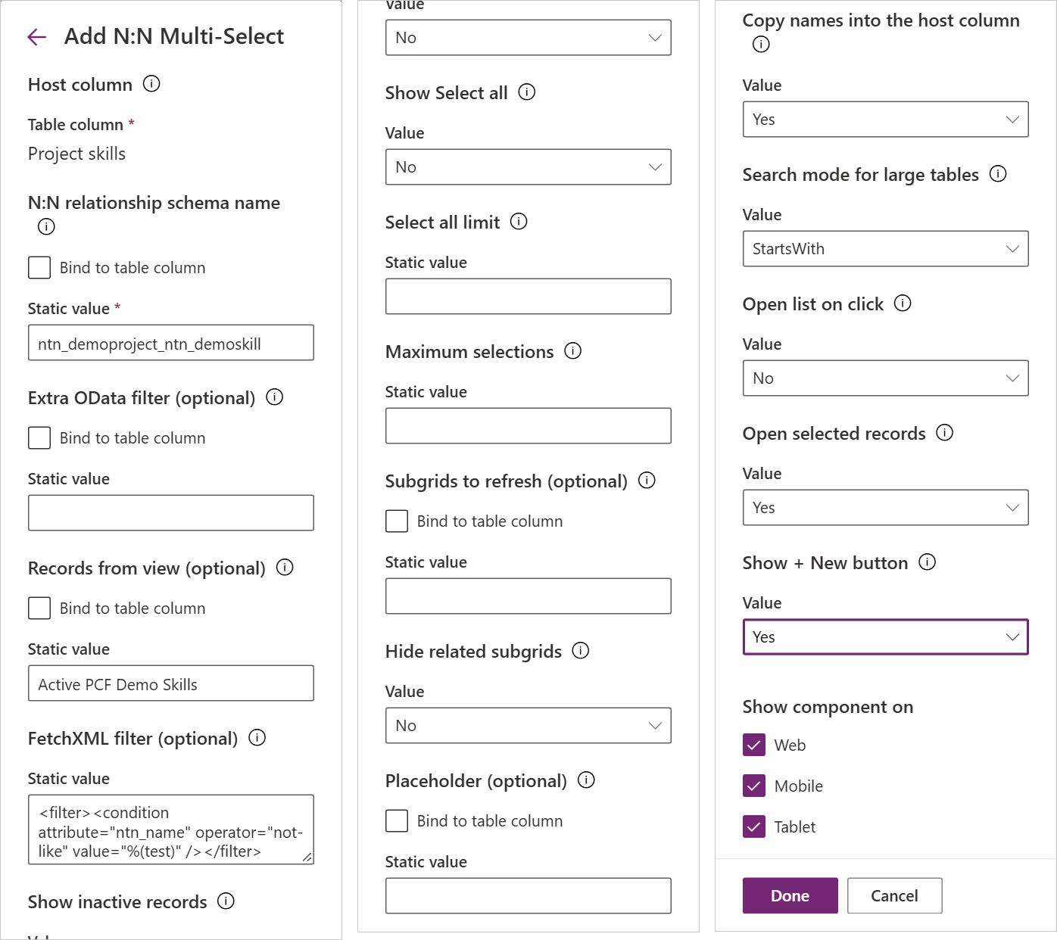
Figure 5. The settings panel the form designer shows when the control is added to a column. The platform builds it from the manifest: each display-name-key becomes a label, each Enum property a drop-down list, and the single line of text properties offer Bind to table column next to the static value.

3.2.4 Resources
control/NToNMultiSelect/ControlManifest.Input.xml, the resources element (about lines 82–84):
<resources>
<code path="index.ts" order="1" />
</resources>

The control declares only its code. There is no CSS file and no .resx language file:
- The CSS is injected by the code itself (see 3.6).
- The texts are in src/strings.ts (see 4.11).
The reason is the same for both: some environments deliver code components to the form without their resources. In such an environment a CSS or .resx resource would never arrive, and the control would look broken. Keeping everything inside bundle.js means that once the bundle runs (delivered by the platform or by the form library in chapter 7), the control is complete.

3.2.5 Rules for manifest texts
Dataverse rejects an apostrophe (') in display-name-key and description-key when the solution is imported. The PCF build tools do not check this, so scripts/build.mjs does, before it builds anything (step 0 in 9.2 shows the check). When you write a new description, write "does not" instead of "doesn't".

3.3 How the platform passes values
The platform passes all values in context.parameters, one entry per manifest property. Each entry has a raw value. The PCF build tools write TypeScript types for them, from the manifest, into generated/ManifestTypes.d.ts (run npm run refreshTypes after changing the manifest; the generated folder is not committed).
control/NToNMultiSelect/generated/ManifestTypes.d.ts (written by the build tools; shortened):
export interface IInputs {
value: ComponentFramework.PropertyTypes.StringProperty;
relationshipName: ComponentFramework.PropertyTypes.StringProperty;
// ...
showInactive: ComponentFramework.PropertyTypes.EnumProperty<"0" | "1">;
// ...
selectAllLimit: ComponentFramework.PropertyTypes.WholeNumberProperty;
// ...
}
export interface IOutputs {
value?: string;
}

What arrives in raw:
Manifest type | raw value | Example
SingleLine.Text, Multiple | a string, or null when empty | "new_project_skill"
Enum | the value of the chosen option as a string | "0" or "1"
Whole.None | a number, or null when empty | 100
bound text column (value) | the column's current text, or null | "API design; Automation"

The bound property carries more than its value. The control reads three extra parts of context.parameters.value:
Part | Used for | Where
raw | The host column text the form loaded with, so the names copy does not write the same text again. | initialize (this.loadedCopy)
attributes.LogicalName, attributes.MaxLength, attributes.RequiredLevel | The column the names are written to, its maximum length, and a console warning when it is required. | startCopy, linkTag, orphanKey, warnAboutRequiredHost
security.editable | Column security: false when the user may not update the column. The control is then read-only. | columnLocked

All settings are read in one place, readConfig. Every read has a fallback, because a setting that was never filled in arrives as null (or not at all).
control/NToNMultiSelect/index.ts, readConfig (about lines 437–461):
private readConfig(context: ComponentFramework.Context<IInputs>): Config {
const p = context.parameters;
return {
relationshipName: (p.relationshipName?.raw ?? "").trim(),
filter: (p.filter?.raw ?? "").trim(),
// ...
showInactive: String(p.showInactive?.raw ?? "0") === "1",
subgrids: (p.subgrids?.raw ?? "")
.split(/[,;]/)
.map((s) => s.trim())
.filter(Boolean),
// ...
showSelectAll: String(p.showSelectAll?.raw ?? "1") !== "0",
// 0 means "as many as the list holds"; nothing above that is ever offered.
selectAllLimit: Math.min(wholeNumber(p.selectAllLimit?.raw, DEFAULT_SELECT_ALL_LIMIT) || CLIENT_MODE_LIMIT, CLIENT_MODE_LIMIT),
maxSelections: wholeNumber(p.maxSelections?.raw, 0),
searchMode: String(p.searchMode?.raw ?? "0") === "1" ? "contains" : "startswith",
// ...
};
}

Notes:
- String(raw ?? "0") === "1" is used for every Yes/No setting, so an unexpected value counts as the default.
- showSelectAll is the only Yes/No setting whose default is Yes, so it is checked with !== "0".
- wholeNumber turns an empty or invalid number into the default and a negative number into 0.
- The single line of text settings can also be bound to a column in the form designer (Bind to table column) instead of typed in. Their value can then change while the form is open. That is why readConfig runs on every updateView (see applyConfig in 4.2.2). The names copy plug-in ignores bound values (8.5).

3.4 The lifecycle
The platform creates one instance of the class for each place the control appears on a form (a copy of the field in the form header is a second instance). It then calls four methods:
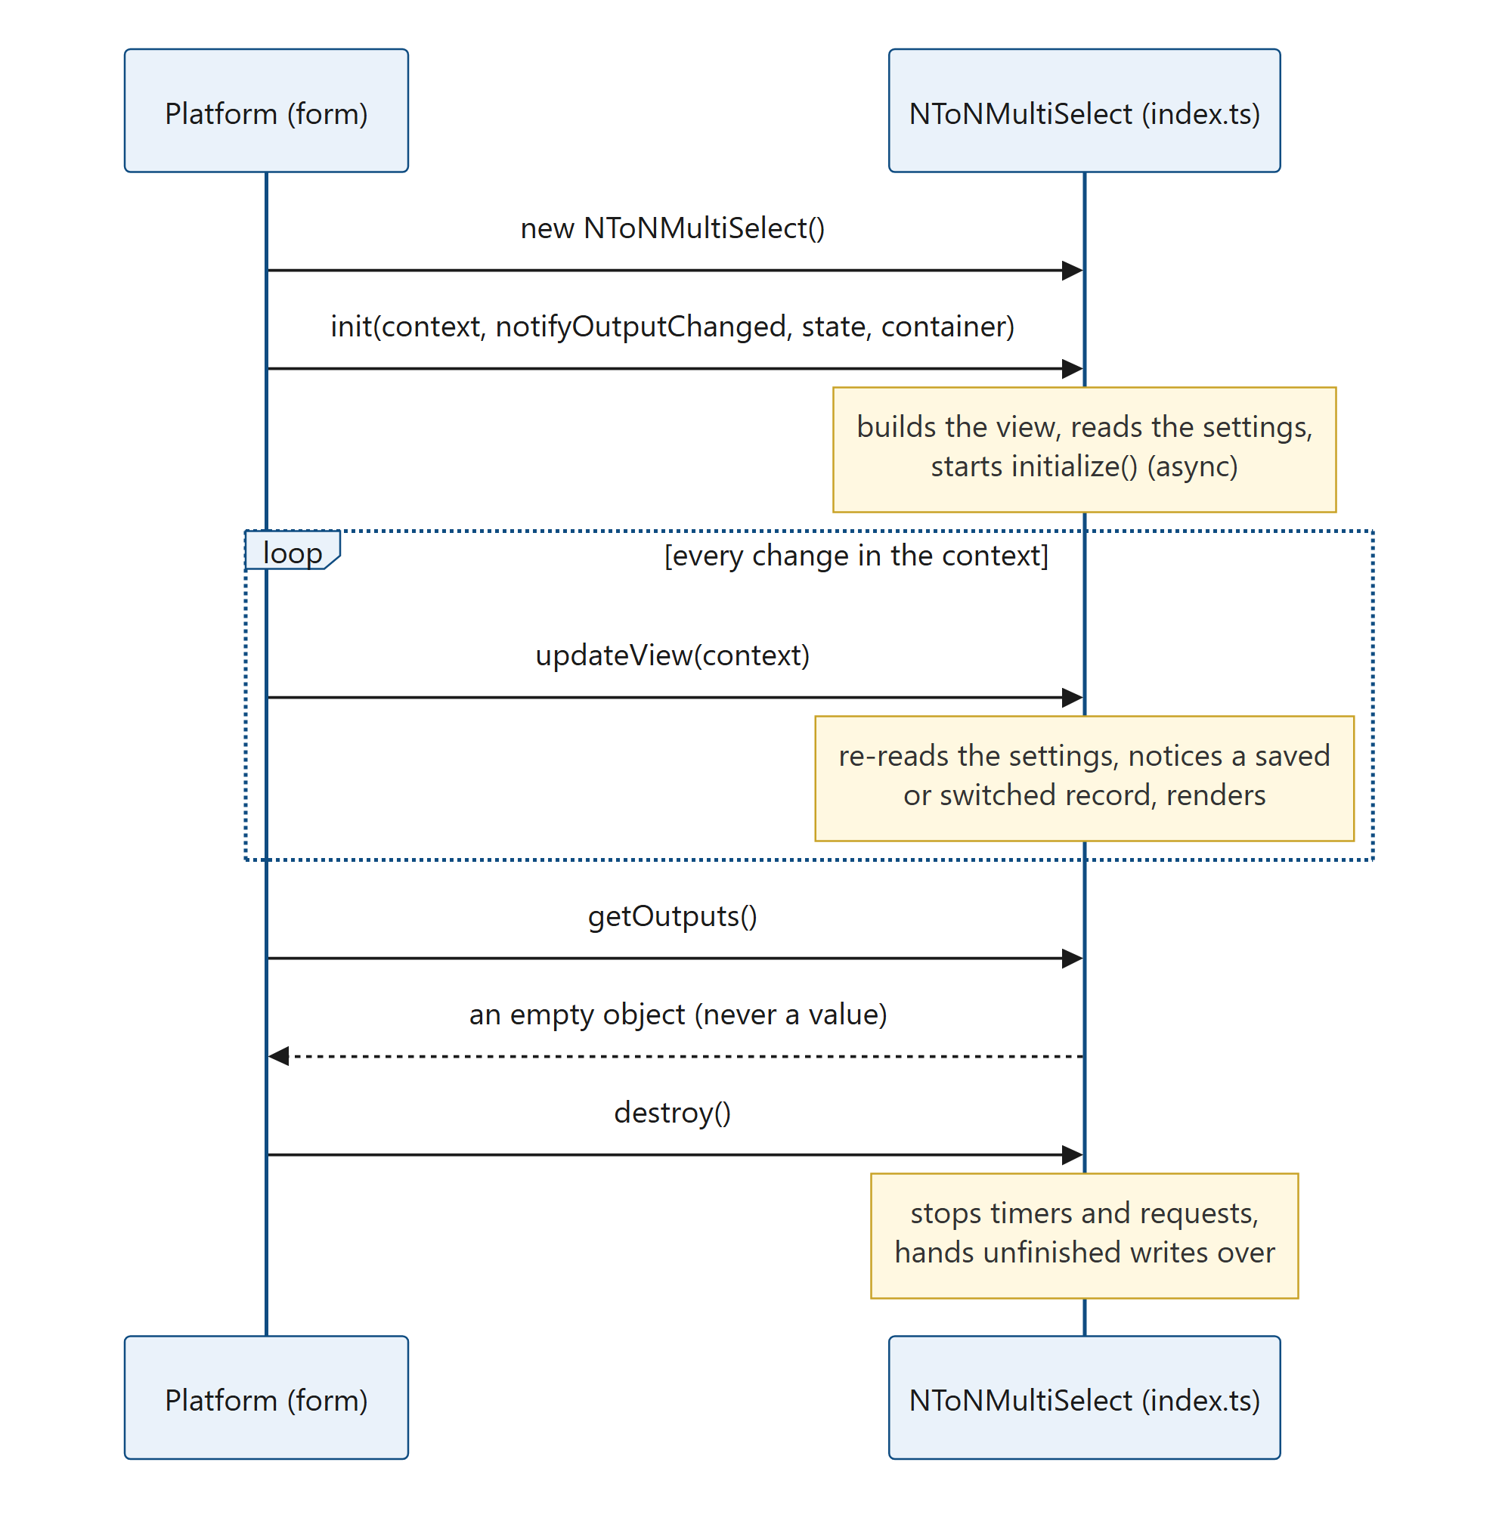
Figure 6. Diagram: 3.4 The lifecycle

3.4.1 init
control/NToNMultiSelect/index.ts, init (about lines 344–371):
public init(context: ComponentFramework.Context<IInputs>, _notifyOutputChanged: () => void, _state: ComponentFramework.Dictionary, container: HTMLDivElement): void {
this.context = context;
this.t = stringsFor(context.userSettings?.languageId);
this.offline = isOffline(context);
this.webClient = isWebClient(context);
this.view = new MultiSelectView(
container,
{
onToggle: (item, select) => this.onToggle([item], select),
onToggleAll: (items, select) => this.onToggle(items, select),
onSearch: (term) => this.onSearch(term),
onOpen: () => void this.ensureOptions(),
onLoadMore: () => void this.loadMore(),
onDismissError: () => {
this.error = null;
this.render();
},
onCreate: () => void this.createRecord(),
recordUrl: (item) => this.recordUrl(item),
onOpenRecord: (item) => void this.openRecord(item),
},
this.t,
);
window.addEventListener("online", this.onOnline);
liveControls.add(this);
this.applyConfig(context);
this.render();
}

What happens, in order:
- The language is chosen from the user's Dynamics language (userSettings.languageId).
- The view is created in the container the platform provides. The view gets callbacks instead of a reference to the controller: it can only report what the user did, never reach into the controller's state.
- The control listens for the browser's online event, to try again after a connection loss.
- applyConfig reads the settings. On the first call it always starts initialize, which is asynchronous (it reads metadata and the saved links, see 5.1). init itself returns at once.
- The first render shows an empty, busy field until the data arrives.
init does not use notifyOutputChanged or state (hence the leading underscores). The control never reports a value to the form, and it keeps no state between sessions.

3.4.2 updateView
The platform calls updateView whenever something in the context changes: a property value, the form's read-only state, the offline state, the label. The control uses it for three jobs.
control/NToNMultiSelect/index.ts, updateView (about lines 373–412, shortened):
public updateView(context: ComponentFramework.Context<IInputs>): void {
this.context = context;
this.offline = isOffline(context);
this.applyConfig(context);
const recordId = this.recordIdFrom(context);
const engine = this.engine;
if (engine && this.bridge && this.rel) {
const current = engine.getRecordId();
// ...
if (!current && recordId) {
// A new record got an id. Only a save of the followed form counts; anything else means the control
// is now showing some other record, and picks made for the unsaved one must not end up there.
if (this.bridge.savedAs(recordId)) {
this.onRecordSaved(engine, this.bridge, recordId, this.rel.schemaName, this.data);
} else {
this.retireEngine(true);
void this.initialize(context);
return;
}
} else if (current && recordId !== current) {
// The same control instance now shows a different record (or a new one): never carry state over.
void this.initialize(context);
return;
}
}
// Grids can register after the control, so both are applied again on every update.
const linkedRecordId = this.engine?.getRecordId() ?? null;
this.applyHideSubgrids(linkedRecordId);
this.bridge?.watchSubgrids(linkedRecordId, this.onSubgridLoad);
this.render();
}

- Settings changed (a setting bound to a column): applyConfig re-initialises when the relationship changed, or reloads only the list when a list setting changed.
- The record changed: a new record that was just saved continues with its new id (see 5.6). An instance that now shows a different record starts over, because the platform can reuse one instance for another record.
- Subgrids appeared: subgrids can register on the form after the control. Hiding and watching them is repeated on every update; both calls skip grids they already handled.

3.4.3 getOutputs
control/NToNMultiSelect/index.ts, getOutputs (about lines 414–418):
public getOutputs(): IOutputs {
// The host column is only an anchor, so the form never gets a value from this control and is never made
// dirty by it. "Copy names into the host column" writes to the record itself (see updateSummary).
return {};
}

Why the control never outputs a value. Each pick is saved to the server at once, as a link. If the control also gave the form a value, the form would become "dirty" (unsaved), the user would be asked to save, and a required field elsewhere on the form could block that save. Returning {} keeps the form clean. The names copy, when it is on, is written with a separate update of the record (see 5.4), not through the form.

3.4.4 destroy
control/NToNMultiSelect/index.ts, destroy (about lines 420–433):
public destroy(): void {
this.destroyed = true;
this.initToken++;
clearTimeout(this.searchTimer);
clearTimeout(this.resyncTimer);
clearTimeout(this.loadRetryTimer);
clearTimeout(this.initRetryTimer);
clearTimeout(this.subgridTimer);
this.searchAbort?.abort();
window.removeEventListener("online", this.onOnline);
liveControls.delete(this);
this.view.destroy();
this.retireEngine();
}

The platform calls destroy when the form closes, when the user moves to another record, or when a business rule hides the field. Increasing initToken makes every asynchronous step that is still running drop its result (see the token pattern in 4.2). retireEngine decides what happens to writes that are still queued: they are not cancelled (see 5.8).

3.5 The context objects the control uses
Member | Used in | What for
context.parameters | readConfig, initialize, startCopy, linkTag, columnLocked | Settings, the host column value, its metadata and its column security (see 3.3).
context.mode.isControlDisabled | readOnly | The form or the field is read-only.
context.mode.label | render, retireEngine, startCopy | The field's label, for screen readers and messages.
context.mode.contextInfo.entityTypeName, .entityId | initialize, recordIdFrom | The table and the id of the record the control is on. contextInfo is not declared in the published PCF type definitions, so it is read through a cast.
context.userSettings.languageId | init | The user's language (English or French texts).
context.client.isOffline() | isOffline | Offline mode (read-only with a note).
context.client.getClient() | isWebClient | Browser, mobile app or Outlook: decides how Open selected records opens a record.
context.navigation.openForm | createRecord, openRecord | Quick create for + New; opening a record inside the mobile app or Outlook.
context.page.getClientUrl(), context.page.appId | clientUrl, recordPageBase | The environment URL for Web API calls and the app id for record links. Read through a cast, with fallbacks.
context.webAPI | not used | See below.

Why fetch instead of context.webAPI. The PCF webAPI object has no associate or disassociate operation, and those are the control's main job. The control therefore has its own small Web API client (src/dataverse.ts) that calls window.fetch with the user's own session (credentials: "same-origin", no tokens). Having its own client also lets it send the headers it needs (Prefer for page sizes and FetchXML paging annotations, If-Match for the names copy), add the tag parameter to link requests, and apply one retry and throttling policy to every request.
The control also uses the global Xrm object in a few places, always defensively (each call is optional and guarded, mostly with try/catch, so the control keeps working where Xrm is missing):
Global API | Where | What for
Xrm.Page (the page form) | src/formBridge.ts | Subgrids (refresh, hide, OnLoad), the save events of a new record. PCF gives a field control no access to other controls on the form.
Xrm.App.addGlobalNotification | notifyApp in index.ts | A message that stays visible after the form is gone (writes that failed after the record was closed).
Xrm.Navigation.openAlertDialog | notifyApp | Fallback when app notifications are not available.
Xrm.Utility.getGlobalContext().getClientUrl() / .getCurrentAppUrl() | clientUrl, recordPageBase | Fallbacks for the environment URL and the app address.

3.6 How the CSS gets in: styles.ts
The whole style sheet is a string constant in src/styles.ts. The view calls ensureStyles in its constructor; the first instance on the page adds a <style> element to the document head, and every later instance finds it by id and does nothing.
control/NToNMultiSelect/src/styles.ts, ensureStyles (about lines 116–126):
const STYLE_ID = "ntnms-styles-v8";

export function ensureStyles(doc: Document = document): void {
if (doc.getElementById(STYLE_ID)) {
return;
}
const style = doc.createElement("style");
style.id = STYLE_ID;
style.textContent = CSS;
(doc.head || doc.documentElement).appendChild(style);
}

- Why not a CSS resource? See 3.2.4: the resources may not be delivered, the bundle always is.
- Why the version in the id (-v8)? If a page ever holds two different builds of the control (for example, an old bundle still cached), each build adds its own style sheet instead of reusing the other's. When you change the CSS, change the id too.
- Why the ntnms prefix on every class? The control's HTML lives inside the model-driven app's page, next to the platform's own styles. A unique prefix keeps the two from affecting each other.

3.7 How the bundle is built and registered
- npm run build (run by scripts/build.mjs in production mode) uses pcf-scripts, which compiles the TypeScript and bundles index.ts and everything it imports with webpack into one file, control/out/controls/NToNMultiSelect/bundle.js, next to the built ControlManifest.xml.
- pcf-scripts appends a short footer to the bundle that registers the class with the platform.
control/out/controls/NToNMultiSelect/bundle.js (output of the build; the end of the file):
if (window.ComponentFramework && window.ComponentFramework.registerControl) {
ComponentFramework.registerControl('KV.NToNMultiSelect', pcf_tools_652ac3f36e1e4bca82eb3c1dc44e6fad.NToNMultiSelect);
} else {
var KV = KV || {};
KV.NToNMultiSelect = pcf_tools_652ac3f36e1e4bca82eb3c1dc44e6fad.NToNMultiSelect;
pcf_tools_652ac3f36e1e4bca82eb3c1dc44e6fad = undefined;
}

- The control registers itself as well, at the end of index.ts. This makes the constructor available as window.KV.NToNMultiSelect in every case, which is what the form library checks (chapter 7).
control/NToNMultiSelect/index.ts, registerGlobally (about lines 1587–1599):
(function registerGlobally(): void {
const w = window as unknown as {
KV?: Record<string, unknown>;
ComponentFramework?: { registerControl?: (name: string, ctor: unknown) => void };
};
w.KV = w.KV || {};
w.KV.NToNMultiSelect = NToNMultiSelect;
try {
w.ComponentFramework?.registerControl?.(CONTROL_NAME, NToNMultiSelect);
} catch {
// ignore – the default lookup above still works
}
})();

- The solution project solution/solution.cdsproj references control/control.pcfproj. dotnet build therefore puts the control into the solution package as the component kv_KV.NToNMultiSelect (folder Controls/kv_KV.NToNMultiSelect/ in the zip, with bundle.js and ControlManifest.xml).
- In the browser, the form library requests the bundle from <environment URL>/webresources/cc_KV.NToNMultiSelect/bundle.js (see 7.2).

3.8 Changing the manifest safely
To add a setting, for example a Yes/No option:
- Add a <property> to ControlManifest.Input.xml. Use usage="input", required="false" and a default-value. Write the display name and description without apostrophes (3.2.5).
- Run npm run refreshTypes in control/. This rewrites generated/ManifestTypes.d.ts, so context.parameters knows the new property.
- Add a field to the Config interface in index.ts and read it in readConfig with a fallback, as the existing settings do.
- If the setting changes what the list offers, add it to optionsKey in applyConfig (so a bound value that changes reloads the list) and to optionsQuery.
- Pass it to the view through ViewState if the view needs it (see 4.3).
- Build with node scripts/build.mjs. The script checks that every property of the source manifest made it into the built manifest, so a stale package is caught.
- Raise version in the manifest before you import the build into an environment that already has the control. Dataverse keeps the old code component when the version is the same.
Recipe 10.4 walks through these steps with a complete example.
Names that other parts depend on. Do not rename these without changing the other side too:
Name | Who else uses it
constructor="NToNMultiSelect", namespace="KV" | CONTROL_NAME and the window.KV.NToNMultiSelect global set by registerGlobally in index.ts; CONTROL, BUNDLE and the global KV.NToNMultiSelect checked in formloader/formloader.js; the names copy plug-in finds forms with the control by the name ending .NToNMultiSelect (ControlName).
Properties value, relationshipName, writeSummary | The names copy plug-in reads these three from the published form definitions to know which relationships and host columns to keep up to date. It only uses values typed in the form designer, not values bound to a column.
The link tag prefix NToNMultiSelect| (see 4.5) | The names copy plug-in recognises the control's own link requests by it.

4. Control architecture

4.1 Module map
The control is one TypeScript class (index.ts) and eleven small modules in src/. No UI framework and no runtime library is used: apart from the small wrapper webpack adds, the compiled bundle contains only this code.

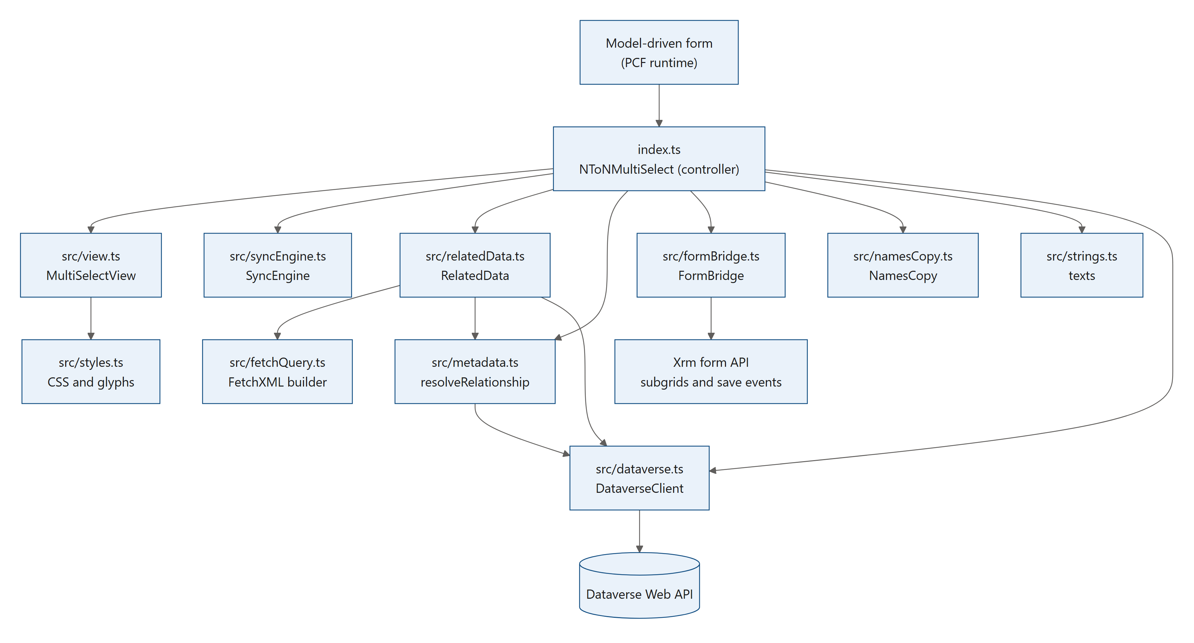
Figure 7. Diagram: 4.1 Module map

src/types.ts (shared types) is used by almost every module and is left out of the picture.
Module | Responsibility | Knows about
index.ts | Controller: settings, start-up, list state, feedback, new records, page-wide coordination | everything
src/view.ts | All HTML, mouse, keyboard, focus and screen reader behaviour | only ViewState, ViewCallbacks, texts and styles
src/syncEngine.ts | Turns "what the user picked" into associate and disassociate calls | an executor interface, no HTTP
src/relatedData.ts | Builds the Web API requests for one relationship | the relationship metadata and the Web API client
src/dataverse.ts | Sends requests: retries, timeouts, throttling, error wording | fetch and the texts
src/fetchQuery.ts | Builds the list's FetchXML from a view or the FetchXML setting | XML only
src/metadata.ts | Finds tables, columns, navigation properties and views from names | the Web API client
src/formBridge.ts | Talks to the surrounding form: subgrids, save events | Xrm.Page
src/namesCopy.ts | Keeps the host column copy of the names in order | a writer interface, no HTTP
src/strings.ts | Every text the user can see, in English and French | nothing
src/styles.ts | The CSS and the icon glyphs | nothing
src/types.ts | Item, RelationshipInfo and small helpers | nothing

Why it is split this way. Each module has one job and gets what it needs from the controller, usually as an interface. The view never sends a request; the sync engine never builds a URL; the names copy never knows how a value is written. This keeps each part small enough to read in one sitting, and lets you change one part (for example the look) without touching the parts that save data.

4.2 index.ts: the controller
Purpose. index.ts exports the class NToNMultiSelect, the class the platform creates (see 3.4). It reads the settings, creates the other modules, keeps the state of the list (the records offered), turns events into actions, and builds the ViewState the view draws. It also holds a few page-wide registries, shared by all instances of the control on the page.
Page-wide state (module-level variables, shared by every instance on the page):
Variable | Holds | Why it is page-wide
detached | Engines whose control is gone but which still have writes to finish (Detached) | The writes must finish after the form closed (see 5.8).
orphans | Picks on an unsaved record left by an instance that was destroyed while the form stayed open (Orphan) | The next instance on the same form adopts them (see 5.6).
liveEngines | Every engine that may still write: the current ones and the detached ones | The "leave page?" guard checks them (see 5.8).
copiesWriting | Number of names copy requests on their way | Same guard.
liveControls | Every instance on the page | When one instance saves a change, the others that show the same record read their links again (resyncPeers).

Instance state (fields of the class, grouped as in the source):
Group | Fields | Notes
Configuration | config, relationshipKey, optionsKey, subgridsKey | The keys detect which settings changed (see applyConfig).
Working parts | rel, data, engine, bridge | Created by initialize for one record. hiddenGrids is created once with the instance and handed to every bridge, so the grids it hid are remembered across restarts (5.5.3).
The list | mode, allOptions, allOptionsKeys, baseOptions, baseNext, shownOptions, shownNext, shownPageSize, optionsStatus, optionsError, loadingMore, loadMoreError, searchTerm, optionsPromise, searchTimer, searchAbort | See 5.2.
Feedback | error, batchErrors, batchFirstError, batchUnknown, fatalError, saveFirst, offline, selectedLoaded, ... | Messages, hints and the reasons the field cannot be edited. batchUnknown: a write of the current batch failed in a way that may still have saved it (5.3).
Names copy | loadedCopy, copy | See 5.4.
Render cache | renderedVersion, renderedRecordId, cachedSelected, cachedPending, cachedHeld, cachedOccupied | The sorted selection, the records that hold a place toward Maximum selections without being selected, and the number of places taken (5.3) are only worked out again when the engine's version changed.
Tokens | initToken, optionsToken, searchToken | See below.

4.2.1 The token pattern
Most work in the controller is asynchronous: a request is sent, and the answer arrives later. By then the user may have moved to another record, changed a setting or typed more text. The controller protects itself with tokens: a counter is read before the request and compared after it. If the counter changed in the meantime, the answer is dropped.
control/NToNMultiSelect/index.ts, serverSearch (about lines 1441–1455, shortened):
private async serverSearch(term: string): Promise<void> {
if (!this.data || !this.config) return;
const token = ++this.searchToken;
const abort = new AbortController();
this.searchAbort = abort;
// ...
try {
const page = await this.data.loadOptions(this.optionsQuery(), term, SERVER_PAGE_SIZE, null, abort.signal);
if (token !== this.searchToken) return;
this.shownOptions = page.items;
// ...

Token | Increased by | Protects
initToken | initialize, destroy | Everything that belongs to one start-up for one record: metadata, the first read of the links, retries, timers.
optionsToken | resetOptions | The first page of the list, when the list settings change while it loads.
searchToken | every search, every reset, clearing the search | Search results and "load more" pages that belong to an earlier search.

When you add asynchronous code to the controller, follow the same pattern: capture the token, await, compare.

4.2.2 Reacting to setting changes: applyConfig
control/NToNMultiSelect/index.ts, applyConfig (about lines 463–488):
private applyConfig(context: ComponentFramework.Context<IInputs>): void {
const config = this.readConfig(context);
this.config = config;
const relationshipKey = config.relationshipName.toLowerCase();
const optionsKey = JSON.stringify([config.filter, config.view, config.fetchXml, config.showInactive, config.searchMode]);
const subgridsKey = config.subgrids.join(",");
if (relationshipKey !== this.relationshipKey) {
this.relationshipKey = relationshipKey;
this.optionsKey = optionsKey;
this.subgridsKey = subgridsKey;
void this.initialize(context);
return;
}
if (optionsKey !== this.optionsKey) {
// Only the list of offered records changes; picks and queued writes are kept.
this.optionsKey = optionsKey;
const warmed = this.optionsStatus !== "idle";
this.resetOptions();
if (warmed) void this.ensureOptions();
}
if (subgridsKey !== this.subgridsKey) {
this.subgridsKey = subgridsKey;
this.bridge?.setSubgrids(config.subgrids);
this.bridge?.watchSubgrids(this.engine?.getRecordId() ?? null, this.onSubgridLoad);
}
}

Three levels of change, from expensive to cheap: a new relationship starts everything again; a new list setting only reloads the list (picks and queued writes stay); new subgrid names only change which grids are followed. Settings that only affect the look (placeholder, Open list on click, ...) need nothing: the next render uses them.

4.2.3 Building what the view shows: render
render is the only place that calls view.render. It is cheap and is called after every change.
control/NToNMultiSelect/index.ts, render (about lines 1507–1573, shortened):
if (engine.version !== this.renderedVersion || recordId !== this.renderedRecordId) {
this.renderedVersion = engine.version;
this.renderedRecordId = recordId;
this.cachedSelected = engine.selected();
// Show the "saving" look only for real writes, not for values waiting for a new record's first save.
this.cachedPending = recordId ? engine.pendingIds() : new Set<string>();
this.cachedHeld = engine.placeHolders();
this.cachedOccupied = this.cachedSelected.length + this.cachedHeld.size;
}
// ...
const max = config?.maxSelections ?? 0;
// Records whose removal is still on its way count until it succeeded (see SyncEngine.occupiedCount).
const maxReached = max > 0 && this.cachedOccupied >= max;

// Select all only appears when every matching row is loaded, the setting allows it, the list is within the
// limit (0 = as many as one load holds, 500) and selecting them all stays within Maximum selections.
const allLoaded = this.mode === "client" || (this.mode === "server" && !this.shownNext && this.searchTerm.trim() !== "");
const limit = config && config.selectAllLimit > 0 ? config.selectAllLimit : CLIENT_MODE_LIMIT;
let canSelectAll = allLoaded && !!config?.showSelectAll && this.shownOptions.length > 0 && this.shownOptions.length <= limit;
if (canSelectAll && max > 0 && engine) {
const extra = this.shownOptions.filter((i) => !engine.occupies(i.id)).length;
canSelectAll = this.cachedOccupied + extra <= max;
}
// ...
const canCreate = !!config?.allowCreate && !!this.rel?.targetQuickCreate && !maxReached;
// ...
this.view.render({
selected: this.cachedSelected,
pending: this.cachedPending,
held: this.cachedHeld,
options: this.shownOptions,
// ...
canSelectAll,
maxReached,
note,
ready: !!engine && this.selectedLoaded,
disabled: this.readOnly() || this.saveFirst || this.offline,
// ...
createLabel: canCreate ? t.newRecord(this.rel!.targetDisplayName) : null,
openOnClick: !!config?.openOnClick,
openRecords,
interceptLinks: openRecords && this.opensRecordsInApp(),
});

All the rules about what the field shows (is Select all allowed? is the field read-only? which hint?) live here, in one function. The view decides only how it is shown.
Maximum selections counts places, not only the selected records: maxReached, Select all and + New use cachedOccupied, the selected records plus the records that hold a place without being selected (SyncEngine.placeHolders, 4.4), and held tells the view which of the rows that are not selected can still be picked at the limit (5.3).

4.2.4 The functions, by job
Job | Functions
Start-up and reading links | readConfig, applyConfig, contextInfo, recordIdFrom, clientUrl, recordKey, initialize, retryInitialize, warmOptions, warnAboutRequiredHost, loadSelected, retryInitialLoad, scheduleResync, firstLoadDone
Engines and records | retireEngine, orphanKey, releaseAbandonedOrphan, adoptOrphan, peersIdle, onRecordSaved, onWriteError, onSettled, finishDetached, resyncPeers
Subgrids | onSubgridLoad, scheduleSubgridRefresh, applyHideSubgrids
Names copy | updateSummary, linkTag, startCopy, showSaved, onCopyFailed
User actions | onToggle, createRecord, recordPageBase, recordUrl, opensRecordsInApp, openRecord, readOnly, columnLocked, canEdit
The list | optionsQuery, resetOptions, ensureOptions, onSearch, applySearch, serverSearch, loadMore
Drawing | render
Helpers outside the class | installUnloadGuard, trackCopy, xrm, notifyApp, wholeNumber, searchKey, stopsBatch, mayHaveSaved, isTransient, isOffline, isWebClient, sameIds, registerGlobally

Chapter 5 walks through these functions flow by flow.
How others use it. Nothing imports index.ts. The platform creates it; the view calls it through ViewCallbacks; the sync engine calls it through SyncCallbacks; the names copy calls it through CopyWriter.
Typical customizations.
- Timing. The delays are constants at the top of the file (SEARCH_DEBOUNCE_MS, RESYNC_DEBOUNCE_MS, SUBGRID_REFRESH_DELAY_MS, ...). Appendix A.2 lists them all.
- Ask before a change is saved (for example, confirm removing a value): onToggle is the single entry point for every pick, Select all and + New. Check there before engine.setMany(items, select).
- Other read-only rules (for example, read-only for a status): extend readOnly(). render passes the result to the view as disabled, and canEdit() blocks every write.
- Tables whose new records cannot be followed: extend NO_POST_SAVE_TABLES. New records of these tables show "Save the record first, then pick values here." instead of holding picks.
- No background loading of the list: warmOptions loads the list 50 ms after start-up so that the first opening is instant. Remove its call in initialize and retryInitialLoad to load the list only when it is first opened.
- Giving the form a value is possible (return it from getOutputs and call notifyOutputChanged), but every pick would then make the form dirty. Read 3.4.3 first.

4.3 src/view.ts: the view
Purpose. MultiSelectView builds and updates all the HTML of the control with plain DOM calls, and handles the mouse, the keyboard, the focus, touch and screen readers. It holds no data of its own: everything it shows comes from the ViewState the controller passes to render, and everything the user does goes back through ViewCallbacks.
control/NToNMultiSelect/src/view.ts, ViewState and ViewCallbacks (about lines 7–68, shortened):
export interface ViewState {
/** Current (desired) selection, sorted. */
selected: Item[];
/** Items whose change is still being written. */
pending: Set<string>;
/** Rows to list in the menu (already filtered by the search term). */
options: Item[];
optionsStatus: OptionsStatus;
optionsError: string | null;
/** More rows can be loaded by scrolling (server mode). */
hasMore: boolean;
// ...
/** Show the "Select all" row (every matching row is loaded and the form's settings allow it). */
canSelectAll: boolean;
/** The "Maximum selections" setting is reached: unselected rows can't be picked until something is removed. */
maxReached: boolean;
/**
* Records that take a place toward the limit without being selected (a removal on its way, an add whose outcome
* isn't known yet): picking one of them again takes no new place, so it isn't blocked at the limit.
*/
held?: ReadonlySet<string>;
// ...
/** False until metadata and the saved values are loaded (the field shows blank instead of a misleading "---"). */
ready: boolean;
disabled: boolean;
// ...
}

export interface ViewCallbacks {
onToggle(item: Item, select: boolean): void;
onToggleAll(items: Item[], select: boolean): void;
onSearch(term: string): void;
onOpen(): void;
onLoadMore(): void;
onDismissError(): void;
onCreate(): void;
/** Address of the item's record for "Open selected records", or null when it can't be linked to. */
recordUrl(item: Item): string | null;
/** Opens the item's record in a new tab: Enter on a highlighted chip, and link clicks while interceptLinks is set. */
onOpenRecord(item: Item): void;
}

Public methods.
Method | Called by | Does
constructor(container, callbacks, t) | init | Injects the CSS, builds the elements, wires the events.
render(state) | index.ts render | Updates the HTML to match state, touching only what changed.
createDone() | createRecord | Quick create has closed: the search box takes the focus back (see 5.7).
element() | initialize | Returns the root element. The form bridge uses it to tell the main form from a quick create pane or dialog.
destroy() | destroy | Removes everything, including the list layer on <body>.

State it owns (only interaction state, never data):
Field | Meaning
active | The mouse is over the field (hover look).
focused | The field has the focus (focused look).
open | The list is open.
expanded | All values are shown ("+N" was used, or the keyboard is on the values).
current | The highlighted list row: an index into options, -1 for Select all, options.length for + New, or null.
chipCurrent | The id of the highlighted value (chip), or null. An id rather than a position, so the highlight stays on its record when the selection changes.
creating | Quick create of + New is open.
keyboardHighlight | The highlight came from the keyboard, so it gets the black outline.
visitedRows | Selected rows the mouse has left (drawn lighter, like the native list).
placeAbove, clippingAncestors, followFrame | Positioning of the floating list (see 6.7).
chipsShownAtPress, tapped | Touch handling (see 6.8).
announcing, announceTimer | Screen reader announcements (see 6.6).

Why plain DOM? The class comment says it: "Renders the control with plain DOM (no framework) so it is tiny, fast and has no style conflicts." A field control appears many times in an app; a framework would add size and start-up time to every form, and its styles could clash with the platform's.
How it stays fast with thousands of values. render compares the new state with the previous one and only redoes what changed:
- The chips are rebuilt only when the selected array is a different array (the sync engine returns the same array until the selection changes), or when the read-only state or Open selected records changed. When only the "saving" state changed, updateChipStates toggles a class.
- At most MAX_COLLAPSED_CHIPS (50) chips are built while the field is collapsed.
- The list rows are rebuilt only when the options array changed; a "load more" only appends rows. Otherwise refreshRows redraws just the rows whose selected, saving, held, visited or highlight state changed (see 6.5).
Typical customizations.
- Look: change the CSS in src/styles.ts (4.12). If you change the row height, update LIST_MAX_HEIGHT and MENU_MAX_HEIGHT at the top of view.ts, which the positioning uses.
- A second line in each row (for example a code under the name): add a field to Item (4.13), select the column in RelatedData (4.5), and add an element in rebuildRows next to ntnms-option-text.
- Different keyboard behaviour: onKeyDown (search box), onChipKey and onChipsListKey (values). Chapter 6.4 describes both models.
- More than one line of values before "+N": the collapsed field shows one line because .ntnms-chips has max-height:34px in the CSS, and countOverflow counts every chip below the first line as hidden. Change both.

4.4 src/syncEngine.ts: from picks to requests
Purpose. SyncEngine keeps the links on the server in line with what the user picked, for one record.
control/NToNMultiSelect/src/syncEngine.ts (about lines 23–45, shortened):
/**
* Keeps the server's N:N links in line with what the user picked.
*
* The UI only ever edits the *desired* set. A worker compares it with the *confirmed* (saved) set and
* performs the missing associate/disassociate calls – at most MAX_PARALLEL at once and never two for the
* same item. Because it reconciles state instead of replaying clicks, rapid toggling (add → remove → add)
* collapses to the minimum number of requests, and nothing is lost or duplicated.
*/
export class SyncEngine {
private confirmed = new Map<string, Item>();
private desired = new Map<string, Item>();
private inFlight = new Set<string>();
/** Adds that failed in a way that may still have saved them, until the next read of the saved links. */
private uncertain = new Set<string>();
private recordId: string | null = null;
// ...
/** Incremented on every change to desired/confirmed state; lets callers detect concurrent edits. */
public version = 0;

The idea. The engine keeps two sets of records:
- confirmed: the links saved on the server, as far as the engine knows;
- desired: what the user wants.
A third set, uncertain, holds the adds that failed in a way that may still have saved them, until the saved links are read again (see below).
A click only changes desired. A worker (pump) then looks for differences and sends requests for them, at most MAX_PARALLEL (4) at a time and never two for the same record.
control/NToNMultiSelect/src/syncEngine.ts, pump (about lines 231–249):
private pump(): void {
if (this.disposed || !this.recordId) {
return;
}
if (!this.running) {
this.running = true;
this.changedInBatch = false;
}
while (this.inFlight.size < MAX_PARALLEL) {
const next = this.nextOperation();
if (!next) {
break;
}
void this.run(next.item, next.operation, this.recordId);
}
if (this.inFlight.size === 0) {
this.finishBatch();
}
}

Without a record id (a new, unsaved record) pump does nothing: the picks wait in desired until setRecordId is called after the first save (see 5.6).
Each request runs in run. On success the record moves into confirmed. On failure it is rolled back: desired goes back to the saved state, so the field never shows a link that is not stored.
control/NToNMultiSelect/src/syncEngine.ts, run (about lines 265–294):
private async run(item: Item, operation: "add" | "remove", recordId: string): Promise<void> {
this.inFlight.add(item.id);
try {
if (operation === "add") {
await this.executor.associate(recordId, item.id);
this.confirmed.set(item.id, item);
this.uncertain.delete(item.id);
} else {
await this.executor.disassociate(recordId, item.id);
this.confirmed.delete(item.id);
}
this.changedInBatch = true;
} catch (error) {
if (this.disposed) {
return;
}
// Roll the item back to its saved state so the UI never shows something that is not stored.
if (operation === "add") {
this.desired.delete(item.id);
} else {
this.desired.set(item.id, this.confirmed.get(item.id) ?? item);
}
this.sortedCache = null;
if (this.callbacks.onError(item, operation, error) === true && operation === "add") {
this.uncertain.add(item.id);
}
} finally {
this.inFlight.delete(item.id);
this.version++;
}

onError (the controller's onWriteError, 5.3) returns true when the failed write may have been saved all the same: the connection dropped, the request timed out, or a gateway or server error answered (mayHaveSaved in index.ts). A failed add is then kept in uncertain. The field still shows the value as not selected, but the engine cannot know whether the link exists until it reads the saved links again: setConfirmed empties uncertain, and an add of the same record that succeeds takes it out.
When nothing is left in flight, finishBatch calls onSettled(changed) once for the whole burst of clicks.
Why reconcile instead of queueing clicks? If the user clicks a value three times quickly (add, remove, add), a queue would send three requests. The engine compares sets: after the three clicks the record is in desired and, once the first add is saved, in confirmed, so nothing more is sent. The same idea makes Select all safe: it is just "add 100 records to desired", and the worker sends them 4 at a time.
Places toward Maximum selections. A record can end up saved without being in desired, so the limit counts more than the selected records. placeHolders() returns the records that take a place without being selected:
- a saved record whose removal has not succeeded yet (confirmed, not desired): the removal may fail and bring it back;
- an add the user undid while it was on its way (inFlight, not desired): it may land, and the removal that then follows may fail;
- an add that may have been saved (uncertain, not desired), until a read of the saved links settles it.
occupiedCount() is the number of selected records plus placeHolders(), and occupies(id) says whether a record takes a place (selected, or one of the above). The controller uses them for the limit (5.3); hasUncertain() tells it that a place is held that only a read of the saved links can free (5.5.2).
control/NToNMultiSelect/src/syncEngine.ts, occupies and placeHolders (about lines 95–120):
/**
* Whether `id` takes a place toward Maximum selections: it is selected, or it may end up saved (see placeHolders).
*/
public occupies(id: string): boolean {
return this.desired.has(id) || this.confirmed.has(id) || this.inFlight.has(id) || this.uncertain.has(id);
}

/**
* Records that take a place toward Maximum selections without being selected, because they may end up saved: a
* saved record whose removal hasn't succeeded yet (it may fail and bring the record back), an add the user undid
* while it was on its way (it may land and need a removal, which may fail), and an add that failed in a way that
* may still have saved it, until a read of the saved links settles it.
*/
public placeHolders(): Set<string> {
const ids = new Set<string>();
for (const id of this.confirmed.keys()) {
if (!this.desired.has(id)) ids.add(id);
}
for (const id of this.inFlight) {
if (!this.desired.has(id)) ids.add(id);
}
for (const id of this.uncertain) {
if (!this.desired.has(id)) ids.add(id);
}
return ids;
}

The controller works them out once per engine version (4.2.3), not on every drawing.
Public API.
Member | Does
setRecordId(id) / getRecordId() | Sets the record the links belong to (starts the worker).
setConfirmed(items) | Loads the saved links from the server, keeping local changes that are not written yet. Empties uncertain.
set(item, selected), setMany(items, selected) | The user's picks.
selected() | The desired selection, sorted by name. Returns the same array until the selection changes.
isSelected(id), selectedCount() | Queries on the desired selection.
occupies(id), placeHolders(), occupiedCount() | The places taken toward Maximum selections (see above).
hasUncertain() | Whether an add whose outcome is not known still holds a place.
pendingIds(), hasPendingChanges(), isBusy() | What still differs from the server, and whether requests are in flight.
cancelQueued() | Drops changes not yet sent (used when every further request would fail the same way).
whenIdle() | A promise that resolves when the current batch is done.
dispose() | Stops the engine.
version | Increased on every change; the controller uses it to detect changes during a read.

Who uses it. Only index.ts. The engine gets an executor with associate and disassociate (built in initialize on top of RelatedData) and three callbacks (onChange, onSettled, onError; onError returns whether the failed write may have been saved). It never knows URLs.
Typical customizations.
- More or fewer parallel requests: MAX_PARALLEL. Dataverse limits concurrent requests per user, so keep it low.
- Sending changes as one batch request: replace the executor in initialize; the engine does not need to change.

4.5 src/relatedData.ts: the requests for one relationship
Purpose. RelatedData knows how to read and change the links of one N:N relationship, and how to read the list of records that can be picked. It builds Web API paths from the relationship metadata and sends them with DataverseClient (4.6).
control/NToNMultiSelect/src/relatedData.ts (about lines 6–9):
/** When the whole target table has at most this many selectable rows, it is loaded once and filtered locally. */
export const CLIENT_MODE_LIMIT = 500;
/** Page size used for server-side search when the target table is larger. */
export const SERVER_PAGE_SIZE = 100;

Main functions.
Function | Request | Used for
loadSelected(recordId) | GET <set>(<id>)/<navigation>?$select=...&$orderby=..., all pages | The saved links (record open, re-reads, names copy).
loadOptions(query, term, pageSize, nextLink) | OData or FetchXML GET on the related table | One page of the list.
isOffered(query, id) | The list query narrowed to one id | Is a record made with + New offered by the list?
associate(recordId, targetId, tag?) | POST <set>(<id>)/<navigation>/$ref | Make a link.
disassociate(recordId, targetId, tag?) | DELETE <set>(<id>)/<navigation>(<target>)/$ref | Remove a link.
updateRecord(recordId, column, value) | PATCH <set>(<id>) with If-Match: *, sent with keepalive (4.6) | The names copy.
optionsPath(query, term) | (builds the OData path) | Used by loadOptions.

Reading the saved links. control/NToNMultiSelect/src/relatedData.ts, loadSelected (about lines 76–84):
public async loadSelected(recordId: string, signal?: AbortSignal): Promise<Item[]> {
const { currentEntitySet, navigationProperty, targetIdAttribute, targetNameAttribute } = this.rel;
// Ordered by name and id: paging over a non-unique order can skip or repeat rows.
const path =
`${currentEntitySet}(${recordId})/${navigationProperty}` +
`?$select=${targetIdAttribute},${targetNameAttribute}&$orderby=${targetNameAttribute} asc,${targetIdAttribute} asc`;
const rows = await this.client.getAll<Record<string, unknown>>(path, { maxPageSize: 5000, signal });
return rows.map((row) => this.toItem(row));
}

The saved links are read without the list's filters: a linked record that is now inactive, or outside the view, still shows as selected. Only the list of records that can be picked is filtered.
Making a link, and why a "duplicate" error is checked. control/NToNMultiSelect/src/relatedData.ts, associate (about lines 212–225):
public async associate(recordId: string, targetId: string, tag?: string): Promise<void> {
const { currentEntitySet, navigationProperty, targetEntitySet } = this.rel;
try {
await this.client.send("POST", `${currentEntitySet}(${recordId})/${navigationProperty}/$ref${tagQuery(tag)}`, {
"@odata.id": `${this.client.apiUrl}/${targetEntitySet}(${targetId})`,
});
} catch (error) {
// Only accept a "duplicate" error when the link really exists; a plugin could use similar wording for a
// real failure, and the UI must never show a link that was not saved.
if (!isAlreadyAssociated(error) || !(await this.isLinked(recordId, targetId))) {
throw error;
}
}
}

A link that already exists (made in a subgrid or another tab a moment earlier) is not an error: the user wanted the link, and it is there. But the control checks that the link really exists before it accepts the error. In the same spirit, disassociate treats "not found" as done.
The link tag. While Copy names into the host column is Yes, every associate and disassociate request carries a tag query parameter. Dataverse hands the tag to the plug-ins of the request (in their shared variables), and the optional names copy plug-in uses it to skip the column the control writes itself, when the user may write that column (see 5.4.5 and 8.8).
control/NToNMultiSelect/src/relatedData.ts, linkTag and tagQuery (about lines 54–61):
export function linkTag(rel: RelationshipInfo, recordId: string, hostColumn: string): string {
return `NToNMultiSelect|${rel.schemaName}|${rel.currentEntity}|${recordId}|${hostColumn}`;
}

/** The query string that hands `tag` to the plug-ins of a request, or "" without one. */
function tagQuery(tag?: string): string {
return tag ? `?tag=${encodeURIComponent(tag)}` : "";
}

The OData list query, with every filter the settings can add. control/NToNMultiSelect/src/relatedData.ts, optionsFilters (about lines 175–193):
private optionsFilters(query: OptionsQuery, searchTerm: string): string[] {
const { targetIdAttribute, targetNameAttribute, activeFilter } = this.rel;
const filters: string[] = [];
if (activeFilter && !query.showInactive) {
filters.push(activeFilter);
}
const extra = query.extraFilter.trim();
if (extra) {
filters.push(`(${extra})`);
}
if (query.excludeId) {
filters.push(`${targetIdAttribute} ne ${query.excludeId}`);
}
const term = searchTerm.trim();
if (term) {
filters.push(`${query.searchMode}(${targetNameAttribute},${odataString(escapeLikeWildcards(term))})`);
}
return filters;
}

- escapeLikeWildcards wraps %, _ and [ in brackets, because Dataverse runs startswith and contains as SQL LIKE, where those characters are wildcards. A search for "50%" then finds "50%" literally.
- odataString doubles single quotes, so a name like "O'Neil" cannot break the query.
- isSearchable refuses a search made only of spaces, hyphens or apostrophes: such a pattern cannot use an index and would scan the whole table.
When Records from view or FetchXML filter is set, loadOptions goes to loadFetchOptions instead, which uses src/fetchQuery.ts (4.7) and pages with FetchXML paging cookies (5.2).
State. None besides the client, the relationship metadata and the "(No name)" text it was created with. A new RelatedData is made for each start-up.
Who uses it. index.ts (list, re-reads, + New, names copy) and, through the executor, the sync engine.
Typical customizations.
- Show another column than the primary name: toItem turns a row into an Item and reads targetNameAttribute. To show, for example, "code – name", add the column to the $select of optionsPath and loadSelected (and to buildListFetch for views and FetchXML), and build the name in toItem. Note that sorting and searching still use the primary name column.
- A fixed extra filter for every form: add it in optionsFilters (OData) and in buildListFetch (FetchXML), or simply use the Extra OData filter setting.

4.6 src/dataverse.ts: the Web API client
Purpose. A small client for the Dataverse Web API with one policy for every request: retries, timeouts, throttling, cancellation and error wording.
control/NToNMultiSelect/src/dataverse.ts, DataverseClient (about lines 123–131):
export class DataverseClient {
/** e.g. https://contoso.crm.dynamics.com/api/data/v9.2 */
public readonly apiUrl: string;
private readonly fetchImpl: FetchLike;

constructor(clientUrl: string, fetchImpl?: FetchLike) {
this.apiUrl = clientUrl.replace(/\/+$/, "") + "/api/data/v9.2";
this.fetchImpl = fetchImpl ?? ((input, init) => window.fetch(input, init));
}

Method | Does
get(path, options) | One GET, with optional Prefer: odata.maxpagesize=... and extra Prefer values. Returns the parsed JSON.
getPage(path, options) | One page of a collection: { value, nextLink }.
getAll(path, options) | Every page, following @odata.nextLink.
send(method, path, body, headers, options) | POST, DELETE or PATCH. With options.keepalive, the request is sent with fetch keepalive (below).

Every request sends Accept: application/json, OData-MaxVersion: 4.0 and OData-Version: 4.0, and runs with the user's own session (credentials: "same-origin").
Keepalive. A request sent with fetch keepalive is finished by the browser even when the page is closed while it is on its way. The names copy's write uses it (RelatedData.updateRecord, 5.4.3), so once that write is on its way, it still reaches the record when the user closes the tab. Browsers take at most 64 KiB of the bodies of such requests at a time, so send only asks for it up to KEEPALIVE_MAX_BYTES (60,000 bytes); a larger body is sent as an ordinary request.
control/NToNMultiSelect/src/dataverse.ts, send (about lines 164–181):
public async send(
method: "POST" | "DELETE" | "PATCH",
path: string,
body?: unknown,
extraHeaders: Record<string, string> = {},
options: SendOptions = {},
): Promise<void> {
const headers = { ...this.baseHeaders(), ...extraHeaders };
if (body !== undefined) {
headers["Content-Type"] = "application/json; charset=utf-8";
}
const json = body === undefined ? undefined : JSON.stringify(body);
const init: RequestInit = { method, headers, body: json };
if (options.keepalive && json !== undefined && new TextEncoder().encode(json).length <= KEEPALIVE_MAX_BYTES) {
init.keepalive = true;
}
await this.request(this.resolve(path), init);
}

A browser also refuses a keepalive request on the spot when the bodies of all the keepalive requests the page has on their way would pass 64 KiB. fetch then fails as for a dropped connection, and request sends it again as an ordinary request (about lines 215–222):
} else if (failure) {
retryable = isNetworkError(failure);
// A browser also refuses a keepalive request on the spot, like a dropped connection, when the bodies of
// all keepalive requests on their way from the page would pass 64 KiB: resend it as an ordinary one.
if (retryable && init.keepalive) init = { ...init, keepalive: false };
} else {
retryable = isRetryableStatus(reply!.status);
}

The resend counts as one of the retries and waits as they do (see the table below).
The retry policy (in request):
Situation | What happens
Answer 429 (throttled) | Waits for Retry-After (at most 5 minutes) and tries again, up to 3 retries. The pause is shared by every instance on the page (pausedUntil), so four parallel writes do not keep hitting the server. A request that would have to wait more than 60 seconds fails at once with "server busy".
Answer 502, 503, 504 | Waits 1 s, 2 s, 4 s (plus up to 250 ms at random) and tries again, up to 3 retries.
Connection failed (fetch throws a TypeError) | Same as 502-504. A keepalive request is sent again as an ordinary one (see above).
Read timed out (2 minutes) | Tried once more.
Write timed out (130 seconds) | Not sent again: it may still finish on the server. Reported as failed; the controller reads the links again.
Any other error | Thrown at once as a DataverseError with the HTTP status, the Dataverse error code and message.

control/NToNMultiSelect/src/dataverse.ts, request (about lines 226–233):
let delay = BACKOFF_MS[attempt] + Math.floor(Math.random() * 250);
if (reply?.status === 429) {
const retryAfter = retryAfterMs(reply.retryAfter);
if (retryAfter !== null) delay = retryAfter;
pausedUntil = Math.max(pausedUntil, Date.now() + delay);
continue; // the wait happens at the top of the loop, where a very long pause fails fast
}
await sleep(delay, signal);

Why writes get 130 seconds. Synchronous plug-ins in Dataverse may run for up to 2 minutes. A write that waits a bit longer than that lets a slow plug-in finish instead of being abandoned halfway.
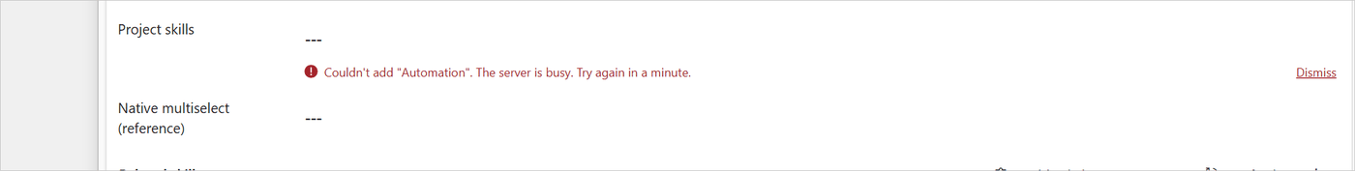
Figure 8. A pick that was still throttled after the retries: isServerBusy recognises the 429 answer, friendlyError words it as "The server is busy. Try again in a minute.", and onWriteError in index.ts shows it under the field.
Error helpers (used by the controller to decide what to do next):
Function | True when
isNetworkError | fetch failed (offline, DNS, dropped connection).
isPermissionError | 401, 403 or the "missing privilege" code 0x80040220.
isServerBusy | 429 or one of the service protection codes.
isAlreadyAssociated | The link exists already (code 0x80040237 or a duplicate message).
isNotFound | 404 about a record or link (not about the URL itself).

friendlyError(error, t, operation) turns any error into a sentence for the user, in the user's language. For a permission error it adds the missing privilege in brackets (for example (prvAppendTonew_skill)), so an administrator knows what to grant. The operation decides the wording: "read" (see), "change" (link) or "update" (the record itself).
Typical customizations.
- API version: "/api/data/v9.2" in the constructor.
- Timeouts and retries: READ_TIMEOUT_MS, WRITE_TIMEOUT_MS, MAX_RETRIES, BACKOFF_MS (Appendix A.2).
- Your own wording for an error code: add a branch to friendlyError and a text to strings.ts.

4.7 src/fetchQuery.ts: the list query for views and FetchXML
Purpose. When Records from view or FetchXML filter is set, the list is read with FetchXML. This module turns the view's query and the setting into one valid FetchXML query for the list, and adds paging. It is made of pure functions over the browser's DOMParser and XMLSerializer.
control/NToNMultiSelect/src/fetchQuery.ts (about lines 4–9):
/*
* FetchXML for the list of records that can be picked, when the form designer chose a system view or gave FetchXML.
* Everything here is a pure function on DOMParser and XMLSerializer, which every supported browser provides.
* Values only ever go in through setAttribute, so a search term or a paging cookie is escaped by the serializer and
* can never change the shape of the query.
*/

Main functions.
Function | Does
readFetchSetting(settings) | Reads the FetchXML filter setting: a complete <fetch> or a list of <filter> / <link-entity> elements. Rejects combinations that cannot work (an OData filter with a view or FetchXML; a complete query with a view).
buildListFetch(rel, setting, viewFetchXml, showInactive) | Builds the list query (see below).
firstPageFetch(xml, count, conditions) | Sets count and page="1" and adds the search and "not this record" conditions.
nextPageFetch(xml, pagingCookie) | The next page: page + 1, with the paging cookie when it can be used.
parsePagingCookie(annotation) | Reads Dataverse's paging cookie annotation (URL-encoded twice).
QueryConfigError | An error for a setting that cannot work; describe(t) words it in the user's language.

What buildListFetch does, step by step:
- Starts from the view's FetchXML, or the complete query of the setting, or a new <fetch><entity name="..."/></fetch>.
- Checks that it queries the related table and is not an aggregate query.
- Remembers the sort order of the view or query (including orders on lookup links).
- Adds the setting's <filter> and <link-entity> elements.
- Removes all <attribute>, <all-attributes> and <order> elements, a Quick Find filter (isquickfindfields="1", which holds a {0} placeholder) and any paging or row limit.
- Adds the id and name columns and the sort order again, with the id last so the order is unique (paging needs that). Without any usable order, it sorts by name, then id.
- Adds distinct="true" when the query has links (a link to the "many" side would repeat records).
- Only for a query the control builds itself (no view, no complete query): adds the active-records condition unless Show inactive records is Yes.
Why so careful with the order? The list keeps the view's sort order (the description of Records from view promises it), and paging needs an order that is unique. Adding the id at the end makes it unique without changing what the user sees.
Who uses it. RelatedData.loadFetchOptions and RelatedData.isOffered; QueryConfigError is also thrown by metadata.ts and worded by friendlyError.
Typical customizations. Change the default sort of the query the control builds itself (step 6, the rel.targetNameAttribute fallback), or add your own conditions with firstPageFetch's conditions.

4.8 src/metadata.ts: finding the relationship and the views
Purpose. The maker only enters a relationship schema name. resolveRelationship finds everything else: which side of the relationship the form's table is on, the related table, its entity set name (the plural name used in Web API URLs), its id and name columns, the navigation property, its display name, whether it allows quick create, and what "active" means for it. The result is a RelationshipInfo (4.13).
control/NToNMultiSelect/src/metadata.ts, resolveRelationship (about lines 42–48):
export function resolveRelationship(client: DataverseClient, schemaName: string, currentEntity: string, refresh = false): Promise<RelationshipInfo> {
const key = `${client.apiUrl}|${schemaName.trim().toLowerCase()}|${currentEntity.trim().toLowerCase()}`;
if (refresh) {
cache.delete(key);
}
return cached(cache, key, () => load(client, schemaName.trim(), currentEntity.trim().toLowerCase()));
}

Caching. Results are kept in memory for the life of the page (cache and viewCache), as promises, so two controls that start at the same time share one request. Failures are never cached, so a fixed setting works on the next try. The source explains why it does not use browser storage: "Microsoft recommends that code components don't keep data in browser storage".
How load works.
- Reads the relationship with RelationshipDefinitions(SchemaName='...'). That lookup is case-sensitive, so on a miss findRelationship lists the table's N:N relationships and matches the name without case. If nothing matches, the error message lists the valid names.
- Picks the side: when the form's table is Entity1, the related table is Entity2 and the navigation property is Entity1NavigationPropertyName, and the other way round. A self-referencing relationship (both sides the same table) is always used from the Entity1 side, which is the side a native subgrid shows by default.
- Reads the metadata of both tables and, in parallel, what "active" means (activeFilterFor).
control/NToNMultiSelect/src/metadata.ts, activeFilterFor (about lines 176–183):
async function activeFilterFor(client: DataverseClient, entity: string): Promise<Pick<RelationshipInfo, "activeFilter" | "activeCondition">> {
if (entity === "systemuser") {
return { activeFilter: "isdisabled eq false", activeCondition: { attribute: "isdisabled", value: "0" } };
}
return (await hasAttribute(client, entity, "statecode"))
? { activeFilter: "statecode eq 0", activeCondition: { attribute: "statecode", value: "0" } }
: { activeFilter: null, activeCondition: null };
}

Views. resolveView(client, table, view) finds an active system view of the related table by its name or id and returns its FetchXML. When nothing is found, loadView builds a helpful error: the view belongs to another table, or the name entered is a translation (the error gives the id to use instead), or a list of the table's views with their ids.
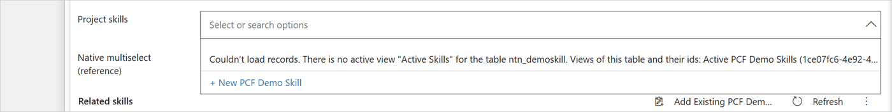
Figure 9. A Records from view setting naming a view that does not exist: loadView throws a QueryConfigError of the kind viewNotFound, which lists the table's views with their ids, and the list shows it after "Couldn't load records."
Who uses it. index.ts (initialize) and RelatedData.listFetch. clearMetadataCache empties both caches.
Typical customizations. Another notion of "active" for a table (for example a custom status column): add a case to activeFilterFor, returning both the OData filter and the FetchXML condition.

4.9 src/formBridge.ts: the surrounding form
Purpose. PCF gives a field control no access to the rest of the form. The form bridge uses the model-driven client API (Xrm.Page) for the four things the control needs from the form:
- refresh the related subgrids after a change;
- follow changes made in those subgrids (their OnLoad event);
- hide them when Hide related subgrids is Yes;
- report when a new record has been saved (OnSave and OnPostSave events).
Every call is optional and guarded, so the control keeps working (without these features) where Xrm is missing.
Finding the right form. On a page with a quick create pane, a dialog or a side pane, Xrm.Page describes the form underneath, not the one the control is on. Acting on it would refresh the wrong grids or, worse, link picks to the wrong record. The bridge therefore checks where its own element is.
control/NToNMultiSelect/src/formBridge.ts, OVERLAY (about lines 53–54):
/** Containers in which the page-level form API (Xrm.Page) describes another form than the control's. */
const OVERLAY = '[role="dialog"], [aria-modal="true"], [data-id*="quickCreate" i], [id*="quickCreate" i], [data-id*="sidePane" i]';

Function | Returns
form(recordId) | The page form if it shows the control's table (and record, when known) and the control is not in an overlay.
hostForm(recordId) | The page form only when it certainly hosts this control (used for hiding grids).
newRecordForm() | The page form when it is an unsaved record of this table and the control is on the page itself.
waitUntilPlaced() | Waits up to 3 seconds for the control's element to be attached (the platform sometimes calls init before that).

Subgrids. relatedSubgrids finds the grids named in Subgrids to refresh or, when that is empty, every subgrid whose getRelationship().name is the control's relationship (for a self-referencing relationship it also compares the navigation property). refreshSubgrids reloads them and returns how many it reloaded (it skips grids the control hid); hideSubgrids hides only visible grids and remembers them in hiddenGrids, so it never shows a grid that someone else hid; watchSubgrids adds an OnLoad handler once per grid.
New records. onPostSave(handler) attaches to the form's OnSave and OnPostSave events and calls handler(newId) once, after the save that creates the record.
control/NToNMultiSelect/src/formBridge.ts, onPostSave (about lines 361–377):
this.postSaveHandler = () => {
// Later saves of the same form are updates of that record, or saves of another record the form moved on
// to: the handler stays attached until dispose, but only the save that creates the record is reported.
if (reported) return;
try {
const id = normalizeId(entity.getId());
if (id && this.savingNew) {
reported = true;
handler(id);
} else if (!id && this.saveHandler) {
// The save failed: only a later save (OnSave again) can still create the record.
this.savingNew = false;
}
} catch {
// ignore
}
};

savedAs(recordId) answers the question "did the followed form really save itself as this record?", taking a cancelled save into account. The controller uses it in updateView to tell a real first save apart from the control being moved to another record.
Who uses it. Only index.ts.
Typical customizations. If your app shows forms in another kind of container where Xrm.Page is not the control's form, add its selector to OVERLAY. To sync other controls than subgrids, extend relatedSubgrids.

4.10 src/namesCopy.ts: the host column copy
Purpose. Implements Copy names into the host column: the text, and the order in which updates are written.
The text. control/NToNMultiSelect/src/namesCopy.ts, namesText (about lines 3–19):
/** How the names are joined in the host column, e.g. "API design; Automation". */
const SEPARATOR = "; ";

/**
* The text "Copy names into the host column" writes: the selected names in the order shown, cut to the column's
* maximum length with an ellipsis, or null when nothing is selected.
*/
export function namesText(selected: Item[], maxLength?: number): string | null {
const value = selected.map((item) => item.name).join(SEPARATOR);
if (maxLength && value.length > maxLength) {
// The length counts UTF-16 code units: never keep the first half of a character outside the BMP (an emoji).
let cut = Math.max(0, maxLength - 1);
if (cut > 0 && isHighSurrogate(value.charCodeAt(cut - 1))) cut--;
return value.slice(0, cut) + "…";
}
return value || null;
}

NamesCopy holds the copy of one record, relationship and host column. All instances on the page that show that record share it (namesCopyFor), so their updates go one at a time, and a newer value waits for the one on its way. It remembers what the column holds (saved) and skips a write that would not change anything, so opening a record never writes to it. It has two entry points. update(selected, writer) runs once the page's links are saved: when the names of selected differ from what the column holds, or a write is on its way, it reads the links saved on the server and writes their names, unless the column already holds them (5.4.3). refresh(writer) does the same even when the page's names have not changed; the controller calls it after a link write whose outcome is not known (5.4.1).
CopyWriter is how the copy reaches the server. The controller provides it (startCopy in index.ts).
control/NToNMultiSelect/src/namesCopy.ts, CopyWriter (about lines 26–37):
export interface CopyWriter {
/** The host column's maximum length, which the names are cut to. */
maxLength?: number;
write(value: string | null): Promise<void>;
/** `step`: whether reading the saved links (see readSaved) or writing the column failed. */
onError(error: unknown, step: "read" | "write"): void;
/**
* The records linked to the record now, as saved on the server (those the user can read). When the writer has it,
* the copy writes their names rather than the page's (see NamesCopy.namesToWrite).
*/
readSaved?(): Promise<Item[]>;
}

The full flow, including the read of the saved links before each write, is in 5.4.
Who uses it. index.ts (startCopy, updateSummary, finishDetached).
Typical customizations. To change the format (another separator, one name per line), change SEPARATOR or namesText. If the names copy plug-in is installed, change it the same way: the plug-in writes the same text (NamesCopyHelpers.Separator and the matching code in plugin/NamesCopy/NamesCopyHelpers.cs). If the two differ, the column changes format depending on where the last link was made. Recipe 10.6 lists every place to change.

4.11 src/strings.ts: the texts
Purpose. Every text the user can see, in English and French. The language follows the user's Dynamics language.
control/NToNMultiSelect/src/strings.ts, LANGUAGES and stringsFor (about lines 228–235):
/** French LCIDs: France, Canada, Belgium, Switzerland, Luxembourg, Monaco. */
const LANGUAGES: { lcids: number[]; strings: Strings }[] = [{ lcids: [1036, 3084, 2060, 4108, 5132, 6156], strings: fr }];

/** Text for the given Dynamics language id; English when the language isn't translated. */
export function stringsFor(languageId: number | null | undefined): Strings {
const match = LANGUAGES.find((l) => languageId !== null && languageId !== undefined && l.lcids.includes(languageId));
return match ? match.strings : en;
}

The Strings interface lists every text. Texts with values are functions, for example addFailed: (name) => `Couldn't add "${name}".`. Why whole sentences? The file's header explains it: word order and agreement differ between languages, so sentences are never glued together from pieces.
To change a text or add a language, follow recipe 10.2.
The settings' names and descriptions in the form designer come from the manifest, not from this file, and are English only (see 3.2.1).
Who uses it. index.ts picks the block once in init and passes it to the view, the error wording (friendlyError) and QueryConfigError.

4.12 src/styles.ts: the look
Purpose. The CSS of the control (a single string) and the icon glyphs. The header comment records the measurements taken from the platform's own multi-select choice control, so both look the same side by side.
control/NToNMultiSelect/src/styles.ts (about lines 1–14):
/*
* Visual spec measured from the platform's own multi-select choice control (MultiSelectPicklist) on the same form,
* so both controls look identical side by side:
* - idle: bold, comma separated values (or "---"), no border
* - hover: 1px #666 border, values as #efefef chips with a remove (x) button
* - focused: chips + "Select or search options" box + chevron; the list opens from the chevron or the keyboard,
* below the field, or above it when there is no room
* - list: "Select all" + item count, 35px rows with CRM MDL2 checkbox glyphs, 4 visible rows
* - list rows: #f0f0f0 under the mouse; selected #bdbdbd, #c7c7c7 under the mouse and #e6e6e6 once the mouse has
* left the row, until the selection changes (see visitedRows in view.ts)
* - read-only: grey box, 44px high, like the native read-only field
* The CSS is injected from code (once per page) rather than shipped as a PCF css resource, because some environments
* send code components to the form without their resources and the bundle is then loaded by the form library.
*/

The main classes.
Class | Element | State classes
ntnms | The root of the field | is-empty, is-active (hover), is-focused, is-open, is-expanded, is-disabled
ntnms-view, ntnms-view-text | The idle text (bold names or ---)
ntnms-chips-row, ntnms-chips, ntnms-chip | The values as chips | is-saving, is-current (keyboard highlight)
ntnms-chip-remove, ntnms-more-button | The × of a chip, "+N" / "less"
ntnms-inner, ntnms-input, ntnms-caret-button | The search row
ntnms-menu | The floating list (on <body>) | is-open
ntnms-option | A row of the list (and Select all) | is-selected, is-visited, is-saving, is-current, is-disabled
ntnms-note, ntnms-status, ntnms-count, ntnms-create | Limit note, "Loading…" / "No entries found", item count, + New
ntnms-error, ntnms-hint, ntnms-a11y | Error under the field, grey hint, text for screen readers only

Glyphs. The icons are characters of the platform's icon font CRM MDL2 (with Segoe Fluent Icons and Segoe MDL2 Assets as fallbacks), the same the native control uses:
GLYPH key | Code point | Icon
remove | U+E711 | × on a chip
chevronDown | U+E70D | the arrow of a closed list
chevronUp | U+E70E | the arrow of an open list
unchecked | U+E739 | empty check box
checked | U+E73A | ticked check box

The CSS also has a Windows high contrast block (@media (forced-colors:active)) that marks selected rows with the system highlight colours, because the grey backgrounds disappear in that mode.
Typical customizations. Colours, fonts and sizes are plain values in CSS. After a change, raise the number in STYLE_ID (see 3.6), and keep LIST_MAX_HEIGHT and MENU_MAX_HEIGHT in view.ts in line with the row height. Recipe 10.3 lists the classes to change for each part of the field.

4.13 src/types.ts: shared types
control/NToNMultiSelect/src/types.ts, Item (about lines 1–5):
/** A record that can be picked in the control. Ids are always lower-case GUIDs without braces. */
export interface Item {
id: string;
name: string;
}

Export | Purpose
Item | A record in the control: id and name. Used everywhere.
RelationshipInfo | Everything about the relationship, from metadata.ts: table and entity set names on both sides, id and name columns, navigation property, display name, activeFilter / activeCondition, targetQuickCreate, selfReferencing.
OptionsMode | "client" or "server" (see 5.2).
normalizeId(id) | Turns "{ABC-...}" into "abc-...". Ids from Xrm, the Web API and quick create come in different forms; the control compares them only after this.
isGuid(id) | Checks the format.
compareItems(a, b) | The one sort order of the control.

control/NToNMultiSelect/src/types.ts, compareItems (about lines 49–58):
// One shared collator: String.localeCompare with options builds a new one on every call, which makes sorting a
// few hundred selected records noticeably slow.
const nameCollator = new Intl.Collator(undefined, { sensitivity: "base", numeric: true });

/** Locale-aware, case-insensitive name comparison used everywhere items are sorted. */
export function compareItems(a: Item, b: Item): number {
const byName = nameCollator.compare(a.name, b.name);
if (byName !== 0) return byName;
return a.id < b.id ? -1 : a.id > b.id ? 1 : 0;
}

sensitivity: "base" ignores case and accents; numeric: true sorts "Team 2" before "Team 10". The id breaks ties, so the order is always the same. The selected values and the names copy use this order. The list itself keeps the order the server returns (by name, or the view's order).
Typical customization. Adding a field to Item (for example a second column) is safe: the engine and the names copy only use id and name.

5. Key flows step by step
This chapter follows the code through the situations that matter. Each section names the functions involved, so you can read along in the source.

5.1 Opening a record
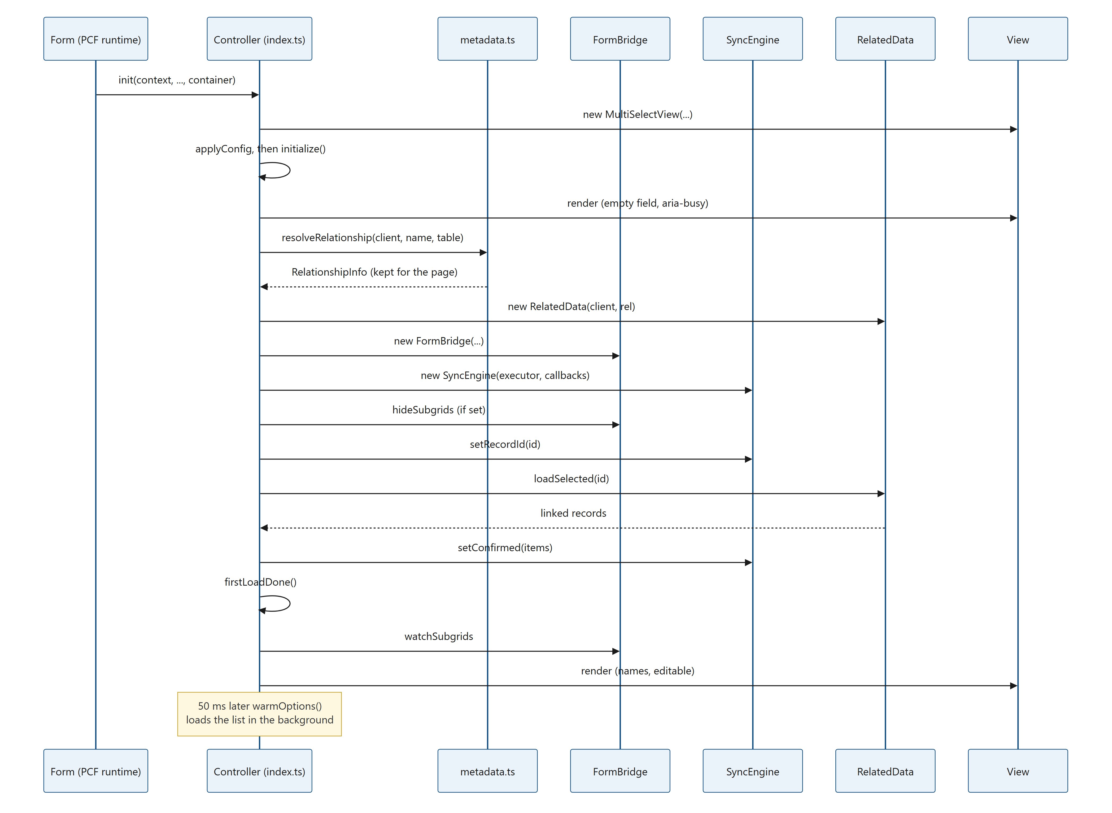
Figure 10. Diagram: 5.1 Opening a record
Step by step (initialize in index.ts):
- Reset. A new initToken is taken, the previous engine is retired (3.4.4), and the field is drawn empty and busy (ready: false). It shows nothing rather than ---, because "nothing selected" is not known yet.
- Where am I? The table comes from context.mode.contextInfo.entityTypeName. Without it the control is not on a model-driven form and shows "This control can only be used on a model-driven form." Without a relationship name it shows "Set the N:N relationship schema name in the control properties."
- Metadata. resolveRelationship (4.8) finds the related table and the navigation property. The result is cached for the page, so the second form costs no request.
- Working parts. RelatedData, FormBridge and SyncEngine are created. While Copy names into the host column is Yes, the engine's executor adds the link tag (4.5) to every associate and disassociate request.
- The record id comes only from the control's own context (recordIdFrom). The source explains why: on a quick create form, the page-level form API describes the record underneath, which would link values to the wrong record.
- Hide subgrids (if set) before the links are read, so replaced grids disappear as early as possible.
- Names copy (if Copy names is Yes): the record's shared copy is joined now, with the host column value the form loaded (see 5.4).
- Read the links (loadSelected), then firstLoadDone: from now on the field can be edited.
- Follow subgrids (watchSubgrids) and draw.
- Warm the list: 50 ms later warmOptions starts loading the list, so the first opening is instant. It is skipped when the field is read-only or offline.
control/NToNMultiSelect/index.ts, initialize (about lines 591–605, shortened):
// Use the latest context: the record may have been saved while the metadata was loading.
const recordId = this.recordIdFrom(this.context);
// Before the links are read, so that replaced subgrids disappear as early as possible.
this.applyHideSubgrids(recordId);
if (recordId) {
engine.setRecordId(recordId);
this.releaseAbandonedOrphan(bridge, recordId);
if (config.writeSummary) {
// ...
this.copy = this.startCopy(recordId, this.recordKey(recordId), data);
}
const loaded = await this.loadSelected(token, false);
if (token !== this.initToken) return;
// ...

When something fails.
Failure | What the control does
A setting that cannot work (wrong relationship name, view not found, bad FetchXML) | Shows the reason in the field (fatalError), worded by friendlyError. No retry: the same setting would fail again.
A passing problem during start-up (offline, timeout, server busy, 5xx) | Shows the reason, tries again once after 30 seconds (INIT_RETRY_DELAY_MS) and again when the browser is back online.
Reading the links fails with 400 or 404 | The metadata may be out of date (for example a renamed relationship): it is read again once, then start-up repeats.
Reading the links fails with a permission error | Shows "You don't have permission to see these related records." No retry.
Reading the links fails otherwise | The field cannot be used yet. It shows "Couldn't load the selected values." with the reason and retries the read after 1, 3 and 9 seconds (LOAD_RETRY_DELAYS_MS). Then it shows "Couldn't load the selected values. Reload the form to try again." and tries once more when the browser is back online.

Why the field is never editable before the first read. The source says it in one line: "Never let the user edit against an unknown baseline". Until the saved links are known, the engine does not know which links exist, so it could neither show the right selection nor work out the right requests. Once the first read is done, the field shows the names in bold: the idle look in 6.2.
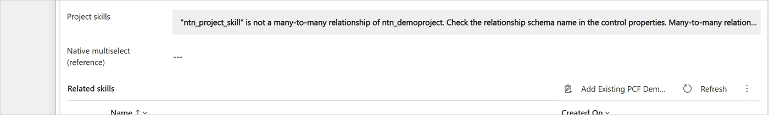
Figure 11. A setting that cannot work (a wrong relationship name). findRelationship throws a QueryConfigError, friendlyError words it, and the view shows it in the field's grey read-only box.

5.2 Opening the list
The list opens from the chevron, ↓ or Alt+↓, Enter, typing, or any click in the box when Open list on click is Yes. The view calls callbacks.onOpen(), which runs ensureOptions. Usually the list was already loaded by warmOptions and opens at once.

5.2.1 One request decides the mode
control/NToNMultiSelect/index.ts, ensureOptions (about lines 1347–1362):
this.optionsPromise = (async () => {
try {
// One request decides the mode: if everything fits in one page of 500, filter locally from then on.
const page = await data.loadOptions(query, "", CLIENT_MODE_LIMIT, null);
if (token !== this.initToken || listToken !== this.optionsToken) return;
if (!page.nextLink) {
this.mode = "client";
this.allOptions = page.items;
this.allOptionsKeys = page.items.map((i) => searchKey(i.name));
} else {
this.mode = "server";
this.baseOptions = page.items;
this.baseNext = page.nextLink;
}
this.optionsStatus = "ready";
this.applySearch(this.searchTerm, true);

The first request asks for 500 records (CLIENT_MODE_LIMIT). If the server says there are no more:
- Client mode (up to 500 records). All records are in memory. Typing filters them instantly, in the browser, with no request. The match is "contains", ignoring case and accents: searchKey normalises each name once (Unicode NFD, accent marks removed, lower case), so "resume" finds "Résumé", like the native search. Select all can be offered.
If there are more:
- Server mode (more than 500 records). The first 500 are shown. Scrolling to the end loads the next 500. Typing searches on the server, 100 records per page (SERVER_PAGE_SIZE), with "starts with" or "contains" (Search mode for large tables).
Why this split? One request of up to 500 short rows (only the id and the name) is quick, and filtering 500 names in the browser is instant and needs no further request. Larger tables are searched on the server, so the browser never has to hold a whole large table.

5.2.2 Searching in server mode
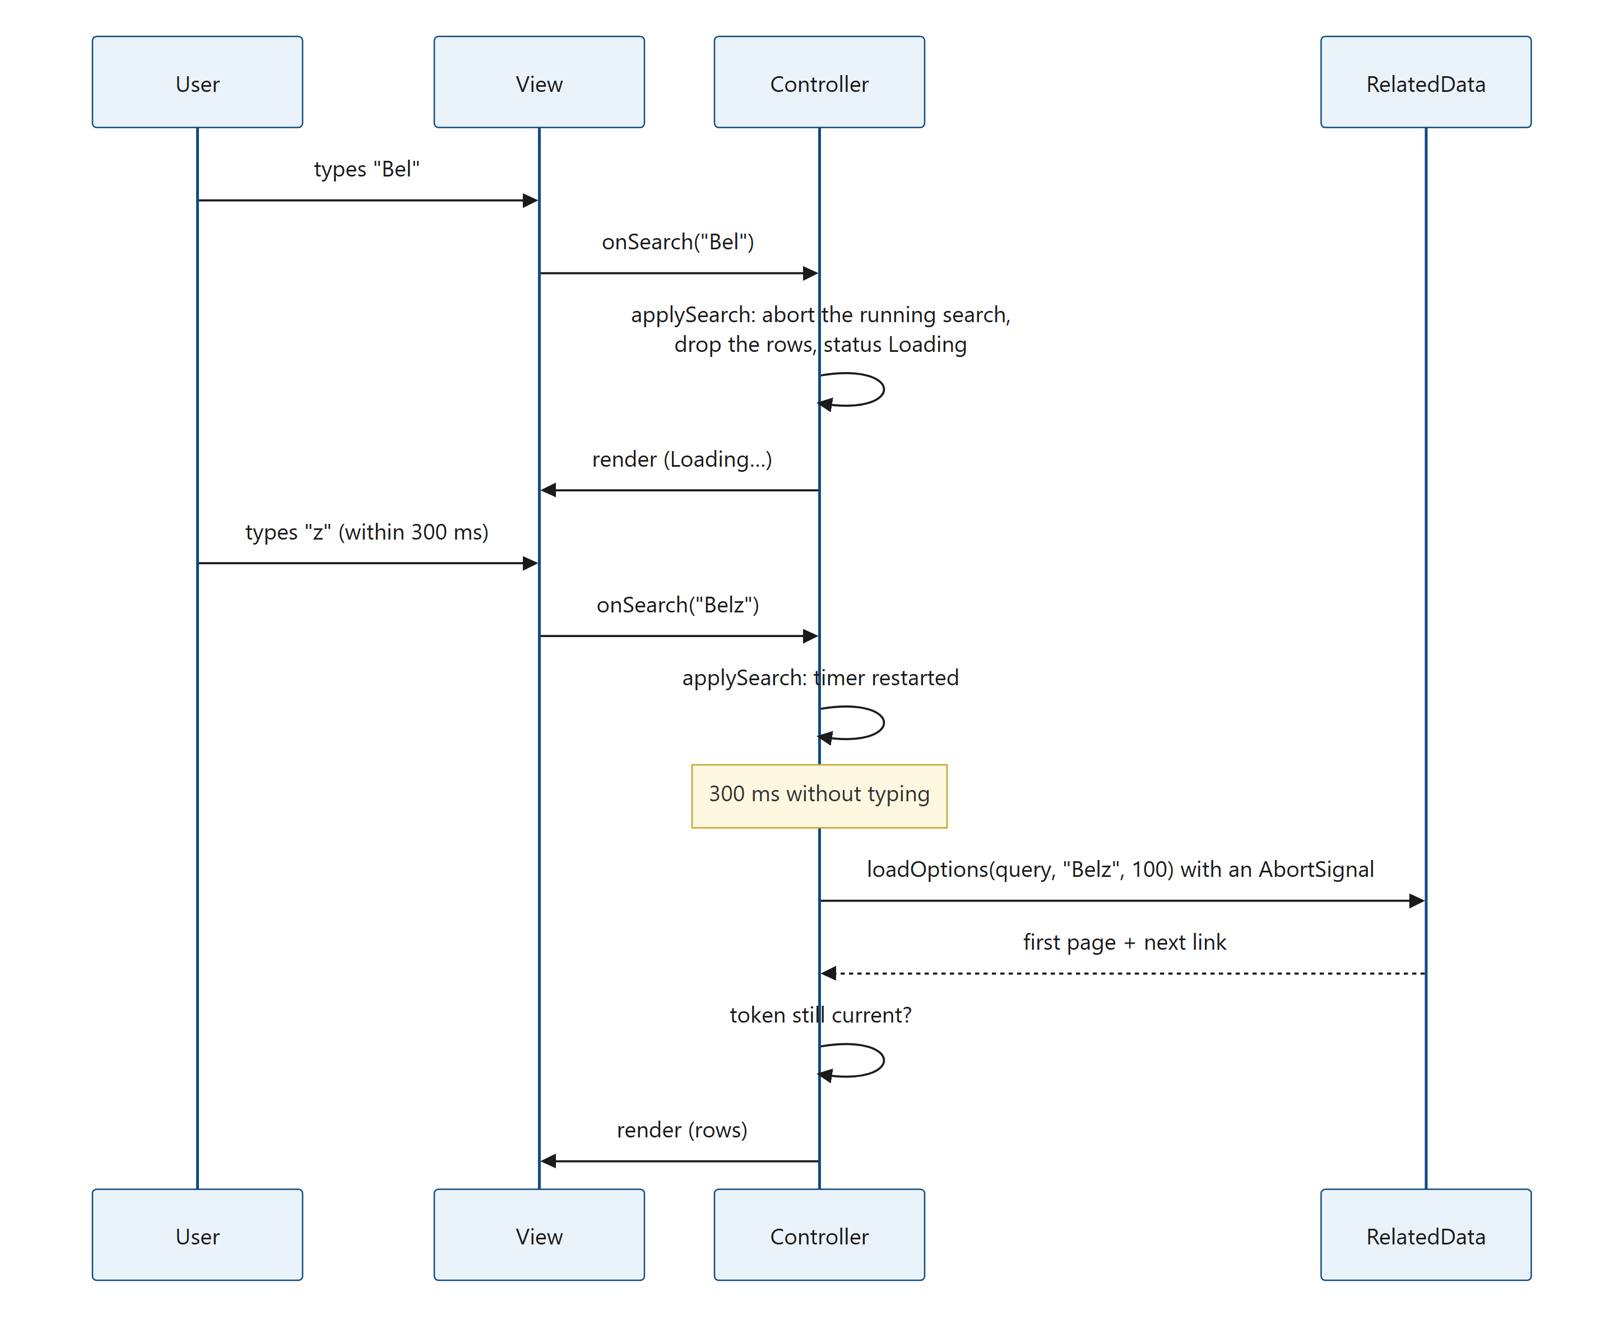
Figure 12. Diagram: 5.2.2 Searching in server mode
The part of applySearch that runs on each keystroke. control/NToNMultiSelect/index.ts, applySearch (about lines 1424–1438):
if (immediate) {
void this.serverSearch(trimmed);
return;
}
// The rows on screen belong to the previous search. They go now rather than when the request starts, so that in
// the meantime nothing of that search can act: a page of it still on its way is dropped, and a click, Enter or
// Select all can't link its records under the new search text.
this.searchToken++;
this.loadingMore = false;
this.loadMoreError = null;
this.optionsStatus = "loading";
this.shownOptions = [];
this.shownNext = null;
this.render();
this.searchTimer = setTimeout(() => void this.serverSearch(trimmed), SEARCH_DEBOUNCE_MS);

Why the rows are removed at once. The search waits 300 ms (SEARCH_DEBOUNCE_MS) after the last keystroke, so that typing "Belz" sends one request instead of four. During that wait, the rows on screen still belong to the previous search text. If they stayed visible, a click, Enter or Select all in that moment would link records the user is no longer looking for. Removing them as soon as the text changes, and showing "Loading…", makes that impossible. Increasing searchToken also drops any page of the previous search that is still on its way.
Other details of the search:
- applySearch aborts the request still on its way (AbortController); serverSearch starts the new one with its own AbortController and a new searchToken.
- An empty search box shows the base list again: the 500 (or more, if the user scrolled) records loaded before, with no new request.
- A search made only of hyphens or apostrophes is not sent (isSearchable); the list shows "No entries found".
- Typing before the first page has arrived is not lost: onSearch stores the term and ensureOptions applies it when the page arrives.
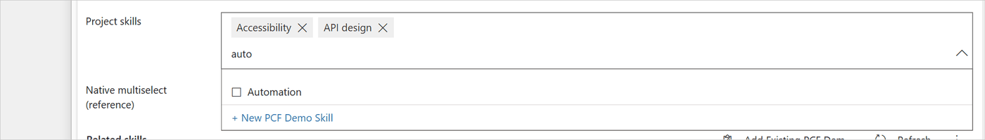
Figure 13. Client mode: typing "auto" filters the list in the browser, through applySearch and searchKey.
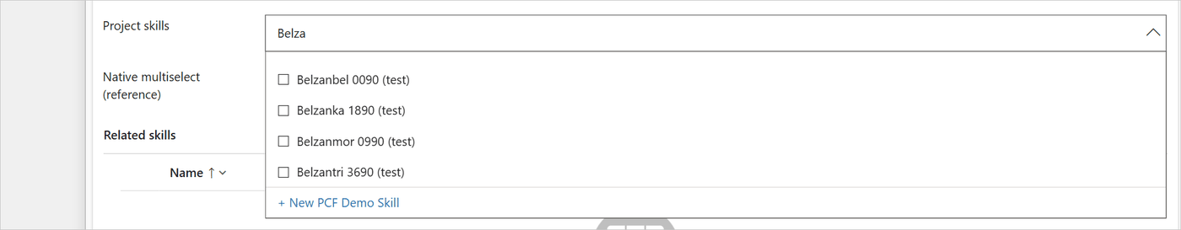
Figure 14. Server mode: the rows come from serverSearch, a "starts with" query on the server.

5.2.3 Loading more rows
When the user scrolls to within 70 pixels of the end of the list, the view calls onLoadMore, which runs loadMore.
control/NToNMultiSelect/index.ts, loadMore (about lines 1478–1488):
// The next link already carries the filter, search term and ordering; it must keep its page size.
const page = await this.data.loadOptions(this.optionsQuery(), "", pageSize, next);
if (token !== this.searchToken) return;
const seen = new Set(this.shownOptions.map((i) => i.id));
const merged = this.shownOptions.concat(page.items.filter((i) => !seen.has(i.id)));
this.shownOptions = merged;
this.shownNext = page.nextLink;
if (isBase) {
this.baseOptions = merged;
this.baseNext = page.nextLink;
}

How the next page is asked for depends on how the list is read:
List read with | Next page | Notes
OData (no view, no FetchXML setting) | The @odata.nextLink the server returned. | It must be requested with the same Prefer: odata.maxpagesize as the first page, so the page size is kept in shownPageSize.
FetchXML (a view or the FetchXML setting) | nextPageFetch: the same query with page + 1 and the paging cookie from the @Microsoft.Dynamics.CRM.fetchxmlpagingcookie annotation. | The server only says there is more with @Microsoft.Dynamics.CRM.morerecords; the control asks for both annotations with a Prefer header.
FetchXML sorted on a linked column, or with useraworderby | page + 1 without a cookie. | The cookie does not work reliably for these queries.
FetchXML whose cookie makes the address longer than 30,000 characters | page + 1 without a cookie. | FetchXML travels in the URL (MAX_URL_LENGTH).

A page that arrives for an earlier search is dropped (token check), and records already in the list are not added twice. A failed page shows "Couldn't load more records. Scroll to try again." at the end of the list.
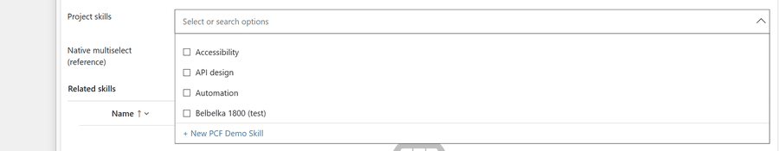
Figure 15. Server mode: scrolling to the end of the list calls loadMore, which appends the next page with rebuildRows (the scroll position is kept).

5.2.4 When Select all is offered
render (4.2.3) offers Select all only when all matching rows are loaded: always in client mode, and in server mode only for a search whose results are all loaded (no next page is left: they fit in one page of 100, or the user scrolled to the end). The number of rows must also be within Select all limit (100 by default, at most 500), and selecting them all must stay within Maximum selections, counting the places already taken (5.3): rows that already take a place add none.
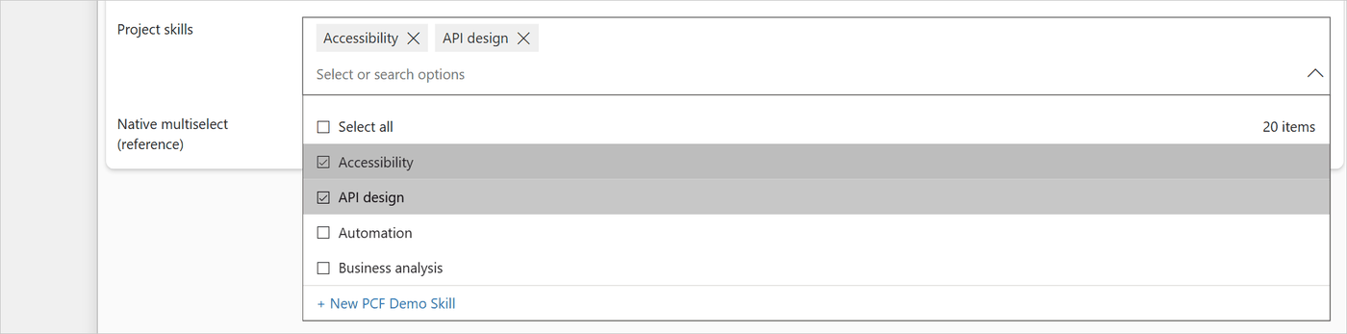
Figure 16. The list in client mode with the Select all row and the item count, drawn by renderMenu.

5.3 Picking and removing
Every way of changing the selection ends in the same function, onToggle in the controller:
User action | View code
Click on a row | list click handler → toggle
Enter or Space on the highlighted row | activateCurrent → toggle
Select all | toggleAll → callbacks.onToggleAll
× on a value | removeWithX → toggle
Delete or Backspace on a highlighted value | onChipKey → toggle
+ New (after quick create) | controller createRecord → onToggle

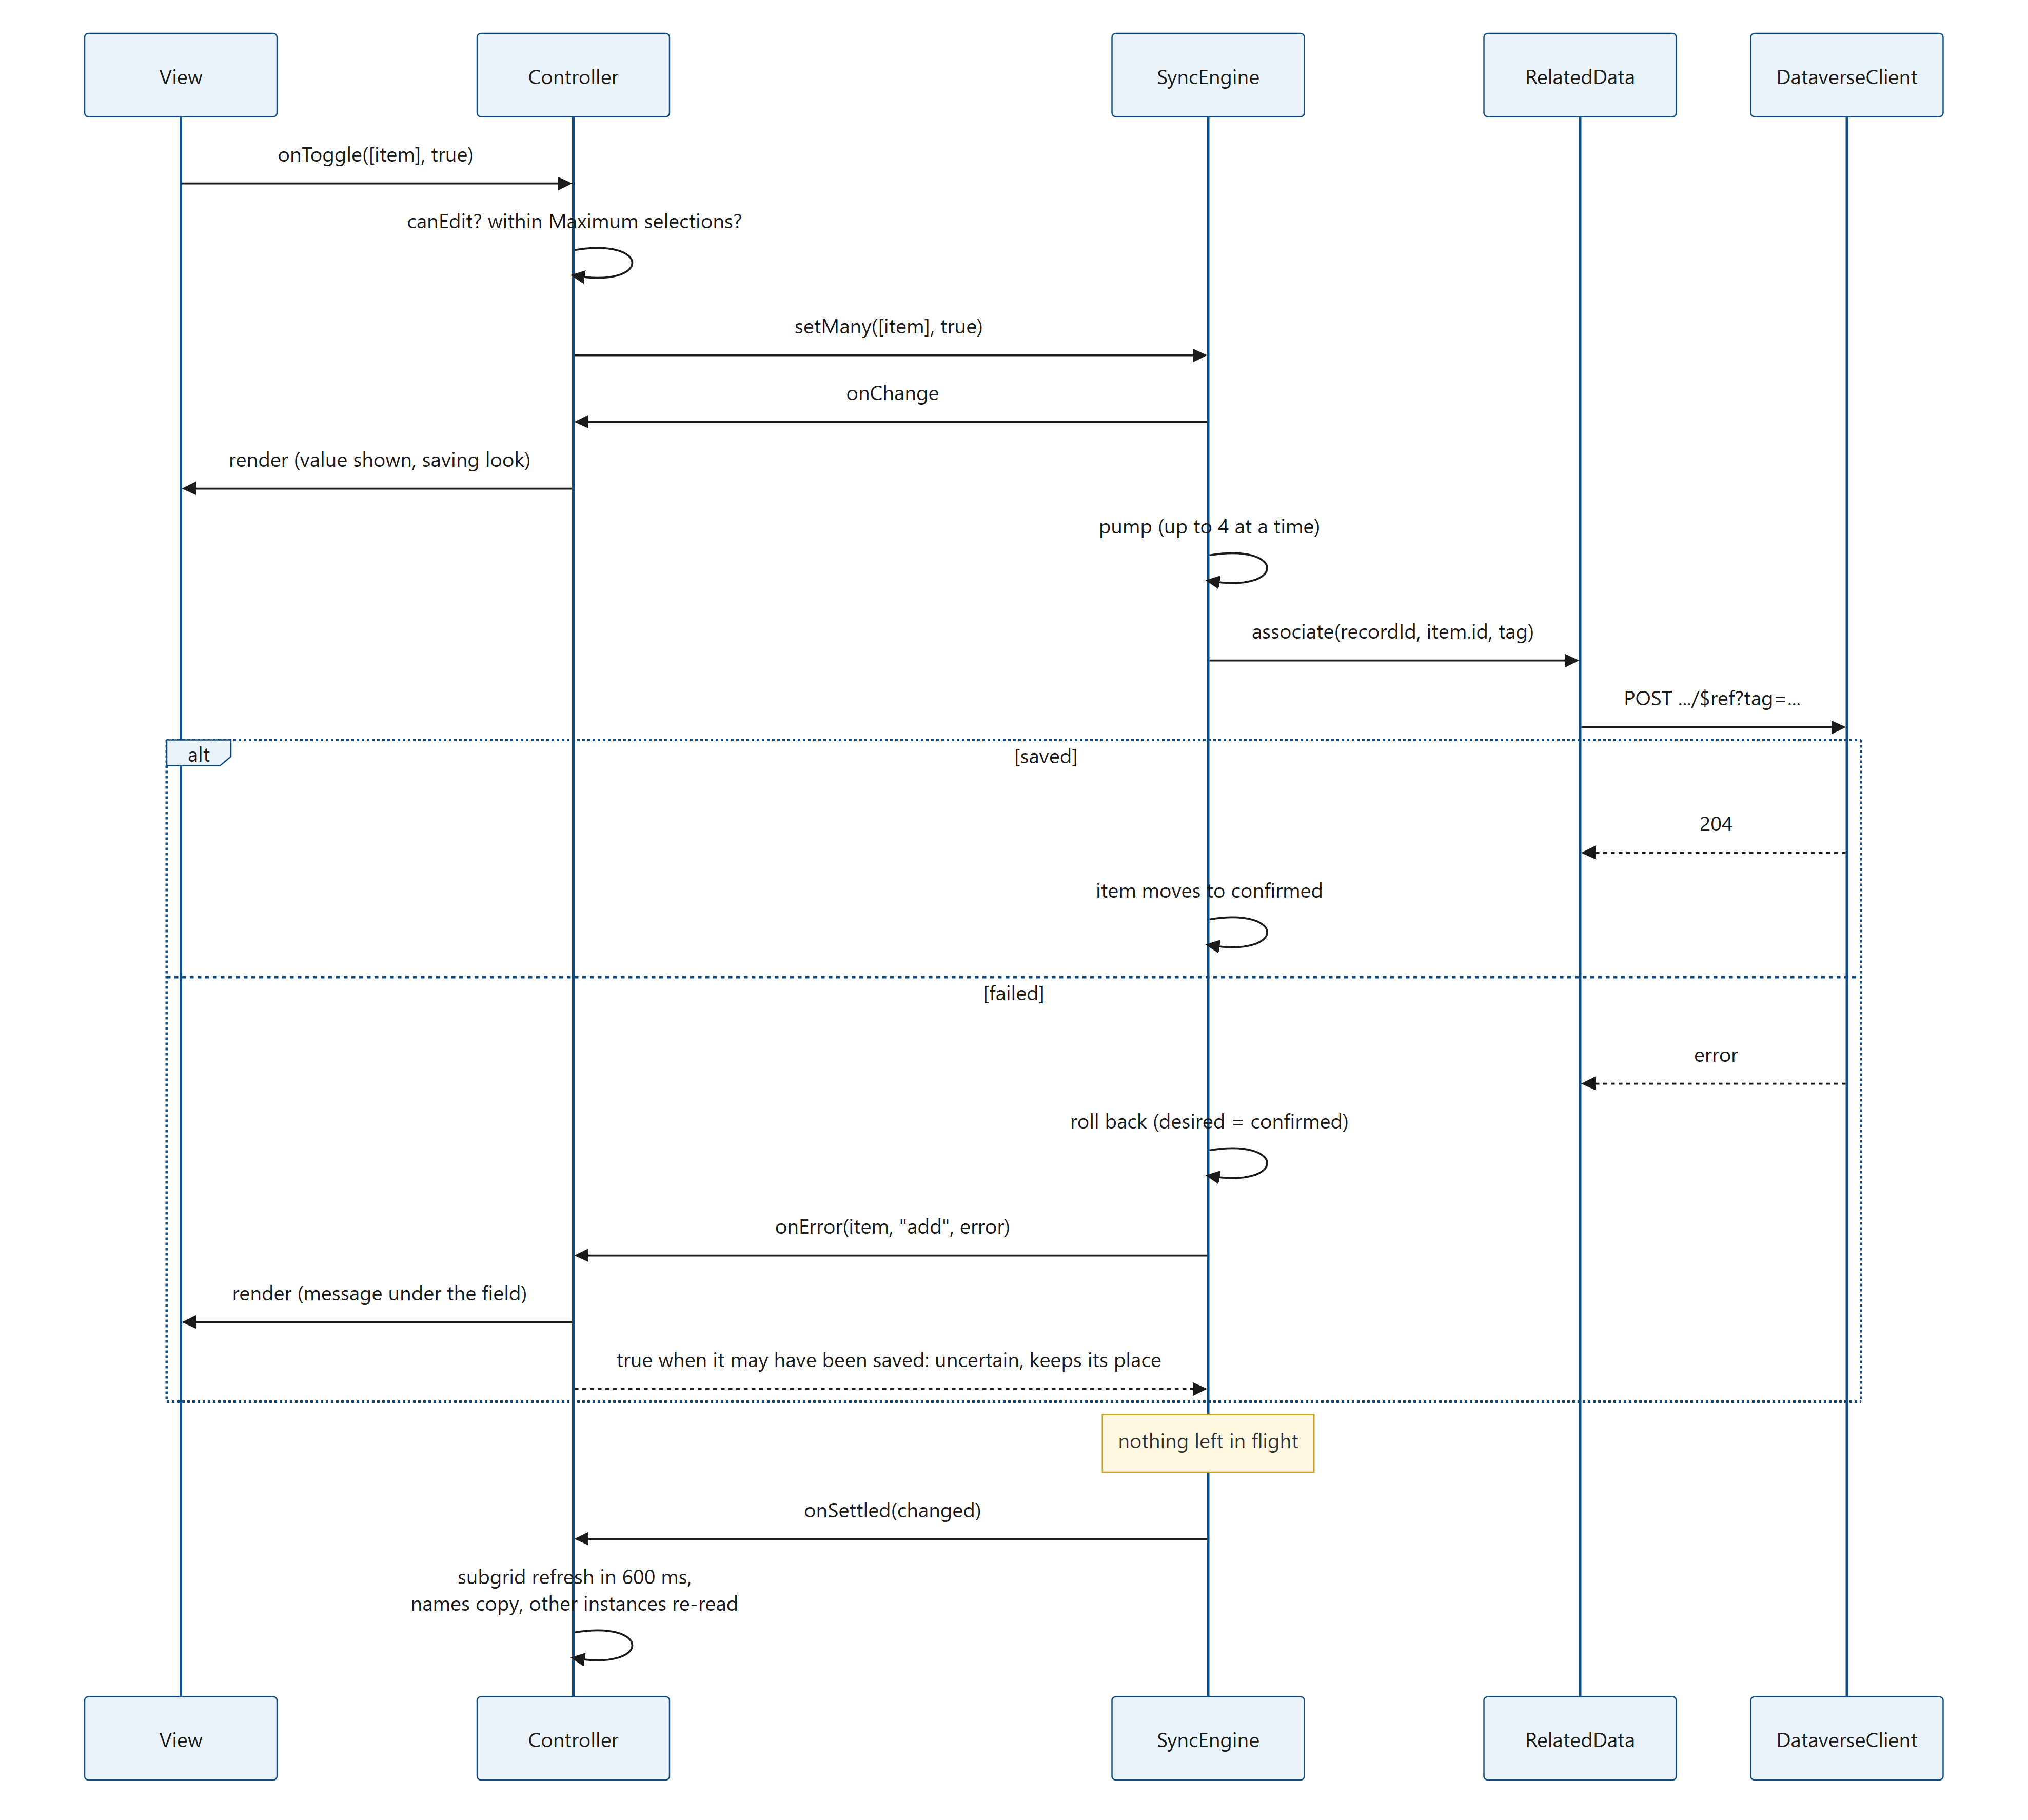
Figure 17. Diagram: 5.3 Picking and removing
control/NToNMultiSelect/index.ts, onToggle (about lines 1227–1245):
private onToggle(items: Item[], select: boolean): void {
const engine = this.engine;
if (!engine || !this.canEdit()) return;
const max = this.config?.maxSelections ?? 0;
if (select && max > 0) {
// A record whose removal is still on its way keeps its place, since the removal may fail and bring it
// back: the limit counts it until the removal succeeded, and picking it again takes no new place.
const adding = items.filter((i) => !engine.occupies(i.id)).length;
// A pick that takes no new place is never refused (the record may hold more links than the limit already).
if (adding > 0 && engine.occupiedCount() + adding > max) {
// The view already blocks this; the check here also covers + New and anything else that selects.
this.error = this.t.maxNote(max);
this.render();
return;
}
}
this.error = null;
engine.setMany(items, select);
}

What the user sees:
- The value appears (or disappears) at once: the view draws the engine's desired set.
- Until its change is saved, the chip and the row are drawn lighter (is-saving, opacity 0.6). The controller passes the engine's pendingIds() as pending.
- When the request succeeds, the light look goes. When it fails, the value goes back to how it was, and a message appears under the field.
The check on Maximum selections in onToggle is a safety net: the view already greys out the other rows once the limit is reached, and toggle in the view refuses them.
Maximum selections and writes on their way. The limit counts places, not only the values the field shows. A record keeps its place until the server has settled it (SyncEngine.occupiedCount, 4.4):
- a saved value whose removal is on its way (its chip goes away at once, as always);
- a pick the user undid while its link was on its way (the link may still land);
- a pick whose save failed in a way that may still have saved it (a lost connection, a timeout, a gateway or server error), until the control has read the saved links again. It does that after any failed write (scheduleResync, below); when that read fails, it tries again after 1, 3 and 9 seconds, at most three times in a row, but only while such a pick holds a place (5.5.2).
The reason: if a removal freed its place at once and the server then refused it while a new pick was saved, the record would end with one link more than the maximum. So, at the limit, the other rows stay greyed and + New and Select all stay hidden until those removals have succeeded, usually a fraction of a second. Picking the value that is being removed again is allowed: it takes no new place (holdsPlace in the view, 6.5). A pick that takes no new place is never refused, also when the record already holds more links than the limit (links made elsewhere, or a limit that was lowered). None of this costs a request, and nothing changes below the limit or without a maximum.
Where the limit holds. The limit is checked by each copy of the field on its own, against the links it knows of. Two copies of the same field on one form, two browser tabs or two users can together go over it, and subgrids, imports, flows, integrations and the Web API are not limited at all. To make the limit hold everywhere, enforce it on the server (10.9).
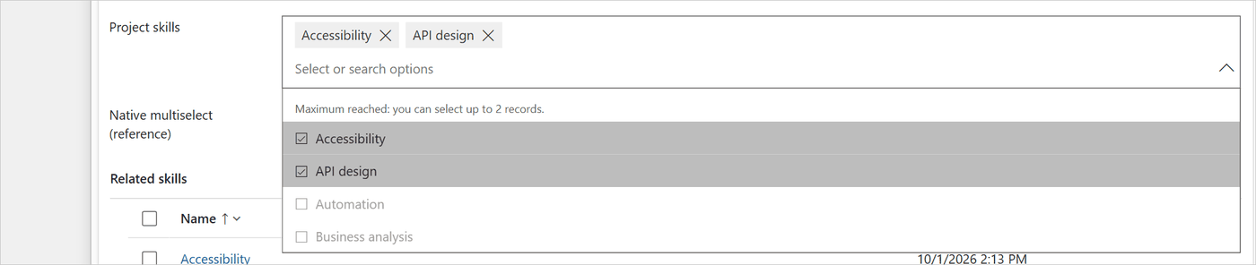
Figure 18. Maximum selections = 2, reached: render passes maxReached and the note maxReached(max), the view draws the other rows with is-disabled (drawRow), and + New is hidden (canCreate is false).
Errors during a batch. control/NToNMultiSelect/index.ts, onWriteError (about lines 935–962):
/** Reports a failed write; returns whether it may have been saved all the same (see mayHaveSaved). */
private onWriteError(engine: SyncEngine, item: Item, operation: "add" | "remove", error: unknown): boolean {
console.error(`[${CONTROL_NAME}] ${operation} failed for ${item.id}`, error);
const reason = friendlyError(error, this.t, "change");
// Every queued change would fail the same way (no permission, offline, server busy): drop them now and count
// them as failed, instead of sending them one by one.
const dropped = stopsBatch(error) ? engine.cancelQueued() : 0;
if (engine !== this.engine) {
const away = detached.get(engine);
if (away) {
away.failures += 1 + dropped;
if (!away.firstError) away.firstError = reason;
if (mayHaveSaved(error)) away.unknown = true;
}
return mayHaveSaved(error);
}
if (mayHaveSaved(error)) this.batchUnknown = true;
this.batchErrors += 1 + dropped;
if (this.batchErrors === 1) {
this.batchFirstError = reason;
this.error = `${operation === "add" ? this.t.addFailed(item.name) : this.t.removeFailed(item.name)} ${reason}`;
} else {
if (this.batchErrors === 1 + dropped) this.batchFirstError = reason;
this.error = `${this.t.manyFailed(this.batchErrors)} ${this.batchFirstError}`;
}
this.render();
return mayHaveSaved(error);
}

- One failure: "Couldn't add "Automation". You don't have permission to change these related records. (prvAppendTo...)".
- Several: "Couldn't save 12 changes." followed by the first reason.
- A permission error, a lost connection, a timeout or "server busy" (stopsBatch) cancels the changes still queued: the remaining 90 requests of a Select all would only fail the same way.
- A write that failed with a lost connection, a timeout, or a gateway or server error (5xx) may still have been saved (mayHaveSaved, below). onWriteError then notes it for the batch (batchUnknown), or for a detached engine in its Detached entry (unknown, 5.8), and returns true, so a failed add keeps its place toward Maximum selections (4.4). The message still says that the value could not be added or removed: for the control the write failed, and the field shows the value as it was.
- After a batch with errors, the links are read again (scheduleResync): a request that "failed" because the connection dropped may in fact have been saved. While a failed add of unknown outcome holds a place, a failed re-read is tried again (5.5.2).
control/NToNMultiSelect/index.ts, mayHaveSaved (about lines 186–192):
/**
* A write that failed this way may still have been saved: the connection dropped or the request timed out after it
* reached the server, or a gateway or server error answered. Only a read of the saved links tells.
*/
function mayHaveSaved(error: unknown): boolean {
return isNetworkError(error) || error instanceof TimeoutError || (error instanceof DataverseError && error.status >= 500);
}

After the batch (onSettled, once nothing is left in flight). control/NToNMultiSelect/index.ts, onSettled (about lines 964–993):
private onSettled(engine: SyncEngine, changed: boolean): void {
if (engine !== this.engine) {
const away = detached.get(engine);
if (away) this.finishDetached(engine, away, changed);
return;
}
const hadErrors = this.batchErrors > 0;
const unknown = this.batchUnknown;
this.batchErrors = 0;
this.batchUnknown = false;
if (unknown) {
// A write may have been saved although it failed: the copy follows the links saved on the server, and the
// re-read that settles it gets its own retries (see loadSelected).
this.resyncRetries = 0;
this.updateSummary(true);
}
// A write that may have been saved changes the links as much as one that was: subgrids and the other instances
// on the page read them again.
if (changed || unknown) {
this.scheduleSubgridRefresh();
if (!unknown) this.updateSummary();
const recordId = engine.getRecordId();
if (recordId) this.resyncPeers(this.recordKey(recordId), engine);
}
if (hadErrors) {
// A failure might not be what it seems (the connection dropped after the server saved): re-read.
this.scheduleResync();
}
this.render();
}

- When at least one write succeeded, or one failed in a way that may have saved it: the related subgrids are refreshed 600 ms later (5.5), and other instances on the page that show the same record read their links again (resyncPeers).
- The names are copied (5.4): after a batch that changed something, when the page's names differ from what the column holds (updateSummary()); after a batch with a write of unknown outcome, whatever the page shows (updateSummary(true), 5.4.1): the field rolled that value back, but the copy follows the links saved on the server.
- After any failure the field reads the saved links again (scheduleResync), and so shows them as they are.
A value removed with its × goes through toggle too; where the focus goes afterwards is described in 6.4.2.
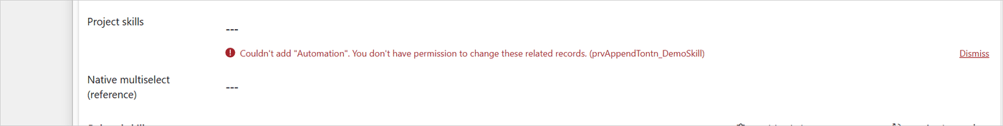
Figure 19. A failed associate: run rolled the value back, and onWriteError shows the reason from friendlyError with the missing privilege.
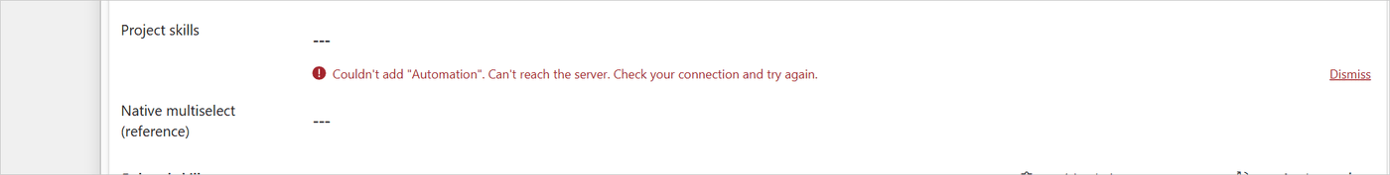
Figure 20. The same for a lost connection: friendlyError words a network error (isNetworkError) as "Can't reach the server. Check your connection and try again."

5.4 The names copy
With Copy names into the host column = Yes, the control writes the selected names ("API design; Automation") into the host column of the record, with its own update. The names then appear in views, searches and exports.
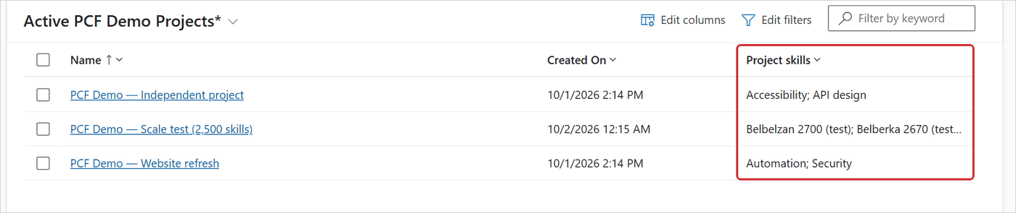
Figure 21. A view of the host table showing the host column filled by the names copy (the names joined with "; " by namesText).

5.4.1 When the copy is written
The copy is written:
- after a batch of writes that changed something (onSettled calls updateSummary, 5.3);
- after a batch in which a link or unlink failed in a way that may still have saved it (mayHaveSaved: a lost connection, a timeout, a gateway or server error). onSettled calls updateSummary(true): the copy reads the links saved on the server and writes their names into the host column, although the field rolled the value back (NamesCopy.refresh). The field then shows the saved links again (its re-read after a failure, 5.3), and the subgrids and the other instances of the control on the page read them again;
- after a re-read that found other links than before, for example a change in a subgrid on the same form (loadSelected calls updateSummary, 5.5);
- for writes that finish after the control is gone, once they are all done (finishDetached updates the copy it was handed, 5.8), also after a write of unknown outcome, and also when the form was closed in the middle of a batch.
updateSummary does nothing when the setting is off, when the record has no id yet, or when column security does not let the user update the host column (columnLocked, 5.9).
control/NToNMultiSelect/index.ts, updateSummary (about lines 1062–1074):
private updateSummary(force = false): void {
const engine = this.engine;
const recordId = engine?.getRecordId();
// With the host column locked by column security, the write would be refused: a change made in a subgrid of the
// form is left to the names copy plug-in, when it is installed.
if (this.destroyed || !this.config?.writeSummary || !engine || !recordId || this.columnLocked()) return;
this.copy ??= this.startCopy(recordId, this.recordKey(recordId), this.data);
if (this.copy) {
// `force`: read the saved links and write their names even when the page's names haven't changed.
if (force) this.copy.names.refresh(this.copy.writer);
else this.copy.names.update(engine.selected(), this.copy.writer);
}
}

What it costs. Nothing in normal use. Only after a failed write of unknown outcome: one read of the saved links, and one write when their names differ from what the column holds.

5.4.2 One queue per record
startCopy gets the record's NamesCopy from namesCopyFor with the key record id | relationship | host column. All instances on the page that show that record (for example the field and its copy in the form header) share it. Updates are written one at a time, in order: a newer update waits until the write on its way has finished. This is why two writes can never arrive at the server in the wrong order and leave old names in the column.
The copy is joined as soon as the record opens (5.1, step 7), with the host column value the form loaded. If another instance on the record writes first, this instance already knows the new value and does not write the same names again.

5.4.3 Read, then write
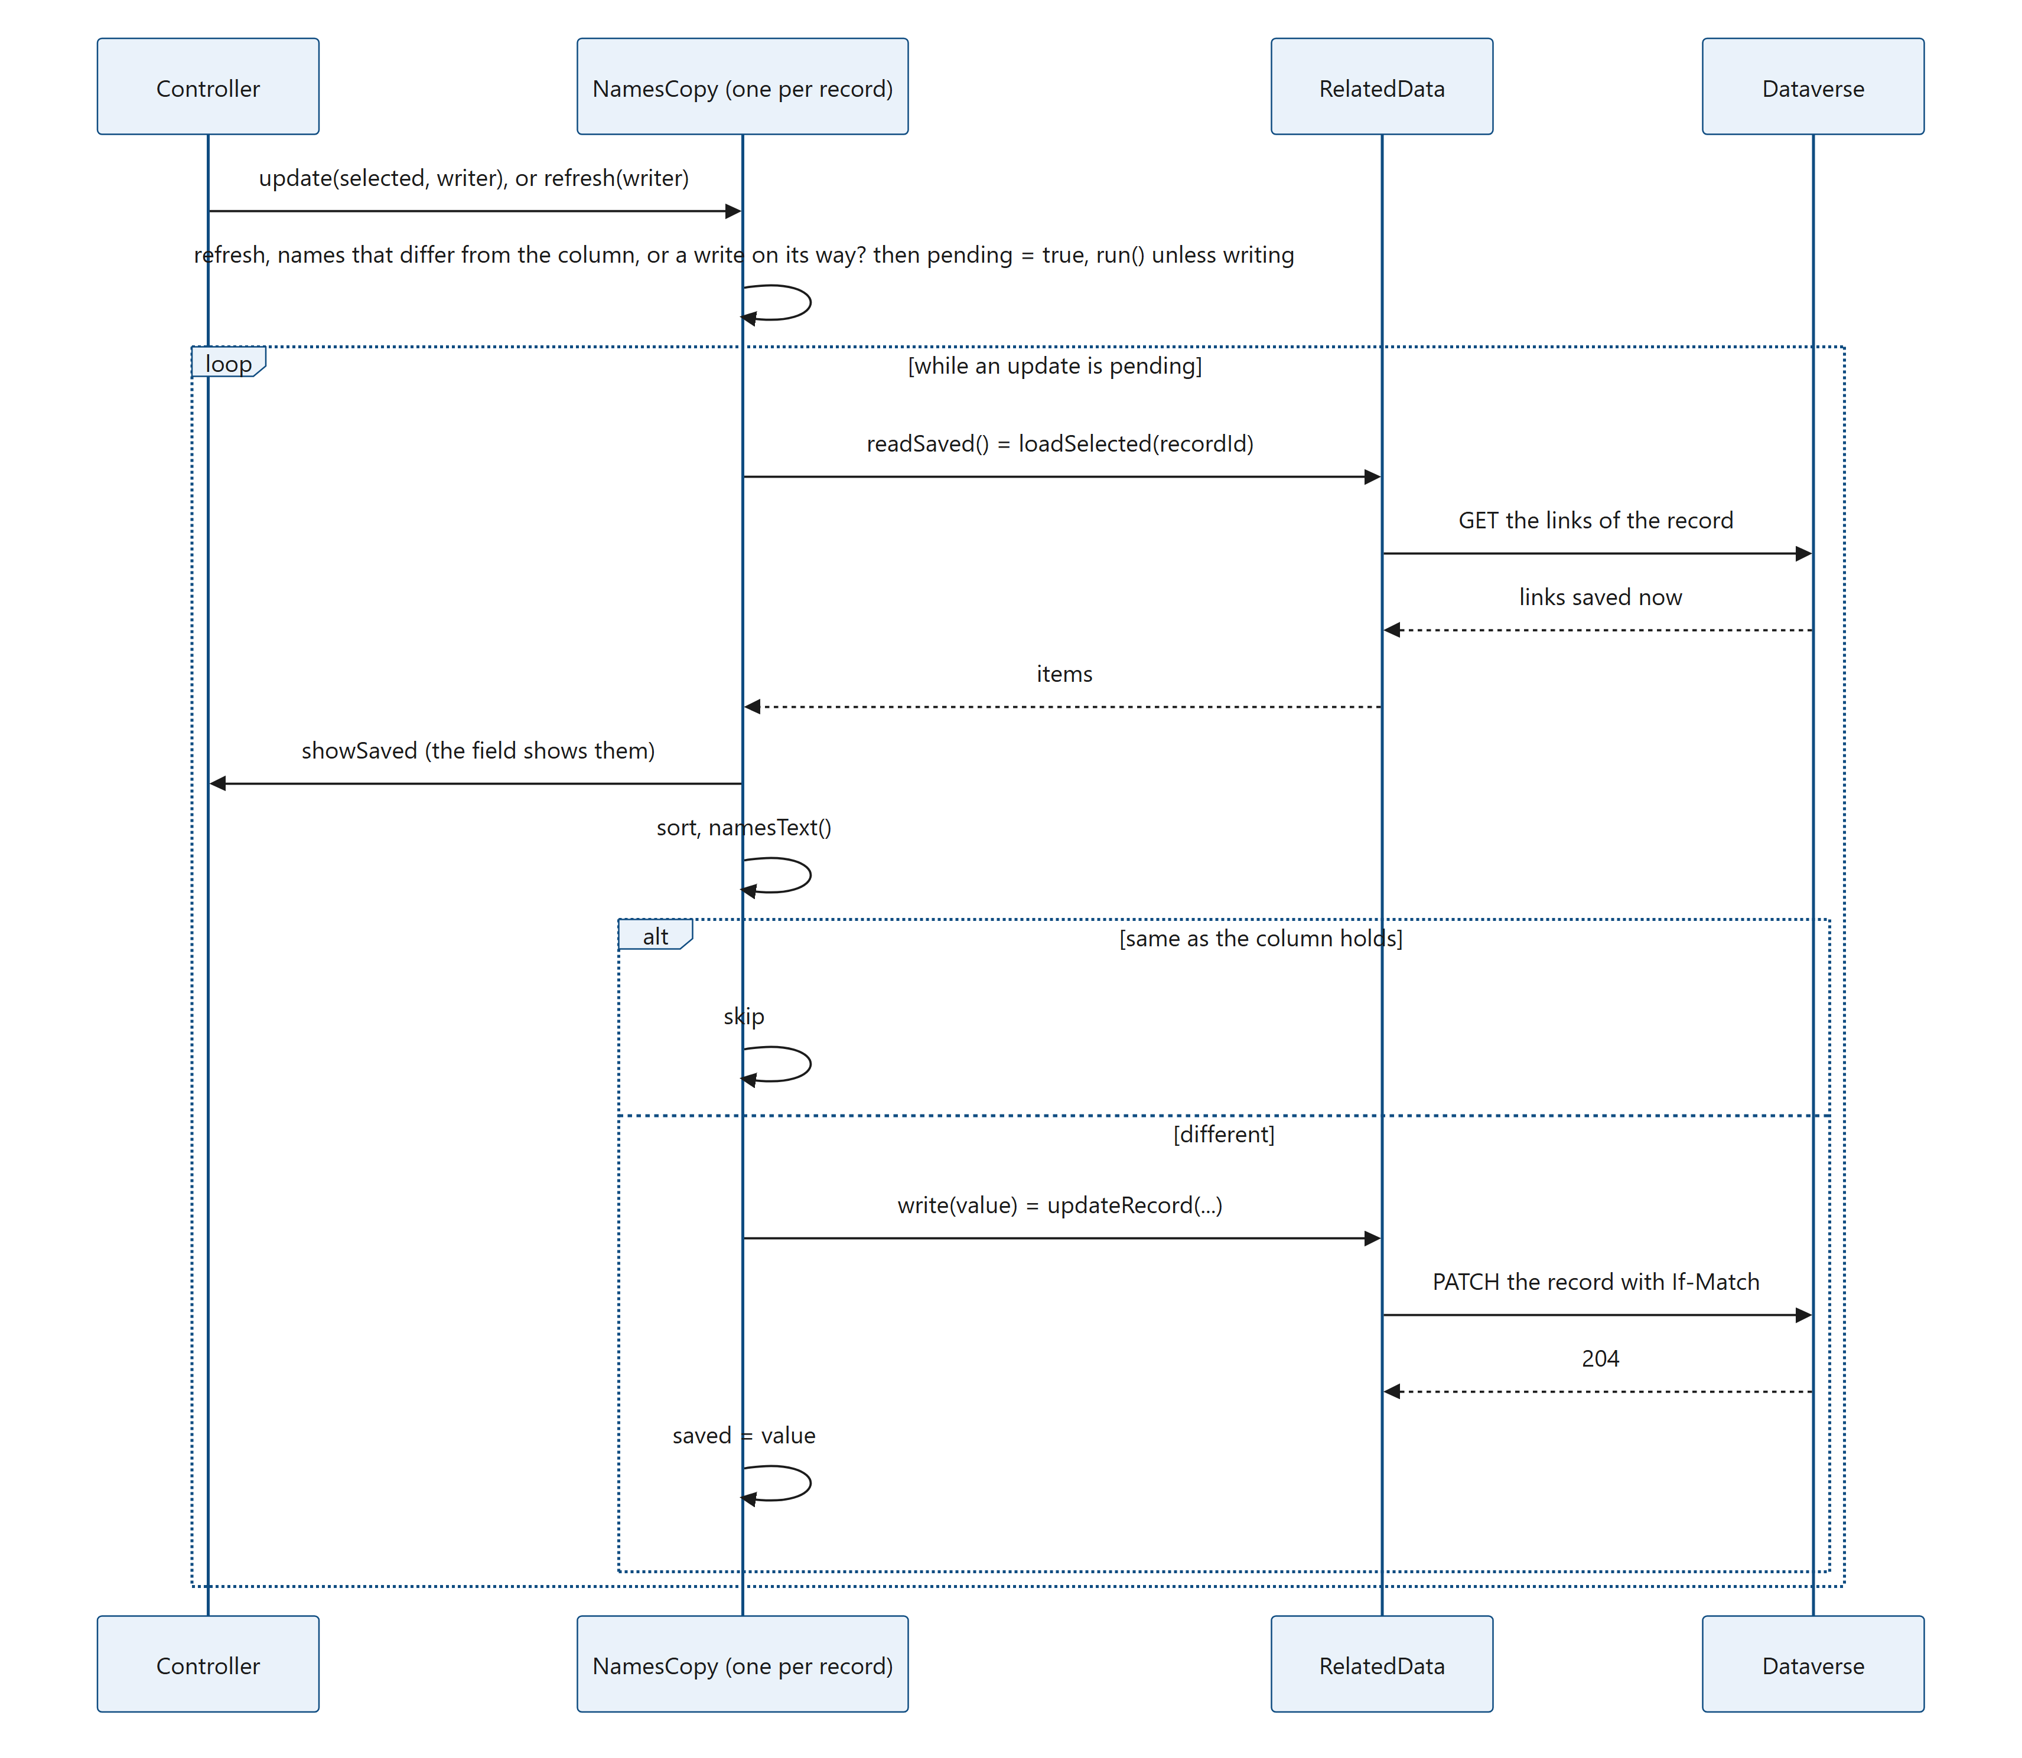
Figure 22. Diagram: 5.4.3 Read, then write
update does nothing (no read, no write) when the page's names equal what the column is known to hold and no write is on its way. refresh always sets pending: it is only called after a link write whose outcome is not known, when the page's names cannot be trusted.
control/NToNMultiSelect/src/namesCopy.ts, NamesCopy.refresh, update and run (about lines 79–131):
public refresh(writer: CopyWriter): void {
if (!writer.readSaved) return;
this.writer = writer;
this.pending = true;
if (!this.writing) void this.run();
}

/** Copies the names of `selected`; call it once their links are saved. */
public update(selected: Item[], writer: CopyWriter): void {
this.wanted = namesText(selected, writer.maxLength);
this.writer = writer;
// While a write is on its way, the update waits for it, whatever its names: it may go back to what the
// column held before that write.
if (this.writing || this.wanted !== this.saved) {
this.pending = true;
if (!this.writing) void this.run();
}
}

private async run(): Promise<void> {
this.writing = true;
try {
while (this.pending) {
this.pending = false;
const writer = this.writer!;
let value: string | null;
try {
value = writer.readSaved ? await this.namesToWrite(writer, writer.readSaved) : this.wanted;
} catch (error) {
// The saved links couldn't be read, so the right names aren't known: the column keeps what it
// holds, and the failure is shown like a failed write. An update asked for during the read is
// still done (it reads again); otherwise the next update tries again.
writer.onError(error, "read");
continue;
}
if (value === this.saved) continue;
try {
await writer.write(value);
this.saved = value;
} catch (error) {
// The links stay as they are. The write may still have reached the column (a timeout, or a
// connection lost after the server saved it), so its value isn't known and the next update writes.
// An update asked for during the write is still done.
this.saved = undefined;
writer.onError(error, "write");
continue;
}
}
} finally {
this.writing = false;
this.writer = null;
}
}

A failed read or write is reported (onError), and the loop goes on: an update that came in while it was on its way (pending set again) is still done, with a new read. Without one, the loop ends and the next update tries again.
Why read the links before writing? The page knows the links it read when the record opened, plus its own changes. A link made elsewhere while the form was open (another user, another tab, a flow, the other side of the relationship) is not in that list. Writing the page's names would remove that link's name from the column. Reading the saved links just before the write avoids that. The read also updates the field (showSaved), so links made elsewhere appear with the user's next change, without a reload. A small window remains: a link made elsewhere in the moment between the read and the write can still be missed. That moment was about 50 ms in a development environment; it is longer on a slow connection, and when the write has to be sent again (the retries wait 1, 2 and 4 seconds, and throttling can make it wait up to about a minute, 4.6). A change missed this way reaches the column with the record's next change of links.
Whose names the control writes. The read runs in the editing user's session, with that user's privileges, so the control writes the names of the linked records that user can read; a linked record the user cannot open is left out of the text. The names copy plug-in, which handles links made elsewhere, writes every linked name as SYSTEM (8.14). With the plug-in installed, the column therefore holds every name after a link made elsewhere, and the names the editing user can see after a change made in the control (or in a subgrid of the same form, which the control writes after the plug-in).
What the read costs. Measured in a development environment, the names were written about 120 ms after the link was saved, instead of 67 ms without the read. Picking is not slower: the read and the write happen after the link is saved, while the user goes on.
The writer the controller builds. control/NToNMultiSelect/index.ts, startCopy (about lines 1100–1114):
const copy: HostCopy = {
names: namesCopyFor(`${recordKey}|${host}`, this.loadedCopy),
writer: {
maxLength: attributes.MaxLength,
write: (value) => trackCopy(data.updateRecord(recordId, host, value)),
onError: (error, step) => this.onCopyFailed(copy, error, label, t, step),
readSaved: async () => {
const engine = this.engine;
const version = engine?.version;
const items = await trackCopy(data.loadSelected(recordId));
this.showSaved(engine, version, recordId, items);
return items;
},
},
};

- The text is the names sorted by compareItems (case and accent insensitive, then by id), joined with "; ", cut to the column's maximum length with "…", or empty (null) when nothing is linked.
- The write is a PATCH of the record with If-Match: *. Without that header a PATCH to a record that was just deleted would create it again. It is sent with keepalive (bodies up to 60,000 bytes, 4.6): once it is on its way, the browser finishes it even if the user closes the page meanwhile. A keepalive request that the browser refuses is sent again as an ordinary one.
- The update goes through Dataverse like any other: it does not make the form dirty, but plug-ins, flows and auditing see it, and the user needs Write permission on the record.
- trackCopy counts the read and the write as "on their way", so leaving the page asks for confirmation (5.8).

5.4.4 Errors
Step | Message | Effect
Read of the saved links fails | "The names could not be copied into Label: " + a read reason, for example "You don't have permission to see these related records." | Nothing is written; the column keeps its value. An update that came in during the read is still done (it reads again); otherwise the next change tries again. After a change whose outcome is not known, the field's re-read of the saved links (5.5.2) also writes the names when it finds links the field did not show (while the record is open).
Write fails | "The names could not be copied into Label: " + an update reason, for example "You don't have permission to change this record. (prvWrite...)" | The column's value is now unknown, so the next change writes for sure. An update that came in during the write is still done.

The message appears under the field, or as an app notification when the control is already gone (onCopyFailed). The links themselves are never undone because of a failed copy.
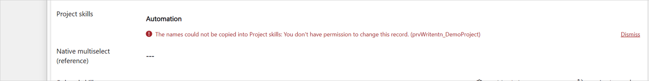
Figure 23. A failed write of the names copy, reported by onCopyFailed with the "update" wording of friendlyError.

5.4.5 The link tag and the names copy plug-in
While Copy names is Yes, each associate and disassociate request of the control carries the tag NToNMultiSelect|<relationship>|<table>|<record id>|<host column> (linkTag, 4.5). The optional names copy plug-in (in the solution with the plug-in) copies the names after links made anywhere. When it sees this tag, it skips exactly that record and column, because the control writes them itself once its links are saved (with the names that user can read, see 5.4.3). So a link made in the control costs about the same with or without the plug-in, and links made elsewhere are still copied. Without the setting, or when the host column's name is not known, no tag is sent. The plug-in also skips that column when the control never gets to write it, because the page was closed first (5.8).
Any caller can send a tag, so the plug-in follows it only when the user who made the link could write that column themselves: the column has no column security, and Dataverse confirms that the user may write the record (for a few tables it cannot be asked, and the tag is then ignored). Otherwise it rewrites the column as for any other link (8.8).

5.5 Subgrids on the same form
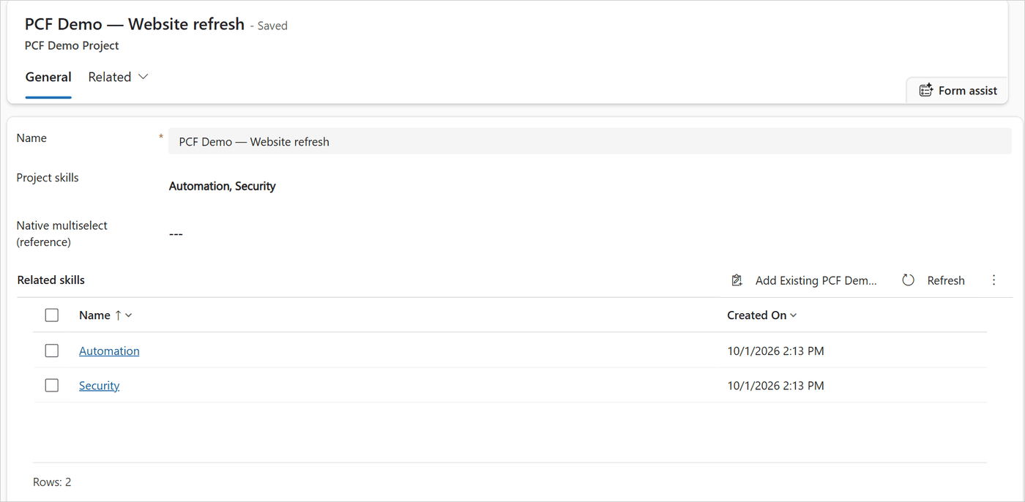
Figure 24. The control and the subgrid Related skills of the same relationship show the same links. FormBridge.refreshSubgrids reloaded the grid after the change; the form stays saved because getOutputs returns nothing.

5.5.1 Refresh after a change
After a batch of writes that changed something, or in which a write failed in a way that may still have saved it (5.3), scheduleSubgridRefresh waits 600 ms (SUBGRID_REFRESH_DELAY_MS), so a burst of clicks causes one refresh, not one per click. Then FormBridge.refreshSubgrids reloads every related subgrid and returns how many it reloaded.

5.5.2 Following changes made in a subgrid
When a user adds or removes a record in a subgrid, the grid reloads and fires its OnLoad event. The control listens to it (watchSubgrids). But the grid also fires OnLoad when the control refreshed it. These "echoes" are not someone else's change, so they are counted and ignored.
control/NToNMultiSelect/index.ts, onSubgridLoad (about lines 320–326):
private readonly onSubgridLoad = (): void => {
if (this.echoesLeft > 0 && Date.now() < this.echoesUntil) {
this.echoesLeft--;
return;
}
this.scheduleResync();
};

echoesLeft is set to the number of grids the control refreshed, for 3 seconds (SELF_REFRESH_WINDOW_MS). Any other OnLoad starts a re-read 400 ms later (scheduleResync, RESYNC_DEBOUNCE_MS).
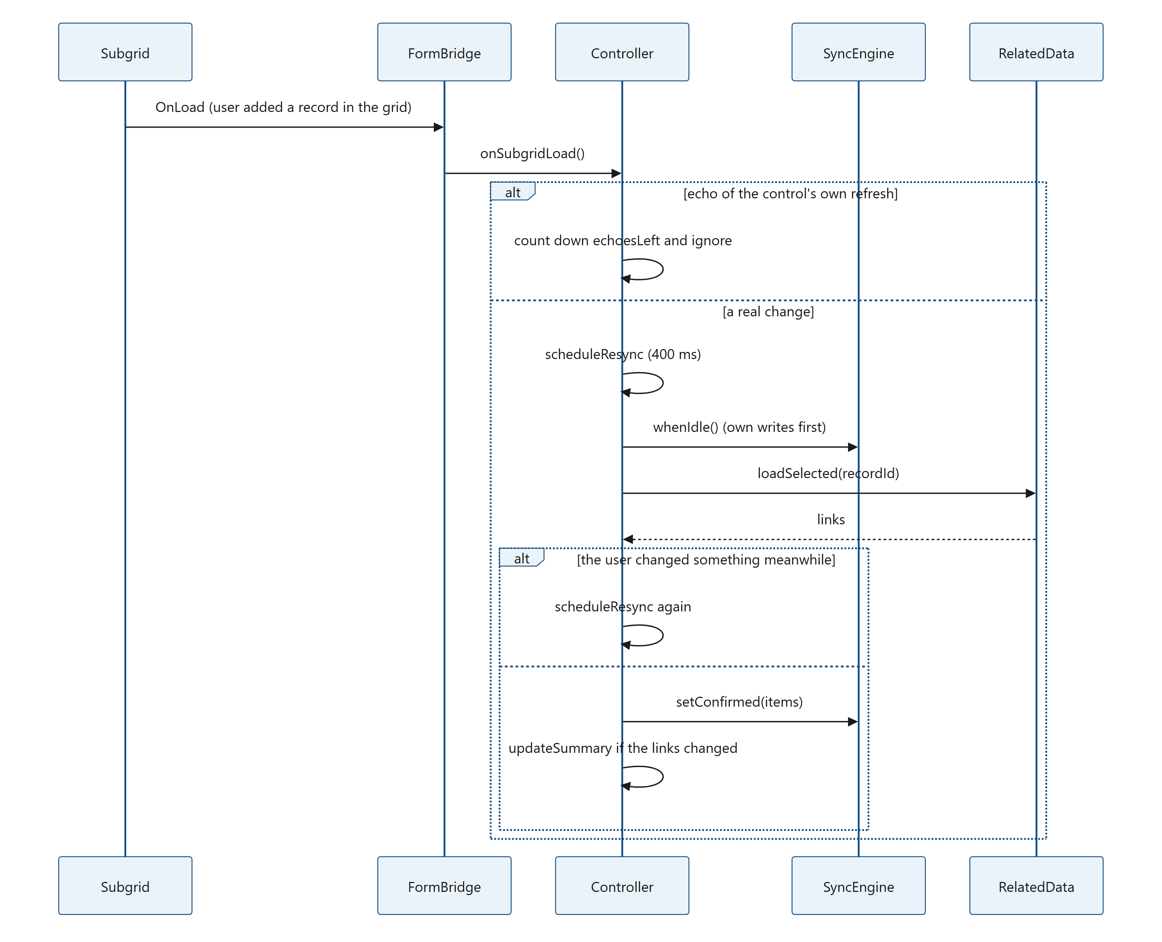
Figure 25. Diagram: 5.5.2 Following changes made in a subgrid
loadSelected always waits first for the engine's own writes (and for writes of an earlier instance on the same record), then reads; with isResync = true it also copies the names when the links changed. If the engine's version changed during the read, the user clicked something in the meantime, so the result may be stale: it reads again later instead of using it.
control/NToNMultiSelect/index.ts, loadSelected (about lines 814–848, shortened):
try {
await this.peersIdle(recordId);
await engine.whenIdle();
const version = engine.version;
const items = await data.loadSelected(recordId);
if (token !== this.initToken || engine !== this.engine) return false;
if (engine.version !== version || engine.isBusy()) {
// The user changed something during the read; read again once those writes are done.
this.scheduleResync();
return true;
}
const before = engine.selected();
engine.setConfirmed(items);
this.resyncRetries = 0;
// The message of an earlier read that failed is out of date now (another message stays).
if (this.error?.startsWith(this.t.loadSelectedFailed)) this.error = null;
if (isResync && !sameIds(before, engine.selected())) {
this.updateSummary();
}
// ...
} catch (error) {
if (token !== this.initToken) return false;
this.lastLoadError = error;
this.error = `${this.t.loadSelectedFailed} ${friendlyError(error, this.t, "read")}`;
console.error(`[${CONTROL_NAME}] loading related records failed`, error);
// A place held by an add whose outcome isn't known is only freed by a read of the saved links: while there
// is one, the read is tried again a few times (as the first load is).
if (isResync && engine === this.engine && engine.hasUncertain() && this.resyncRetries < LOAD_RETRY_DELAYS_MS.length) {
const delay = LOAD_RETRY_DELAYS_MS[this.resyncRetries++];
clearTimeout(this.resyncTimer);
this.resyncTimer = setTimeout(() => {
if (!this.destroyed && token === this.initToken) void this.loadSelected(token, true);
}, delay);
}

When a re-read fails. The field keeps what it shows and says "Couldn't load the selected values." with the reason; a later re-read that succeeds takes that message away (any other message stays). A failed add whose outcome is not known keeps its place toward Maximum selections until a read of the saved links succeeds (4.4, 5.3), so while the engine has one (hasUncertain), a failed re-read is tried again after 1, 3 and 9 seconds (LOAD_RETRY_DELAYS_MS, as for the first read), at most three times in a row. resyncRetries counts them. It starts again at 0 after a read of the saved links that succeeds (also the names copy's read, when showSaved takes it over) and after each batch with a write of unknown outcome (onSettled), so each such batch gets its own retries. Without such an add, a failed re-read is not tried again on a timer.
Other instances on the page. A field can appear twice (for example in the header and in the body). When one saves a change, resyncPeers makes the others that show the same record re-read, even when no subgrid would tell them.
Turning sync off. Subgrids to refresh = none makes FormBridge.subgrids return no grids: nothing is refreshed and nothing is followed. Changes made in a subgrid then appear in the control only after the form reloads.

5.5.3 Hiding the subgrids
With Hide related subgrids = Yes, applyHideSubgrids calls FormBridge.hideSubgrids at start-up (before the links are read) and again on every updateView, because grids can register on the form after the control. Only grids that are visible are hidden, and their names are remembered in hiddenGrids. When the setting is turned off, showHiddenSubgrids shows those grids again and they are refreshed (they were not refreshed while hidden). Hidden grids are not refreshed after changes: nobody sees them.
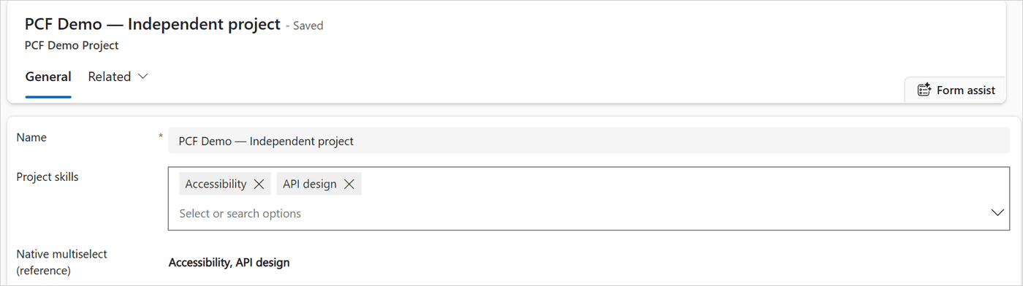
Figure 26. Hide related subgrids = Yes: FormBridge.hideSubgrids hid the related subgrid, and the control takes its place.

5.6 New records
On a new record that has not been saved yet, there is no record id to link to. The control keeps the picks and links them after the first save.
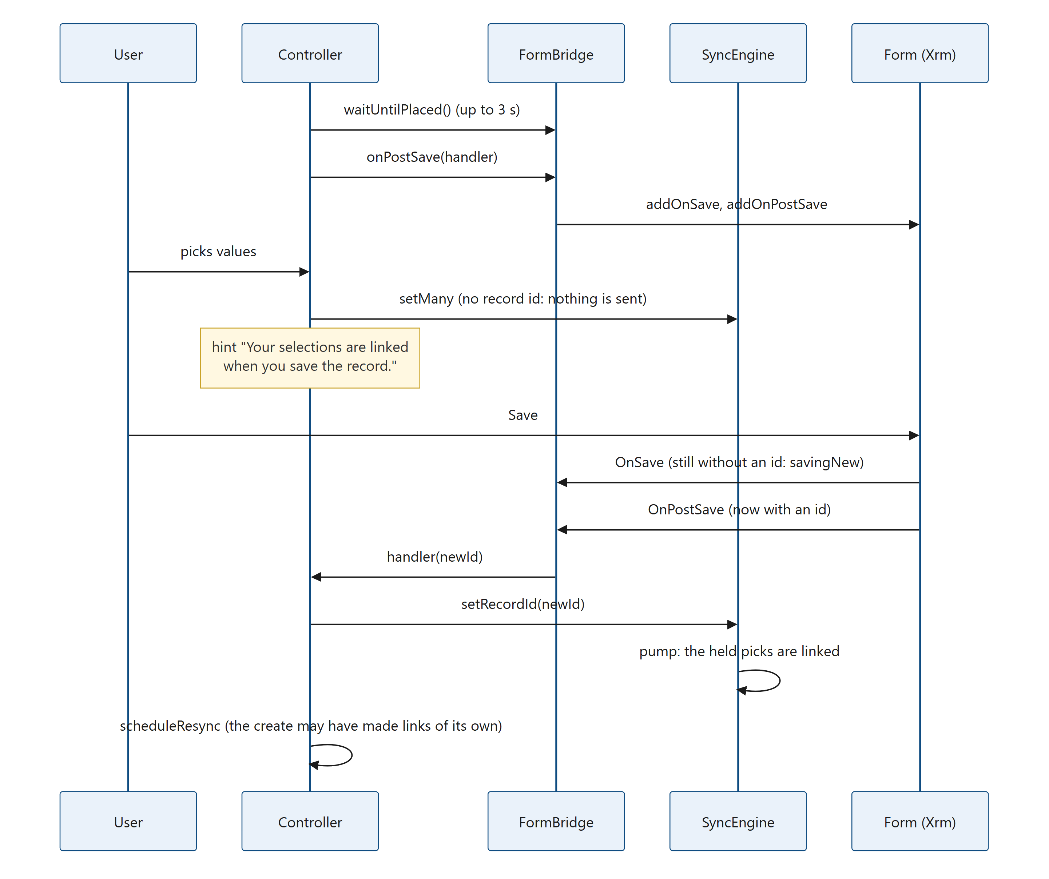
Figure 27. Diagram: 5.6 New records
Step by step:
- Can the save be followed? initialize finds no record id. For Appointment, Recurring Appointment and Service Activity (NO_POST_SAVE_TABLES), whose new-record save skips the save events, the field shows "Save the record first, then pick values here." Otherwise it waits until its element is on the page (waitUntilPlaced) and asks the bridge to follow the save (onPostSave).
- Where the save cannot be followed safely (a quick create form, a new record in a dialog or side pane), onPostSave returns false and the field also shows "Save the record first ...". The reason is in 4.9: Xrm.Page would describe another form, and picks could be linked to the wrong record.
- Picks are held. The engine has no record id, so pump sends nothing. The values show normally (not in the "saving" look), with the grey hint "Your selections are linked when you save the record."
- The save. OnSave notes that the form saves a new record; OnPostSave then sees the new id and calls onRecordSaved, which gives the engine its id. The engine sends the held picks at once.
- The control may also learn the id from updateView. There, FormBridge.savedAs checks that the followed form really saved itself as that record. Otherwise the control was moved to another record: its held picks are dropped (retireEngine(true)) so they never end up on the wrong record.
- After the links are written, the links are read once more: the create may have made links of its own (a plug-in, or a record created from a related record's subgrid).
A failed or cancelled save (for example a required field is empty) links nothing; the picks stay until a later save succeeds.
Destroyed while the form stays open. A business rule can hide and show the field, which destroys and re-creates the control. The held picks then become an orphan (retireEngine), stored per form and per relationship and host column. The next instance on the same form adopts them (adoptOrphan). If no instance comes back (Save & Close), the orphan's own save handler still fires and links the picks on its own (onRecordSaved → detached, 5.8).
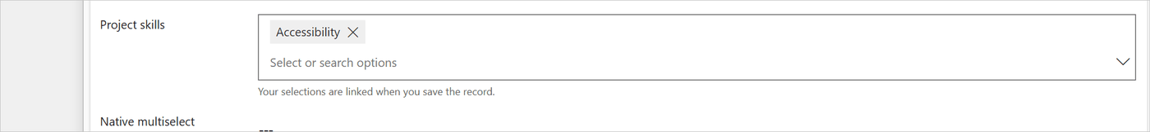
Figure 28. A new, unsaved record with a held pick and the hint from render (heldHint). The chip has no "saving" look because cachedPending is empty while there is no record id.

5.7 + New and quick create
The + New row appears at the end of the list when Show + New button is Yes, the related table allows quick create (targetQuickCreate from the metadata) and Maximum selections is not reached. Its text is "+ New" plus the related table's display name.

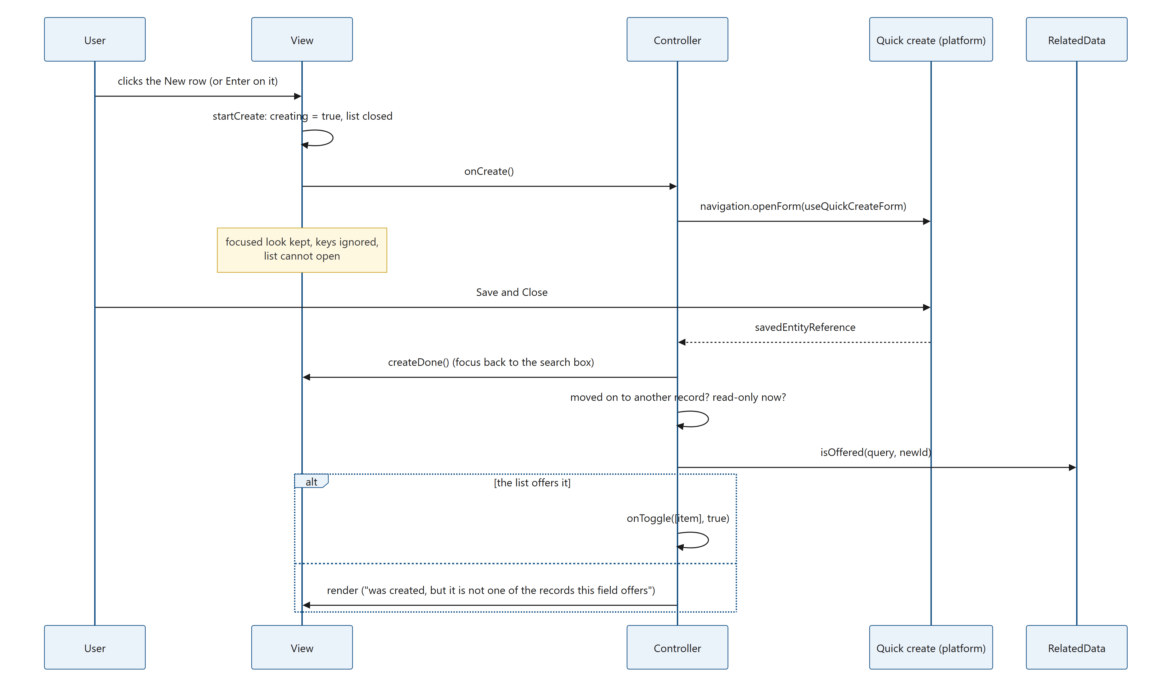
Figure 29. Diagram: 5.7 + New and quick create

- startCreate (view) sets creating, closes the list and calls onCreate. While creating is set, the focusout handler leaves the field in its focused look, onKeyDown ignores keys, openMenu refuses to open and a second startCreate does nothing. This covers the moment before quick create has taken the focus, too: a second Enter, typing or the chevron cannot bring the list back over the quick create panel.
- createRecord (controller) opens quick create with context.navigation.openForm({ entityName, useQuickCreateForm: true }) and waits until it closes. If quick create cannot open, the field shows "Couldn't create the record." with the reason.
- createDone (view) runs whether the record was saved or not: creating ends, text typed in the meantime is cleared, and the search box takes the focus back (with the list closed).
- If a record was saved, the controller checks that it has not moved on (same start-up, same engine, still editable). Otherwise it says "... was created but couldn't be linked here. Pick it from the list."
- The list is reloaded, so the new record appears in its place.
- Is it offered? Quick create knows nothing of the list's filter, view or FetchXML. isOffered runs the list's query narrowed to the new id. If the list offers it, it is selected through onToggle (the same path as a click); otherwise the field explains why it was not selected.
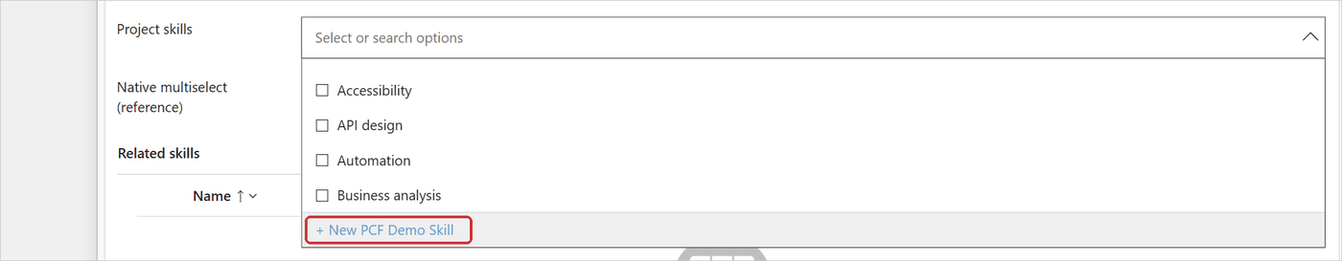
Figure 30. The + New row at the end of the list (createButton, shown when ViewState.createLabel is set).
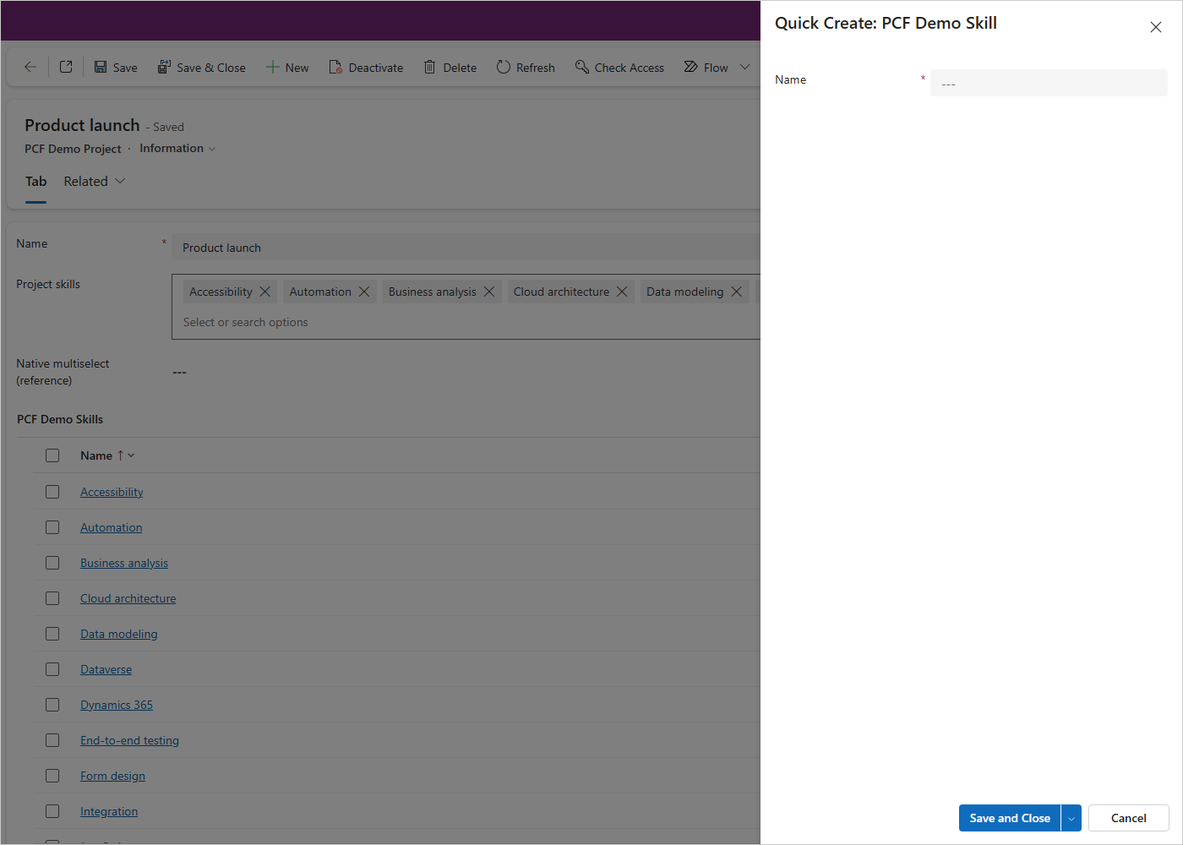
Figure 31. Quick create open on the right. The field keeps its focused look with the list closed, because creating is set (startCreate).
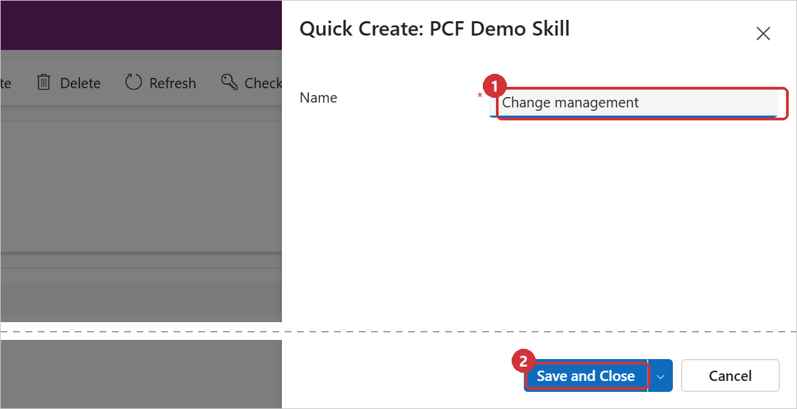
Figure 32. The platform's quick create form, opened by createRecord with useQuickCreateForm: true.
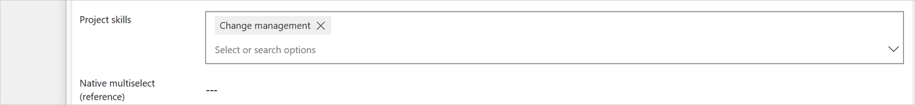
Figure 33. After Save and Close: isOffered found the record in the list and onToggle selected it; createDone put the focus back in the search box.
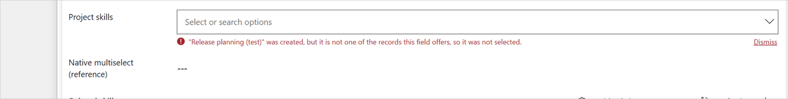
Figure 34. The new record does not match the list's filter: createRecord shows createdNotOffered.

5.8 Leaving the page while writes are pending
Two cases are handled differently.
Closing the browser tab or reloading. This would cancel the link requests on their way (an update of the names already on its way is finished by the browser, 4.6). The control installs one beforeunload handler per page that asks the browser to confirm while anything is unsaved.
control/NToNMultiSelect/index.ts, installUnloadGuard (about lines 128–133):
window.addEventListener("beforeunload", (event) => {
if (copiesWriting > 0 || [...liveEngines].some((engine) => engine.hasPendingChanges() || engine.isBusy())) {
event.preventDefault();
event.returnValue = "";
}
});

The names copy's write is sent with keepalive (5.4.3): once it is on its way, the browser finishes it even if the user leaves the page meanwhile.
What the prompt cannot cover. The names are written once the last link of a batch is saved: about 0.1–0.3 seconds after a single pick, and up to many seconds after a Select all of hundreds of records. If the user leaves anyway (Leave in the browser's prompt), or the browser or the app closes without asking (a crash, the mobile app closed), the links already saved stay, but the host column can miss their names until the record's links next change. The names copy plug-in does not fill them in: it leaves the control's own links to the control (the tag, 5.4.5 and 8.8). Only a server-side write of the names for every link would cover this case. That is not done, because it would cost about 70 ms on every link (a rebuild, 8.15).
Moving within the app (Save & Close, another record, the back button). The page stays loaded, so the requests can finish. The platform calls destroy, and retireEngine hands the engine over to the page-wide detached map instead of stopping it:
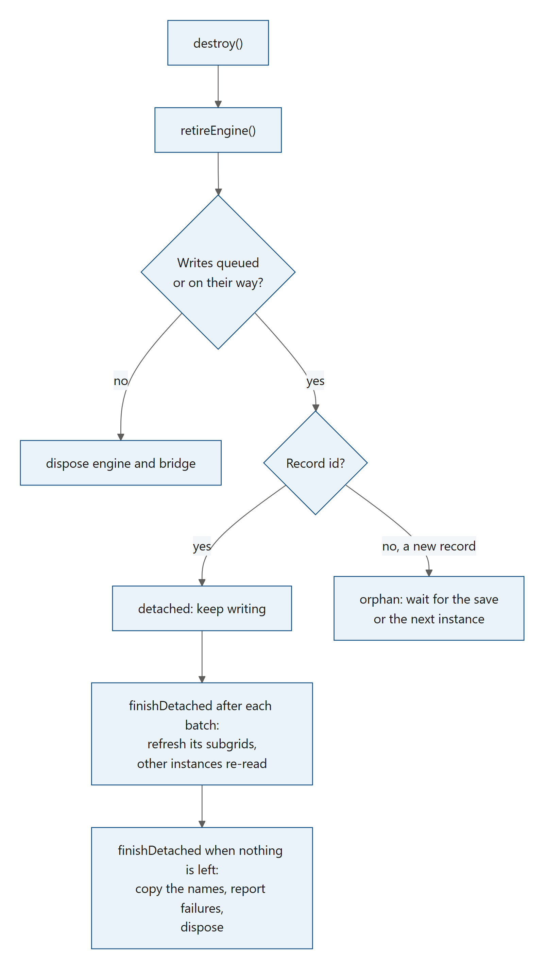
Figure 35. Diagram: 5.8 Leaving the page while writes are pending
finishDetached runs after each batch of the detached engine, and finishes the job when nothing is left.
control/NToNMultiSelect/index.ts, finishDetached (about lines 995–1016):
private finishDetached(engine: SyncEngine, away: Detached, changed: boolean): void {
if (changed || away.unknown) {
away.bridge.refreshSubgrids(engine.getRecordId());
this.resyncPeers(away.key, engine);
}
if (engine.hasPendingChanges() || engine.isBusy()) return;
if (away.failures > 0) {
notifyApp(`${away.t.closedFailures(away.failures, away.label)} ${away.firstError}`);
}
// Every link is saved (or has failed for good), so the copy can follow them, unless none of them changed
// anything. Changes that were saved before the engine was detached have been copied already (updateSummary).
// A write that failed may still have been saved (see mayHaveSaved): then the copy reads the saved links and
// writes their names, whatever the page shows.
if (away.copy) {
if (away.unknown) away.copy.names.refresh(away.copy.writer);
else if (changed) away.copy.names.update(engine.selected(), away.copy.writer);
}
detached.delete(engine);
liveEngines.delete(engine);
engine.dispose();
away.bridge.dispose();
}

- Failures are reported with an app notification (Xrm.App.addGlobalNotification), because the form that could show them is gone: "3 changes to Project skills couldn't be saved after the form was closed." plus the reason.
- A write of unknown outcome (mayHaveSaved, 5.3) sets unknown on the Detached entry, whether it failed before the form was closed (retireEngine takes over the batch's batchUnknown, also when the form is closed in the middle of a batch) or after (onWriteError). The subgrids still on screen and the other instances on the page then read the links again, and at the end the copy reads the saved links and writes their names (NamesCopy.refresh).
- Reopening the same record while its detached writes run: loadSelected first waits for them (peersIdle), so the reopened form reads the final links, not a half-written state.

5.9 Offline and read-only

5.9.1 Offline
isOffline asks the platform (context.client.isOffline()) whether the app runs offline (for example the mobile app in offline mode). While offline the field is read-only and shows "Not available while you're offline." The list is not warmed.
A lost connection in the browser is a different case: requests fail with a network error and are retried (4.6). If they still fail, the user sees "Can't reach the server. Check your connection and try again.", and the rest of the batch is cancelled. When the browser fires its online event, onOnline recovers.
control/NToNMultiSelect/index.ts, onOnline (about lines 327–342):
private readonly onOnline = (): void => {
this.offline = isOffline(this.context);
if (this.initGaveUp) {
void this.initialize(this.context);
return;
}
if (this.loadGaveUp && this.engine?.getRecordId()) {
this.loadGaveUp = false;
this.fatalError = null;
clearTimeout(this.loadRetryTimer);
this.retryInitialLoad(this.initToken, 0);
} else {
this.scheduleResync();
}
this.render();
};

5.9.2 Read-only
control/NToNMultiSelect/index.ts, readOnly and columnLocked (about lines 1214–1221):
private readOnly(): boolean {
return this.context.mode.isControlDisabled || this.columnLocked();
}

/** Column security doesn't let the user update the host column (when it isn't secured, the form doesn't say). */
private columnLocked(): boolean {
return this.context.parameters.value?.security?.editable === false;
}

The field is read-only when:
- the form or the field is read-only (mode.isControlDisabled: a read-only form, a disabled field, a business rule, a user without Write permission on the record, an inactive record);
- column security does not let the user update the host column (columnLocked);
- the platform is offline, or the record is new and the save cannot be followed (saveFirst).
Read-only means: render passes disabled: true, the view draws the grey box with the names (links with Open selected records), no chips, no ×, no search box, and canEdit() blocks every write. The list is not loaded.
Column security in detail. A field security profile can secure the host column. The platform then passes security.editable for the bound property; when the user may not update the column, it is false. The control reacts like a native field on that column: it becomes read-only. It also never writes the names copy for such a user (updateSummary checks columnLocked), because that update would be refused. A change made by that user in a subgrid on the same form is then left to the names copy plug-in, when it is installed.
Read-only follows the update permission only. The control does not mask the values (no "****" for a user who may not read the column): what it shows are the related records, read through the relationship, and only those the user is allowed to read.
The read-only look is shown in 6.2.

6. The view in detail
This chapter describes src/view.ts and the CSS in src/styles.ts: what the user sees and how each part is made.

6.1 The elements
The constructor builds this structure once. render only changes text, attributes and classes on it.
container (from the platform)
├── div.ntnms root of the field (state classes, see 6.2)
│ ├── div.ntnms-view idle text
│ │ └── div.ntnms-view-text bold names, "---", or links when read-only
│ ├── div.ntnms-chips-row
│ │ ├── ul.ntnms-chips the values (role="list", focusable by code only)
│ │ │ └── li.ntnms-chip one value: span or a.ntnms-chip-text + button.ntnms-chip-remove
│ │ └── div.ntnms-more button.ntnms-more-button: "+N" or "less"
│ ├── div.ntnms-inner the search row
│ │ ├── div.ntnms-input-wrap input.ntnms-input (role="combobox")
│ │ └── div.ntnms-caret button.ntnms-caret-button (the chevron)
│ ├── span.ntnms-a11y spoken summary of the selection
│ └── div.ntnms-a11y live region for announcements
├── div.ntnms-error message under the field (role="alert") with "Dismiss"
└── div.ntnms-hint grey hint under the field

document.body
└── div.ntnms-menu the floating list (role="listbox")
├── div.ntnms-option.ntnms-select-all "Select all" + item count
├── div.ntnms-note limit note ("You can select up to 5 records.")
├── div.ntnms-status "Loading…", "No entries found" or an error
├── ul.ntnms-list the rows: li.ntnms-option (role="option")
└── button.ntnms-create "+ New ..." (role="option")

Why the list is on <body>. The source says: "The list lives in a layer on <body>: form sections clip overflow, so it could not drop down otherwise." The list is placed with position: fixed next to the field (6.7).

6.2 Field states
The look of the field is controlled by classes on the root element, set in one place.
control/NToNMultiSelect/src/view.ts, applyClasses (about lines 413–425):
private applyClasses(): void {
const s = this.state;
const cls = this.root.classList;
cls.toggle("is-empty", !s || s.selected.length === 0);
cls.toggle("is-disabled", !!s && (s.disabled || !!s.fatalError));
cls.toggle("is-active", this.active && this.editable());
cls.toggle("is-focused", this.focused);
cls.toggle("is-open", this.open);
this.menu.classList.toggle("is-open", this.open);
cls.toggle("is-expanded", this.expanded);
this.input.setAttribute("aria-expanded", String(this.open));
this.caretGlyph.textContent = this.open ? GLYPH.chevronUp : GLYPH.chevronDown;
}

State | Classes on .ntnms | What shows | Set by
Idle | none of the ones below | .ntnms-view: the names in bold, comma separated, --- when empty (blank while loading) | default
Hover | is-active | Grey border; the values as chips with ×; the search row only when nothing is selected | mouseenter / mouseleave
Focused | is-focused | Chips, the search box and the chevron | focus of the input or the values
List open | is-open (and is-open on the menu) | The floating list; the chevron points up | openMenu / closeMenu
Expanded | is-expanded | All values, up to 136 px high with a scroll bar | "+N", chip navigation
Read-only | is-disabled | Grey box with the names (links with Open selected records); no chips, no search row | ViewState.disabled or fatalError

The CSS does the rest: for example, a rule on .ntnms.is-active:not(.is-disabled) .ntnms-view sets display:none, which hides the idle text on hover. Because the states are just classes, you can restyle any state in styles.ts without touching the logic.
Figure 36. Idle: .ntnms-view-text shows the names in bold, comma separated (render sets its text from state.selected). The native multi-select choice column below it looks the same.
Figure 37. The pointer over the field (is-active): the chips built by renderChips, with ×. The names are links because Open selected records is Yes.
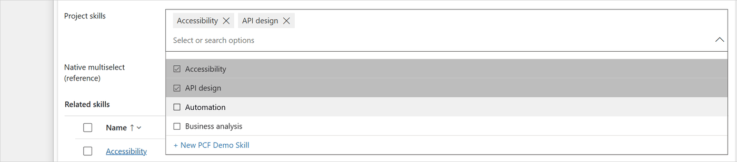
Figure 38. Focused with the list open (is-focused, is-open): check-box rows drawn by rebuildRows / drawRow, selected rows grey, + New at the end.
Figure 39. Read-only (is-disabled): the grey box; with Open selected records the names are links built by renderViewLinks.

6.3 Values, "+N" and "less"
Chips. renderChips builds one li.ntnms-chip per value. A chip holds the name (a span, or a link with Open selected records) and, unless the field is read-only, a × button. A chip whose change is not saved yet gets is-saving; the keyboard highlight is is-current (a 1 px black border drawn with ::after). While the field is collapsed, at most 50 chips are built (MAX_COLLAPSED_CHIPS); the rest are built when the field expands.
"+N". The collapsed chip list is one line high (max-height:34px, overflow:hidden). After every render, countOverflow counts the chips whose top is below the first line, plus the values not built, and writes "+N". In the expanded field the same button says "less", but only when collapsing would hide something (like the native control). measureOverflow measures twice when the button's own width changed, because the button's width decides how many chips fit on the first line. A ResizeObserver measures again when the field changes width.
control/NToNMultiSelect/src/view.ts, the "+N" / "less" click handler in wireEvents (about lines 960–976):
this.expanded = !this.expanded;
// Collapsed, the list still keeps its scroll position (it only hides what overflows): back to the first line.
if (!this.expanded) this.chipsList.scrollTop = 0;
// As in the native control, +N and less put the focus on the values, the first one highlighted (an open list
// closes): the field stays open until the focus leaves it, not only while the mouse is over it.
const s = this.state;
const focusValues = !!s && s.selected.length > 0 && this.editable();
const highlight = focusValues && this.chipCurrent === null ? s.selected[0] : null;
if (focusValues) this.closeMenu();
if (highlight) this.chipCurrent = highlight.id;
this.applyClasses();
if (s) this.renderChips(s);
this.scheduleMeasure();
if (focusValues && this.container.ownerDocument.activeElement !== this.chipsList) this.chipsList.focus();
if (highlight) this.announce(highlight.name);
// A highlight kept from before (on a lower line, say) comes into view with the rest.
else if (s && this.expanded && this.chipCurrent !== null) this.scrollChipIntoView(s.selected.findIndex((i) => i.id === this.chipCurrent));

- "+N" shows all values, closes an open list, and puts the focus on the values with the first value highlighted. The field stays expanded when the mouse leaves, until the focus leaves the field (a click outside or Tab away).
- "less" collapses and keeps the focus and the highlight.
- When the focus leaves the field, the focusout handler collapses it, ends the highlight, closes the list and clears any search text.
Figure 40. A record with 2,499 links, collapsed: one line of chips and "+2494", counted by countOverflow (only 50 chips are built).
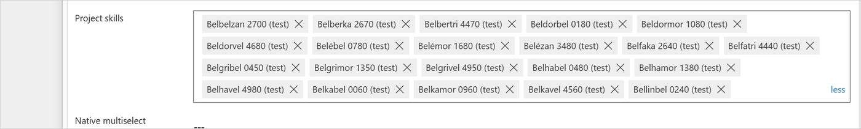
Figure 41. After "+N": is-expanded lets the chip list grow to 136 px with a scroll bar; the button says "less".
Figure 42. After "+N" with the mouse away: all values shown, the focus on the values with the first one highlighted (chipCurrent), and the "less" link.
Open selected records. With this setting, each chip's name is a real link (<a target="_blank" rel="noopener noreferrer">) built by recordLink, so Ctrl+click and middle-click work as for any link. The address comes from the controller (recordUrl): the current app's main.aspx with pagetype=entityrecord, the table and the id, so the record opens in the same app. The read-only field shows the names as links too (renderViewLinks). Where a browser tab cannot simply be opened (the mobile app, Outlook, offline), the controller sets interceptLinks, and a click opens the record with context.navigation.openForm instead.

6.4 The two keyboard models
The control copies the native multi-select choice field, which has two places the keyboard can be: the search box, and the values (after a value was removed with its ×, or after "+N"). Each has its own handler.

6.4.1 Focus in the search box (onKeyDown)
Key | List closed | List open
↓ or Alt+↓ | Opens the list with the first row highlighted | Next row
↑ | – | Previous row
Alt+↑ | – | Closes the list
Page Down / Page Up | – | 4 rows down / up
Ctrl+Home / Ctrl+End | – | First / last row
Enter | Opens the list | Toggles the highlighted row (or Select all, or + New)
Space | (types a space) | Toggles the highlighted row when the search box is empty
Esc | Clears the search text | Closes the list (and clears the search text)
Backspace in the empty box | Moves to the values: the last value is highlighted | Does nothing (as in the native control)
Tab | Moves on | Closes the list and moves on
Typing | Opens the list and filters | Filters

The highlight moves over one sequence of positions: -1 (Select all, when shown), 0 to n-1 (the rows), n (+ New, when shown). refreshRowsAndScroll keeps the highlighted row in view, and aria-activedescendant tells screen readers which one it is (6.6).
Values reached with Backspace (the focus stays in the search box; chipCurrent is set, so onKeyDown hands every key to onChipKey):
Key | Does
← / → | Previous / next value. → on the last value ends the navigation (back to typing). In a right-to-left language the arrows are swapped.
Delete / Backspace | Removes the highlighted value; the highlight moves to the next one (the previous one after the last). Holding the key down removes only one.
Enter | Opens the highlighted record (with Open selected records; otherwise nothing).
Esc | Ends the navigation (and closes the list if open).
↓ | Ends the navigation and opens the list with the first row highlighted.
Tab | Ends the navigation; the focus moves on.
Typing | Ends the navigation; the character goes into the search box.

6.4.2 Focus on the values (onChipsListKey)
After a value is removed with its × (removeWithX) or after "+N", the focus is on the chip list itself (ul.ntnms-chips, tabIndex = -1, so Tab never lands there). This is the model the native control uses after a click on ×:
Key | Does
← / → | Moves the highlight. The first and the last value keep it (no wrap, no leaving).
Delete / Backspace | Removes the highlighted value. With nothing left, the search box takes the focus.
Enter | Opens the highlighted record (with Open selected records).
Esc | Collapses an expanded field (as "less" does).
Tab | Moves to the search box.
↓ | Opens the list with the first row highlighted; the search box takes the focus.
Typing | Does nothing; the highlight stays. Shortcuts such as Ctrl+S still reach the page.

control/NToNMultiSelect/src/view.ts, removeWithX (about lines 1234–1254):
private removeWithX(item: Item): void {
const index = this.state?.selected.findIndex((i) => i.id === item.id) ?? -1;
this.closeMenu();
this.toggle(item, false);
// The controller re-rendered synchronously: continue from the new selection.
const s = this.state;
if (!s || !this.editable()) return;
const next = Math.min(Math.max(index, 0), s.selected.length - 1);
if (next < 0 || s.selected[next].id === item.id) {
this.focusInput();
return;
}
this.chipCurrent = s.selected[next].id;
// The next value moved into the x's place, so it is among the chips built: the field stays as it is.
this.renderChips(s);
this.applyClasses();
this.scheduleMeasure();
if (this.container.ownerDocument.activeElement !== this.chipsList) this.chipsList.focus();
this.scrollChipIntoView(next);
this.announce(s.selected[next].name);
}

Note the comment "The controller re-rendered synchronously": toggle calls the controller, which updates the engine and calls view.render before toggle returns. The code after it can therefore read the new selection from this.state.
Figure 43. After × on a value: removeWithX moved the focus to the values and highlighted the next value with a black border (is-current).

6.5 The list
Rows. rebuildRows creates one li.ntnms-option per record: a check glyph (span.ntnms-check) and the name (div.ntnms-option-text), with id <uid>-opt-<index> and data-index. When a "load more" only adds rows at the end, the existing rows and the scroll position are kept and only the new rows are created. Each time the list opens, openMenu scrolls it back to its beginning, as the native list does, wherever it was scrolled to before it closed.
Row looks (drawRow), like the native list:
Class | Look | When
(hover) | #f0f0f0 | The mouse is over an unselected row.
is-selected | #bdbdbd, ticked box | The record is selected. #c7c7c7 under the mouse.
is-visited | #e6e6e6 | A selected row the mouse has left, until the selection changes (visitedRows).
is-saving | 60 % opacity | Its change is not saved yet.
is-current | 1 px black border | Keyboard highlight (not for mouse clicks).
is-disabled | grey text | Maximum selections reached, and the row is not selected and does not hold a place (5.3).

A row that is not selected but holds a place toward the limit (its removal is on its way, an add of it that the user undid is still on its way, or an add of it has an unknown outcome; ViewState.held, 4.3) is not blocked at the limit: picking it again takes no new place. drawRow and toggle both ask holdsPlace.
control/NToNMultiSelect/src/view.ts, drawRow and holdsPlace (about lines 669–683 and 1557–1560):
private drawRow(state: ViewState, row: HTMLLIElement, id: string, index: number): void {
const selected = this.isSelected(id);
// A record being removed (saving, not selected) keeps its place toward the limit, so picking it again is allowed.
const blocked = state.maxReached && !selected && !holdsPlace(state, id);
row.classList.toggle("is-selected", selected);
row.classList.toggle("is-visited", selected && this.visitedRows.has(id));
row.classList.toggle("is-saving", state.pending.has(id));
row.classList.toggle("is-current", this.keyboardHighlight && this.current === index);
row.classList.toggle("is-disabled", blocked);
row.setAttribute("aria-selected", String(selected));
row.setAttribute("aria-disabled", String(blocked));
const check = row.firstChild as HTMLSpanElement;
const glyph = selected ? GLYPH.checked : GLYPH.unchecked;
if (check.textContent !== glyph) check.textContent = glyph;
}
// ...
/** Whether a record that isn't selected still takes a place toward the limit (see ViewState.held), or is being removed. */
function holdsPlace(state: ViewState, id: string): boolean {
return state.pending.has(id) || !!state.held?.has(id);
}

Redrawing only what changed. With thousands of rows loaded, redrawing every row after each saved write or each arrow key would be slow. refreshRows remembers what it drew (drawnRows) and redraws only the rows whose state changed.
control/NToNMultiSelect/src/view.ts, refreshRows (about lines 642–649):
// Otherwise only the rows that were picked or removed, started or finished saving, lost their lighter
// grey, or gained or lost the highlight. Redrawing every loaded row for each finished write and each arrow
// key takes tens of milliseconds a time once thousands of rows are loaded.
const changed = new Set<string>();
addDifference(changed, drawn.selected, this.selectedIds);
addDifference(changed, drawn.pending, state.pending);
addDifference(changed, drawn.held, state.held ?? NONE);
addDifference(changed, drawn.visited, this.visitedRows);

The rows that start or stop holding a place (held) are redrawn too, because that decides whether they are blocked at the limit.
While the list is closed, refreshRows does nothing at all; openMenu brings the rows up to date when it opens.
The header and the footer.
- Select all (selectAllRow) shows when state.canSelectAll, with the item count on the right. A click (or Enter on it) calls toggleAll: if every listed row is selected it removes them all, otherwise it selects them all.
- The note (ntnms-note) shows the Maximum selections hint.
- The status line shows "Loading…" (no rows yet), "No entries found", or an error.
- + New (createButton) shows when state.createLabel is set. It is the last keyboard position.
Load more. A scroll listener asks for the next page when the user is within 70 px of the end.
control/NToNMultiSelect/src/view.ts, wireEvents (about lines 1004–1010):
this.list.addEventListener("scroll", () => {
const s = this.state;
if (!s || !s.hasMore || s.loadingMore) return;
if (this.list.scrollTop + this.list.clientHeight >= this.list.scrollHeight - 70) {
this.callbacks.onLoadMore();
}
});

While a page loads, a "Loading…" row is added at the end; a failed page shows its error there, and scrolling again retries.
The mouse in the list. mousedown on the list layer is cancelled (preventDefault), so the search box keeps the focus while the user clicks rows.
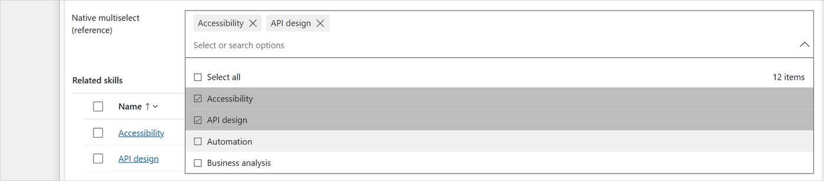
Figure 44. The platform's own multi-select choice list, which the CSS in styles.ts copies: compare it with the control's list in 6.2.

6.6 Accessibility
Roles and attributes.
Element | Role and attributes
Search box | role="combobox", aria-autocomplete="list", aria-expanded, aria-controls (the list), aria-label (the field label), aria-activedescendant (the highlighted row), aria-describedby (summary, error, hint), aria-invalid when an error shows
Floating list | role="listbox", aria-multiselectable="true", aria-label (the field label)
Rows, Select all, + New | role="option" with aria-selected; rows also aria-disabled when blocked by the limit
The ul of rows | role="group"
Values | ul with role="list" and aria-label "Selected values for Label"; each chip has aria-label (the name)
× buttons | aria-label "Remove Name"
"+N" / "less" | aria-label "+N, show all M selected values" / "Show less" (the label contains the visible text, so speech input users can say what they see)
Root | aria-busy="true" while loading
Error box | role="alert"
Read-only links | wrapped in role="group" with aria-label "Selected values for Label"

Why the whole list is one listbox. Select all, the records and + New are all options of one list, so the keyboard highlight can move through all of them with aria-activedescendant while the focus stays in the search box (updateActiveDescendant). The highlighted element must exist in the document; otherwise the attribute is removed.
What a screen reader hears.
- The search box is described by a hidden summary (spokenSelection): "3 selected: A, B, C", or only the count above 10 values (MAX_SPOKEN_NAMES), plus the error and the hint when shown.
- A live region (aria-live="polite") announces what changed: "Automation selected", "Automation removed", "All 12 items selected", the highlighted value during chip navigation (with a short help text when Backspace starts it), "No entries found" or a load error while the list is open, and the limit note when a pick is refused.
- The note and the status line are hidden from the accessibility tree (aria-hidden), because the live region already says them.
Announcements made in one go are read together.
control/NToNMultiSelect/src/view.ts, announce (about lines 1495–1511):
private announce(message: string): void {
if (this.announceBatchOpen) {
if (!this.announcing.includes(message)) this.announcing.push(message);
return;
}
this.announcing = [message];
this.announceBatchOpen = true;
queueMicrotask(() => {
this.announceBatchOpen = false;
});
this.live.textContent = "";
clearTimeout(this.announceTimer);
// A tick later so screen readers notice the change even when the same text repeats.
this.announceTimer = setTimeout(() => {
if (!this.destroyed) this.live.textContent = this.announcing.join(". ");
}, 30);
}

For example, × on a value says "Automation removed. Business analysis": the removal and the next highlighted value, in one message. Written one after the other, the second would replace the first before a screen reader noticed it.
High contrast. In Windows high contrast mode the grey backgrounds disappear. A @media (forced-colors:active) block in styles.ts marks selected rows with the system colours Highlight / HighlightText and blocked rows with GrayText.

6.7 Positioning of the floating list
The list is a position: fixed layer on <body> (z-index: 1000000). It must follow the field, which can move at any time (the form scrolls, a subgrid above it refreshes, a notification appears, the phone keyboard opens).
- Pick a side once. openMenu measures the room below and above the field, using the tallest the list can get (MENU_MAX_HEIGHT, 247 px). It opens above only when it does not fit below and there is more room above. The side is kept while the list is open, so it never jumps when rows arrive or are filtered.
control/NToNMultiSelect/src/view.ts, openMenu (about lines 1433–1438):
// Pick the side once, using the tallest the list can get, so it doesn't jump when rows arrive or are filtered.
const rect = this.root.getBoundingClientRect();
const area = this.visibleArea();
const below = area.bottom - rect.bottom;
const above = rect.top - area.top;
this.placeAbove = below < MENU_MAX_HEIGHT + 8 && above > below;

- Place it (positionMenu): same left edge and width as the field; below, its top is one pixel above the field's bottom, so the two borders read as one line, like the native control; above, it is anchored by its bottom. When the window is too short (200 % zoom, a phone in landscape), the scrolling part shrinks, down to one 35 px row.
- Follow the field (followField): once per animation frame, while the list is open, it compares the field's rectangle and the visible area with the last ones and places the list again when they changed. Only one list is open at a time, so this costs one measurement per frame.
- Close when the field is gone: when the field scrolls out of sight (also under the form's header or command bar, which are outside the form's scrolling area) or disappears, the list closes. The visible area is the window cut down by every scrolling container around the field (findClippingAncestors, clipArea); on a phone it is the visual viewport, which is smaller while the keyboard is open (visibleArea).
- Close on a click outside: while open, a capturing mousedown and pointerdown listener on the document closes the list when the press is outside the field and the list.
- Right to left: the list gets dir="rtl" when the form is written right to left.

6.8 Touch handling
On a touch screen there is no hover. A tap on the idle field produces, in order: pointerdown, an emulated mouseenter (which switches the idle names to chips), then mousedown and click, which land on whatever chip, ×, link or "+N" is now under the finger. The user never saw those, so acting on them would be a surprise. The view remembers whether the chips were already showing when the press started.
control/NToNMultiSelect/src/view.ts, wireEvents (about lines 829–834):
// Every press starts with pointerdown. For a tap, that is before the emulated mouseenter switches to the chips.
this.root.addEventListener("pointerdown", () => {
const cls = this.root.classList;
this.chipsShownAtPress = cls.contains("is-active") || cls.contains("is-focused");
this.tapped = null;
});

If they were not, the mousedown handler only focuses the search box and remembers the element in tapped; the click that follows on that element is ignored. A mouse always enters the field before pressing, so for a mouse the chips are always showing and nothing is ignored.
Other touch details:
- The document listener that closes the list also listens to pointerdown, because touch scrolling and some taps produce no mousedown.
- Text that arrives without a key press (paste, IME, a phone keyboard) also ends chip navigation (input handler).
- visibleArea uses the visual viewport, so the list is placed in the part of the screen the phone keyboard leaves free.
- A ResizeObserver measures "+N" again when the field changes width (a rotated phone).

6.9 Matching the native look
The goal is that the control and a native multi-select choice field on the same form look and behave the same. The values in styles.ts were measured from the native control (see the header comment in 4.12). The main points:
Detail | Value
Idle text | Segoe UI, weight 600, comma separated, --- when empty
Hover and focus border | 1 px #666
Chips | #efefef, 28 px high, × hover #b3b3b3
"+N" / "less" | #2975b2 text
List | border #5d5a58, 13 px top padding, 35 px rows, 4 rows visible (140 px)
Check boxes and chevron | CRM MDL2 glyphs (4.12)
Read-only | #efefef box with a border of the same colour
Errors | #a4262c, 12 px, with an icon, like a model-driven field notification

Behaviour copied from the native control:
- Clicking into the box only focuses it; the list opens from the chevron, ↓, Enter or typing (Open list on click changes this).
- ↓ opens the list with the first row already highlighted.
- Backspace does not touch the values while the list is open.
- Selected rows the mouse has left are drawn lighter until the selection changes.
- "less" appears only when collapsing would hide something.
- The empty box keeps the same height on hover and focus (a 4 px top padding instead of 6 px), so the field never jumps.
To check the result, compare list-open.png (6.2) with native-list.png (6.5).

7. The form library
formloader/formloader.js is an optional form library (a JavaScript web resource added to a form). In the solution it is the web resource kv_/NToNMultiSelect/formloader.js, display name N:N Multi-Select form loader. It does nothing unless a maker adds it to a form.

7.1 Why it exists
Some Dataverse environments send code components to the form with an empty resource list. The platform then never downloads the control's bundle.js, the field shows "Error loading control", and the browser console reports "Could not find/invoke ... constructor". The form library fixes this: it downloads the bundle as soon as the form starts loading, and re-creates the controls that tried to start before the bundle arrived.
This is also why the control keeps its CSS and texts inside the bundle (3.2.4): once the bundle runs, nothing else is needed.

7.2 How it loads the bundle
formloader/formloader.js (about lines 20–24):
var CONTROL = "KV.NToNMultiSelect";
var BUNDLE = "cc_KV.NToNMultiSelect/bundle.js";
var VERSION = "__VERSION__";
var STATE_KEY = "__pcfLoader:" + CONTROL;
var REMOUNTS_KEY = "__pcfRemounts:" + CONTROL;

- Find the app window. Form libraries run in a hidden frame of the same origin; the controls live in its parent, the app window (hostWindow). Everything the loader keeps is stored on that window, under keys named after the control, so loaders of other controls (or an older copy of this one) never share state.
- Start at once. The file calls load() as soon as it runs, while the form is still loading, before any OnLoad handler.
- Already there? isRegistered checks ComponentFramework.getRegisteredControl("KV.NToNMultiSelect") and the global KV.NToNMultiSelect that the bundle sets (3.7). If either exists, there is nothing to do.
- Is the platform already downloading it? If a <script> for the bundle is on the page, the loader waits up to 10 seconds (checking every 100 ms) for the control to register, and only then downloads a copy itself.
- Download. Otherwise it adds <script src="<environment URL>/webresources/cc_KV.NToNMultiSelect/bundle.js?v=<version>">. When the script has run, it checks that the control registered.
- One download per page. The promise is kept on the app window (STATE_KEY), so several forms and handlers share one download. If it fails, the key is cleared so the next form load tries again; a failed script tag of the loader is replaced by a fresh one.

7.3 How it re-creates failed controls
A control that tried to start before the bundle arrived shows "Error loading control". Hiding and showing it makes the form create it again, now that the constructor exists.
formloader/formloader.js, remount (about lines 169–179):
function remount(formContext, name) {
var control = formContext.getControl(name);
if (!control || typeof control.setVisible !== "function" || (control.getVisible && !control.getVisible())) {
return;
}
control.setVisible(false);
// Give the form one render pass with the control removed, otherwise the two updates are batched.
host.setTimeout(function () {
control.setVisible(true);
}, 200);
}

remountFailedControls finds the failed controls by the platform's error container (.customControl.inError[data-id$=".fieldControl_container_error"]) and remounts only:
- visible controls;
- controls bound to one of the column names given to the handler (when names are given), including copies of the field in the header or on another tab (columnOf maps a control to its column);
- at most twice per control and record (REMOUNTS_KEY), so a control that fails for another reason is not hidden and shown forever.

7.4 The version stamp
VERSION = "__VERSION__" is a placeholder. scripts/build.mjs replaces it with the control version from the manifest and writes the result into the solution as the web resource (step 1 in 9.2 shows the code).
The version ends up in the bundle address (?v=1.0.0). When the version changes, the address changes, so browsers download the new bundle instead of using a cached old one. The build also checks that the packaged copy contains the handler name and the current version. Edit formloader/formloader.js, never the copy under solution/src/WebResources: the build overwrites it.

7.5 The OnLoad handler
formloader/formloader.js, KVNToNMultiSelectLoader.onLoad (about lines 184–211):
window.KVNToNMultiSelectLoader = host.KVNToNMultiSelectLoader = {
/**
* OnLoad handler. Optional extra parameters: the column names the N:N Multi-Select is on. When none are given,
* every control on the form that failed to load is retried.
*/
onLoad: function (executionContext) {
var formContext = executionContext && executionContext.getFormContext ? executionContext.getFormContext() : null;
var names = Array.prototype.slice.call(arguments, 1).filter(function (n) {
return typeof n === "string" && n;
});
load().then(
function () {
if (!formContext) return;
remountFailedControls(formContext, names);
// Late renders (slow networks, tabs that render after OnLoad) get two more checks.
host.setTimeout(function () {
remountFailedControls(formContext, names);
}, 400);
host.setTimeout(function () {
remountFailedControls(formContext, names);
}, 1500);
},
function () {
// Already reported by load(); the next form load tries again.
}
);
},
};

Register it in the form designer as an On Load event handler:
Field | Value
Library | kv_/NToNMultiSelect/formloader.js
Function | KVNToNMultiSelectLoader.onLoad
Pass execution context as first parameter | ticked (the handler needs the form context)
Comma separated list of parameters | the logical names of the host columns in quotes, for example 'new_projectskills'; empty = every failed control on the form

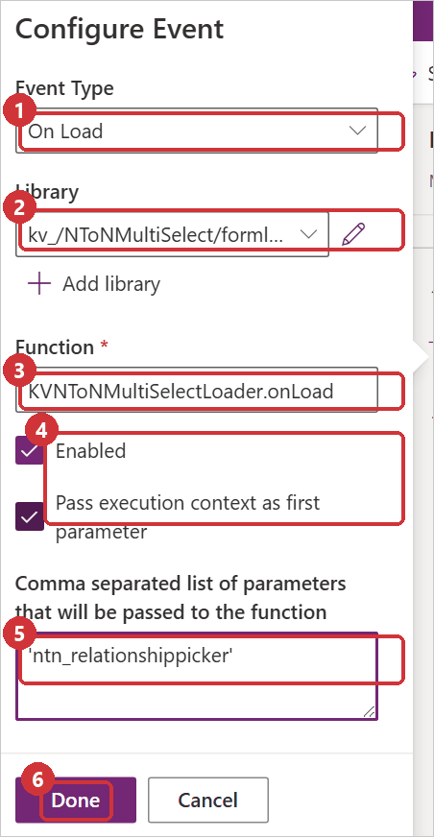
Figure 45. The On Load event handler in the form designer: the library kv_/NToNMultiSelect/formloader.js, the function KVNToNMultiSelectLoader.onLoad (the object formloader.js puts on the window), Pass execution context as first parameter ticked, and a host column name as the parameter. The README shows every step of adding the library: Form library (optional).

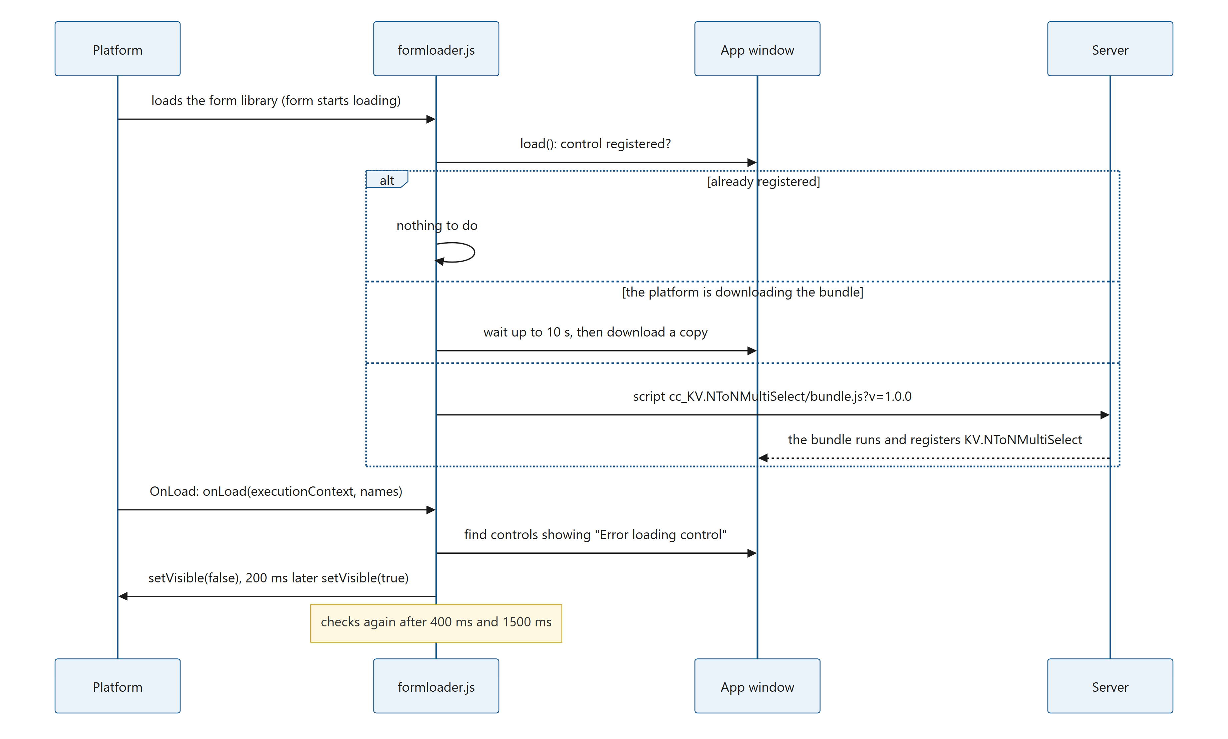
Figure 46. Diagram: 7.5 The OnLoad handler

When not to use it. When the platform delivers the control itself, the field works without the library. If the library is added anyway, it finds the control registered (or waits for the platform's download) and does nothing else.

7.6 Using the loader for another control
The loader is generic apart from its names. For a control of your own:
- Change CONTROL to your namespace.constructor and BUNDLE to cc_<namespace>.<constructor>/bundle.js.
- In isRegistered, change the global it checks (host.KV.NToNMultiSelect) to the global your bundle sets.
- Rename the handler object KVNToNMultiSelectLoader, so two loaders on one form do not overwrite each other.
- Keep the __VERSION__ placeholder and stamp it in your build, as scripts/build.mjs does.

8. The names copy plug-in
This chapter explains the C# plug-in in plugin/NamesCopy/: what it does, how it is registered, and how each part of the code works.

8.1 Purpose
Copy names into the host column lets the control write the selected names into the host column. On its own, the control only sees changes made in the control itself and in subgrids on the same form. It cannot see links made:
- in subgrids on other forms, or from the other side of the relationship;
- by Power Automate flows, imports, integrations or the Web API.
The plug-in runs inside Dataverse for every link made or removed, wherever it comes from. After each Associate or Disassociate, it rewrites the host column of each affected record from the links saved in the database. Two other changes make the host columns out of date without any link message:
- When a linked record is deleted, Dataverse removes its links without a Disassociate message. The two Delete steps cover that case (8.10).
- When a linked record is renamed, no link changes at all. The Update step covers that case (8.11).
The solution NToNMultiSelectWithPlugin contains the Associate and Disassociate steps only (1.2). The Delete and Update steps are created in the environment, for each linked table only, by the steps page that the solution also contains (8.17). Limited to the linked tables, they cost nothing on the deletes and updates of any other table (8.15).
The plug-in has no configuration of its own. It reads the settings of the control on the published forms.
Where to look | What it does
NamesCopyPlugin.Execute | Entry point of every step
ReadForms, LoadForms, NamesCopyHelpers.ParseFormXml | Finds which relationships and host columns copy names
CopyPlanOf, LoadPlan, TableMetadata, SupportsPrincipalAccess | Works out where the names come from, checks the host columns, and reads what the tag check needs: the host table's ownership, its Write privilege, and whether Dataverse answers RetrievePrincipalAccess for it
ControlCopy, ControlMayWrite, Without | The tag check: leaves alone the column the control writes itself, when the user who made the link may write it
Rebuild, ReadRecord, ReadLinks, Changes, NamesCopyHelpers.NamesText | Reads the links and writes the names (for a rename, with the new name in place of the saved one)
ExecuteDelete, NoteLinkedHosts, RebuildNotedHosts | The two Delete steps (8.10)
ExecuteUpdate, ReadOther, CopyIntoTarget | The Update step (8.11)
ReadRoutes, LoadRoutes, ReadHosts | Finds the host records linked to a record that is deleted or renamed (Delete and Update steps)
Deadline, CopiesTime, Deadlines | The 30-second budget that the copies of the deletes and renames of one operation share
FromCache, Cached<T>, DropExpiredPlans | The 2-minute caches
SystemService | The organization service that runs as SYSTEM (8.14)
BeingDeleted | Leaves out records that the same operation is deleting

The steps page, which creates the Delete and Update steps for each linked table, is a web page of its own in plugin/steps-page/ (8.17).

8.2 Registration
To run, a plug-in must be registered: Dataverse must know the assembly (the compiled .dll), the plug-in type (the class) and the steps. A step says on which message (operation) the class runs, at which stage, and how.
Assembly and type (plugin/registration/PluginAssemblies/.../NToNMultiSelectNamesCopy.dll.data.xml):
Item | Value
Assembly | NToNMultiSelect.NamesCopy, version 1.0.0.0, .NET Framework 4.6.2, strong-named
Isolation | Sandbox (<IsolationMode>2</IsolationMode>); stored in the database (<SourceType>0</SourceType>)
Plug-in type | NToNMultiSelect.NamesCopy.NamesCopyPlugin, friendly name N:N Multi-Select names copy
Plug-in type description | "Writes the linked names into the host column of N:N Multi-Select (Copy names into the host column = Yes) when records are linked or unlinked anywhere; with the Delete and Update steps its steps page makes, also when a linked record is deleted or renamed."

The link steps in the package (plugin/registration/SdkMessageProcessingSteps/, one file per step; there are no other step files):
Step name | Message | Stage | Mode | Primary table
N:N Multi-Select names copy: Associate | Associate | PostOperation (40) | Synchronous | None
N:N Multi-Select names copy: Disassociate | Disassociate | PostOperation (40) | Synchronous | None

Both have the description "Copies the linked names into the host column (N:N Multi-Select)." They have no images (no copies of the record before or after the change), no filtering attributes, rank 1, server deployment, and they are customizable (<IsCustomizable>1</IsCustomizable>), so an administrator can turn them off even in a managed installation. scripts/build-with-plugin.mjs stops when plugin/registration holds a step of another message, or not exactly one step of each (9.3).
The steps the steps page creates for each linked table, in the environment (no released package contains them):
Step name | Message | Stage | Mode | Primary table | Filtering attributes
N:N Multi-Select names copy: Delete 1 of 2 (find linked records) for <table> | Delete | PreValidation (10) | Synchronous | The linked table | None
N:N Multi-Select names copy: Delete 2 of 2 (update their names) for <table> | Delete | PostOperation (40) | Synchronous | The linked table | None
N:N Multi-Select names copy: Update (follow renames) for <table> | Update | PreOperation (20) | Synchronous | The linked table | The table's primary name column

For example N:N Multi-Select names copy: Update (follow renames) for new_skill. Each has a fixed id computed from the table and the step (8.17.6), rank 1, server deployment and no images. Their descriptions are in the page (KINDS, 8.17.7); the Update step's reads "Before an update of this table that sets its name, compares the saved name with the new one; when it changes, writes the new name into the names columns of the records linked to it."
Why the link steps have no primary table, and the others one. The Associate and Disassociate messages cannot be registered for one table, so a step on them runs for every N:N link in the environment, including system relationships. For any relationship that no form copies, the step ends after a dictionary lookup in memory, without a service call once the forms are cached (8.5, 8.6). The Delete and Update messages can be limited to a table, and they are: a Delete or Update step registered for every table would run on every delete and every update in the environment, and the call into the sandbox alone costs time even when the plug-in returns at once. Measured, about 15–50 ms more per delete and 15–30 ms more per update, on every table (8.15). Limited to the linked tables, and the Update step to the name column, they cost nothing on any other table. The steps page creates them so (8.17, recipe 10.8).

8.3 The entry point: Execute
Every step calls Execute. It sends Delete and Update to methods of their own (ExecuteDelete, 8.10, and ExecuteUpdate, 8.11), ignores any other message, and handles Associate and Disassociate itself.
plugin/NamesCopy/NamesCopyPlugin.cs, Execute (about lines 69–128):
public void Execute(IServiceProvider serviceProvider)
{
var context = (IPluginExecutionContext)serviceProvider.GetService(typeof(IPluginExecutionContext));
if (context.MessageName == "Delete")
{
ExecuteDelete(serviceProvider, context);
return;
}
if (context.MessageName == "Update")
{
ExecuteUpdate(serviceProvider, context);
return;
}
if (context.MessageName != "Associate" && context.MessageName != "Disassociate") return;
var target = Input<EntityReference>(context, "Target");
var relationship = Input<Relationship>(context, "Relationship");
var related = Input<EntityReferenceCollection>(context, "RelatedEntities");
if (target == null || string.IsNullOrEmpty(relationship?.SchemaName) || related == null) return;

var service = SystemService(serviceProvider);
var forms = ReadForms(context, service);
// Links of every other relationship end here, without a service call once the forms are read.
if (!forms.TryGetValue(relationship.SchemaName.ToLowerInvariant(), out var hosts)) return;

var tracing = (ITracingService)serviceProvider.GetService(typeof(ITracingService));
var records = new[] { target }.Concat(related).ToList();
var control = ControlCopy(context, relationship.SchemaName);
foreach (var host in hosts)
{
// ...
var ids = records.Where(r => r.LogicalName == host.Table).Select(r => r.Id).Distinct()
.Where(id => !BeingDeleted(context, host.Table, id))
.OrderBy(id => id)
.ToList();
if (ids.Count == 0) continue;
var plan = CopyPlanOf(context, service, tracing, relationship.SchemaName, host);
if (plan == null) continue;
try
{
foreach (var id in ids)
{
// The control's record: the other host columns, if any.
var copied = control != null && control.Table == host.Table && control.Id == id && ControlMayWrite(service.Value, context, plan, control)
? Without(plan, control.Column)
: plan;
if (copied != null) Rebuild(service.Value, tracing, copied, id);
}
}
catch (Exception error)
{
// The transaction has ended: the link is rolled back with this message.
throw new InvalidPluginExecutionException(
$"N:N Multi-Select could not copy the names into {ColumnNames(plan.Table, plan.Columns.Select(c => c.Name))}: {error.Message}", error);
}
}
}

Step by step, for Associate and Disassociate:
- Read the input parameters. An Associate or Disassociate request carries the Target record, the Relationship (its schema name) and the RelatedEntities (the records linked to or unlinked from the target).
- Look the relationship up in the form settings (ReadForms). For any relationship that no form copies, the step ends here. Once the forms are cached, this costs no call to the server.
- Find the tag of the control (ControlCopy, 8.8).
- For each host table of the relationship, take the records of the request that belong to that table, leave out records that are being deleted (BeingDeleted, for example a Disassociate that a Delete performs first), and sort them by id.
- Get the copy plan (8.7) and rebuild each record (8.9). For the record whose column the control writes itself, the plan without that column is used, when the user who made the link could write that column (ControlMayWrite, 8.8).
Why a fixed order? Rebuild locks each record it updates until the transaction ends. Two requests that update the same records in a different order could each wait for a record the other holds: a deadlock, and one link rolled back. Sorting by table (the hosts are already sorted, see LoadForms) and then by id gives every request the same order.
A self-referencing relationship (a table linked to itself, for example "related projects") has the same table on both sides: both records of the link are rebuilt.

8.4 The Associate and Disassociate flow
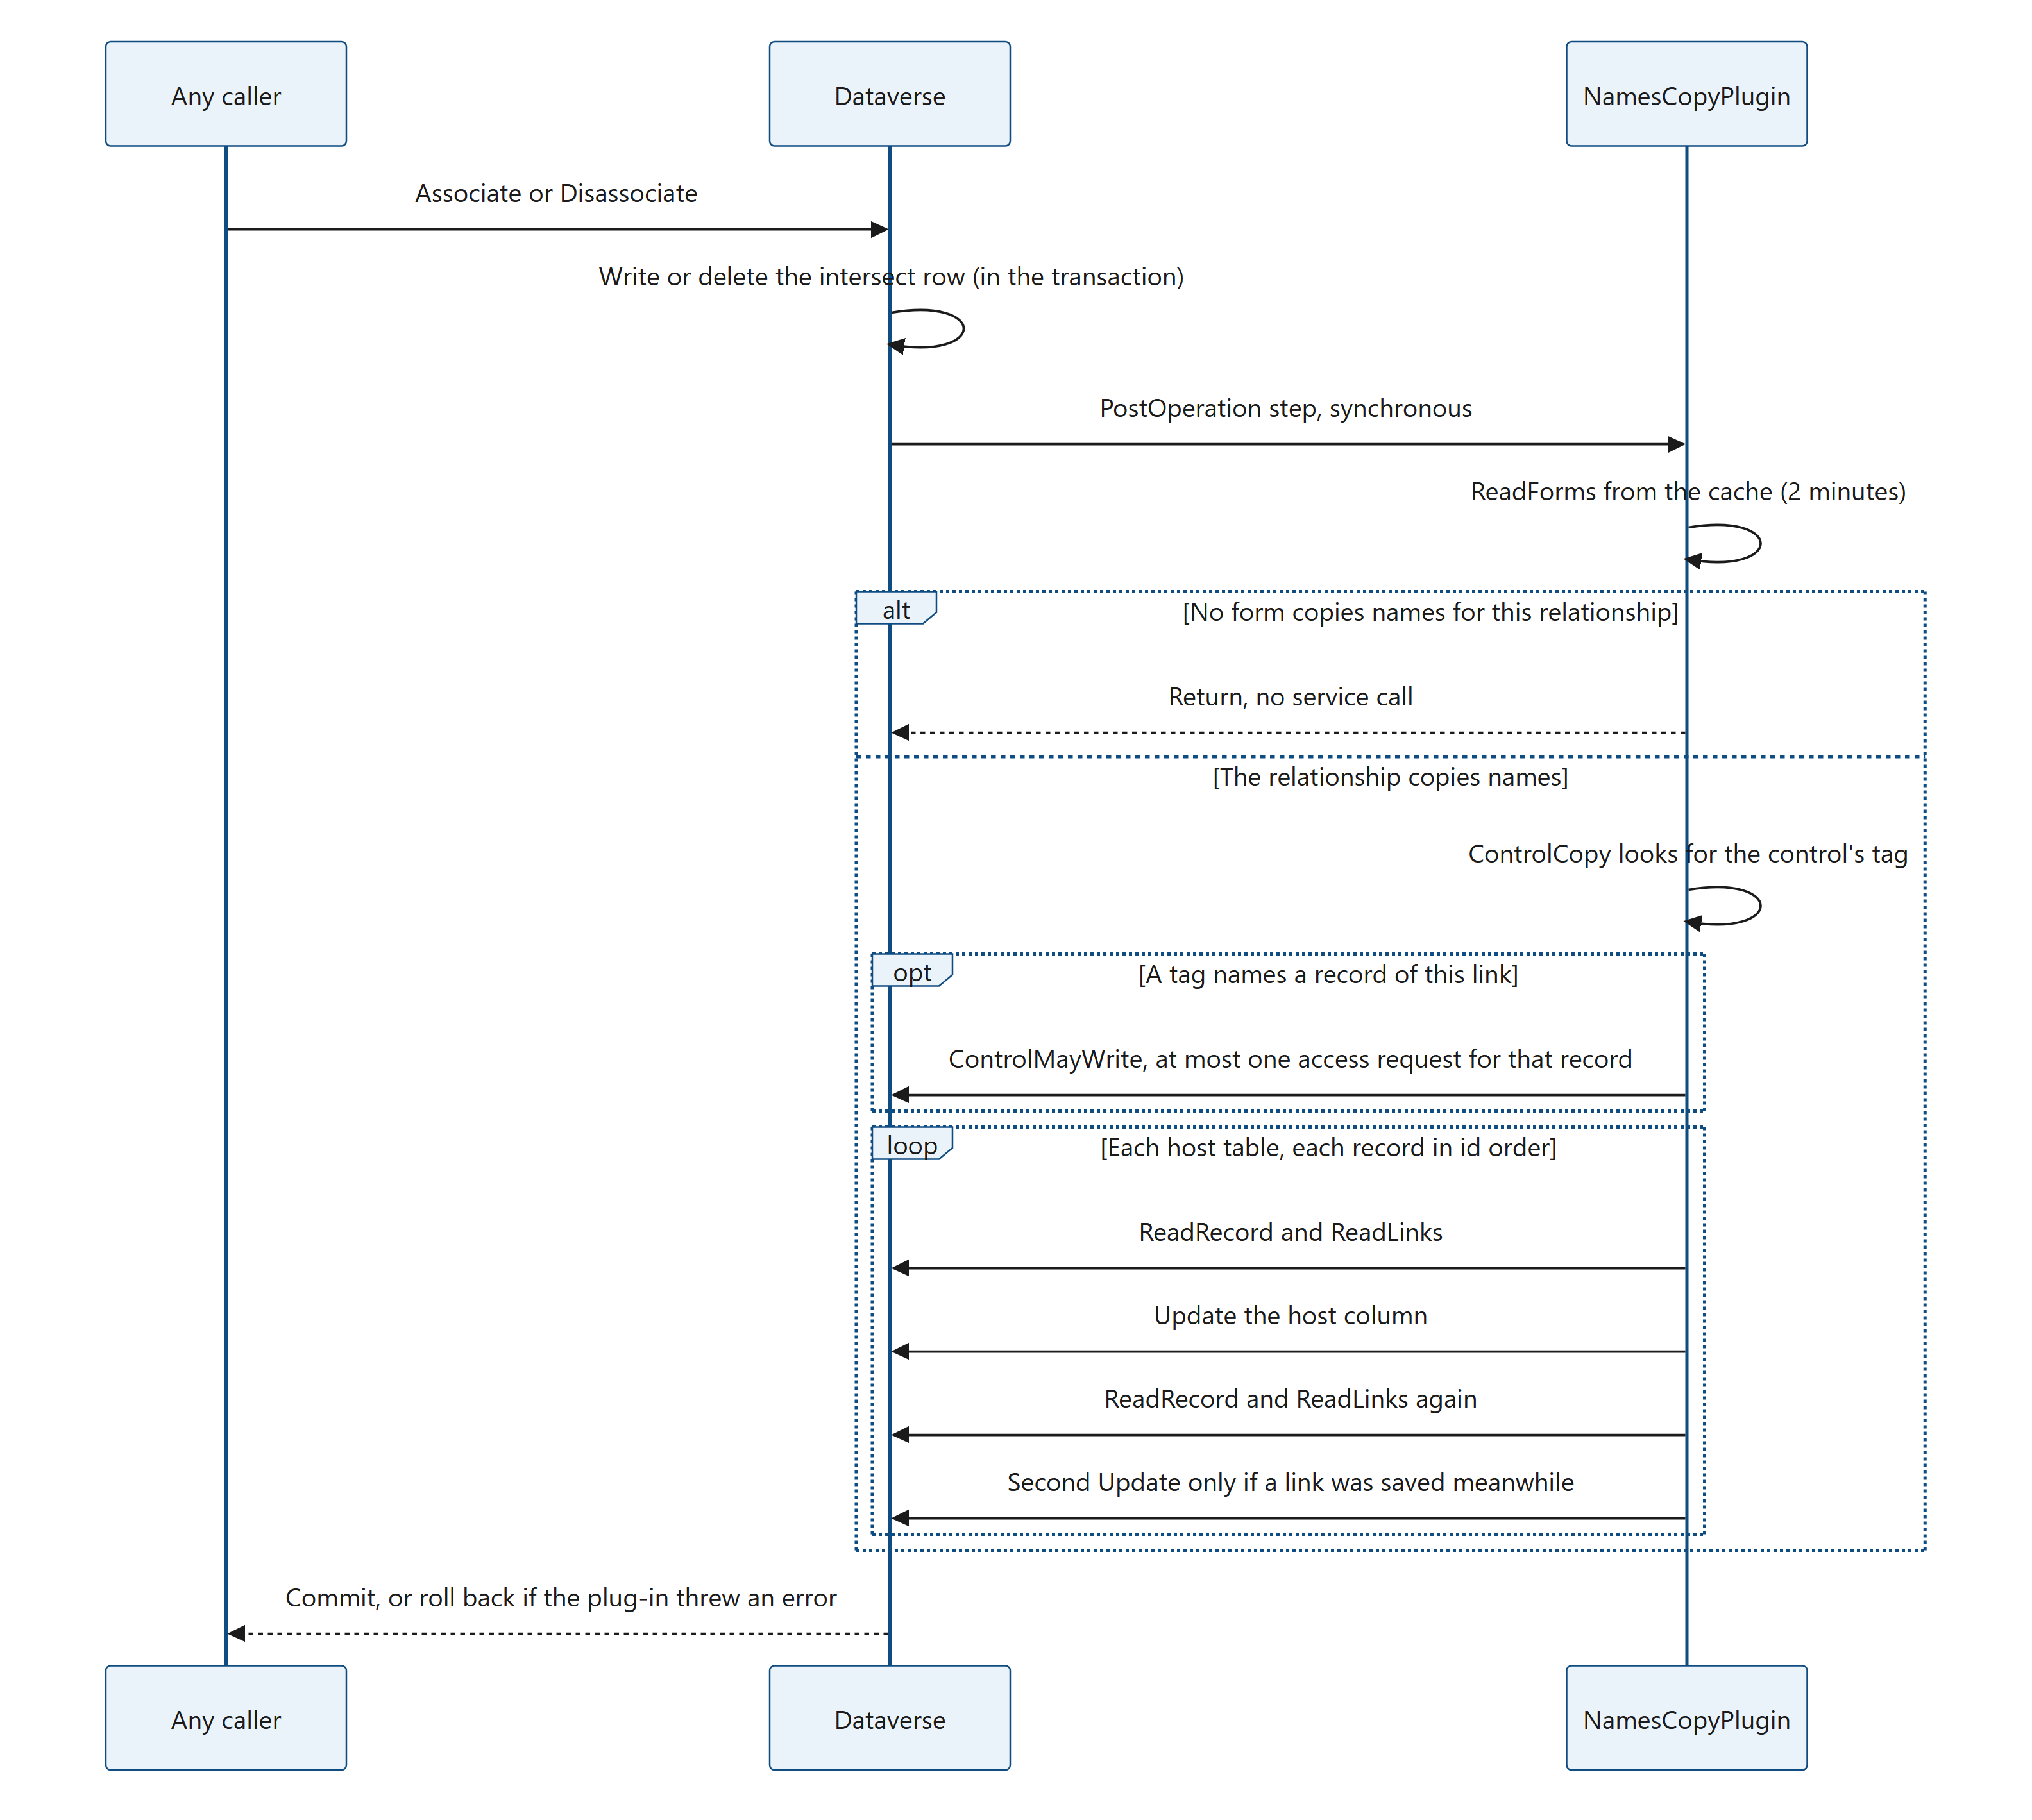
Figure 47. Diagram: 8.4 The Associate and Disassociate flow
Because the steps are PostOperation and synchronous, they run inside the same database transaction as the link, after the link is written. The plug-in therefore sees the new state (the new link is there; the removed link is gone). If the plug-in throws an exception, the whole operation, link included, is rolled back.
Very large link requests. One Associate or Disassociate request can carry very many records (RelatedEntities), which the SDK allows; the control sends one link per request, up to four at a time (4.4). The plug-in rewrites each host record of the request in the same transaction, about 80–100 ms each. More than about 1,000 host records in one request can reach the 2-minute limit of synchronous plug-ins, and Dataverse then rolls the whole request back. Link such numbers of records in smaller batches.

8.5 Finding the configuration in the published forms
The plug-in reads the settings of the control from the forms. A form's layout and its controls' settings are stored as form XML in the systemform table.
plugin/NamesCopy/NamesCopyPlugin.cs, LoadForms (about lines 715–737):
private static IReadOnlyDictionary<string, Host[]> LoadForms(IOrganizationService service)
{
// RetrieveMultiple returns the published form XML. The like filter leaves out the forms without the control;
// an inactive form (formactivationstate 0) isn't shown to anyone, so its settings don't count.
var query = new QueryExpression("systemform") { ColumnSet = new ColumnSet("objecttypecode", "formxml") };
query.Criteria.AddCondition("formxml", ConditionOperator.Like, "%" + NamesCopyHelpers.ControlName + "%");
query.Criteria.AddCondition("formactivationstate", ConditionOperator.Equal, 1);
return service.RetrieveMultiple(query).Entities
.SelectMany(form => NamesCopyHelpers.ParseFormXml(form.GetAttributeValue<string>("formxml")).Select(setting => new
{
Relationship = setting.RelationshipName.ToLowerInvariant(),
Table = form.GetAttributeValue<string>("objecttypecode"),
Column = setting.HostColumn,
}))
.Where(setting => !string.IsNullOrEmpty(setting.Table))
.GroupBy(setting => setting.Relationship)
.ToDictionary(byRelationship => byRelationship.Key, byRelationship => byRelationship
.GroupBy(setting => setting.Table)
.OrderBy(byTable => byTable.Key, StringComparer.Ordinal)
.Select(byTable => new Host(byTable.Key,
byTable.Select(setting => setting.Column).Distinct().OrderBy(column => column, StringComparer.Ordinal).ToArray()))
.ToArray());
}

- One query for the whole environment: the active forms whose XML contains .NToNMultiSelect. The query returns the published form XML, so a form change counts once the form is published.
- The result is a dictionary: relationship schema name (lower case) → host tables → host columns. Tables and columns are sorted, which gives Execute its fixed order.
- The query has no paging: Dataverse returns at most 5,000 forms. More matching forms than that is practically never reached; the forms after the first 5,000 would be ignored.
Each form's XML is parsed by ParseFormXml.
plugin/NamesCopy/NamesCopyHelpers.cs, ParseFormXml (about lines 100–117):
foreach (var control in form.Descendants().Where(e => e.Name.LocalName == "customControl"))
{
var name = (string)control.Attribute("name");
var parameters = Child(control, "parameters");
// ...
if (name == null || !name.EndsWith(ControlName, StringComparison.OrdinalIgnoreCase) || parameters == null) continue;
var relationship = StaticValue(parameters, "relationshipName");
var column = Child(parameters, "value")?.Value.Trim().ToLowerInvariant();
if (string.IsNullOrEmpty(relationship) || string.IsNullOrEmpty(column) ||
StaticValue(parameters, "writeSummary") != "1")
{
continue;
}
if (!settings.Any(s => string.Equals(s.RelationshipName, relationship, StringComparison.OrdinalIgnoreCase) && s.HostColumn == column))
{
settings.Add(new CopySetting(relationship, column));
}
}

A control counts when:
- its name ends with .NToNMultiSelect (the constant ControlName), whatever the publisher prefix and namespace before it;
- its relationshipName parameter is a static value (typed in the form designer, static="true");
- it is bound to a host column (the value parameter);
- its writeSummary parameter (Copy names into the host column) is a static 1 (Yes).
A form has a copy of the settings for each form factor (web, phone, tablet); any of them counts. Malformed XML gives no settings. The XML is read with DTD processing prohibited and no external resolver.
For orientation, a simplified example of what the parser looks for (not a complete form):
<customControl formFactor="0" name="kv_KV.NToNMultiSelect">
<parameters>
<value>new_projectskills</value>
<relationshipName type="SingleLine.Text" static="true">new_project_skill</relationshipName>
<writeSummary type="Enum" static="true">1</writeSummary>
</parameters>
</customControl>

What this means for administrators: setting Copy names into the host column to No on every form turns the plug-in off for that relationship. A change takes effect after the form is published and the cache has expired (within about 2 minutes).

8.6 Caches and their 2-minute lifetime
A plug-in instance is created once and reused, and it may run on several threads at once. Static fields live as long as the sandbox worker process that loaded the assembly. The plug-in keeps four caches there:
Cache | Key | Holds | Lifetime
Forms | Organization id | The dictionary from LoadForms | 2 minutes (CacheTime)
Plans | Organization, relationship, host table, host columns | The copy plan (8.7) | 2 minutes; expired plans are dropped when the forms are loaded again (DropExpiredPlans)
Routes | Organization id | The tables whose names are copied (8.7), built from the cached forms | Rebuilt whenever the forms are loaded again
Deadlines | CorrelationId of a delete or rename operation | The 30-second deadline of the copies of the Delete and Update steps (8.10, 8.11) | Removed at the next delete or rename operation in that worker that starts a deadline, once the deadline is more than 2 minutes past

plugin/NamesCopy/NamesCopyPlugin.cs, FromCache (about lines 997–1012):
private static T FromCache<TKey, T>(ConcurrentDictionary<TKey, Cached<T>> cache, TKey key, Func<T> load)
{
if (cache.TryGetValue(key, out var cached) && (cached.Expires > Clock() || !cached.StartReload())) return cached.Value;
T value;
try
{
value = load();
}
catch
{
cached?.ReloadFailed();
throw;
}
cache[key] = new Cached<T>(value);
return value;
}

- A cached value younger than 2 minutes is returned at once.
- When it has expired, one thread loads it again (StartReload uses Interlocked.CompareExchange); the other threads keep using the old value meanwhile. Every link in the environment reads the forms, so this avoids many identical queries at once.
- A failed load is never cached: the next caller tries again.
- Cached values are never changed, only replaced whole, so other threads always read a complete value.
Why 2 minutes? It is a balance between cost and freshness. A longer time means fewer queries; a shorter time means form changes count sooner. Each sandbox worker has its own caches, so after a form is published, different workers may pick up the change at slightly different times, all within about 2 minutes. To change the time, see recipe 10.5.

8.7 Copy plans and routes
A copy plan says, for one relationship and one host table, where the names come from and which host columns can take them. LoadPlan builds it with two metadata calls and one query:
- RetrieveRelationship gets the relationship. If it is not an N:N relationship, nothing is copied.
- It finds the side of the host table: Entity1 or Entity2. With a self-referencing relationship it uses Entity1, the same side the control reads.
- TableMetadata reads both tables (primary id, primary name, ownership type, privileges, the host columns) with one metadata query.
- It checks each host column. A column is left out, with the reason, when it does not exist, is not a text column, is calculated, rollup or formula (SourceType > 0), cannot be updated, or has no maximum length. Each column kept becomes a HostColumn: its name, its maximum length, and whether it has column security (Secured, from the column's IsSecured).
- It records the intersect table and its two id columns, the other table's id and primary name column, and for the tag check (8.8) how the host table is owned (Ownership), the name of its Write privilege (WritePrivilege, the name of the table's privilege of type Write, read from its metadata), and whether Dataverse answers RetrievePrincipalAccess for it (PrincipalAccess, one query of its message filters by SupportsPrincipalAccess, 8.8).
The reasons are stored in Problems. CopyPlanOf traces them in every execution that meets them and skips the columns, and the link is kept. A plan with no usable column counts as "copies nothing".
Why queries rather than Retrieve calls? In a Dataverse transaction, a failed service call ends the transaction. A RetrieveAttribute call for a column that does not exist would fail and roll back the user's link. A metadata query simply returns nothing for a missing column. The same idea is used for records: ReadRecord uses RetrieveMultiple, which returns no row for a record deleted meanwhile, instead of a Retrieve, which would fail.
Routes are the reverse view, used by the Delete steps and the Update step: for each table whose records' names are copied somewhere (a linked table), the relationships and host columns that hold them. LoadRoutes builds them with one metadata query of the host tables' N:N relationships. A relationship named in a form that no longer exists is simply not found, again without a failed call. For a delete or an update of a table that is not in the routes, Delete 1 of 2 and the Update step end with that dictionary lookup.

8.8 The tag protocol with the control
When the control makes a link while Copy names into the host column is Yes, it writes the names itself once its links are saved. If the plug-in also rewrote that column, every link would be written twice and cost more time. So the control tags its own requests, and the plug-in leaves exactly that column of that record alone, after checking that the user who made the link could write that column themselves.
How the control builds the tag. linkTag and tagQuery in control/NToNMultiSelect/src/relatedData.ts build the tag and the query string (the code is in 4.5). The five parts are: the fixed prefix NToNMultiSelect, the relationship schema name, the logical name of the form's table, the record id (lower case, no braces) and the host column's logical name. The controller only passes a tag while the setting is on and the host column is known.
control/NToNMultiSelect/index.ts, linkTag (about lines 1080–1083):
private linkTag(rel: RelationshipInfo, recordId: string): string | undefined {
const host = (this.context.parameters.value as unknown as { attributes?: { LogicalName?: string } }).attributes?.LogicalName;
return this.config?.writeSummary && host ? linkTag(rel, recordId, host) : undefined;
}

The tag travels as the Web API's tag query parameter, for example POST <environment URL>/api/data/v9.2/<entity set>(<id>)/<navigation property>/$ref?tag=NToNMultiSelect%7C.... Dataverse hands this value to the plug-ins of the request in SharedVariables["tag"]. SharedVariables is a property bag of the execution context that carries values between the steps of one request.
How the plug-in reads it. plugin/NamesCopy/NamesCopyPlugin.cs, ControlCopy (about lines 166–179):
private static ControlColumn ControlCopy(IPluginExecutionContext context, string relationshipName)
{
for (var c = context; c != null && c.Mode == 0; c = c.ParentContext)
{
if (!c.SharedVariables.TryGetValue("tag", out object value) || !(value is string tag) || !tag.StartsWith(ControlTag, StringComparison.Ordinal)) continue;
var parts = tag.Split('|');
if (parts.Length == 5 && string.Equals(parts[1], relationshipName, StringComparison.OrdinalIgnoreCase) &&
!string.IsNullOrEmpty(parts[2]) && Guid.TryParse(parts[3], out var id) && !string.IsNullOrEmpty(parts[4]))
{
return new ControlColumn(parts[2], id, parts[4]);
}
}
return null;
}

- It looks in the step's own context and then up the parent contexts. A parent context is the context of the operation that caused this one; for example, another plug-in that makes a link during the control's request.
- It stops at an asynchronous parent (Mode 1). Work queued by the request runs later, maybe after the control has written the names, so its links count as made elsewhere.
- The tag must have five parts and name the same relationship (not case-sensitive).
Why the tag is checked. Any caller can send a tag: it is an ordinary parameter of the request. A user who may link records but not write the host record could otherwise send a tag of the control's form with the links, and the plug-in would leave the host column alone: the column would stay out of date. So the plug-in follows the tag only when the user who made the link could write that column themselves. Execute asks ControlMayWrite only for the record the tag names (8.3).
plugin/NamesCopy/NamesCopyPlugin.cs, ControlMayWrite (about lines 191–215):
private static bool ControlMayWrite(IOrganizationService service, IPluginExecutionContext context, CopyPlan plan, ControlColumn control)
{
var column = plan.Columns.FirstOrDefault(c => c.Name == control.Column);
if (column == null || column.Secured) return false;
if (plan.PrincipalAccess)
{
var access = (RetrievePrincipalAccessResponse)service.Execute(new RetrievePrincipalAccessRequest
{
Principal = new EntityReference("systemuser", context.InitiatingUserId),
Target = new EntityReference(control.Table, control.Id),
});
return (access.AccessRights & AccessRights.WriteAccess) != 0;
}
if (plan.Ownership == OwnershipTypes.OrganizationOwned && !string.IsNullOrEmpty(plan.WritePrivilege))
{
// Organization-owned: the privilege is for every record of the table. Roles of the user's teams count.
var privileges = (RetrieveUserPrivilegeByPrivilegeNameResponse)service.Execute(new RetrieveUserPrivilegeByPrivilegeNameRequest
{
PrivilegeName = plan.WritePrivilege,
UserId = context.InitiatingUserId,
});
return privileges.RolePrivileges != null && privileges.RolePrivileges.Length > 0;
}
return false;
}

- No column security. A host column with column security (HostColumn.Secured, 8.7) never lets the tag count. For such a column the plug-in rewrites the column on the control's links too; the control writes it as well when the user may update it (5.9.2).
- The user may write the record. The question is asked for the user the request runs for (InitiatingUserId: the user who made the link; with impersonation, the impersonated user), with the copy plan's PrincipalAccess, Ownership and WritePrivilege (8.7), which are cached with the plan:
- a table for which Dataverse answers RetrievePrincipalAccess (most tables owned by users or teams): RetrievePrincipalAccess returns that user's access rights to the tagged record, and the tag counts when they include Write (AccessRights.WriteAccess);
- otherwise, a table owned by the organization: the Write privilege is for every record of the table, so RetrieveUserPrivilegeByPrivilegeName asks whether the user has the table's Write privilege, under the name read from the table's metadata; roles the user has through teams count too;
- any other table: the tag is ignored.
- Otherwise ControlMayWrite returns false, and the column is rebuilt as for any other link.
Which tables answer RetrievePrincipalAccess. Dataverse lists the messages it supports for each table in the sdkmessagefilter table (the message filters), and support for RetrievePrincipalAccess does not follow from how a table is owned. Measured in a development environment, no table owned by the organization had a message filter for it, and 17 of the 384 user-owned tables (owned by users or teams) had none either, for example activitypointer. A RetrievePrincipalAccess request for such a table fails, and a failed request ends the link's transaction. So LoadPlan looks for that message filter of the host table when it builds the copy plan, and stores the answer as PrincipalAccess. plugin/NamesCopy/NamesCopyPlugin.cs, SupportsPrincipalAccess (about lines 222–229):
private static bool SupportsPrincipalAccess(IOrganizationService service, string table)
{
var query = new QueryExpression("sdkmessagefilter") { ColumnSet = new ColumnSet("sdkmessagefilterid"), TopCount = 1 };
query.Criteria.AddCondition("primaryobjecttypecode", ConditionOperator.Equal, table);
var message = query.AddLink("sdkmessage", "sdkmessageid", "sdkmessageid");
message.LinkCriteria.AddCondition("name", ConditionOperator.Equal, "RetrievePrincipalAccess");
return service.RetrieveMultiple(query).Entities.Count > 0;
}

The query asks for at most one message filter whose primary table is the host table and whose message (sdkmessage) is RetrievePrincipalAccess. Unlike a request that the table does not support, it does not fail for any table: it finds no row. It runs when the copy plan is loaded, so at most once every 2 minutes for each relationship, host table and host columns in each sandbox worker (8.6), and never on a link that finds its plan in the cache.
One request, and never a failed one. The check costs at most one request, only for a tagged link, and none when the column has column security or the table gets no check. It runs inside the link's transaction, where a failed request would end the transaction and roll the link back with an error (8.12). So each table gets only a request that works for it: RetrievePrincipalAccess only where its message filter shows that Dataverse answers it, and RetrieveUserPrivilegeByPrivilegeName, which asks about a privilege rather than a record, for the other tables owned by the organization. Should the request still fail, the error is thrown like any failed call of the rebuild ("N:N Multi-Select could not copy the names into <columns>: <reason>", Appendix B), and the link is rolled back.
What it skips: only that host column, of that record, for that relationship, and only when ControlMayWrite returns true (Without removes the column from the plan; when it was the only column, the record is skipped).
What it does not skip: the other records of the same link (for example the related record, when its table also copies names), other host columns of the same record, every untagged link (subgrids, flows, imports, the Web API), and the tagged column when the check says no or the host table gets no check.
Effect: a user who can link records but cannot write the host record (or its secured host column) can no longer keep the host column out of date with a forged tag. Links made in the control cost about the same with or without the plug-in installed (see the measurements in 8.15): measured in a development environment, the check made no measurable difference (the times stayed within the run-to-run variation). On a host table that gets no check, the plug-in rewrites the tagged column on the control's links too: the column stays right, and each of those links takes the time of a rebuild (about 70 ms, 8.15).
Whose names end up in the column. For the column it skips, the control writes the names itself, from the saved links read with the editing user's privileges (5.4.3): the names that user can see. For links made elsewhere, the plug-in writes every linked name as SYSTEM (8.14). Where some users cannot read some related records, the text in the column therefore depends on where the last change was made.
When the control does not get to write. The plug-in skips the tagged column whether or not the control writes it later. If the page is closed before the control has written the names (the user leaves through the browser's prompt, or the browser or app closes without asking), the links stay, and the host column can miss their names until the record's links next change (5.8). Covering that case would mean rebuilding the column on every link of the control, about 70 ms each (8.15).

8.9 Rebuild: writing the names
plugin/NamesCopy/NamesCopyPlugin.cs, Rebuild (about lines 872–905):
private static void Rebuild(IOrganizationService service, ITracingService tracing, CopyPlan plan, Guid id, LinkedName rename = null)
{
var record = ReadRecord(service, plan, id);
if (record == null)
{
tracing.Trace("{0} {1} no longer exists.", plan.Table, id);
return;
}
var links = ReadLinks(service, plan, id, rename);
// ...
var update = Changes(plan, id, record, links, true);
service.Update(update);
tracing.Trace("{0} {1}: {2} updated ({3} links).", plan.Table, id, string.Join(", ", update.Attributes.Keys), links.Count);

// ...
record = ReadRecord(service, plan, id);
if (record == null) return;
links = ReadLinks(service, plan, id, rename);
update = Changes(plan, id, record, links, false);
if (update == null) return;
service.Update(update);
tracing.Trace("{0} {1}: {2} updated again with links saved meanwhile ({3} links).",
plan.Table, id, string.Join(", ", update.Attributes.Keys), links.Count);
}

- ReadRecord reads the host columns of the record. A record that no longer exists is traced and skipped.
- ReadLinks reads every link of the record from the intersect table, joined to the other table for the primary name. It reads pages of 5,000 rows and follows the paging cookie, so a record with any number of links is read completely.
- Changes(..., true) builds an update with the names text of every copied column, and the first Update is sent even when the text has not changed.
- The second read. The first update takes the record's row lock and holds it until the transaction commits. Links to one record can be saved in parallel transactions (other users, flows, integrations). A transaction does not see the links of the others until they commit. Reading the record and its links again after taking the lock includes every link committed before this transaction got the lock. Changes(..., false) keeps only the columns whose text differs, and a second update writes them. Because the first update is always sent, this transaction always holds the lock, so of two parallel transactions the second one always sees the first one's change.
- rename is only given by the Update step (8.11): a linked record renamed in this transaction, whose new name is not saved yet. Both reads of the links get it.
plugin/NamesCopy/NamesCopyPlugin.cs, ReadLinks (about lines 922–948):
private static List<LinkedName> ReadLinks(IOrganizationService service, CopyPlan plan, Guid id, LinkedName rename = null)
{
var query = new QueryExpression(plan.Intersect)
{
ColumnSet = new ColumnSet(plan.OtherAttribute),
PageInfo = new PagingInfo { Count = PageSize, PageNumber = 1 },
};
query.Criteria.AddCondition(plan.HostAttribute, ConditionOperator.Equal, id);
var linked = query.AddLink(plan.OtherTable, plan.OtherAttribute, plan.OtherId, JoinOperator.Inner);
linked.EntityAlias = "t";
linked.Columns = new ColumnSet(plan.OtherName);
var links = new List<LinkedName>();
for (;;)
{
var page = service.RetrieveMultiple(query);
foreach (var row in page.Entities)
{
var other = row.GetAttributeValue<Guid>(plan.OtherAttribute).ToString();
var name = row.GetAttributeValue<AliasedValue>("t." + plan.OtherName)?.Value as string;
links.Add(rename != null && rename.Id == other ? rename : new LinkedName(other, name));
}
if (!page.MoreRecords) break;
query.PageInfo.PageNumber++;
query.PageInfo.PagingCookie = page.PagingCookie;
}
return links;
}

Each row of the intersect table becomes a LinkedName: the linked record's id and its saved name, or (No name) when the name is blank. The link whose id is that of rename takes the new name instead of the saved one.
The names text. plugin/NamesCopy/NamesCopyHelpers.cs, NamesText (about lines 214–228):
public static string NamesText(IEnumerable<LinkedName> links, int? maxLength, out bool wasCut)
{
var sorted = links.ToList();
sorted.Sort(CompareLinks);
var value = string.Join(Separator, sorted.Select(link => link.Name));
wasCut = maxLength > 0 && value.Length > maxLength;
if (wasCut)
{
// The length counts UTF-16 code units: never keep the first half of a character outside the BMP (an emoji).
var cut = maxLength.Value - 1;
if (cut > 0 && char.IsHighSurrogate(value[cut - 1])) cut--;
return value.Substring(0, cut) + "…";
}
return value.Length == 0 ? null : value;
}

The text follows exactly the rules of the control (namesText in control/NToNMultiSelect/src/namesCopy.ts):
- names sorted by name, ignoring case and accents, with numbers compared by value ("Skill 2" before "Skill 10"), then by id so that equal names always come in the same order;
- joined with "; ";
- cut to the column's maximum length, ending with …;
- empty (null) when nothing is linked;
- a record without a name is written as (No name).
The control sorts with the browser's Intl.Collator. NamesCopyHelpers.SortKey turns each name into a key that the invariant culture of .NET compares in the same order (digit runs become their length and digits; punctuation becomes an apostrophe and its rank in the browser's order). The source names what can still differ: letters that a language sorts its own way (for example å in Swedish) and symbols outside ASCII. Both sides must stay in step: see recipe 10.6.

8.10 The Delete steps
When a record is deleted, Dataverse deletes its intersect rows itself, before the PreOperation stage, and without a Disassociate. The host records that were linked to it would keep its name. Two steps on Delete fix that. The steps page creates them in the environment for each linked table, with that table as primary table (8.17); no package contains them.
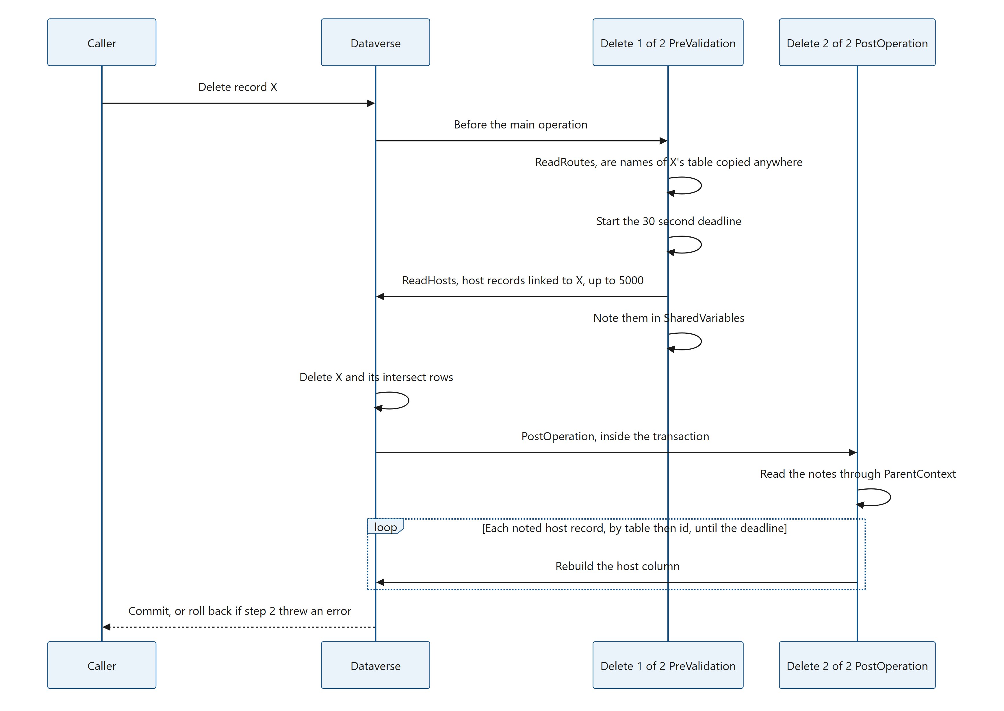
Figure 48. Diagram: 8.10 The Delete steps
plugin/NamesCopy/NamesCopyPlugin.cs, ExecuteDelete (about lines 290–297):
private static void ExecuteDelete(IServiceProvider serviceProvider, IPluginExecutionContext context)
{
var target = Input<EntityReference>(context, "Target");
if (target == null || target.Id == Guid.Empty || string.IsNullOrEmpty(target.LogicalName)) return;
var key = NotesKey(target);
if (context.Stage == 10) NoteLinkedHosts(serviceProvider, context, target, key);
else if (context.Stage == 40) RebuildNotedHosts(serviceProvider, context, target, key);
}

Step 1 of 2, PreValidation (NoteLinkedHosts). PreValidation runs while the links still exist.
- ReadRoutes checks whether the deleted record's table holds names that are copied anywhere. Deletes of every other table end here, with a dictionary lookup. With the steps limited to the linked tables, Dataverse calls the steps only for those tables, so this lookup ends a delete only when no active form copies the names of the step's table (for example a relationship added by hand on the steps page that no form uses yet, 8.17.4).
- It starts the deadline (see below).
- For each route, ReadHosts reads the host records linked to the deleted record: one page of up to 5,000. More could not be rebuilt within the deadline anyway; the excess is traced.
- It writes notes into SharedVariables under the key NToNMultiSelect.NamesCopy.Delete|<table>|<id>. Each note has the form relationship schema name|host table|host columns|id,id,...; notes are joined with ;. A note holds everything step 2 needs, so step 2 reads neither the forms nor the routes.
Step 2 of 2, PostOperation (RebuildNotedHosts). PostOperation runs after the record and its links are gone.
- It reads the notes. Variables set in PreValidation reach PostOperation through ParentContext (the PreValidation step runs in a context of its own), so it looks in its own variables first and then up the parent contexts.
- It sorts the work by table and id, the same order as every rebuild, so that a delete and a link of the same records cannot deadlock.
- It rebuilds each noted record until the deadline has passed. The records left over keep the deleted name, and their number is traced.
The 30-second deadline. Dataverse stops a whole operation after 2 minutes, with all its synchronous steps and cascaded deletes, and rolls it back. The copies of one delete or rename operation therefore get a budget of 30 seconds (CopiesTime). The Delete steps and the Update step (8.11) share it.
plugin/NamesCopy/NamesCopyPlugin.cs, Deadline (about lines 413–431):
private static DateTime Deadline(IPluginExecutionContext context)
{
for (var c = context; c != null; c = c.ParentContext)
{
if (c.SharedVariables.TryGetValue(DeadlineKey, out object value) && value is long ticks) return new DateTime(ticks, DateTimeKind.Utc);
}
var now = Clock();
var deadline = now + CopiesTime;
if (context.CorrelationId != Guid.Empty)
{
foreach (var old in Deadlines.Where(d => d.Value < now - CacheTime))
{
((ICollection<KeyValuePair<Guid, DateTime>>)Deadlines).Remove(old);
}
deadline = Deadlines.GetOrAdd(context.CorrelationId, deadline);
}
context.SharedVariables[DeadlineKey] = deadline.Ticks;
return deadline;
}

The first delete or rename of a request that needs the deadline sets it in its SharedVariables. A nested or cascaded delete (a delete caused by another delete) or rename finds it through ParentContext, or else in the Deadlines dictionary by the request's CorrelationId (an id that all operations of one request share), when it runs in the same sandbox worker. So all the deletes and renames of one operation share one 30-second budget.
Limits of the Delete steps:
- About 80–100 ms per linked record, so roughly 300–350 records fit in the 30 seconds. Records beyond that, and beyond the first 5,000 linked records, keep the deleted name until their links next change.
- The user who deletes waits while the names are rewritten (the steps are synchronous).
- A record linked to itself (self-referencing relationship) is deleted with its copy, so it is left out.
Turning the Delete steps off is safe. With step 1 off, with step 2 off, with both off and with both deleted, deletes succeed and links made anywhere are still copied. The only effect: the deleted record's name stays in the host columns of the records it was linked to, until their links next change. See 8.16.

8.11 The Update step: following renames
Renaming a linked record (for example a skill) changes none of its links: Dataverse sends no Associate, Disassociate or Delete, and the host records linked to it would keep its old name. The Update step rewrites them with the new name. The steps page creates it in the environment for each linked table, with that table as primary table and its primary name column as filtering attribute (8.17); no package contains it.
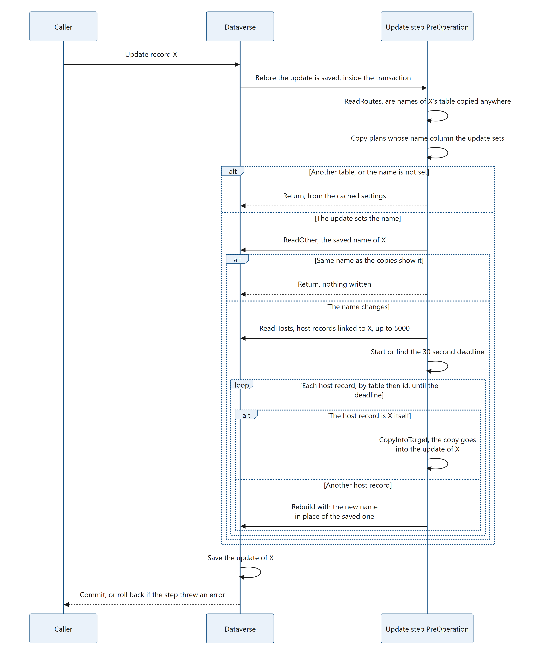
Figure 49. Diagram: 8.11 The Update step: following renames
plugin/NamesCopy/NamesCopyPlugin.cs, ExecuteUpdate (about lines 444–505):
private static void ExecuteUpdate(IServiceProvider serviceProvider, IPluginExecutionContext context)
{
if (context.Stage != 20) return;
var target = Input<Entity>(context, "Target");
if (target == null || target.Id == Guid.Empty || string.IsNullOrEmpty(target.LogicalName)) return;
var service = SystemService(serviceProvider);
// Updates of every other table end here, without a service call once the forms and routes are read.
if (!ReadRoutes(context, service).TryGetValue(target.LogicalName, out var routes)) return;
var tracing = (ITracingService)serviceProvider.GetService(typeof(ITracingService));
var plans = routes.Select(route => CopyPlanOf(context, service, tracing, route.SchemaName, route.Host))
.Where(plan => plan != null && plan.OtherTable == target.LogicalName && target.Contains(plan.OtherName))
.ToList();
if (plans.Count == 0) return;

// Every plan reads the same column: the table's primary name.
var rename = new LinkedName(target.Id.ToString(), target.GetAttributeValue<string>(plans[0].OtherName));
var work = new List<KeyValuePair<CopyPlan, Guid>>();
try
{
var saved = ReadOther(service.Value, plans[0], target.Id);
// Compared as the copies show them: no name and a blank one are both "(No name)".
if (saved == null || new LinkedName(rename.Id, saved.GetAttributeValue<string>(plans[0].OtherName)).Name == rename.Name) return;
foreach (var plan in plans)
{
foreach (var id in ReadHosts(service.Value, tracing, plan, target.ToEntityReference()).Where(id => !BeingDeleted(context, plan.Table, id)))
{
work.Add(new KeyValuePair<CopyPlan, Guid>(plan, id));
}
}
}
catch (Exception error)
{
throw new InvalidPluginExecutionException(
$"N:N Multi-Select could not read the records that hold the name of {target.LogicalName} {target.Id}: {error.Message}", error);
}
// In the order of every rebuild (by table, then id), so that a rename and a link of the same records can't
// deadlock. A record linked through two relationships is rebuilt once for each, one after the other.
work = work.OrderBy(w => w.Key.Table, StringComparer.Ordinal).ThenBy(w => w.Value).ToList();

var deadline = Deadline(context);
for (var i = 0; i < work.Count; i++)
{
var plan = work[i].Key;
var id = work[i].Value;
if (Clock() > deadline)
{
tracing.Trace("{0} {1}: the time for the copies of this rename ran out; {2} linked records keep its old name until their links next change.",
target.LogicalName, target.Id, work.Count - i);
return;
}
try
{
if (plan.Table == target.LogicalName && id == target.Id) CopyIntoTarget(service.Value, plan, target, rename);
else Rebuild(service.Value, tracing, plan, id, rename);
}
catch (Exception error)
{
throw new InvalidPluginExecutionException(
$"N:N Multi-Select could not copy the names into {ColumnNames(plan.Table, plan.Columns.Select(c => c.Name))} of {plan.Table} {id}: {error.Message}", error);
}
}
}

Why PreOperation. Only before the update is saved can the old name still be read. PreOperation (stage 20) runs inside the transaction, just before Dataverse writes the update: the saved row still holds the old name, and the Target holds the new one. The step can therefore tell a rename from an update that sets the name the record already has (imports and integrations that send every column do that) or that sets other columns only, and it writes nothing for those. After the save, in PostOperation, the old name is gone. ExecuteUpdate returns at once in any other stage, so keep the step synchronous and in PreOperation (an asynchronous step runs after the operation).
Step by step:
- Is the table's name copied anywhere? The Target of an Update is an Entity with the columns the update sets. ReadRoutes (8.7) looks its table up in the routes. Updates of every other table end here, without a service call once the forms and routes are cached.
- Does the update set the name? For each route, CopyPlanOf gets the copy plan from the cache. A plan is kept when it copies the names of the target's table (plan.OtherTable) and the target contains that table's primary name column (plan.OtherName). An update of a linked table that does not set the name ends here, from the cached plans, without a service call. (With the filtering attribute that the steps page sets, the table's primary name column, Dataverse does not even call the step for such updates.) Every plan kept reads the same column, so the new name is taken once, as the LinkedName rename.
- Has the name changed? ReadOther reads the saved name with one query. The two names are compared as the copies show them: both go through LinkedName, which shows a blank or missing name as (No name), so a blank name replacing a missing one is no change. When the names are the same, or the record is not found, the step returns and writes nothing.
- Which records hold the name? For each plan, ReadHosts reads the host records linked to the renamed record: one page of up to 5,000 per relationship (more are traced, 8.13). Records that the same operation is deleting are left out (BeingDeleted). The work is sorted by table, then id, the order of every rebuild, so that a rename and a link of the same records cannot deadlock.
- The deadline. Deadline (8.10) starts the 30-second budget, or finds the one that a delete or rename of the same operation already started.
- Rewrite each record. Rebuild(..., rename) writes the names of each host record (8.9). The records left when the deadline has passed keep the old name, and their number is traced.
plugin/NamesCopy/NamesCopyPlugin.cs, ReadOther (about lines 522–527):
private static Entity ReadOther(IOrganizationService service, CopyPlan plan, Guid id)
{
var query = new QueryExpression(plan.OtherTable) { ColumnSet = new ColumnSet(plan.OtherName) };
query.Criteria.AddCondition(plan.OtherId, ConditionOperator.Equal, id);
return service.RetrieveMultiple(query).Entities.FirstOrDefault();
}

As in ReadRecord, a query rather than a Retrieve: a record that is not found gives no row instead of a failed call (8.7).
The new name in place of the saved one. In PreOperation the new name is not saved yet, so the join to the renamed record's table in ReadLinks still returns the old name. ReadLinks therefore puts rename in place of the link to the renamed record. plugin/NamesCopy/NamesCopyPlugin.cs, ReadLinks (about line 941; the whole function is in 8.9):
links.Add(rename != null && rename.Id == other ? rename : new LinkedName(other, name));

Rebuild passes rename to both of its reads of the links, and the second one needs it as much as the first. The second read, under the row lock (8.9), also runs before the rename is saved. Without rename it would read the old name, find that the text differs from the one the first update has just written, and write the old name back with the second update.
A record linked to itself. In a self-referencing relationship (8.3), the renamed record can be one of the host records linked to it. Rebuilding it would send a second Update of the same record from inside its own update. That would change the record's row version before the update being saved is written, and fail an update that checks the row version. CopyIntoTarget puts the copy into the Target of the update being saved instead, so that one save writes both the new name and its copy.
plugin/NamesCopy/NamesCopyPlugin.cs, CopyIntoTarget (about lines 512–516):
private static void CopyIntoTarget(IOrganizationService service, CopyPlan plan, Entity target, LinkedName rename)
{
var links = ReadLinks(service, plan, target.Id, rename);
foreach (var column in plan.Columns) target[column.Name] = NamesCopyHelpers.NamesText(links, column.MaxLength);
}

Errors. The update runs in a transaction, and a failed call has ended it, so every failure is thrown and the rename is rolled back (8.12):
- a failed read of the saved name or of the linked records: N:N Multi-Select could not read the records that hold the name of <table> <id>: <reason>;
- a failed rewrite of a host record, or a failed read of the links of a record linked to itself: N:N Multi-Select could not copy the names into <columns> of <table> <id>: <reason>;
- a failed read of the forms, the routes or a copy plan, with the messages of ReadForms, ReadRoutes and CopyPlanOf (Appendix B). The step runs only for updates of the linked table that set its name; the forms and the routes are read for such an update once their cache has expired, so a failure there rolls back that update, even when the name it sets is the one the record already has.
The time running out is not an error: the rename is kept, and the trace says <table> <id>: the time for the copies of this rename ran out; <n> linked records keep its old name until their links next change. (8.13).
What it costs (measured in a development environment, see 8.15):
- On updates of other tables, and on updates of the linked table that do not set its name: no extra time (71–74 ms against 72–80 ms), because the step is limited to the table and its name column. A step for every table would add about 15–30 ms to every update in the environment (88–92 ms).
- An update that sets a linked table's name to the name it already has: 97–104 ms against 72–79 ms (the saved name is read, nothing is written).
- A rename of a record linked to 0, 1, 10 or 100 records: 0.12 s, 0.24 s, 0.9 s and 10.3 s, against about 0.1–0.2 s without the step. That is about 10 records a second, so roughly 300–350 records fit in the 30 seconds.
Turning the Update step off is safe. Renames still work, and links made anywhere are still copied. The old name stays in the host columns of the records linked to the renamed one until their links next change. No other step depends on it (8.16).

8.12 Transactions and error handling
The plug-in follows one rule: a failed service call inside a transaction is never caught and continued. In Dataverse, a failed call inside a transaction ends that transaction; carrying on would fail later with a less clear error. The plug-in throws an InvalidPluginExecutionException with a clear message instead, and Dataverse rolls the operation back. A setting that cannot work is found after successful calls only, so it can be traced and skipped safely.
Situation | In a transaction? | What happens
Associate or Disassociate: a read or write fails | Yes | Thrown; the link (or unlink) is rolled back with a message starting "N:N Multi-Select could not ..."
Delete 1 of 2 for the first delete of a request: a read fails | No (IsInTransaction is false) | Traced; the delete goes on without the copies, as it would without the plug-in
Delete 1 of 2 for a nested or cascaded delete: a read fails | Yes | Thrown; the delete is rolled back
Delete 2 of 2: a rewrite fails | Yes | Thrown, naming the record that cannot be written; the delete is rolled back
Update: reading the saved name or the linked records fails | Yes (PreOperation) | Thrown; the update, and with it the rename, is rolled back
Update: a rewrite, or the copy into the update of a record linked to itself, fails | Yes | Thrown, naming the record that cannot be written; the update is rolled back
A setting that cannot work (not an N:N relationship, host column not text, calculated, read-only, missing, no maximum length) | Either | Traced in every execution that meets it; skipped; the link, delete or update is kept
A host record deleted meanwhile | Either | Traced ("no longer exists"); skipped
The 30-second budget of a delete or rename operation is used up | Yes | Traced with the number of records left; the delete or rename is kept

All messages are listed in Appendix B. The caller sees the message: the control shows it under the field (for example Couldn't add "Security". N:N Multi-Select could not copy the names into ...), a subgrid shows it in an error dialog, and a flow or integration gets it as the error of its request.
The same rule decides how the tag check asks its question: it sends only a request that the host table supports, as its message filters show when the copy plan is loaded, so that no request of the check fails and ends the link's transaction (8.8).
NoteLinkedHosts shows the rule in code (about lines 343–347):
catch (InvalidPluginExecutionException error) when (!context.IsInTransaction)
{
tracing.Trace("{0} The records linked to {1} {2} keep its name.", error.Message, target.LogicalName, target.Id);
return;
}

8.13 Tracing
The plug-in writes short lines to the tracing service (ITracingService). Dataverse stores them in the Plug-in Trace Log when logging is turned on (12.4). What the plug-in traces:
Trace line (pattern) | Meaning
<table> <id>: <columns> updated (<n> links). | A rebuild wrote the names
<table> <id>: <columns> updated again with links saved meanwhile (<n> links). | The second read found links saved by a parallel transaction
<table> <id> no longer exists. | The host record was deleted meanwhile
<relationship> is not an N:N relationship: nothing is copied into <columns>. | A form names a relationship that is not N:N
<relationship> doesn't link <table>: ..., The tables of <relationship> were not found: ..., <table> has no primary name column: ... | The relationship does not fit the form's table
<table>.<column> doesn't exist, is not a text column, is a calculated, rollup or formula column, can't be updated, has no maximum length (each ending "nothing is copied into it.") | The host column cannot take the copy
<table> <id> has more than <n> records linked through <intersect>; the others keep its name. | Delete or rename: more than 5,000 linked host records
<table> <id>: the time for the copies of this delete ran out; <n> linked records keep its name until their links next change. | Delete: the 30-second budget was used up
<table> <id>: the time for the copies of this rename ran out; <n> linked records keep its old name until their links next change. | Rename: the 30-second budget was used up
<error message> The records linked to <table> <id> keep its name. | Delete 1 of 2 failed outside a transaction; the delete went on

8.14 Running as SYSTEM, and why
plugin/NamesCopy/NamesCopyPlugin.cs, SystemService (about lines 254–262):
/// <summary>
/// As the system user: the copy holds every linked name, also those the editing user can't read, and it is
/// written whatever column security the host column has. The audit history shows SYSTEM as Modified By.
/// </summary>
private static Lazy<IOrganizationService> SystemService(IServiceProvider serviceProvider)
{
var factory = (IOrganizationServiceFactory)serviceProvider.GetService(typeof(IOrganizationServiceFactory));
return new Lazy<IOrganizationService>(() => factory.CreateOrganizationService(null));
}

CreateOrganizationService(null) returns a service that runs as SYSTEM. The reasons:
- Links made elsewhere get every linked name. The plug-in writes all linked names, including records some users cannot open. Links made in the control are different: the plug-in leaves that column to the control (8.8), and the control writes the names of the saved links that the editing user can read (5.4.3). When some users cannot read all related records, the text can therefore differ depending on where the last change was made.
- Linking only needs Append and Append To. Running as the calling user would also need Write on the host record (and Update on a secured host column). A user who may link but not write would get an error, and the error would roll back the link.
The tag check (8.8) runs on the same SYSTEM service, but its request names the user the request runs for (InitiatingUserId, normally the user who made the link), so the answer is that user's access, not SYSTEM's.
The service is Lazy: it is only created when a step really needs it, so links and unlinks of relationships no form copies make no service call (the step itself still runs; see 8.15 for the measured cost). Deletes and updates of tables that have no steps made on the steps page do not call the plug-in at all.
After a change made elsewhere, the host column holds every linked name, also names that some readers of the host record may not be allowed to see. After a change made in the control, it holds the names the editing user can see. When that matters, secure the host column with column security; Column security on the host column in the README explains how the control behaves then.

8.15 Performance: what each step costs
A step costs time in two ways:
- On every operation Dataverse calls it for, also those that have nothing to do with the control: Dataverse calls the plug-in in its sandbox, and the plug-in returns after a lookup in its cached settings. The link steps have no table, so this is every link and unlink in the environment. The Delete and Update steps that the steps page creates are limited to one linked table, and the Update step to updates that set its primary name column, so Dataverse calls them for nothing else.
- When it does its work: rewriting the host column of each record concerned (8.9), about 80–100 ms per record, while the user who made the change waits.
Measured in a development environment: medians of single Web API requests seen from the browser, so the times include the network. Each step was turned off and on in turn, in alternating blocks.
On operations the step has nothing to do with
Step | Called for | Measured with the step on | Extra time
Associate, Disassociate | Every link and unlink in the environment (these messages have no table) | 164 ms for a link the plug-in leaves alone, against 161 ms without the steps | about 3 ms
Delete 1 and 2, as the steps page makes them | Deletes of the linked table only | 107–109 ms for a delete of another table | None
Update, as the steps page makes it | Updates of the linked table that set its name | 71–74 ms for an update of another table, or of the linked table without its name, against 72–80 ms without the step | None

Why the steps page limits the Delete and Update steps to the linked tables. The same steps registered for every table were measured too: the two Delete steps added about 15–50 ms to every delete in the environment (131, 194, 137 and 143 ms against 109, 149, 111 and 127 ms in four measurements), and the Update step about 15–30 ms to every update (88–92 ms against 72–80 ms; 110 ms against 77 ms in a first measurement), on every table. An Update step for every table would also run for the plug-in's own write of each host column, which is an update itself: a link made elsewhere cost about 20 ms more (266–270 ms against 240–253 ms, in a separate series of measurements made on another day, so these times are not comparable with the 232 ms in the next table), a delete of a record linked to 100 records took 10.0 s instead of 8.6 s, and a rename of a record linked to 10 records 1.1 s instead of 0.9 s. The Update step the page makes is not called for that write: it is limited to the linked table and its name column.
When the step does its work
What happens | Without the step(s) | With the step(s)
One link made elsewhere (copied) | 161 ms | 232 ms
48 links made elsewhere, 4 at a time | 2.08 s | 4.06 s
Delete of a record linked to 100 records | 0.5 s | 8.6 s
Rename of a record linked to nothing | about 0.1 s | 0.12 s (the saved name is read and compared)
Rename of a record linked to 1 record | about 0.1 s | 0.24 s
Rename of a record linked to 10 records | about 0.1 s | 0.9 s
Rename of a record linked to 100 records | 0.1–0.2 s | 10.3 s
Update that sets a linked table's name to the name it already has (an import or integration that sends every column) | 72–79 ms | 97–104 ms: the saved name is read, nothing is written

Links made in the control are left to the control (8.8): 48 of them, sent 4 at a time, took 2.18 s with the plug-in installed, against 2.08 s without it. The tag check (8.8) made no measurable difference to them. The control's own names copy (5.4.3) was written about 120 ms after the link was saved, against 67 ms without its read of the saved links; picking is not slower.
Deletes and renames rewrite about 10 records a second, up to the 30-second budget per operation (CopiesTime, 8.10): roughly 300–350 records. At most 5,000 linked records are read per relationship. The records left after that keep the deleted or old name until their links next change, and the trace says how many (8.13). One link request with very many records has no such budget: more than about 1,000 host records in one request can reach the 2-minute limit (8.4).
In short
- The link steps cost almost nothing on links they do not copy, and about 70 ms on each link they copy. Only the people and processes who link records pay for them.
- The Delete and Update steps that the steps page makes cost nothing on the deletes and updates of any other table, and nothing on updates of their table that do not set its name. Deletes and renames of linked records wait about 0.1 s for each linked record.
- Production: use NToNMultiSelectWithPlugin. When the host columns must follow deletes and renames straight away, create the Delete and Update steps for your linked tables with the steps page (8.17, recipe 10.8). Without them, a deleted or renamed record's name stays in the host columns until their links next change; the form itself always shows the current links and names.

8.16 Turning steps off
Each step of the plug-in can be turned off on its own: the Associate and Disassociate steps that come with NToNMultiSelectWithPlugin, and the Delete and Update steps that the steps page made for a linked table (8.17). Turning a step off is safe for the rest of the plug-in and for the control. To take the Delete and Update steps of a table away for good, remove them with the steps page instead (8.17.9).
Why nothing else breaks. All the steps call one class, but no step depends on the work of a Delete or Update step:
- Execute sends a Delete to ExecuteDelete and an Update to ExecuteUpdate, and handles Associate and Disassociate on a path of its own (8.3). That path never reads the notes or the deadline of a delete or rename.
- With step 1 off, step 2 finds no notes in SharedVariables and returns at once (RebuildNotedHosts).
- With step 2 off, step 1 still runs on every delete of its table, reads the linked records and notes them, and nothing uses the notes. That is why both Delete steps of a table must be turned off: step 1 does the reading, so turning off only step 2 keeps that cost on every delete of the table.
- With both Delete steps off, or deleted, ExecuteDelete never runs.
- With the Update step off, or deleted, ExecuteUpdate never runs, and nothing else depends on it: the Delete steps start the shared deadline themselves when they need it (8.10).
Turning the Delete steps off was checked in a development environment with step 1 off, with step 2 off, with both off and with both deleted: in every case deletes succeed, and links made anywhere are still copied by the Associate and Disassociate steps. With the Delete steps off, a deleted record's name stays in the host columns of the records it was linked to until their links next change. With the Update step off, renames still work, and a renamed record's old name stays there in the same way. With all steps off, the control works as without the plug-in: it still writes the names for the changes made on the form. The form itself always shows the current links and names.
Turning steps off in the maker portal. The steps page creates, updates and removes steps, but has no command to turn one off: it shows a step that is off as Off, and Create or update the steps of the ticked tables turns it back on (8.17.7). To turn a step off:
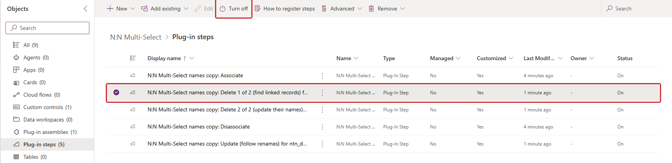
Figure 50. The maker portal in a development environment, Objects > Plug-in steps (5) of the solution NToNMultiSelectWithPlugin: the Associate and Disassociate steps, which come from plugin/registration/SdkMessageProcessingSteps/, and the three steps that the steps page made for one linked table (... for ntn_demoskill). The step Delete 1 of 2 (find linked records) for ntn_demoskill is selected and the Turn off command is marked.
- Go to make.powerapps.com, select the environment, then Solutions.
- Open the solution that holds the step: N:N Multi-Select with the name NToNMultiSelectWithPlugin for the Associate and Disassociate steps and, in development, for the steps the page made there (new steps go into the unmanaged solution the page is in, 8.17.8); for steps in a solution of your own (moved there, or made there because the page is in it), that solution. Section 2 of the steps page shows which solutions the page's steps are in (8.17.5).
- Select Objects → Plug-in steps.
- Select one step, for example N:N Multi-Select names copy: Delete 1 of 2 (find linked records) for new_skill, then select Turn off. The command is offered only while exactly one step is selected (it disappears with two selected), so turn each step off on its own.
- Repeat for each step to turn off, for example Delete 2 of 2 (update their names) for new_skill and Update (follow renames) for new_skill.
To turn a step back on, select it on its own and select Turn on. To delete a step instead (unmanaged installation only), select it, choose Remove → Delete from this environment and confirm; for the steps the page made, its Remove buttons do the same (8.17.9).
Rules:
- Turn both Delete steps of a table off (or remove both).
- In a managed installation the steps cannot be deleted, only turned off.
- An unmanaged import of NToNMultiSelectWithPlugin turns its Associate and Disassociate steps back on and re-creates deleted ones; after a managed import (an upgrade too), check them. After every import of that solution, turn off again the ones that should stay off. The import does not touch the steps that the steps page made: they are components of their own, with their own ids, and no package contains them (8.17.12).
- To switch the whole plug-in off, turn off all its steps the same way, one at a time. The control then writes the names for the changes made on the form, as it does without the plug-in. Importing the solution without the plug-in does not remove or stop a plug-in that is already installed: both solutions are then installed, they share the control and the form library, and the plug-in keeps running.
- To remove the plug-in and keep the control, first remove the steps made with the steps page (Remove all the steps made here, 8.17.9; the page skips steps that came with a managed solution of your own: remove them from that solution in development and deploy it again, or delete that solution): they depend on the plug-in, and Dataverse refuses to remove it while they exist. Then:
- Managed: import the solution without the plug-in (NToNMultiSelect) if it is not installed yet, then delete the managed solution NToNMultiSelectWithPlugin. Dataverse keeps the control and the form library because the other managed solution still contains them, and removes the plug-in assembly, its steps and the steps page.
- Unmanaged: deleting a solution removes only its container. Delete the Associate and Disassociate steps, one at a time, then the plug-in assembly NToNMultiSelect.NamesCopy and the steps page web resource kv_/NToNMultiSelect/namescopysteps.html as components (Remove → Delete from this environment), then delete the solution itself, and NToNMultiSelectTableSteps if the steps page made one (it holds steps only). The control and the form library stay in the environment.
Not covered by the plug-in:
- Deletes and renames of the records of a linked table that has no Delete and Update steps made by the steps page, or whose steps are off: host columns keep the deleted or old name until their links next change (the form always shows the current links and names, and the next change in the control writes them).
- Large deletes and renames: the records left when the 30-second budget has run out (after roughly 300–350 records), and those beyond the first 5,000 per relationship, keep the deleted or old name until their links next change (8.10, 8.11).
- One Associate or Disassociate request with very many records (possible with the SDK, not with the control): more than about 1,000 host records in one request can reach the 2-minute limit of synchronous plug-ins, and Dataverse rolls the whole request back. Link in smaller batches (8.4).
- Records linked before the solution was installed, or before Copy names was turned on, keep their old text until their links change. Fill them once, for example with a flow.
- Imports or integrations that bypass custom plug-ins (the BypassCustomPluginExecution option, or a data migration with plug-ins turned off).
- More than 5,000 forms with the control: only the first 5,000 are read.

8.17 The steps page
The solution NToNMultiSelectWithPlugin comes with the plug-in's Associate and Disassociate steps only. The Delete and Update steps (8.10, 8.11) are made in the environment, for each linked table, by the steps page: an HTML web resource that the same solution contains. This section explains how the page works. Recipe 10.8 gives the procedure, and 11.15 the tests.
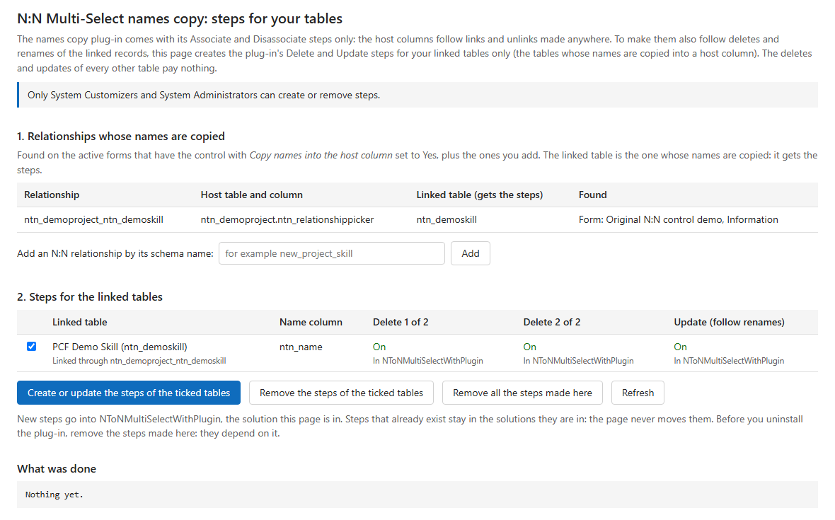
Figure 51. The steps page in a development environment. Section 1 shows one relationship whose names are copied, found on two forms, with its host table and column and its linked table. Section 2 shows that linked table, "PCF Demo Skill", with its name column and its three steps, each "On" and "In NToNMultiSelectWithPlugin", and the buttons. There is no warning at the top: the plug-in has no Delete or Update step that the page did not make.

8.17.1 What it is and how to open it
Item | Value
Web resource | kv_/NToNMultiSelect/namescopysteps.html, type HTML, in NToNMultiSelectWithPlugin (not in NToNMultiSelect); you can add it to a solution of your own (8.17.8)
Display name | N:N Multi-Select names copy: steps for your tables
Source | plugin/steps-page/namescopysteps.html: one HTML file with its style and its script, without libraries or files of its own. The build writes the web resource name into its copy (8.17.2)
Address | https://<your environment>/WebResources/kv_/NToNMultiSelect/namescopysteps.html, for example https://contoso.crm.dynamics.com/WebResources/kv_/NToNMultiSelect/namescopysteps.html

Open the address in a browser that is signed in to the environment. The page runs at the environment's own address, so it calls the Dataverse Web API with the signed-in user's session and privileges: it has no sign-in and no server code of its own. Anyone can open it; only System Customizers and System Administrators can create or remove steps (Dataverse refuses the others, and the page explains it, 8.17.11).
From top to bottom, the page shows:
- The intro. The plug-in comes with its Associate and Disassociate steps only, so the host columns follow links and unlinks made anywhere. To make them also follow deletes and renames of the linked records, the page creates the plug-in's Delete and Update steps for the linked tables only; the deletes and updates of every other table pay nothing.
- A warning, only when it applies: the plug-in's Delete and Update steps that this page did not make (8.17.9).
- A status line: "Reading the environment..." while it starts, then "Only System Customizers and System Administrators can create or remove steps.", or why the page cannot work (8.17.3).
- 1. Relationships whose names are copied (8.17.4), with a box to add one by its schema name.
- 2. Steps for the linked tables (8.17.5): each linked table with its name column and its three steps, and the buttons Create or update the steps of the ticked tables, Remove the steps of the ticked tables, Remove all the steps made here and Refresh. Below them, only when the page is in more than one unmanaged solution, a list to choose the one new steps go into; then where new steps go (8.17.8), and "Before you uninstall the plug-in, remove the steps made here: they depend on it."
- What was done: a log of every action, with the time.

8.17.2 How it is packaged
scripts/build-with-plugin.mjs adds the page to the solution project (9.3). scripts/build-with-plugin.mjs, addStepsPage (about lines 99–125):
function addStepsPage(folder, prefix) {
const name = `${prefix}_/NToNMultiSelect/namescopysteps.html`;
const file = `${prefix}_NToNMultiSelectnamescopystepshtml${STEPS_PAGE_ID.toUpperCase()}`;
mkdirSync(folder, { recursive: true });
// The page says its own address when it is opened elsewhere (see the page): its name is written into it.
const page = readFileSync(stepsPage, "utf8");
if (!page.includes("__STEPS_PAGE_NAME__")) throw new Error("The steps page has no __STEPS_PAGE_NAME__ to fill in.");
writeFileSync(join(folder, file), page.split("__STEPS_PAGE_NAME__").join(name));
// ...
return name;
}

- The web resource is named with the prefix of the solution's publisher (<CustomizationPrefix> of Solution.xml, here kv), so a build with your own publisher names it <your prefix>_/NToNMultiSelect/namescopysteps.html.
- The content file has the name SolutionPackager expects: the web resource name without punctuation, followed by the id STEPS_PAGE_ID in upper case (as for the form library, 9.5).
- The page's placeholder __STEPS_PAGE_NAME__ is replaced with the web resource name, so the page can say its own address (8.17.3) and find the solutions it is in (8.17.8). The build stops when the placeholder is missing.
- The lines left out write the .data.xml file: the id STEPS_PAGE_ID, the name, the display name, a description, type 1 (HTML) and the content file name.
The page reads its name like this. plugin/steps-page/namescopysteps.html, PAGE_NAME (about line 115):
const PAGE_NAME = "__STEPS_PAGE_NAME__".startsWith("__") ? "<prefix>_/NToNMultiSelect/namescopysteps.html" : "__STEPS_PAGE_NAME__";

In the source, the text still starts with __, and the page says <prefix>_/.... In the built copy, both texts are the web resource name. The page uses it in its messages (8.17.3) and to find its own web resource, and with it the solutions it is in (8.17.8).

8.17.3 Starting: the address check
start runs once the page has loaded. It first checks where the page runs. plugin/steps-page/namescopysteps.html, start (about lines 922–927):
if (!/^https?:$/.test(location.protocol) || !/\/WebResources\//i.test(location.pathname)) {
status.className = "warning";
status.textContent = "Open this page at your environment's address: https://<your environment>/WebResources/" + PAGE_NAME +
" (for example https://contoso.crm.dynamics.com/WebResources/" + PAGE_NAME + "). A preview, such as the one in the maker portal, cannot reach Dataverse.";
return;
}

Opened anywhere else (the file from disk, or a preview such as the one of the maker portal), the page cannot reach Dataverse, so it only says where to open it. At the right address, start:
- finds the plug-in type NToNMultiSelect.NamesCopy.NamesCopyPlugin (PLUGIN_TYPE) and its assembly. Without it, the page says "The names copy plug-in is not installed in this environment. Import the solution with the plug-in first, then open this page again.";
- reads the forms (8.17.4), the relationships added by hand, and the steps and their solutions (8.17.5);
- draws the page (8.17.10), and only then shows sections 1 and 2, so that nothing can be clicked before the tables are there.
A failure shows "Could not read the environment: " and the reason.
Every request goes through one function. plugin/steps-page/namescopysteps.html, api (about lines 157–178):
async function api(method, path, body, options) {
const headers = { Accept: "application/json", "OData-MaxVersion": "4.0", "OData-Version": "4.0" };
if (body !== undefined) headers["Content-Type"] = "application/json; charset=utf-8";
// A PATCH only updates: it never creates a record that is not there.
if (method === "PATCH") headers["If-Match"] = "*";
if (options && options.maxPageSize) headers.Prefer = "odata.maxpagesize=" + options.maxPageSize;
const response = await fetch(path.startsWith("http") ? path : location.origin + API + path, {
method, headers, credentials: "same-origin", body: body === undefined ? undefined : JSON.stringify(body),
});
const text = await response.text();
let json = null;
if (text) {
try { json = JSON.parse(text); } catch (e) { json = null; }
}
if (response.status === 404 && options && options.allow404) return null;
if (!response.ok) {
const error = new Error((json && json.error && json.error.message) || response.status + " " + response.statusText);
error.status = response.status;
throw error;
}
return json || {};
}

- Requests go to the environment's own Web API (/api/data/v9.2/), with the browser's session (credentials: "same-origin"). A full address is only used for the next-page links that Dataverse returns (all follows them, 500 rows a page).
- A PATCH carries If-Match: *, so it updates a step that exists and never creates one.
- allow404 turns "not found" into null for the reads that expect it (a table or a step that may not exist) and for deletes of steps that are already gone.
- explain words the errors an administrator can act on: 401 "You are no longer signed in. Reload the page.", 403 "You do not have the privileges to change plug-in steps or solutions (System Customizer or System Administrator is needed)." followed by Dataverse's message.

8.17.4 Reading the forms as the plug-in does
Section 1 lists the relationships whose names are copied, found the way the plug-in finds them (8.5). readForms reads the active forms (formactivationstate eq 1) whose form XML contains .NToNMultiSelect; if the service refuses the text filter on the form XML, it reads all active forms and filters them in the browser. Each form's XML is parsed with the rules of NamesCopyHelpers.ParseFormXml. plugin/steps-page/namescopysteps.html, parseFormXml (about lines 219–230):
for (const control of Array.from(doc.getElementsByTagNameNS("*", "customControl"))) {
const name = control.getAttribute("name");
const parameters = child(control, "parameters");
if (!name || !name.toLowerCase().endsWith(CONTROL_NAME.toLowerCase()) || !parameters) continue;
const relationship = staticValue(parameters, "relationshipName");
const value = child(parameters, "value");
const column = value ? value.textContent.trim().toLowerCase() : "";
if (!relationship || !column || staticValue(parameters, "writeSummary") !== "1") continue;
if (!settings.some((s) => s.relationship.toLowerCase() === relationship.toLowerCase() && s.column === column)) {
settings.push({ relationship, column });
}
}

A control counts as in the plug-in: its name ends with .NToNMultiSelect (any publisher), its relationship name is a static value, it is bound to a host column, and Copy names into the host column is a static 1. Malformed XML gives nothing (DOMParser reports a parsererror).
For each relationship, host table and host column, section 1 shows:
- the relationship, with its schema name as the metadata has it (all N:N relationships of the environment are read once, and the name is matched in any case);
- the host table and column;
- the linked table: the other side of the relationship, the table whose names are copied, which gets the steps (linkedTableOf: Entity2 when the host table is Entity1, Entity1 when it is Entity2; for a self-referencing relationship the same table, as in the plug-in's LoadRoutes, 8.7). A name that is not an N:N relationship of the environment shows "Not an N:N relationship of this environment"; one that does not link the host table, "Does not link <table>";
- the forms on which it was found.
Relationships added by hand. A relationship that no active form copies yet can be added by its schema name, in any case. For a relationship between two tables, the administrator chooses its linked side: one table, the other, or both; for a self-referencing one it is the table itself. Hand-added relationships are kept in that browser only (localStorage, under a key with the environment's host name), with the side chosen. One that no active form copies is marked: "No active form copies names through it yet: its steps do nothing until one does." The plug-in only acts on relationships the forms copy (8.10, step 1). Take off the list removes it from the list; its steps, if any, stay.

8.17.5 Reading the steps and their solutions
readSteps reads everything the page shows about steps, and keeps it only when all of it could be read:
- The plug-in's steps: every step of the plug-in type, with its name, message, primary table, stage, mode, state (on or off), filtering attributes and whether it is managed.
- The solutions of each step that has a table: the solution components of type 92 (plug-in step), named by the solutions' unique names. The system solutions (Active, Default, Basic) and hidden ones are left out, so the page shows the solutions you see in the maker portal.
- The solutions that contain the plug-in assembly (components of type 91): whether one of them is managed (then the environment is most likely a test or production environment, 8.17.12), and the publisher of one of them (for NToNMultiSelectTableSteps, 8.17.8).
- The solutions this page is in: its own web resource, found by its name (PAGE_NAME, 8.17.2), and the solution components of type 61 (web resource) for it. The unmanaged ones among the solutions you see in the maker portal are the solutions new steps can go into (8.17.8).
- NToNMultiSelectTableSteps, by its unique name: its id and whether it is managed, if it is there.
At the end, pickTarget sets the solution new steps go into (8.17.8).
Section 2 lists the linked tables of section 1 (found and added), plus any table that already has steps of the page (found by their ids, 8.17.6) but no relationship above: those show "No relationship above uses it: its steps can be removed". For each table it shows its display name and logical name, the relationships it is linked through, its primary name column ("None: names cannot be copied" when it has none), and the state of each of its three steps. plugin/steps-page/namescopysteps.html, stepState (about lines 503–527):
/**
* The state of one step of this page: missing, on, off, managed, on another message (changed with another tool:
* Create can't correct that, see wrongMessages), or with other settings than this page gives it.
*/
async function stepState(table, kind, info) {
const step = stepById(await idOf(table, kind));
if (!step) return { text: "Missing", css: "muted" };
const message = step.sdkmessageid && step.sdkmessageid.name;
const same = step.stage === kind.stage && step.mode === 0 && message === kind.message &&
step.sdkmessagefilterid && step.sdkmessagefilterid.primaryobjecttypecode === table &&
(step.filteringattributes || "") === (kind.filtered ? (info && info.nameColumn) || "" : "");
let text = message !== kind.message ? "On " + message + ", not " + kind.message + ": Remove, then Create" :
!same ? "Other settings: Create updates it" : step.statecode === 0 ? "On" : "Off";
let css = !same ? "error" : step.statecode === 0 ? "ok" : "muted";
// Where the step is, wherever it was moved (it is found by its id). A step in no solution (its adding failed) is
// the only one Create puts into a solution.
const solutions = state.stepSolutions.get(step.sdkmessageprocessingstepid) || [];
let detail = (step.ismanaged ? "Managed, in " : "In ") + (solutions.length ? solutions.join(", ") : "no solution");
if (step.ismanaged) detail += ": change it in development";
else if (!solutions.length && !state.target.managed && message === kind.message) {
detail += ": Create adds it to " + state.target.uniqueName;
css = "error";
}
return { text, css, detail };
}

- Missing: the table has no step with that id.
- On or Off: the step has the settings the page gives it.
- On <message>, not <its message>: Remove, then Create (in red), for example "On Update, not Delete: Remove, then Create": the step was put on another message with another tool. A step's message can't be changed, so Create leaves its table alone; remove the table's steps, then Create makes them again (8.17.7).
- Other settings: Create updates it (in red): another stage, mode, table or filtering attribute. Create corrects these in place.
- Under each state, the solutions the step is in: "In NToNMultiSelectWithPlugin", "In YourSolution", "In no solution: Create adds it to ...", or "Managed, in ...: change it in development".
A table's box is ticked at first when the table comes from a relationship and has a primary name column. It cannot be ticked when the table is not found, or when all its steps that exist are managed.

8.17.6 The step ids
Each step of the page has a fixed id, computed from the table and the step. plugin/steps-page/namescopysteps.html, stepId (about lines 248–259):
/** A name-based UUID (version 5, SHA-1) of the table and the step: the ids of a table's steps never change. */
async function stepId(table, kind) {
const name = new TextEncoder().encode(table.toLowerCase() + "|" + kind);
const data = new Uint8Array(16 + name.length);
data.set(uuidBytes(STEP_NAMESPACE), 0);
data.set(name, 16);
const hash = new Uint8Array(await crypto.subtle.digest("SHA-1", data)).slice(0, 16);
hash[6] = (hash[6] & 0x0f) | 0x50;
hash[8] = (hash[8] & 0x3f) | 0x80;
const hex = Array.from(hash, (b) => b.toString(16).padStart(2, "0")).join("");
return hex.substr(0, 8) + "-" + hex.substr(8, 4) + "-" + hex.substr(12, 4) + "-" + hex.substr(16, 4) + "-" + hex.substr(20, 12);
}

The id is a name-based UUID (version 5, as RFC 4122 defines it): the SHA-1 hash of the namespace STEP_NAMESPACE and the name <table in lower case>|<kind>, where the kind is find (Delete 1 of 2), rebuild (Delete 2 of 2) or rename (Update). What follows from it:
- Create again updates the same steps. It never makes a second set, also after the steps were moved to another solution: the page finds a step by its id, wherever it is.
- The same table gets the same ids in every environment. Steps created in development keep their ids when you deploy them, and the page in test or production recognizes them. It is also why steps created by the page in test or production would block the import of the same steps from development (8.17.12).
- A step counts as the page's when its id is the id the page computes for its table and kind. Delete and Update steps with any other id are reported as steps the page did not make (8.17.9).

8.17.7 Creating or updating the steps
The three steps of a table are described once. plugin/steps-page/namescopysteps.html, KINDS and the orders (about lines 125–137):
const KINDS = [
{ key: "find", message: "Delete", stage: 10, label: "Delete 1 of 2 (find linked records)",
description: "Before a delete of this table, notes the records whose names column holds the name of the record being deleted. Works with step 2 of 2: keep both or neither." },
{ key: "rebuild", message: "Delete", stage: 40, label: "Delete 2 of 2 (update their names)",
description: "After a delete of this table, writes the names columns of the records step 1 of 2 noted, without the deleted name. Works with step 1 of 2: keep both or neither." },
{ key: "rename", message: "Update", stage: 20, label: "Update (follow renames)", filtered: true,
description: "Before an update of this table that sets its name, compares the saved name with the new one; when it changes, writes the new name into the names columns of the records linked to it." },
];
const byKey = (key) => KINDS.find((k) => k.key === key);
// The Delete pair is created in this order (a lone Delete 2 of 2 finds nothing to do; a lone Delete 1 of 2 would
// read for nothing) and removed in the reverse order; Update comes last both times.
const CREATE_ORDER = ["rebuild", "find", "rename"].map(byKey);
const REMOVE_ORDER = ["find", "rebuild", "rename"].map(byKey);

Create or update the steps of the ticked tables (createSteps) first asks for confirmation, with the ticked tables and where new steps go (8.17.8), and with a warning in a probable test or production environment (8.17.12). Then:
- Every ticked table is checked before anything is written. It must have a primary name column, Dataverse must allow plug-in steps on Delete and on Update of it (filterOf reads the message filter of each message and table and its iscustomprocessingstepallowed), none of its steps may be managed, and none may be on another message than its own (wrongMessages). A table that fails is skipped whole, with the reason in the log, and nothing of it is changed; the others go on.
- The steps, table by table, in CREATE_ORDER: Delete 2 of 2, Delete 1 of 2, Update. A lone Delete 2 of 2 finds nothing to do, and a lone Delete 1 of 2 would read for nothing, so this order never leaves a half-made pair that costs time. A table that fails stops with "Run Create again to finish it."; the other tables go on.
- The log ends with "Dataverse uses new or changed steps within a short time."
The last two checks of step 1. plugin/steps-page/namescopysteps.html, createSteps and wrongMessages (about lines 768–778 and 795–802):
const existing = await pageSteps(table);
if (existing.some((e) => e.step.ismanaged)) {
log(table + ": skipped, its steps come from a managed solution here. Change them in development and deploy them again.", "error");
continue;
}
const wrong = wrongMessages(existing);
if (wrong) {
log(table + ": skipped, " + wrong + ". A step's message can't be changed: remove the table's steps (Remove the steps of the ticked tables), then Create makes them again.", "error");
continue;
}
plans.push({ table, info, filters });
// ...
/**
* The steps of this page on another message than their own (changed with another tool), as "<step> is registered on
* <message>", or "" when there is none. The page doesn't delete them itself: you remove them, then Create.
*/
function wrongMessages(existing) {
return existing.filter((e) => e.step.sdkmessageid && e.step.sdkmessageid.name !== e.kind.message)
.map((e) => e.kind.label + " is registered on " + e.step.sdkmessageid.name).join(" and ");
}

Each step is written by writeStep. plugin/steps-page/namescopysteps.html, writeStep (about lines 804–844):
async function writeStep(plan, kind) {
const id = await idOf(plan.table, kind);
const fields = {
name: "N:N Multi-Select names copy: " + kind.label + " for " + plan.table,
description: kind.description,
stage: kind.stage,
mode: 0,
rank: 1,
supporteddeployment: 0,
asyncautodelete: false,
filteringattributes: kind.filtered ? plan.info.nameColumn : null,
"sdkmessagefilterid@odata.bind": "/sdkmessagefilters(" + plan.filters[kind.message].id + ")",
};
const existing = await api("GET", "sdkmessageprocessingsteps(" + id + ")?$select=statecode,ismanaged&$expand=sdkmessageid($select=name)", undefined, { allow404: true });
// Managed steps are never changed here (also when one came with an import since the page read the steps).
if (existing && existing.ismanaged) throw new Error(kind.label + " comes from a managed solution here: change it in development.");
// Another message can't be set on a step, and the page doesn't delete it (also when it was changed since the page
// read the steps): you remove it, then Create.
if (existing && existing.sdkmessageid && existing.sdkmessageid.name !== kind.message) {
const error = new Error(kind.label + " is registered on " + existing.sdkmessageid.name + ": remove the table's steps, then Create makes them again.");
// Running Create again doesn't help here (see createSteps).
error.final = true;
throw error;
}
let what;
if (existing) {
await api("PATCH", "sdkmessageprocessingsteps(" + id + ")", fields);
what = "updated";
if (existing.statecode !== 0) {
await api("PATCH", "sdkmessageprocessingsteps(" + id + ")", { statecode: 0, statuscode: 1 });
what += " and turned on";
}
} else {
await api("POST", "sdkmessageprocessingsteps", Object.assign({
sdkmessageprocessingstepid: id,
"eventhandler_plugintype@odata.bind": "/plugintypes(" + state.pluginTypeId + ")",
"sdkmessageid@odata.bind": "/sdkmessages(" + await messageId(kind.message) + ")",
}, fields));
what = "created";
}
log(plan.table + ": " + kind.label + " " + what + (kind.filtered ? ", only when " + plan.info.nameColumn + " changes" : "") + ".", "ok");

- The settings. The name N:N Multi-Select names copy: <label> for <table>, the description of KINDS, the stage, synchronous (mode 0), rank 1, server deployment (supporteddeployment 0), and the message filter of the message and table, which makes the table the step's primary table. The Update step gets the table's primary name column as filtering attribute; the Delete steps get none.
- A new step is created with the computed id (8.17.6), on the plug-in type, for the message.
- An existing step is updated in place: its settings are set again (so a step with Other settings gets the page's settings back), and a step that is off is turned back on.
- A step on another message than its own (put there with another tool, shown as "On <message>, not <its message>: Remove, then Create", 8.17.5) is not changed, and the page does not delete it: the message of a step can't be changed, and the page deletes a step only when you remove it. Step 1 above skips its table whole: "<table>: skipped, Delete 1 of 2 (find linked records) is registered on Update. A step's message can't be changed: remove the table's steps (Remove the steps of the ticked tables), then Create makes them again." Nothing of that table is changed. If a step was changed in the short time between that check and its write, writeStep stops its table with "... is registered on <message>: remove the table's steps, then Create makes them again." Remove deletes the table's steps by their ids, that one too (8.17.9); Create then makes the three steps fresh, with the same ids, in the solution new steps go into (8.17.8). A step that was in a solution of your own is then only in the solution new steps go into: if that is not yours, add it to yours again, as for any new step.
- A managed step is never changed: the table is skipped in step 1 above, and writeStep refuses one that came with an import since the page read the steps.
The rest of writeStep adds a new step to a solution when needed (8.17.8).

8.17.8 Where new steps go, and why the page never moves steps
New steps go into one solution: the unmanaged solution the page is in, or NToNMultiSelectTableSteps where it is in none. readSteps finds the solutions it is in by its own web resource. plugin/steps-page/namescopysteps.html, readSteps (about lines 364–379):
// The unmanaged solutions this page is in, found by its own web resource: the one that also holds the plug-in
// first, then by name.
const homes = [];
const page = (await api("GET", "webresourceset?$select=webresourceid&$filter=name eq " + quote(PAGE_NAME))).value[0];
if (page) {
for (const row of await all("solutioncomponents?$select=_solutionid_value&$filter=componenttype eq 61 and objectid eq " + page.webresourceid)) {
const info = await solutionInfo(row._solutionid_value);
if (info && info.shown && !info.managed && !homes.some((h) => h.id === row._solutionid_value)) {
homes.push({ uniqueName: info.uniqueName, id: row._solutionid_value, plugin: holders.has(row._solutionid_value) });
}
}
}
homes.sort((a, b) => Number(b.plugin) - Number(a.plugin) || a.uniqueName.localeCompare(b.uniqueName));
const temp = (await api("GET", "solutions?$select=solutionid,ismanaged&$filter=uniquename eq " + quote(TEMP_SOLUTION))).value[0];
Object.assign(state, { steps, stepSolutions, pluginManaged, holderPublisher, homes, temp: temp ? { id: temp.solutionid, managed: !!temp.ismanaged } : null });
pickTarget();

- The page's own web resource is read by its name (PAGE_NAME, written in by the build, 8.17.2), then the solutions that contain it (solution components of type 61, web resource).
- The candidates are the unmanaged ones among these solutions, as you see them in the maker portal: managed solutions, hidden ones and the system solutions (Active, Default, Basic) don't count (solutionInfo, the same rule as for the solutions of the steps, 8.17.5).
- Their order: the solutions that also contain the plug-in assembly (holders, the solutions of the component of type 91) first, then by unique name.
- NToNMultiSelectTableSteps is read by its unique name: its id and whether it is managed, or null when it is not there.
pickTarget sets the solution new steps go into, and choose keeps a choice made on the page. plugin/steps-page/namescopysteps.html, pickTarget and choose (about lines 382–403):
/**
* The solution new steps go into: the one chosen of the unmanaged solutions this page is in (in this browser; the
* first one when none was chosen), otherwise NToNMultiSelectTableSteps.
*/
function pickTarget() {
if (state.chosen === null) {
try { state.chosen = localStorage.getItem(CHOSEN_KEY) || ""; } catch (e) { state.chosen = ""; }
}
const home = state.homes.find((h) => h.uniqueName === state.chosen) || state.homes[0];
state.target = home
? { uniqueName: home.uniqueName, id: home.id, managed: false, temp: false }
: { uniqueName: TEMP_SOLUTION, id: state.temp ? state.temp.id : null, managed: !!(state.temp && state.temp.managed), temp: true };
}

/** Chooses which of the unmanaged solutions this page is in gets the new steps (kept in this browser). */
function choose(uniqueName) {
state.chosen = uniqueName;
try { localStorage.setItem(CHOSEN_KEY, uniqueName); } catch (e) { /* private browsing: kept for this visit only */ }
pickTarget();
log("New steps go into " + state.target.uniqueName + ".");
render();
}

- The page is in one unmanaged solution (the usual case): new steps go into it, and into no other solution, with no question. With the published package installed unmanaged (a development environment), that is NToNMultiSelectWithPlugin, the solution with the plug-in.
- The page is in several unmanaged solutions (for example you also added it to a solution of your own): under the buttons of section 2, a list appears, labelled "This page is in more than one unmanaged solution. New steps go into:". It lists the candidates in their order, a solution that also contains the plug-in shown as "<name> (with the plug-in)", and has the solution new steps go into selected: the first one until you choose. A choice (choose, called when the list changes) is kept in that browser for that environment (localStorage, key NToNMultiSelect.steps.solution.<host>, CHOSEN_KEY, as for the hand-added relationships, 8.17.4) and logged: "New steps go into <name>.". When the kept choice is no longer one of the candidates, the first one is used.
- The page is in no unmanaged solution (it is only in managed solutions, as in test or production with the managed package): new steps go into the unmanaged solution NToNMultiSelectTableSteps. The page makes it only when a new step needs it (ensureTarget), with the publisher of a solution that contains the plug-in (or, when it finds none, the environment's default publisher), the display name N:N Multi-Select names copy: steps for your tables, version 1.0.0.0 and the description "The Delete and Update steps of the names copy plug-in for the linked tables, made by the steps page where it is in no unmanaged solution. Move them to the solution you deploy.", and logs "Created the unmanaged solution NToNMultiSelectTableSteps (this page is in no unmanaged solution here)."
- The exception: NToNMultiSelectTableSteps is itself installed managed (for example deployed from development) where the page is in no unmanaged solution. Nothing can be added to a managed solution, so new steps go into no solution: Dataverse keeps them in the environment's default solution. The page says so before Create, in the note under the buttons and in the question: "NToNMultiSelectTableSteps is managed here: its steps are changed in development. New steps made here are not added to a solution."
New steps straight into the solution you deploy. Add the steps page web resource to that unmanaged solution (Solutions → your solution → Add existing → More → Web resource, N:N Multi-Select names copy: steps for your tables), open the page again or select Refresh, and, if the page is now in more than one unmanaged solution, choose yours in the list. New steps then go into it. Steps made before stay where they are: move those yourself (8.17.12). The page is then also a component of your solution and goes with it to test and production.
The end of writeStep (about lines 845–860):
// A new step goes into the solution this page is in (the chosen one when it is in several), or
// NToNMultiSelectTableSteps where it is in none. A step that already exists stays in the solutions it is in (you
// move steps yourself); only one in no solution at all (its adding failed before) is added. Nothing is ever taken
// out of a solution.
const target = state.target;
const inSolutions = state.stepSolutions.get(id) || [];
if (target.managed || (what !== "created" && inSolutions.length)) return;
// NToNMultiSelectTableSteps is made only when a step has to go into it.
if (!target.id) await ensureTarget();
try {
await api("POST", "AddSolutionComponent", { ComponentId: id, ComponentType: 92, SolutionUniqueName: target.uniqueName, AddRequiredComponents: false, DoNotIncludeSubcomponents: false });
log(plan.table + ": " + kind.label + " added to " + target.uniqueName + ".", "ok");
} catch (error) {
log(plan.table + ": " + kind.label + " could not be added to " + target.uniqueName + ": " + explain(error) + " Run Create again.", "error");
}
}

- A new step goes into the target solution, unless that one is managed.
- A step that already exists stays where it is; only one in no solution at all is added to the target solution.
- A failed add is logged and the other steps go on: "... could not be added to <solution>: <reason> Run Create again." The next Create adds the step, which is then in no solution.
The page never moves a step between solutions and never deletes a solution. A step that already exists stays in the solutions it is in: you may have moved it into the solution you deploy (8.17.12), and the page must not take it out of there, nor put a second copy of it into another solution. Only a new step, or a step that is in no solution at all (because adding it failed earlier, shown as "In no solution: Create adds it to ..."), is added. A step that you removed and Create made again is a new step: it goes into the target solution only (8.17.7). Nothing is ever taken out of a solution. Managed steps are never changed or removed by the page.
The note under the buttons (targetText) says which case applies, followed by "Steps that already exist stay in the solutions they are in: the page never moves them.":
- one solution: "New steps go into <name>, the solution this page is in.", for example in development "New steps go into NToNMultiSelectWithPlugin, the solution this page is in.";
- several: "New steps go into <name>, the solution chosen above (this page is in <n> unmanaged solutions).";
- none: "This page is in no unmanaged solution here, so new steps go into the solution NToNMultiSelectTableSteps, made when a new step needs it." (without "made when a new step needs it" once that solution exists);
- NToNMultiSelectTableSteps managed: the text of the exception above.

8.17.9 Removing steps, and the steps the page did not make
Remove the steps of the ticked tables and Remove all the steps made here (removeSteps, removeAll) delete the page's steps of the ticked tables, or of every table that has at least one unmanaged step of the page. They first ask: "Remove the Delete and Update steps of: <tables>? Deletes and renames of their records are then no longer followed in the host columns." plugin/steps-page/namescopysteps.html, removeSteps and removeAll (about lines 867–885 and 889–895):
for (const table of tables) {
try {
let removed = 0;
for (const kind of REMOVE_ORDER) {
const step = stepById(await idOf(table, kind));
if (!step) continue;
if (step.ismanaged) {
log(table + ": " + kind.label + " comes from a managed solution here: remove it in development and deploy again.", "error");
continue;
}
await api("DELETE", "sdkmessageprocessingsteps(" + step.sdkmessageprocessingstepid + ")", undefined, { allow404: true });
removed++;
log(table + ": " + kind.label + " removed.", "ok");
}
if (!removed) log(table + ": no steps to remove.");
} catch (error) {
log(table + ": stopped: " + explain(error) + " Run Remove again.", "error");
}
}
// ...
async function removeAll() {
const tables = [];
for (const entry of await linkedTables()) {
if ((await pageSteps(entry.table)).some((e) => !e.step.ismanaged)) tables.push(entry.table);
}
await removeSteps(tables, true);
}

Table by table, in REMOVE_ORDER (Delete 1 of 2, Delete 2 of 2, Update):
- a managed step is skipped with "... comes from a managed solution here: remove it in development and deploy again.";
- every other step of the page is deleted, found by its id whatever its message, so also a step on another message than its own (8.17.7); a step that is already gone counts as removed;
- a table without steps of the page logs "<table>: no steps to remove.";
- a table that fails stops with "Run Remove again."; the other tables go on.
This is the only place where the page deletes a step: when you remove it. After Remove, Create makes the table's three steps fresh, with the same ids, on their own messages, in the solution new steps go into (8.17.8).
Remove deletes only steps with the page's ids (8.17.6). Before you uninstall the plug-in, remove the steps made here: they depend on it, and Dataverse refuses to remove the plug-in while they exist (8.16).
The steps the page did not make. The plug-in can also have Delete or Update steps that the page did not make, for example steps registered by hand with the Plugin Registration Tool (12.5). plugin/steps-page/namescopysteps.html, otherSteps (about lines 669–684):
/**
* The plug-in's Delete and Update steps that this page did not make (for example registered by hand with the Plugin
* Registration Tool), as "name (every table or only <table>, on or off)".
*/
async function otherSteps() {
const others = [];
for (const step of state.steps) {
const message = step.sdkmessageid && step.sdkmessageid.name;
if (message !== "Delete" && message !== "Update") continue;
const table = step.sdkmessagefilterid && step.sdkmessagefilterid.primaryobjecttypecode;
let mine = false;
if (table) for (const kind of KINDS) if (step.sdkmessageprocessingstepid === await idOf(table, kind)) mine = true;
if (!mine) others.push(step.name + " (" + (table ? "only " + table : "every table") + ", " + (step.statecode === 0 ? "on" : "off") + ")");
}
return others;
}

When there are any, a warning at the top of the page lists them, for example "<step name> (every table, on)" or "<step name> (only <table>, off)", and says: "Those that are on run as well as the steps made here: a table that has both is handled twice (same result, twice the time), and a step for every table makes every delete or update in the environment slower. Turn off or delete the ones you no longer need (in the solution's plug-in steps, or with the Plugin Registration Tool)." Without such steps, the warning is not shown. The page only reports them: it never turns them off, changes or deletes them, because it did not make them and cannot know why they are there. Turn them off in the maker portal (8.16), or delete them there or with the Plugin Registration Tool (12.5).

8.17.10 Drawing the page: render, the render token and setBusy
render draws sections 1 and 2 from the state that readForms and readSteps built. It builds the new table bodies off the page, reading what it still needs (the tables' metadata, the step ids, the states) as it goes, and only then replaces the old ones, sets the warning, the list of solutions (filled with the candidates and shown only when the page is in more than one unmanaged solution, 8.17.8) and the note under the buttons. Two drawings can overlap, for example a change of a linked side in section 1 while the previous drawing still waits for a table's metadata. The render token keeps only the newest. plugin/steps-page/namescopysteps.html, render (about lines 550–552 and 641–646):
async function render() {
const token = ++state.renderToken;
const relationships = document.createElement("tbody");
// ...
// Only the newest drawing is shown.
if (token !== state.renderToken) return;
$("relationships").replaceWith(relationships);
relationships.id = "relationships";
$("tables").replaceWith(tables);
tables.id = "tables";

Every action runs through run. plugin/steps-page/namescopysteps.html, run (about lines 710–727):
async function run(work) {
if (state.busy) return;
setBusy(true);
try {
await work();
} catch (error) {
log("Failed: " + explain(error), "error");
} finally {
// The page shows the new state before its buttons can be used again.
try {
await readSteps();
await render();
} catch (error) {
log("Could not read the steps again: " + explain(error), "error");
}
setBusy(false);
}
}

- One action at a time. setBusy(true) turns off every button, choice and box of the page and sets aria-busy="true" on it; a second click while an action runs does nothing.
- The new state before the next click. After every action, also a failed one, the page reads the steps again and draws them before its buttons work again, so what it shows is what Dataverse has.
- Locked boxes stay locked. setBusy(false) keeps a table's box off when the table cannot be changed here (not found, or only managed steps).
- Accessibility. The status line is a role="status" region, the log a role="log" region that is read out politely, the box column has a header for screen readers ("Selected"), each box and each choice of a linked side has a label naming its table or relationship, the list of solutions has its label, and every control shows a focus outline.

8.17.11 Security
- No privileges of its own. Every request is the signed-in user's, with that user's session and privileges. The page cannot do anything the user could not do in the maker portal. Dataverse refuses to create, change or delete a step for a user who is not a System Customizer or System Administrator, and the page shows its 403 message with an explanation (8.17.3). Reading its own web resource and the solutions it is in (8.17.8) needs no privilege beyond these: reading web resources is part of the System Customizer role.
- Only the environment. The page talks to the Web API of the environment it is opened from (credentials: "same-origin"), and loads nothing from anywhere else: its style and script are in the file.
- No markup from data. Every text the page shows (relationship, table, form and step names, Dataverse's messages) is set with textContent or as a text node, never as HTML, so a name cannot add markup or script to the page. Form XML is parsed as XML with DOMParser, which runs nothing.
- What it keeps. Only the relationships added by hand and their linked sides, and the solution chosen for new steps (8.17.8), in that browser's localStorage, under keys with the environment's host name.
- Writes it makes. Steps on the plug-in type NToNMultiSelect.NamesCopy.NamesCopyPlugin: it creates and updates them, deletes them only when you remove them, and adds a new step (or one in no solution) to one solution: the unmanaged solution the page is in (the one chosen on the page when it is in several), or NToNMultiSelectTableSteps, which it creates only where the page is in no unmanaged solution and a new step needs it. A PATCH never creates a step (If-Match: *), and managed steps are never changed or removed.
- What the steps can do. The steps only make Dataverse call the plug-in for deletes and renames of a table. They run the same class as the link steps, as SYSTEM (8.14), and can do nothing the plug-in does not already do.

8.17.12 Deploying the steps to test and production
The usual way: create the steps in development and deploy them with your own solution.
- In development, NToNMultiSelectWithPlugin is installed unmanaged, and the page is in it, so the page puts new steps into it (8.17.8).
- Add the steps to the solution you deploy: Solutions → your solution → Add existing → Plug-in step, and select the page's steps (N:N Multi-Select names copy: ... for <table>). Or deploy from development the solution that holds them. Or, before you create the steps, add the steps page to the solution you deploy and choose that solution on the page: new steps then go straight into it (8.17.8).
- Export that solution (managed for test and production) and import it where NToNMultiSelectWithPlugin is installed: the steps depend on the plug-in.
- The steps keep their ids in every environment (8.17.6). The page there shows them as On and "Managed, in <your solution>: change it in development".
The released packages never contain table steps.
The warning in test and production. Where a managed solution contains the plug-in and the page is in no unmanaged solution (so new steps would go into NToNMultiSelectTableSteps), the page assumes a test or production environment. Create then asks first: "The plug-in comes from a managed solution here, so this is probably a test or production environment. The usual way is to create the steps in development and deploy them with the plug-in: steps created here get the same ids, so they would block that import. Create them here anyway?" The note under the buttons says the same.
Imports of NToNMultiSelectWithPlugin do not touch the page's steps. They are separate components with their own ids, and an unmanaged import adds and updates components but does not take components out of a solution. An unmanaged import turns the Associate and Disassociate steps back on and re-creates deleted ones; after a managed import, check them (8.16).
Checked in a development environment: the steps were created only for the linked table, with the same ids after Remove and Create; a rename and a delete were followed by them alone; and Delete or Update steps made elsewhere were listed in the warning and left untouched. Also checked: steps moved by hand into another solution are still shown On and are neither moved nor duplicated by Create, and a step in no solution is added by Create. And a step whose message was changed elsewhere is shown as "On <message>, not <its message>: Remove, then Create"; Create skips its table and sends no delete; Remove deletes the table's three steps; then Create makes them again on their own messages, with the same ids. With the page in NToNMultiSelectWithPlugin only, there is no list and new steps go there; with the page also added to a second unmanaged solution, the list showed NToNMultiSelectWithPlugin (with the plug-in) first and chosen, the steps made after choosing the other solution went into it only, and the choice stayed after a reload.

9. Building and packaging
This chapter walks through the two build scripts and the solution projects, so that you can change them safely. Together the scripts write four packages: build.mjs the two of NToNMultiSelect, build-with-plugin.mjs the two of NToNMultiSelectWithPlugin.

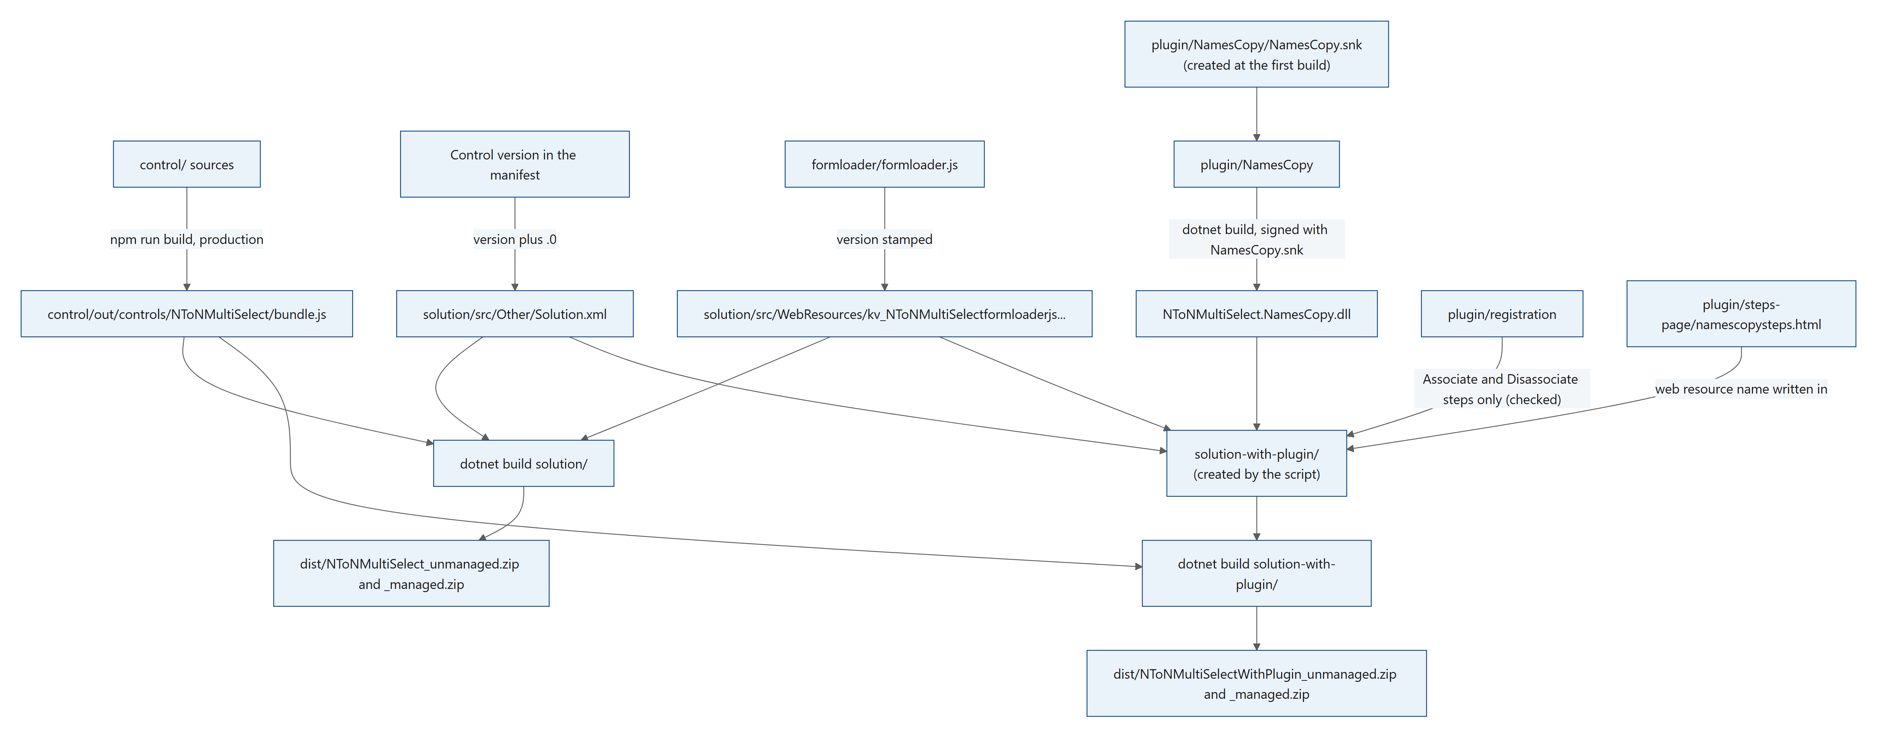
Figure 52. Diagram: 9. Building and packaging

9.1 What gets packaged
A solution is the unit Dataverse uses to move customizations between environments: a zip file with XML files that describe the components, and the files they need. The components here are:
Component | Type in Solution.xml | Comes from
Code component kv_KV.NToNMultiSelect | 66 | The control project, through the ProjectReference in solution/solution.cdsproj
Web resource kv_/NToNMultiSelect/formloader.js | 61 | solution/src/WebResources/
Plug-in assembly NToNMultiSelect.NamesCopy (solution with the plug-in) | 91 | plugin/registration/PluginAssemblies/ and the built .dll
Plug-in steps: Associate and Disassociate only (solution with the plug-in) | 92 | plugin/registration/SdkMessageProcessingSteps/; scripts/build-with-plugin.mjs checks that there is exactly one step of each
Web resource kv_/NToNMultiSelect/namescopysteps.html, the steps page (solution with the plug-in) | 61 | plugin/steps-page/namescopysteps.html, written into the project by addStepsPage (8.17.2)

9.2 scripts/build.mjs, step by step
Step 0: read the version and check the manifest texts. scripts/build.mjs (about lines 17–26):
const root = join(dirname(fileURLToPath(import.meta.url)), "..");
const manifest = readFileSync(join(root, "control/NToNMultiSelect/ControlManifest.Input.xml"), "utf8");
const version = /<control[^>]*\sversion="([^"]+)"/.exec(manifest)[1];
console.log(`Building N:N Multi-Select ${version} (solution version ${version}.0)`);

// Dataverse rejects apostrophes in manifest display and description keys on import (noAposStringType), but the PCF
// build tools don't check for it. Fail here instead of halfway through an import.
for (const m of manifest.matchAll(/(display-name-key|description-key)="([^"]*)"/g)) {
if (m[2].includes("'")) throw new Error(`Manifest ${m[1]} contains an apostrophe, which Dataverse rejects on import: ${m[2]}`);
}

The control version in the manifest is the only place to set the version. The script fails early when a setting's display name or description contains an apostrophe, because Dataverse would reject the import (3.2.5).
Steps 1 and 2: stamp the version. (about lines 28–36)
// 1. Form loader web resource. SolutionPackager expects a flat file named <name without punctuation><GUID>.
// The control version is stamped in so the bundle URL changes with every release.
const loader = readFileSync(join(root, "formloader/formloader.js"), "utf8").replace("__VERSION__", version);
writeFileSync(join(root, "solution/src/WebResources/kv_NToNMultiSelectformloaderjs078EAC10-CCC9-489A-8EEB-8FA3FEECD8F8"), loader);

// 2. Solution version = control version + ".0".
const solutionXmlPath = join(root, "solution/src/Other/Solution.xml");
const solutionXml = readFileSync(solutionXmlPath, "utf8").replace(/<Version>[^<]*<\/Version>/, `<Version>${version}.0</Version>`);
writeFileSync(solutionXmlPath, solutionXml);

- The form library's VERSION = "__VERSION__" becomes the control version. The library adds it to the bundle address (?v=1.0.0), so browsers download a new bundle after an upgrade.
- The copy is written to the file name SolutionPackager expects: the web resource name without punctuation, followed by its id.
- The solution version becomes the control version plus .0 (1.0.0 → 1.0.0.0).
Step 3: build and package. (about lines 41–44)
execSync("npm run build -- --noColor --buildMode production", { cwd: join(root, "control"), stdio: "inherit" });
// Packages left over from an earlier build would otherwise be copied to dist/ if packaging were skipped.
rmSync(join(root, "solution/bin/Release"), { recursive: true, force: true });
execSync("dotnet build -c Release -nologo -v:minimal", { cwd: join(root, "solution"), stdio: "inherit" });

The production bundle is built first, because dotnet build skips the control when control/out is newer than the sources (and after a plain npm run build, that would be the development bundle). Old packages are removed, then dotnet build packs the solution.
Step 3b: check what went into the package. (about lines 48–56)
const builtManifest = readFileSync(join(root, "control/out/controls/NToNMultiSelect/ControlManifest.xml"), "utf8");
for (const [, name] of manifest.matchAll(/<property name="([^"]+)"/g)) {
if (!builtManifest.includes(`name="${name}"`)) throw new Error(`Built manifest is missing property ${name}; the package is stale.`);
}
if (!builtManifest.includes(`version="${version}"`)) throw new Error("Built manifest has a different version; the package is stale.");
const packagedLoader = readFileSync(join(root, "solution/src/WebResources/kv_NToNMultiSelectformloaderjs078EAC10-CCC9-489A-8EEB-8FA3FEECD8F8"), "utf8");
if (!packagedLoader.includes("KVNToNMultiSelectLoader") || !packagedLoader.includes(`VERSION = "${version}"`)) {
throw new Error("Packaged form loader is not the current one.");
}

Every setting of the source manifest must be in the built manifest, with the same version, and the packaged form library must carry the handler name the documentation gives and the current version.
Step 4: copy the packages to dist/. The two zips from solution/bin/Release are copied as dist/NToNMultiSelect_unmanaged.zip and dist/NToNMultiSelect_managed.zip. The file names carry no version; the version is inside the solution.

9.3 scripts/build-with-plugin.mjs, step by step
The script builds the control's production bundle and the plug-in, then the solution NToNMultiSelectWithPlugin: the solution without the plug-in under another unique name, plus the plug-in registration from plugin/registration/ and the steps page from plugin/steps-page/. Its numbered comments (1 to 4) are the steps below.
The constants at the top. scripts/build-with-plugin.mjs (about lines 32–42):
/** The messages of the steps in the solution, by message id: Associate and Disassociate only. */
const MESSAGES = {
"16e7c888-3b24-448b-b7da-ebfe9b681762": "Associate",
"bdfc191d-fc56-493a-a6b1-cb0c47a22ecc": "Disassociate",
};

const SOLUTION = {
uniqueName: "NToNMultiSelectWithPlugin",
description:
"Many-to-many multi-select field control, with the plug-in that keeps the names in the host column up to date when records are linked or unlinked. Its steps page creates the Delete and Update steps for the linked tables.",
};

- MESSAGES names the message of a step file by the id in its <SdkMessageId> element. It holds the Associate and Disassociate messages only: a step file of any other message stops the build (step 3).
- SOLUTION holds the unique name of the solution, which also names its output files, and the description written into its Solution.xml.
- Above them, stepsPage is the source of the steps page and STEPS_PAGE_ID the id of its web resource (8.17.2).
Step 1: the control's production bundle. (about lines 127–130)
// 1. The control's production bundle, as scripts/build.mjs builds it. The solution project takes the bundle from
// control/out, and dotnet build skips the control when control/out is newer than the sources: after a plain
// `npm run build` or `npm start watch`, that would be the development bundle.
execSync("npm run build -- --noColor --buildMode production", { cwd: join(root, "control"), stdio: "inherit" });

The solution with the plug-in takes the control's bundle from control/out, as the solution without it does. A plain npm run build or npm start watch leaves a development bundle there, and dotnet build would package it as it is (it skips the control when control/out is newer than the sources). So the script runs the control's production build itself, with the same command as build.mjs (9.2, step 3), and the package always carries the production bundle of the current sources. The version in Solution.xml and the form library copy, on the other hand, come from solution/src, which only build.mjs writes: after a change to the version or to formloader/formloader.js, run node scripts/build.mjs before node scripts/build-with-plugin.mjs.
Step 2: the key, the plug-in and its public key token. (about lines 132–140)
// 2. The plug-in assembly (.NET Framework 4.6.2, as the Dataverse sandbox requires), signed with the key of this copy
// of the repository, created at the first build.
const keyFile = join(pluginProject, "NamesCopy.snk");
if (!existsSync(keyFile)) {
createKey(keyFile);
console.log("Created the strong name key plugin/NamesCopy/NamesCopy.snk. Keep it (it is not committed): every later build of the plug-in must be signed with it.");
}
execSync("dotnet build -c Release -nologo -v:minimal", { cwd: pluginProject, stdio: "inherit" });
const token = publicKeyToken(keyFile);

- The repository has no key: plugin/NamesCopy/NamesCopy.snk is ignored by Git. At the first run the script creates one (createKey, 9.4) and says so; every later run uses it.
- dotnet build -c Release builds the plug-in into plugin/NamesCopy/bin/Release/net462/, signed with that key (NamesCopy.csproj, 9.4).
- publicKeyToken reads the token from the key (9.4). It is written into the registration in step 3, so any key works without further changes.
Step 3: the solution project. (about lines 145–154)
// 3. The solution project: the solution without the plug-in under another unique name, plus the plug-in registration.
const project = join(root, "solution-with-plugin");
rmSync(project, { recursive: true, force: true });
mkdirSync(project, { recursive: true });
writeFileSync(
join(project, "solution.cdsproj"),
readFileSync(join(root, "solution/solution.cdsproj"), "utf8").replace(/<ProjectGuid>[^<]*<\/ProjectGuid>/, `<ProjectGuid>${randomUUID()}</ProjectGuid>`),
);
cpSync(join(root, "solution/src"), join(project, "src"), { recursive: true });
cpSync(registration, join(project, "src"), { recursive: true });

The folder solution-with-plugin/ is deleted and created again on every run. It gets a copy of the solution project (with a new project id), the solution sources (already stamped by build.mjs) and all the plug-in registration files. It sits next to solution/, at the same depth, so the project's reference to the control project (..\control\control.pcfproj, 9.5) works unchanged. The files in plugin/registration/ are never changed.
Step 3, continued: the assembly and its token. (about lines 156–160)
// The assembly and the public key token of this build.
const asmFolder = readdirSync(join(project, "src/PluginAssemblies"))[0];
copyFileSync(dll, join(project, "src/PluginAssemblies", asmFolder, "NToNMultiSelectNamesCopy.dll"));
const withToken = (path) => writeFileSync(path, readFileSync(path, "utf8").replace(/PublicKeyToken=[0-9a-f]{16}/g, `PublicKeyToken=${token}`));
withToken(join(project, "src/PluginAssemblies", asmFolder, "NToNMultiSelectNamesCopy.dll.data.xml"));

The built .dll is copied next to its registration file, and the public key token in the assembly file is replaced with the token of this build's key.
Step 3, continued: the steps, one Associate and one Disassociate step. (about lines 162–176)
// The steps: one Associate and one Disassociate step, nothing else.
const stepsFolder = join(project, "src/SdkMessageProcessingSteps");
const steps = [];
const messages = [];
for (const file of readdirSync(stepsFolder)) {
const path = join(stepsFolder, file);
const messageId = /<SdkMessageId>([^<]+)<\/SdkMessageId>/.exec(readFileSync(path, "utf8"))?.[1];
if (!MESSAGES[messageId]) throw new Error(`${file}: a step of message ${messageId}; the solution only has Associate and Disassociate steps.`);
withToken(path);
steps.push(file.replace(/\.xml$/, ""));
messages.push(MESSAGES[messageId]);
}
if (messages.sort().join(", ") !== "Associate, Disassociate") {
throw new Error(`Expected one Associate and one Disassociate step in plugin/registration, found: ${messages.join(", ") || "none"}.`);
}

- The <SdkMessageId> of each step file is looked up in MESSAGES. A step of any other message (a Delete or an Update step, for example) stops the build with <file>: a step of message <id>; the solution only has Associate and Disassociate steps. The Delete and Update steps never go into the package: the steps page creates them in the environment, for the linked tables (8.17).
- The messages of the step files, sorted and joined with ", ", must read exactly Associate, Disassociate: one step of each. A missing step, a second step of the same message or any further step file stops the build with Expected one Associate and one Disassociate step in plugin/registration, found: <messages>., which lists the messages found in sorted order (none when there are no step files). Recipe 10.7 shows what to change for a step of your own.
- The step files get the token of this build, and their ids (the file names without .xml) become the solution's steps.
Step 3, continued: the steps page, Solution.xml and Customizations.xml. (about lines 183–197)
const solutionXmlPath = join(project, "src/Other/Solution.xml");
const plainSolutionXml = readFileSync(solutionXmlPath, "utf8");
const prefix = /<CustomizationPrefix>([^<]+)<\/CustomizationPrefix>/.exec(plainSolutionXml)[1];
const pageName = addStepsPage(join(project, "src/WebResources"), prefix);
const solutionXml = plainSolutionXml
.replace("<UniqueName>NToNMultiSelect</UniqueName>", `<UniqueName>${SOLUTION.uniqueName}</UniqueName>`)
// Same display name as the solution without the plug-in; the unique name and the description tell them apart.
.replace(/(<Descriptions>\s*<Description description=")[^"]*(" languagecode="1033" \/>)/, `$1${SOLUTION.description}$2`)
.replace(
"</RootComponents>",
` <RootComponent type="91" id="{${asmId}}" schemaName="${asmName}" behavior="0" />\n` +
steps.map((id) => ` <RootComponent type="92" id="${id}" behavior="0" />\n`).join("") +
` <RootComponent type="61" schemaName="${pageName}" behavior="0" />\n` +
" </RootComponents>",
);

- addStepsPage writes the steps page into the project's WebResources folder, named with the publisher's prefix read from Solution.xml (8.17.2).
- The unique name NToNMultiSelect becomes NToNMultiSelectWithPlugin, and the English (1033) description the one in SOLUTION. The display name stays N:N Multi-Select.
- The root components get the assembly (type 91, read from its registration file), the two steps (type 92) and the steps page (type 61; by this component the page finds the solutions it is in, 8.17.8).
- The script fails if the unique name was not replaced. If Customizations.xml has no <SdkMessageProcessingSteps /> element, it adds one after <SolutionPluginAssemblies />.
Step 4: package and copy. (about lines 206–215)
// 4. Package (the control's bundle is taken from control/out, built in step 1) and copy to dist/.
execSync("dotnet build -c Release -nologo -v:minimal", { cwd: project, stdio: "inherit" });
const out = join(project, "bin/Release");
const packages = readdirSync(out).filter((f) => f.endsWith(".zip"));
if (packages.length !== 2) throw new Error(`Expected a managed and an unmanaged package in ${out}, found: ${packages.join(", ") || "none"}.`);
for (const file of packages) {
const target = `${SOLUTION.uniqueName}_${file.includes("_managed") ? "managed" : "unmanaged"}.zip`;
copyFileSync(join(out, file), join(dist, target));
console.log(`Wrote dist/${target} (${steps.length} steps, plug-in public key token ${token})`);
}

dotnet build -c Release packs the project, with the bundle that step 1 built in control/out (the same production build as that of build.mjs), and its two zips are copied to dist/ under the solution's unique name: dist/NToNMultiSelectWithPlugin_unmanaged.zip and dist/NToNMultiSelectWithPlugin_managed.zip. Together with the two of build.mjs, that makes the four packages of a release (13.4). For each zip, the console shows the number of steps (2) and the public key token used.

9.4 The strong-name key and the public key token
Dataverse only registers strong-named assemblies. A strong name is a signature made with a key pair; it gives the assembly a unique identity. The public key token is a short (8-byte) fingerprint of the public key, written as 16 hexadecimal digits, for example PublicKeyToken=5cb2560336bdade3. The registration files must name the token of the key that signed the assembly.
plugin/NamesCopy/NamesCopy.csproj signs the assembly (about lines 10–12):
<!-- Dataverse only registers strong-named plug-in assemblies. -->
<SignAssembly>true</SignAssembly>
<AssemblyOriginatorKeyFile>NamesCopy.snk</AssemblyOriginatorKeyFile>

The key is private, and not in the repository. plugin/NamesCopy/NamesCopy.snk gives the assembly its identity, its public key token. It is listed in .gitignore, so the repository has no key. The released packages are signed with the maintainer's key. scripts/build-with-plugin.mjs creates a new key the first time it runs without one, prints "Created the strong name key plugin/NamesCopy/NamesCopy.snk. ...", and uses it for every later build (9.3, step 2). scripts/build-with-plugin.mjs, createKey (about lines 75–93):
function createKey(snkPath, bits = 2048) {
const jwk = generateKeyPairSync("rsa", { modulusLength: bits, publicExponent: 0x10001 }).privateKey.export({ format: "jwk" });
// A JWK number is big-endian without leading zeros: little-endian, padded to `size` bytes.
const le = (value, size) => {
const bytes = Buffer.from(value, "base64url").reverse();
if (bytes.length > size) throw new Error("Unexpected key part length.");
return Buffer.concat([bytes, Buffer.alloc(size - bytes.length)]);
};
const header = Buffer.alloc(20);
header.writeUInt8(0x07, 0); // PRIVATEKEYBLOB
header.writeUInt8(0x02, 1); // version
header.writeUInt32LE(0x2400, 4); // CALG_RSA_SIGN
header.write("RSA2", 8, "ascii");
header.writeUInt32LE(bits, 12);
header.writeUInt32LE(Buffer.from(jwk.e, "base64url").readUIntBE(0, Buffer.from(jwk.e, "base64url").length), 16);
const whole = bits / 8;
const half = bits / 16;
writeFileSync(snkPath, Buffer.concat([header, le(jwk.n, whole), le(jwk.p, half), le(jwk.q, half), le(jwk.dp, half), le(jwk.dq, half), le(jwk.qi, half), le(jwk.d, whole)]));
}

Node.js makes a 2048-bit RSA key pair (public exponent 65537). createKey writes it in the format that sn -k writes, a PRIVATEKEYBLOB: a header (blob type 0x07, version 2, algorithm CALG_RSA_SIGN, the marker RSA2, the bit length and the public exponent), then the modulus, the two primes, the two exponents, the coefficient and the private exponent, each little-endian and of its fixed size. No Windows tool is needed.
scripts/build-with-plugin.mjs, publicKeyToken (about lines 48–68), computes the token from the key file:
function publicKeyToken(snkPath) {
const snk = readFileSync(snkPath);
// A key pair file: BLOBHEADER (8 bytes), RSAPUBKEY ("RSA2", bit length, exponent), modulus, private parts.
if (snk[0] !== 0x07 || snk.toString("ascii", 8, 12) !== "RSA2") throw new Error(`${snkPath} is not a strong name key pair file.`);
const bitLength = snk.readUInt32LE(12);
const modulus = snk.subarray(20, 20 + bitLength / 8);
// The same key as a PUBLICKEYBLOB, after the signature algorithm, hash algorithm and length.
const blob = Buffer.alloc(20);
blob.writeUInt8(0x06, 0);
blob.writeUInt8(0x02, 1);
blob.writeUInt32LE(0x2400, 4);
blob.write("RSA1", 8, "ascii");
blob.writeUInt32LE(bitLength, 12);
snk.copy(blob, 16, 16, 20);
const head = Buffer.alloc(12);
head.writeUInt32LE(0x2400, 0);
head.writeUInt32LE(0x8004, 4);
head.writeUInt32LE(blob.length + modulus.length, 8);
const sha = createHash("sha1").update(Buffer.concat([head, blob, modulus])).digest();
return Buffer.from(sha.subarray(sha.length - 8)).reverse().toString("hex");
}

In plain words:
- A .snk file holds the whole key pair. The script checks that it is one (first byte 0x07, the marker RSA2), then reads the key length and the modulus (the public part of the RSA key).
- It rebuilds the public key in the form assemblies store it: a 12-byte header (signature algorithm 0x2400, hash algorithm 0x8004 = SHA-1, length), then a public key blob (0x06 = public key, marker RSA1, length, exponent), then the modulus.
- It hashes that with SHA-1 and takes the last 8 bytes in reverse order. That is the .NET definition of a public key token.
The script writes this token into the registration files of each build (9.3, step 3), so any key works without further changes.
Keep the key file. An environment that has the plug-in only takes an update signed with the same key. Back up plugin/NamesCopy/NamesCopy.snk and build every later version of your plug-in with it. To use a key you already have (made with sn -k, the Strong Name tool of the Windows SDK, or with Visual Studio), put it at plugin/NamesCopy/NamesCopy.snk before the first build; the script only creates a key when that file is missing.
Your build has another identity than the released plug-in. A build signed with your own key has another public key token than the released packages. To switch an environment from the released plug-in to your own build, remove the released one first (8.16 shows how to remove the plug-in and keep the control), or give the registration new ids (10.1). Test it in a development environment first.
Signing gives an identity, not security. Anyone can build the plug-in with a key of their own; what protects an environment is that only administrators and customizers can import solutions. Keep your private key private all the same: anyone with it can sign assemblies as you.

9.5 The solution project
solution/solution.cdsproj is an MSBuild project that uses the Microsoft.PowerApps.MSBuild.Solution package (downloaded from NuGet on the first build). It packs the folder src (<SolutionRootPath>src</SolutionRootPath>) into a solution zip. Two settings matter.
solution/solution.cdsproj, the package type (about lines 35–38):
<PropertyGroup>
<SolutionPackageType>Both</SolutionPackageType>
<SolutionPackageEnableLocalization>false</SolutionPackageEnableLocalization>
</PropertyGroup>

solution/solution.cdsproj, the reference to the control project (about lines 56–58):
<ItemGroup>
<ProjectReference Include="..\control\control.pcfproj" />
</ItemGroup>

- Both builds a managed and an unmanaged package from the same sources.
- The project reference to the control project adds the code component to the package (as root component kv_KV.NToNMultiSelect, type 66). That is why Solution.xml in the repository only lists the web resource. The copy that build-with-plugin.mjs makes in solution-with-plugin/ sits at the same depth as solution/, so the reference works there unchanged (9.3).
solution/src/Other/Solution.xml (about lines 5–95, shortened):
<UniqueName>NToNMultiSelect</UniqueName>
<LocalizedNames>
<!-- Localized Solution Name in language code -->
<LocalizedName description="N:N Multi-Select" languagecode="1033" />
</LocalizedNames>
<Descriptions>
<Description description="Many-to-many multi-select field control that looks like the native multi-select choice field." languagecode="1033" />
</Descriptions>
<Version>1.0.0.0</Version>
<!-- Solution Package Type: Unmanaged(0)/Managed(1)/Both(2)-->
<Managed>2</Managed>
<Publisher>
<!-- Unique Publisher Name of Cds Solution -->
<UniqueName>KV</UniqueName>
<!-- ... -->
<!-- Customization Prefix for the Cds Publisher-->
<CustomizationPrefix>kv</CustomizationPrefix>
<!-- Derived Option Value Prefix for the Customization Prefix of Cds Publisher -->
<CustomizationOptionValuePrefix>72720</CustomizationOptionValuePrefix>
<!-- ... -->
</Publisher>
<RootComponents>
<RootComponent type="61" schemaName="kv_/NToNMultiSelect/formloader.js" behavior="0" />
</RootComponents>

Element | Meaning
UniqueName | The solution's unique name, NToNMultiSelect (the unique name of the solution with the plug-in is set by build-with-plugin.mjs from SOLUTION)
LocalizedName, Description | Display name and description in English (1033). The solution with the plug-in keeps the display name and gets the description from SOLUTION
Version | Set by build.mjs from the control version
Publisher | The publisher owns the components. Its unique name is KV. When the environment already has a publisher with this unique name, the import uses it
CustomizationPrefix | The publisher prefix kv: it starts the names of the components (kv_KV.NToNMultiSelect, kv_/NToNMultiSelect/formloader.js)
CustomizationOptionValuePrefix | The choice value prefix 72720: the first digits of choice values this publisher would create (the solution creates none)
RootComponents | The components of the solution

solution/src/Other/Customizations.xml holds the solution's customizations. It is empty here (only language 1033), because the control and the web resource are described by their own files. Relationships.xml is empty too.
The web resource files. SolutionPackager stores a web resource as two files:
- kv_NToNMultiSelectformloaderjs078EAC10-CCC9-489A-8EEB-8FA3FEECD8F8: the content. The name is the web resource name without punctuation (kv_/NToNMultiSelect/formloader.js → kv_NToNMultiSelectformloaderjs) followed by the web resource id in upper case.
- The same name plus .data.xml: the web resource's id, name (kv_/NToNMultiSelect/formloader.js), display name, description, type (3 = script) and the content file name.
Never edit the content file by hand: build.mjs overwrites it from formloader/formloader.js.

9.6 Managed and unmanaged packages
 | Unmanaged | Managed
Use for | Development environments | Test and production environments
Components | Can be changed, and added to other solutions | Locked; owned by the solution
After import | Publish all customizations is needed | Live at once
Removing the solution | Removes only the container; the components stay | Removes its components, except those another installed managed solution also contains
Plug-in steps | Can be turned off or deleted | Can be turned off, not deleted

Develop in an unmanaged installation; ship the managed package to test and production. Do not import both kinds of the same solution into one environment.
The two solutions share the control and the form library (1.2). When both are installed as managed solutions, deleting one of them keeps the components the other still contains. Deleting NToNMultiSelectWithPlugin while NToNMultiSelect is installed, for example, removes the plug-in assembly, its link steps and the steps page, and keeps the control and the form library (remove the steps made with the steps page first: they depend on the plug-in, 8.16). Only deleting both removes everything (13.5). An unmanaged import never removes components, and deleting an unmanaged solution removes only its container.

10. Customization recipes
Each recipe gives the goal, the files to change, the exact edits, and how to check the result. After any change to the control, raise the control version (2.9) and rebuild.

10.1 Use your own publisher, prefix and namespace instead of KV
Goal: ship the control under your own publisher (for example Contoso, prefix con), so that it can live next to other solutions without name clashes.
Every place that holds KV, kv or the publisher:
File | Line(s), about | Current value | Change to
control/NToNMultiSelect/ControlManifest.Input.xml | 13 | namespace="KV" | namespace="Contoso". The control becomes Contoso.NToNMultiSelect, its solution component con_Contoso.NToNMultiSelect and its bundle cc_Contoso.NToNMultiSelect/bundle.js
control/NToNMultiSelect/ControlManifest.Input.xml | 3 (comment) | N:N Multi-Select (KV.NToNMultiSelect) | Your name (comment only)
control/NToNMultiSelect/index.ts | 12 | const CONTROL_NAME = "KV.NToNMultiSelect"; | "Contoso.NToNMultiSelect" (console prefix and registerControl)
control/NToNMultiSelect/index.ts | 1584, 1589, 1592–1593 | window.KV.NToNMultiSelect (comment), KV?:, w.KV | Contoso in each (the window global the form library checks)
solution/src/Other/Solution.xml | 18, 21, 25 | Publisher unique name, display name and description KV | Contoso
solution/src/Other/Solution.xml | 30 | <CustomizationPrefix>kv</CustomizationPrefix> | con (2 to 8 letters or digits, starting with a letter)
solution/src/Other/Solution.xml | 32 | <CustomizationOptionValuePrefix>72720</CustomizationOptionValuePrefix> | Your publisher's choice value prefix (a number from 10000 to 99999; see below)
solution/src/Other/Solution.xml | 94 | schemaName="kv_/NToNMultiSelect/formloader.js" | con_/NToNMultiSelect/formloader.js
solution/src/WebResources/kv_NToNMultiSelectformloaderjs<ID> and .data.xml | file names | kv_...078EAC10-CCC9-489A-8EEB-8FA3FEECD8F8 | con_NToNMultiSelectformloaderjs<NEW ID> (see below)
...data.xml | 3, 4, 6, 13 | <WebResourceId>, <Name>kv_/NToNMultiSelect/formloader.js</Name>, the description, <FileName> | The new id, con_/NToNMultiSelect/formloader.js, your description, the new file name
scripts/build.mjs | 31, 53 | The web resource file name | The new file name
scripts/build.mjs | 54 | "KVNToNMultiSelectLoader" | The new handler global (below)
formloader/formloader.js | 2, 4–5 (comments) | kv_/..., KV.NToNMultiSelect, KVNToNMultiSelectLoader | Your names
formloader/formloader.js | 20 | var CONTROL = "KV.NToNMultiSelect"; | "Contoso.NToNMultiSelect"
formloader/formloader.js | 21 | var BUNDLE = "cc_KV.NToNMultiSelect/bundle.js"; | "cc_Contoso.NToNMultiSelect/bundle.js"
formloader/formloader.js | 46 | host.KV && typeof host.KV.NToNMultiSelect | host.Contoso && typeof host.Contoso.NToNMultiSelect
formloader/formloader.js | 184 | window.KVNToNMultiSelectLoader = host.KVNToNMultiSelectLoader | For example ContosoNToNMultiSelectLoader (forms then call ContosoNToNMultiSelectLoader.onLoad)
plugin/NamesCopy/NamesCopyHelpers.cs | 53 (comment) | (for example kv_KV.) | Your prefix and namespace (comment only)
LICENSE | 3 | Copyright (c) 2026 KV | Keep this line, as the MIT license requires, and add Copyright (c) <year> <your name> on the next line
README.md, docs/ | many | Names, handler, publisher | Your names

The plug-in needs no change. It finds the control by the end of its name (ControlName = ".NToNMultiSelect" in NamesCopyHelpers.cs), whatever the prefix and namespace, and the tag prefix NToNMultiSelect| contains no publisher.
The publisher and its choice value prefix. If the publisher already exists in your environments (Solutions → Publishers), use its unique name, prefix and choice value prefix exactly as they are there. Otherwise any number from 10000 to 99999 works: the solution creates no choices, so the value only matters for choices you add later. Use the same publisher, with the same values, in every environment.
A new id for the web resource. Create one in PowerShell with [guid]::NewGuid(), or with node -e "console.log(crypto.randomUUID())" anywhere Node.js runs. Use it in lower case with braces in <WebResourceId>, and in upper case without braces at the end of the two file names. A new id keeps your web resource apart from the KV one if both are ever in one environment.
Your own solution names (required when the KV solution may be in the same environment). Dataverse identifies a solution by its unique name, so two solutions named NToNMultiSelect cannot be installed side by side. The unique name NToNMultiSelect is in Solution.xml (line 5), and scripts/build-with-plugin.mjs looks for it there to replace it (<UniqueName>NToNMultiSelect</UniqueName>, line 188): change both together. The unique name NToNMultiSelectWithPlugin is in SOLUTION at the top of scripts/build-with-plugin.mjs (line 39), which also names its output files. The steps page needs no change for it: it does not look for NToNMultiSelectWithPlugin by name, but finds the solutions it is in by its own web resource (8.17.8). TEMP_SOLUTION in plugin/steps-page/namescopysteps.html (line 121) names the solution the page makes where it is in no unmanaged solution. The output file names of the solution without the plug-in are in scripts/build.mjs (line 65). Also change the display name and description in Solution.xml (lines 8 and 11), the description in SOLUTION (line 41), and display-name-key on the <control> element of the manifest. Makers can then tell your control from the KV one in the form designer and in the solution list.
The steps page needs no other change for your publisher: the build names its web resource with your prefix (<your prefix>_/NToNMultiSelect/namescopysteps.html, 8.17.2). Give it a new id as for the form library: STEPS_PAGE_ID in scripts/build-with-plugin.mjs (line 30).
Optional: your own plug-in identity. If your solution with the plug-in may meet the KV one in an environment (one replacing the other, or both installed), give the registration new ids (create each one as above):
- PluginAssemblyId: in the PluginAssembly element of NToNMultiSelectNamesCopy.dll.data.xml (lower case, no braces), and in upper case at the end of the folder name and in the <FileName> path on line 6 of the same file. Rename the folder rather than copying it: build-with-plugin.mjs uses the first folder in PluginAssemblies.
- PluginTypeId: in the PluginType element of the assembly file and in <PluginTypeId> of every step file (lower case, no braces).
- Each step's SdkMessageProcessingStepId (lower case, with braces), which is also the step's file name.
- STEP_NAMESPACE in plugin/steps-page/namescopysteps.html (line 139), the namespace of the ids that the steps page computes for the steps of each table (8.17.6), so that the steps of your plug-in never take the ids of the KV page's steps. If you also rename the plug-in type, change PLUGIN_TYPE (line 116), by which the page finds it.
Sign with your own key (9.4), and test this in a development environment. Keep only one names copy plug-in running per environment, though: both plug-ins find the KV control and yours by the name ending .NToNMultiSelect (8.5), so with two running every link made elsewhere is copied twice. Remove one of them, or turn its steps off (8.16).
The control version. Your control is a new component (con_Contoso.NToNMultiSelect) that no environment has yet, so it can keep its version for the first import. Raise it for every later change (2.9).
Keep the constructor name. Renaming the class NToNMultiSelect touches many more places: constructor= in the manifest, the class name in index.ts, CONTROL_NAME and the window global, the folder control/NToNMultiSelect and the paths to it in both build scripts, the bundle path and the global checked in the form library, and ControlName in NamesCopyHelpers.cs (the plug-in finds the control on the forms by it). It is rarely worth it.
Check: build, import into a development environment, and confirm in the solution that the component is named con_Contoso.NToNMultiSelect and the web resource con_/NToNMultiSelect/formloader.js. Add the new control to a form (it is a different component from the KV one), open a record, and check that the browser console prefix reads [Contoso.NToNMultiSelect] when you cause an error.

10.2 Change texts or add a language
Files: control/NToNMultiSelect/src/strings.ts (and, for the "no name" text of the names copy, plugin/NamesCopy/NamesCopyHelpers.cs).
Every text the control shows is in the Strings interface, with one block per language: en and fr. Texts that depend on a number or a name are functions. Whole sentences are kept per language, because word order differs between languages.
Change a text: edit its value in en (and fr). For example placeholder: "Select or search options".
Add a language (German as the example):
- Copy the en block, rename it de, and translate every value. TypeScript reports any missing key, because the block has the type Strings.
- Add the language to LANGUAGES with its language ids (LCIDs). control/NToNMultiSelect/src/strings.ts (about line 229) currently reads:
const LANGUAGES: { lcids: number[]; strings: Strings }[] = [{ lcids: [1036, 3084, 2060, 4108, 5132, 6156], strings: fr }];

Add an entry such as { lcids: [1031, 2055, 3079, 4103, 5127], strings: de } (German for Germany, Switzerland, Austria, Luxembourg and Liechtenstein).
- stringsFor picks the block by the user's language (context.userSettings.languageId); any other language gets English.
Notes:
- The settings' names and descriptions in the form designer come from the manifest and are English. They must never contain an apostrophe (build.mjs checks this). PCF can translate them with .resx resource files listed under <resources>, with keys in display-name-key and description-key. This control has none, because some environments deliver code components without their resources (3.2.4); if you add them, check in a development environment that the form designer and the form both still work.
- With Copy names into the host column, a linked record without a name is written as the control's noName text, for example (Sans nom) in French. The plug-in always writes NoName = "(No name)". If records without a name are common in your data, decide which text you want and use it in both places.
Build and import: the texts are part of the control's bundle, so a change shows only after a new build and import. Raise the control version (2.9), run node scripts/build.mjs, and also node scripts/build-with-plugin.mjs if you use the solution with the plug-in; then import the package and publish (2.8). Without a higher version, an environment that already has the same version keeps the old texts until the old copy is removed (13.5). A change to NamesCopyHelpers.cs alone needs build-with-plugin.mjs and an import, but no new control version (2.8).
Check: in the app, Settings (gear) → Personalization Settings → Languages, choose the language (the environment must have that language enabled), reload, and walk through the messages (chapter 11).

10.3 Change the look
File: control/NToNMultiSelect/src/styles.ts.
The CSS is one string, CSS, injected once per page by ensureStyles. It is injected from code rather than shipped as a PCF CSS resource because some environments send code components to the form without their resources. The values were measured from the native multi-select choice control, so both look the same side by side.
What | Class | Example property
Idle names (bold) | .ntnms-view-text | font-weight:600
Border on hover and focus | .ntnms.is-active, .ntnms.is-focused | border-color:#666
Chips | .ntnms-chip | background:#efefef
Keyboard highlight of a chip or row | .is-current::after | border:1px solid #000
Chip being saved | .ntnms-chip.is-saving | opacity:.6
List rows, selected rows | .ntnms-option, .ntnms-option.is-selected | min-height:35px, background:#bdbdbd
List height (4 rows) | .ntnms-list | max-height:140px (also LIST_MAX_HEIGHT in view.ts)
+ New button | .ntnms-menu .ntnms-create | color:#2975b2
Read-only field | .ntnms.is-disabled | background-color:#efefef
Error and hint under the field | .ntnms-error, .ntnms-hint | color:#a4262c (error), color:#616161 (hint)
Windows high contrast | @media (forced-colors:active) | System colours

The icons are characters of the CRM MDL2 icon font (GLYPH at the end of the file); they are private-use characters and may look empty in your editor.
When you change the CSS, also give STYLE_ID ("ntnms-styles-v8") a new value, for example "ntnms-styles-v9". ensureStyles injects nothing when an element with that id is already on the page, so another build of this control on the same page could otherwise keep its CSS.
If you change the list height, change LIST_MAX_HEIGHT in view.ts too: it is used to place the list above or below the field.
Check: reload with Ctrl+F5, then in the developer tools find <style id="ntnms-styles-v9"> in <head> and inspect the field. Check the idle, hover, focused, open, read-only and high contrast looks (chapter 11).

10.4 Add a new setting
Goal (example): a setting Show item count that hides the count next to Select all.
Files: the manifest, index.ts, src/view.ts.
- Add the property to the manifest (ControlManifest.Input.xml, before <resources>). No apostrophes in the texts:
<property name="showCount" display-name-key="Show item count" description-key="Yes (default): the Select all row shows the number of records in the list. No: the number is hidden." of-type="Enum" usage="input" required="false" default-value="1">
<value name="No" display-name-key="No">0</value>
<value name="Yes" display-name-key="Yes">1</value>
</property>

Other property types used by the control: SingleLine.Text (text), Multiple (long text), Whole.None (whole number). usage="input" means a value typed in the form designer (or bound to a column); usage="bound" is the host column.
- Update the types: npm run refreshTypes (or any build) adds showCount to IInputs in generated/ManifestTypes.d.ts.
- Read the setting in index.ts: add showCount: boolean; to the Config interface, and in readConfig:
showCount: String(p.showCount?.raw ?? "1") !== "0",

If the setting changes which records the list offers, use it in optionsQuery (which builds the list query) and add it to optionsKey in applyConfig, so that the list reloads when the value changes (3.8).
- Pass it to the view. Add showCount: boolean; to ViewState in src/view.ts, and in render() in index.ts add showCount: config?.showCount ?? true, to the object passed to this.view.render.
- Use it in renderMenu in src/view.ts:
this.countText.textContent = state.showCount ? this.t.itemCount(state.options.length) : "";

- Raise the control version and run node scripts/build.mjs. The build checks that the new property is in the built manifest.
- Document the setting in the README settings table, and in 3.2.3 and A.1 of this guide.
If the plug-in must read the setting (as it reads Copy names into the host column), read it in NamesCopyHelpers.ParseFormXml with StaticValue(parameters, "showCount"); it returns the value typed in the form designer, or null. A setting that changes what the plug-in copies needs more than that line: add it to CopySetting, carry it through LoadForms into Host, and add it to the key of the Plans cache in CopyPlanOf, so that forms with different values get different plans. If it matters for deletes too, add it to the notes of the Delete steps (8.10), which carry everything step 2 needs. A changed value then counts within 2 minutes, like any form change (8.6).
Check: in the form designer, the control's settings show Show item count. Set it to No, save and publish, open a record and open the list of a relationship whose related table has at most 100 active records (Select all only appears up to Select all limit, 100 by default): Select all shows without the count.

10.5 Change limits and timings
Every limit and timing is a named constant (or, in a few places, a literal value). Appendix A.2 lists them all, with the file, the value and what to watch out for. The ones changed most often:
- List sizes in src/relatedData.ts. CLIENT_MODE_LIMIT (500) decides when a list is filtered in the browser and when it searches on the server; it is also the page size of a large list without a search, and the highest Select all limit. SERVER_PAGE_SIZE (100) is the page size of server searches. Dataverse returns at most 5,000 rows per page. If you change 500, also change the manifest descriptions of Select all limit and Search mode for large tables, which say 500.
- Timings in index.ts (the excerpt below). A shorter search pause (SEARCH_DEBOUNCE_MS) means more requests while the user types; a shorter subgrid pause (SUBGRID_REFRESH_DELAY_MS) means more grid reloads during fast clicking.
- Parallel requests: MAX_PARALLEL (4) in src/syncEngine.ts. Dataverse limits the concurrent requests of each user; keep it low.
- Timeouts and retries in src/dataverse.ts: READ_TIMEOUT_MS, WRITE_TIMEOUT_MS, MAX_RETRIES and BACKOFF_MS. Keep the write timeout a little above the 2-minute limit of synchronous plug-ins (4.6).
- Plug-in constants in NamesCopyPlugin.cs: CacheTime (2 minutes; shorter means more queries on every link), CopiesTime (30 seconds, the budget of the copies of one delete or rename operation, shared by the Delete and Update steps; must stay well under the 2-minute limit of the whole operation) and PageSize (5,000, the Dataverse maximum).
control/NToNMultiSelect/index.ts, the constants at the top of the file (about lines 12–23):
const CONTROL_NAME = "KV.NToNMultiSelect";
const SEARCH_DEBOUNCE_MS = 300;
const RESYNC_DEBOUNCE_MS = 400;
/** Subgrids are refreshed once the user pauses, not after every single click. */
const SUBGRID_REFRESH_DELAY_MS = 600;
/** The control's own subgrid refresh comes back as one OnLoad per grid within this time. */
const SELF_REFRESH_WINDOW_MS = 3000;
/** Default for the "Select all limit" setting: each record is its own request, so keep bulk changes reasonable. */
const DEFAULT_SELECT_ALL_LIMIT = 100;
const LOAD_RETRY_DELAYS_MS = [1000, 3000, 9000];
/** An initialisation that failed on a passing problem is tried again once after this pause (and when back online). */
const INIT_RETRY_DELAY_MS = 30_000;

Check: for list sizes, use a related table with more records than the new limit and watch the requests in the Network tab (the Prefer: odata.maxpagesize header shows the page size). For timings, use the network throttling of the developer tools (chapter 11).

10.6 Change the names format or separator
The rule: the control and the plug-in must write exactly the same text (for the same records: the control includes only the records the editing user can read, the plug-in all of them; see 5.4.3). The control writes the names for its own links; the plug-in writes them for links made elsewhere. If the formats differ, the column changes format depending on who changed the links last.
What | Control | Plug-in
Separator "; " | SEPARATOR in src/namesCopy.ts | Separator in NamesCopyHelpers.cs
Order of the names | compareItems in src/types.ts (via NamesCopy.namesToWrite) | CompareLinks, SortKey and CompareKeys in NamesCopyHelpers.cs
Cut and ellipsis … | namesText in src/namesCopy.ts | NamesText in NamesCopyHelpers.cs
Empty when nothing is linked (null) | namesText | NamesText
Name of a record without one | noName in src/strings.ts | NoName in NamesCopyHelpers.cs

The control's side is shown in 4.10 (namesText), the plug-in's in 8.9 (NamesText).
In NamesCopyHelpers.cs, change Separator (line 56), not Separators (line 73), which is the sort order of punctuation. Update the comments that show the format too (namesCopy.ts line 3, NamesCopyHelpers.cs lines 48 and 202). The field's own idle text joins the names with ", " in view.ts; it is not part of the copy and does not change.
Example: use a comma. Set SEPARATOR = ", " in namesCopy.ts and Separator = ", " in NamesCopyHelpers.cs. Update the example in the description of Copy names into the host column in the manifest ("for example API design; Automation"), the README (the settings table and the Copy names into the host column section), section 5.4 of this guide and the Technical Reference.
Changing the order: compareItems also sorts the chips and the idle text of the field. To change only the order of the copy, leave compareItems alone and sort the names your way in NamesCopy (both in update, which decides whether a write is needed, and in namesToWrite, which builds the text that is written) and in NamesText in the plug-in.
Existing records keep the old format until their links next change. Raise the control version (2.9) first: otherwise the import replaces the plug-in but keeps the old control, and the two write different formats. Then rebuild both packages.
Check: with Copy names = Yes and a solution with the plug-in, link three records in the control and check the host column; then link one more in a subgrid on another form and check that the format is the same.

10.7 Add a step of your own to the solution
Goal: put a step of your own into the solution with the plug-in, for example the Associate step of a plug-in that enforces a rule on the server (10.9).
File: scripts/build-with-plugin.mjs, step 3 (9.3).
The solution carries the step files of plugin/registration/SdkMessageProcessingSteps, and the script checks them:
- a step file whose <SdkMessageId> is not in MESSAGES (Associate and Disassociate) stops the build with <file>: a step of message <id>; the solution only has Associate and Disassociate steps.;
- step files other than exactly one Associate and one Disassociate step stop it with Expected one Associate and one Disassociate step in plugin/registration, found: <messages>.
To add a step of your own on Associate or Disassociate:
- Get its step file. Register the step in a development environment (for example with the Plugin Registration Tool, 12.5), add it to a solution there, export that solution and unpack it with pac solution unpack. Copy its file from the SdkMessageProcessingSteps folder into plugin/registration/SdkMessageProcessingSteps. A step of a plug-in type of its own also needs that type in the assembly's registration file (10.9).
- Change the expected messages. In the check after the loop, write the messages of all the step files, sorted and joined with ", ", and the error text to match. For example, for a second Associate step (new code):
if (messages.sort().join(", ") !== "Associate, Associate, Disassociate") {
throw new Error(`Expected two Associate steps and one Disassociate step in plugin/registration, found: ${messages.join(", ") || "none"}.`);
}

- Build: node scripts/build.mjs, then node scripts/build-with-plugin.mjs. The "Wrote dist/..." lines give the number of steps of each zip. The script writes the public key token of this build into your step file too.
Writing a step file by hand. For a step without a primary table you can copy one of the two step files and change: Name; SdkMessageProcessingStepId (a new id, lower case with braces, also the file name); Description; Stage (10 PreValidation, 20 PreOperation, 40 PostOperation); Mode (0 synchronous, 1 asynchronous); and, for another plug-in type, PluginTypeName and PluginTypeId. Keep SdkMessageId: the files in this repository import into any environment with these message ids.
The Delete and Update steps do not go into the package. MESSAGES lets the build refuse them on purpose. They belong to the linked tables of each environment: create them with the steps page (8.17, recipe 10.8), and deploy them with your own solution (8.17.12).
Check: import the new package into a development environment, open the solution and select Objects → Plug-in steps: it lists the two link steps and yours. Then test as in 11.11.

10.8 Create the Delete and Update steps for your tables
Goal: make the host columns follow deletes and renames of the linked records, with no cost on the deletes and updates of any other table (8.15). 8.17 explains how the steps page works; 8.16 why turning steps off is safe.
Which tables. The linked tables: the tables whose names are copied. For a control on the Project form that copies the names of skills, that is the Skill table (new_skill in the examples below); both tables when forms on both sides copy. The Associate and Disassociate steps need nothing: they come with the solution, and those messages have no table.
In the development environment (with NToNMultiSelectWithPlugin installed unmanaged):
- Make sure the forms that copy the names are published, with Copy names into the host column = Yes: the page reads the active forms (8.17.4).
- Open https://<your environment>/WebResources/kv_/NToNMultiSelect/namescopysteps.html in a browser where you are signed in as a System Customizer or System Administrator.
- Section 1. Check the relationships whose names your forms copy, and their linked tables. To prepare the steps of a relationship that no active form copies yet, add it by its schema name and choose its linked side.
- Section 2. Tick the linked tables, select Create or update the steps of the ticked tables, read the question and confirm. Each table gets its three steps, on, in the unmanaged solution the page is in, here NToNMultiSelectWithPlugin (8.17.8; when the page is in more than one, first choose the solution in the list under the buttons). What was done lists every step created or updated.
- Check the result. In section 2 each step of the table shows On and "In NToNMultiSelectWithPlugin" (or the solution you chose). If a warning at the top lists Delete or Update steps that the page did not make, turn off or delete those you no longer need (8.17.9): those that are on run as well, and a table that has both is handled twice.
A table added later gets its steps the same way. Running Create again for a table updates its steps in place (8.17.6), and turns a step that was off back on. A step put on another message with another tool cannot be corrected in place: it shows "On <message>, not <its message>: Remove, then Create", and Create skips its table. Remove the table's steps, then Create makes them again (8.17.7); if they were in a solution of yours and new steps go elsewhere, add them to it again.
To test and production. Add the steps to the solution you deploy (Solutions → your solution → Add existing → Plug-in step), or deploy from development the solution that holds them, and import it where NToNMultiSelectWithPlugin is installed (8.17.12). To have new steps go straight into the solution you deploy, add the steps page to it before you create them (Add existing → More → Web resource) and choose it on the page (8.17.8); the page then goes with that solution too. Do not create the steps with the page in test or production: steps created there get the same ids as those from development and would block their import.
After an import of NToNMultiSelectWithPlugin, including upgrades, the page's steps stay as they are: no package contains them (8.17.12). There is nothing to redo for them.
Removing them. Remove the steps of the ticked tables, or Remove all the steps made here (8.17.9). Remove them before you uninstall the plug-in: they depend on it.
Check: delete and rename a record of each linked table and check the host columns (11.12). Delete and update a record of another table and check that it is not slower (8.15 has the times to compare). With the Plug-in Trace Log on All (12.4), deletes and updates of other tables leave no entry of NToNMultiSelect.NamesCopy.NamesCopyPlugin.

10.9 Enforce rules on the server
The view, the filters, Show inactive records and Maximum selections only apply in the control. Maximum selections is also checked by each copy of the field on its own: two copies of the same field on one form, two browser tabs or two users can together go over the limit (5.3). To make a rule hold everywhere (subgrids, imports, flows, the Web API, and every copy of the field), use a plug-in on Associate, PreValidation, that throws an InvalidPluginExecutionException when a link breaks the rule. When the control makes the link, it undoes the pick and shows the plug-in's message under the field.
The README has a complete sample: Enforcing the rules on the server. Key points:
- Check the relationship name first and return at once for any other relationship (the step runs for every N:N link).
- Register it as a separate plug-in type, in its own assembly or in plugin/NamesCopy next to NamesCopyPlugin. In the second case, copy from the unpacked export of your development environment (as in 10.7) both the new <PluginType ...> element into <PluginTypes> of NToNMultiSelectNamesCopy.dll.data.xml and its step file into plugin/registration/SdkMessageProcessingSteps; build-with-plugin.mjs rewrites the public key token in both. Without the PluginType entry the package's step points to a type that is not in the package, and the import fails. The build expects exactly one Associate and one Disassociate step file, so also change the expected messages in its check (recipe 10.7).
- PreValidation runs before the transaction, so refusing a link there costs little and changes nothing.

11. Testing your changes
Test every change in a development environment, in the browser you and your users use. The checklist below covers every feature.
The repository has no automated test suite and no build pipeline. What a change has to pass is the type check and ESLint (2.5), the checks the build scripts make (9.2, 9.3) and this checklist. If you add automated tests of your own: NamesCopyHelpers.cs needs no Dataverse (form XML, the sort order, the names text), so an ordinary .NET test project can call it; in the control, SyncEngine and NamesCopy take interfaces (an executor, a writer), so a JavaScript test runner can drive them with fakes.
Prepare:
- a form with the control on a relationship whose related table has fewer than 500 records, and one whose related table has more than 500 (a view or filter that matches more than 500 also works);
- a subgrid of the same relationship on the form, and a second form or the related table's form with a subgrid of the other side;
- a user with a restricted security role, and (for column security) a field security profile;
- the browser's developer tools open (F12) on the Console tab.

11.1 States and look
Test | Expected
Open a record with links | Bold names, comma separated; --- when there are none
Move the mouse over the field | Grey border; the values become chips with an ×
Click into the field | Chips, the "Select or search options" box and the chevron; the list stays closed (unless Open list on click = Yes)
Form or field read-only | Grey box with the names; nothing can be changed
Windows high contrast on | Selected rows use the system highlight colours

11.2 Picking and removing
Test | Expected
Open the list with the chevron, pick and unpick rows | Each change is saved at once (the chip is pale while it saves); the form is not made dirty
Click the same row quickly several times | Ends in the last state, with the fewest requests (Network tab)
Select all, then again | All rows selected, then all removed; only offered within Select all limit
Maximum selections reached | Other rows are greyed out with a note; + New is hidden
Maximum selections reached, slow network (Network throttling): remove a value with its ×, and open the list at once | Until the removal is saved, the other rows stay greyed and + New and Select all stay hidden; the removed value can be picked again
Remove a value with its × | The field keeps its focused look and the next value has a black border, as in the screenshot in 6.4.2

After an ×: ← and → move the highlight (the first and last value keep it), Delete or Backspace removes the highlighted value, typing does nothing, Escape collapses an expanded field, Tab moves to the search box, Enter opens the record (Open selected records = Yes). With the list open, the × also closes the list.

11.3 Keyboard and the native-like behaviours
Test | Expected
Tab into the field, then ↓ or Alt+↓ | The list opens with the first row (or Select all) highlighted
↑/↓, PageUp/PageDown, Ctrl+Home/Ctrl+End | The highlight moves; the list scrolls with it
Enter on a row (or Space, with an empty search box) | The row is toggled; Enter on + New opens quick create
Escape | The list closes and the search text is cleared
Backspace in the empty search box, list closed | The last value is highlighted; ← → Delete work as after an ×
Backspace while the list is open | Nothing happens to the values
Click "+N" with several lines of values | All values show, the first one highlighted, as in the screenshot in 6.3

"+N" also closes an open list. The field stays open when the mouse leaves, until the focus leaves the field (a click outside, or Tab). "less" collapses and keeps the focus and the highlight. A highlight on a lower value is scrolled into view by "+N".

11.4 + New (quick create)
Prepare the related table: quick create enabled and a Quick Create form, and Show + New button = Yes.
Test | Expected
Click "+ New ..." (or Enter on it) | The list closes; quick create opens; the field keeps its focused look
While quick create is open, type, press Enter or click the chevron | Nothing opens; a second quick create cannot start
Save and Close | The new record is selected (if the list offers it); the focus is back in the search box; the list is closed
Cancel | The same, without a new value
Create a record the list does not offer (inactive, or outside the view) | "... was created, but it is not one of the records this field offers ..."

The screenshots in 5.7 show each of these states.

11.5 Large lists and search
Test | Expected
Open the list of a table with more than 500 records | 500 rows; scrolling to the end loads the next 500
Type a search | The previous rows disappear at once and "Loading…" shows; after a 300 ms pause the server results appear (100 per page)
Type quickly, then click a row as soon as results show | Only rows of the current search can be picked
Search mode Starts with / Contains | Matches the start of the name / anywhere in the name
Search for 50% or C_Sharp | Matches the literal text (wildcards escaped)
Search for only - or ' | "No entries found", no request
Select all in a large list | Only offered for a search whose results are all loaded and within the limit
Lists of 500 or fewer | Search matches anywhere in the name, ignoring case and accents

11.6 List settings
Test | Expected
Records from view with a view name, then its id | Only the view's records, in its sort order
A view that does not exist, a translated view name, a view of another table | A clear message in the list naming the problem (and the ids)
FetchXML filter with <filter>; with a complete <fetch>; invalid XML | Narrowed list; the query's order; a message with the parser error
Extra OData filter together with a view | "The extra OData filter can't be combined with a view ..."
Show inactive records = Yes | Inactive records offered too

11.7 Subgrids
Test | Expected
Pick in the control | The subgrid refreshes about half a second after the last saved change
Add or remove in the subgrid | The control follows
Subgrids to refresh = none | No refresh either way
Hide related subgrids = Yes, then No | The subgrid is hidden, then shown again
The field twice on the form (header and body) | A change in one shows in the other

11.8 New records
Test | Expected
Pick values on a new record | "Your selections are linked when you save the record."
Save (or Save & Close) | The picks are linked
Save blocked by an empty required field, then fixed | Nothing is linked until the save succeeds
The control on a quick create form, or a new Appointment | "Save the record first, then pick values here."

11.9 Read-only and column security
- Create a field security profile in which a test user may read but not update the host column, and enable column security on the host column.
- Open a record as that user: the control is read-only, as a native field on that column would be.
- With Copy names = Yes, add a link in a subgrid on the same form as that user: the control does not write the host column. With the solution with the plug-in, the plug-in writes it.
The read-only check is columnLocked() in index.ts (the code is in 5.9.2).
Also test a user without Append To on the related table: picks are undone with "You don't have permission to change these related records. (prvAppendTo...)".

11.10 The names copy, without the plug-in
Test | Expected
Copy names = Yes; pick values | The host column gets "A; B; C" (check in a view); the form is not made dirty
Link a record in another browser tab, then pick a value in the first tab | The host column holds both links, and the first tab's field shows the other tab's link
Open a record as a test user who has Write, then (as an administrator, in another tab) remove the Write privilege on that table from the user's role, and pick a value in the open form | The link is saved; "The names could not be copied into (field label): You don't have permission to change this record."
After the form has loaded, block the read of the saved links (developer tools → Network → right-click the GET .../<navigation property>?$select=... request → Block request URL), then pick a value | After the client's retries (about 7 seconds): "The names could not be copied into (field label): Can't reach the server. Check your connection and try again."; the link is saved and the column keeps its value
Block the link requests instead (right-click a POST .../$ref request → Block request URL), then pick a value | After the client's retries: "Couldn't add ..." and the value goes back. A write that fails this way may still have been saved, so the control reads the saved links (a GET of the navigation property) and sends no PATCH when the column already holds their names (5.4.1)
A host column shorter than the names | The text ends with "…"

11.11 The names copy, with the plug-in
Test | Expected
Link in a subgrid on a form without the control | The host column follows
Link from the other side of the relationship | The host column of each affected record follows
Link with a flow or the Web API | The host column follows
Link in the control, once on a host table owned by users or teams and once on one owned by the organization | The control writes the column; the link is kept, and the plug-in's trace shows no update for that record and column (the tag check asks whichever question the table supports, 8.8)
Link in the control as a user who may link records but has no Write access to the host record | The control cannot write the column ("The names could not be copied into ...", 5.4.4); the plug-in ignores the tag and writes it: the trace shows an updated line for that record and column (8.8)
Host column with column security: link in the control | The plug-in writes the column too (8.8): the trace shows an updated line for that record and column
Set Copy names = No on every form, publish, wait 2 minutes, link in a subgrid | The host column no longer changes
A host column that cannot take the copy (for example a calculated column) | The link is kept; the trace explains why nothing was copied

11.12 Deletes and renames
With NToNMultiSelectWithPlugin installed and the Delete and Update steps of the related table created with the steps page (recipe 10.8). Prepare a related record linked to host records whose host columns copy its name, on more than one form or host column if you can, and the Plug-in Trace Log on All (12.4).
Test | Expected
Delete a related record linked to some host records | Their host columns no longer hold its name
Turn both Delete steps of the table off, repeat | The delete works; the name stays until their links next change
Delete and update records of a table that has no steps of the page | Not slower (8.15); no entry of the plug-in in the trace log
Rename a related record linked to some host records | Every host column that held its old name shows the new one, sorted into its place among the other names
Update the related record with the name it already has (for example a Web API PATCH that sends the name), or change another column only | Nothing is written: the host records keep their Modified On and row version, and the trace shows no updated line
Rename a record linked to many host records (for example 100) | The rename waits while the names are rewritten (about 10 records a second, 8.15); all host columns follow, or, beyond the 30-second budget, the trace says how many keep the old name
Self-referencing relationship: rename a record linked to itself | Its own host column gets the new name in the same save, and the other linked records follow
Turn the Update step off, rename | The rename works; the old name stays until their links next change
Import NToNMultiSelectWithPlugin again, then delete and rename a linked record | The steps page still shows the table's steps On, and the host columns follow (the import does not touch them, 8.17.12)

11.13 Messages, tabs and slow networks
Test | How | Expected
Offline | Developer tools → Network → Offline, then pick | "Can't reach the server ..."; the pick is undone
Slow network | Network throttling (for example Slow 4G or 3G), then pick several values quickly | Pale chips while saving; at most 4 requests at a time
Leave while saving | With a slow network, pick and close the tab at once | The browser asks for confirmation. If you leave anyway, the links already saved stay, and the host column can miss their names until the record's links next change (5.8)
Close the record while saving | Pick many values, then go back to the list | The writes finish; failures show as an app notification
French | User language French | Every text in French

11.14 Checking the plug-in with the Plug-in Trace Log
- Turn the trace log on with All (12.4).
- Link a record in a subgrid on a form that has the control with Copy names = Yes.
- Open the Plug-in Trace Log and find the newest entry for NToNMultiSelect.NamesCopy.NamesCopyPlugin with the message Associate.
- Its message block should hold a line such as new_project <id>: new_projectskills updated (3 links).
- Link a record in the control: no line for the control's own record and column.
- Delete a linked related record: entries for Delete, with updated lines for the records it was linked to.
- Rename a linked related record: an entry for Update, with updated lines for the records it is linked to. An update that sends the same name again: no updated line.
- Set the trace log back to Exception (or Off) when you are done.

11.15 The steps page
In a development environment with NToNMultiSelectWithPlugin installed unmanaged and a form that copies names (recipe 10.8 gives the procedure, 8.17 the details):
Test | Expected
Open the page in the maker portal's preview, or the repository file from disk | It only says where to open it: "Open this page at your environment's address: https:///WebResources/kv_/NToNMultiSelect/namescopysteps.html ..." (the repository file, before the build writes its name in, says <prefix>_/NToNMultiSelect/namescopysteps.html)
Open it at the environment's address | Section 1 lists the relationship, its host table and column, its linked table and the forms; section 2 lists the linked table with its three steps Missing; no list of solutions, and the note under the buttons says "New steps go into NToNMultiSelectWithPlugin, the solution this page is in. ..."
As a user who is neither System Customizer nor System Administrator, try to create steps | Dataverse refuses, and the page says "You do not have the privileges to change plug-in steps or solutions (System Customizer or System Administrator is needed)."
Tick the table, Create or update the steps of the ticked tables | Three steps On, each "In NToNMultiSelectWithPlugin"; no NToNMultiSelectTableSteps is made; the log lists each step
Delete and rename a linked record | The host columns follow (11.12)
Create again | The same steps are updated, not doubled (the step ids do not change)
Turn a step off in the maker portal, Refresh, then Create | The page shows it Off, then On again
Move a step by hand into another unmanaged solution, Refresh, Create | Still On, shown in the other solution; neither moved nor duplicated
Change the message of a step of the page elsewhere (for example Delete 1 of 2 to Update in the Plugin Registration Tool), Refresh | The step shows "On Update, not Delete: Remove, then Create", in red, with the solutions it is in
Then tick its table, Create | The log says "<table>: skipped, Delete 1 of 2 (find linked records) is registered on Update. A step's message can't be changed: remove the table's steps (Remove the steps of the ticked tables), then Create makes them again."; nothing of that table is changed, and no step is deleted
Then Remove the steps of the ticked tables, and Create | Remove deletes the table's three steps, that one too; Create makes them again on their own messages, with the same ids, On, in NToNMultiSelectWithPlugin
Register a Delete or Update step on the plug-in by hand (Plugin Registration Tool), Refresh | The warning at the top lists it, "(every table, on)" or "(only <table>, on)"; the page does not change it
Add a relationship by its schema name in other letter case | It is found; for a relationship between two tables, the page asks which side is linked; it stays after a reload in the same browser
A hand-added relationship that no active form copies | Marked "No active form copies names through it yet: its steps do nothing until one does."
Remove the steps of the ticked tables, confirm | The three steps are gone (Missing); deletes and renames are no longer followed; Create makes them again with the same ids
Add the steps page to a second unmanaged solution of yours, one without the plug-in (Add existing → More → Web resource), Refresh | A list under the buttons, "This page is in more than one unmanaged solution. New steps go into:", with "NToNMultiSelectWithPlugin (with the plug-in)" first and selected; the note says "... (this page is in 2 unmanaged solutions)."
Choose your solution in the list, reload the page, tick a table without steps, Create | Choosing logs "New steps go into <your solution>."; after the reload your solution is still chosen; Create logs "... added to <your solution>." for each new step; steps that already existed stay where they are
Where the page is in no unmanaged solution (for example NToNMultiSelectWithPlugin installed managed): Create | The note says "This page is in no unmanaged solution here, ..."; Create first asks with the test or production warning (8.17.12); the steps go into NToNMultiSelectTableSteps, made with the publisher of a solution that contains the plug-in

12. Debugging and troubleshooting

12.1 The browser console
Press F12 → Console. The control and the form library write their own lines with a fixed prefix, so you can filter on it:
Prefix | Who | Examples
[KV.NToNMultiSelect] | The control | initialisation failed, loading related records failed, add failed for <id>, remove failed for <id>, copying the names into the host column failed, loading options failed, searching failed, loading more records failed, checking the new record against the list failed, opening the record <id> failed
[KV.NToNMultiSelect] (warning) | The control | The host column is Business Required; the host column's logical name is not available
[KV.NToNMultiSelect loader] | The form library | Could not download cc_KV.NToNMultiSelect/bundle.js., KV.NToNMultiSelect bundle loaded but did not register the control.

Each error line is followed by the error object, with the Web API's message and code.

12.2 The network requests to look at
Developer tools → Network, filter on api/data. The control's requests:
What | Request
Relationship metadata | GET .../RelationshipDefinitions(SchemaName='<name>')/Microsoft.Dynamics.CRM.ManyToManyRelationshipMetadata?...; when not found, GET .../EntityDefinitions(LogicalName='<table>')/ManyToManyRelationships?...
Table metadata | GET .../EntityDefinitions(LogicalName='<table>')?$select=LogicalName,EntitySetName,... and .../Attributes(LogicalName='statecode')
Saved links | GET .../<entity set>(<id>)/<navigation property>?$select=...&$orderby=... (Prefer: odata.maxpagesize=5000)
List | GET .../<related entity set>?$select=...&$orderby=...&$filter=..., or ?fetchXml=... with a view or FetchXML
View | GET .../savedqueries?$select=savedqueryid,name,fetchxml,returnedtypecode&$filter=...
Link | POST .../<entity set>(<id>)/<navigation property>/$ref (with ?tag=... while Copy names = Yes)
Unlink | DELETE .../<entity set>(<id>)/<navigation property>(<related id>)/$ref (with ?tag=...)
Names copy | GET of the saved links, then PATCH .../<entity set>(<id>) with If-Match: * and the host column, sent with keepalive
Form library | GET <environment URL>/webresources/cc_KV.NToNMultiSelect/bundle.js?v=1.0.0

A request's Response tab shows the Web API's error (error.code, error.message).

12.3 Common errors and their causes
The README's Troubleshooting table covers what users and administrators meet. For developers, also:
Symptom | Cause | Fix
Your change has no effect after the import | Same control version (2.9), or the browser kept the old bundle | Raise the version; Ctrl+F5; clear site data
build.mjs: "Manifest ... contains an apostrophe, which Dataverse rejects on import" | An apostrophe in a setting's display name or description | Reword the text without the apostrophe
dotnet build (in either script): MSB3030 "Could not copy the file ... because it was not found", although the file exists | On Windows, the repository folder is too deep: the full path passes the 260-character limit | Move the repository to a short folder, for example C:\src\NToNMultiSelect (2.2)
npx tsc --noEmit: "Cannot find module './generated/ManifestTypes'" | The types are written from the manifest and are not committed | Run npm run refreshTypes (or any build) in control/ first
The solution with the plug-in has the old solution version or the old form library | build.mjs was not run after the version or formloader/formloader.js changed: build-with-plugin.mjs builds the control itself, but takes both from solution/src (9.3, step 1) | Run node scripts/build.mjs, then node scripts/build-with-plugin.mjs
build.mjs: "Built manifest is missing property ..." or "the package is stale" | The build used an old control/out | Delete control/out and build again
"Expected a managed and an unmanaged package ..." | Packaging failed or was skipped | Read the dotnet build output above the message
build-with-plugin.mjs: <file>: a step of message <id>; the solution only has Associate and Disassociate steps. | A step file in plugin/registration/SdkMessageProcessingSteps has another message than Associate or Disassociate, for example a Delete or Update step | Remove it: the Delete and Update steps are created per linked table by the steps page (8.17). A step of your own: recipe 10.7
build-with-plugin.mjs: "Expected one Associate and one Disassociate step in plugin/registration, found: <messages>." | plugin/registration/SdkMessageProcessingSteps does not hold exactly one Associate and one Disassociate step file | Restore the two files; for a step of your own, change the expected messages (recipe 10.7)
build-with-plugin.mjs: "The steps page has no STEPS_PAGE_NAME to fill in." | The placeholder was removed from plugin/steps-page/namescopysteps.html | Put __STEPS_PAGE_NAME__ back where the page names itself (PAGE_NAME, 8.17.2)
The import of the solution with the plug-in fails about the assembly | The public key token in the registration does not match the assembly | Build with build-with-plugin.mjs, which writes the token
The import of a new build of the plug-in fails where the plug-in is installed | Your build is signed with another key than the installed plug-in (9.4) | Build with the key the installed plug-in was signed with, or remove the installed plug-in first (8.16)
"N:N Multi-Select could not ..." under the field or in a dialog | The plug-in failed and rolled back the link, delete or update | See Appendix B and the Plug-in Trace Log
The plug-in does not update the host column | No active, published form with Copy names = Yes for that relationship; the cache (2 minutes); steps off; a host column that cannot take the copy; an import that bypasses plug-ins | Check each in that order; the trace log names column problems
The trace shows updated lines for the record and column of the control's own links | The plug-in did not follow the control's tag: the host column has column security, the user may not write the record, or the host table gets no check (Dataverse does not answer RetrievePrincipalAccess for it, and the organization does not own it) (8.8) | Nothing to fix: the plug-in keeps the column right, at the cost of a rebuild on each of those links
A host column keeps the name of a deleted record, or a renamed record's old name | The linked table has no Delete and Update steps (the solution brings only the Associate and Disassociate steps); its steps are off; or the record had more linked records than the 30-second budget covers (the trace log says how many) | Create the steps of the linked table with the steps page (recipe 10.8), or turn them back on (8.16); the name goes when those records' links next change
The steps page says where to open it, or that the plug-in is not installed | It was opened outside the environment's address, or NToNMultiSelectWithPlugin is not installed | Open it at <environment URL>/WebResources/kv_/NToNMultiSelect/namescopysteps.html (8.17.3)
The steps page puts new steps into another solution than you expect, or makes NToNMultiSelectTableSteps | New steps go into the unmanaged solution the page is in: the page is in several and another one is chosen in that browser, or it is in no unmanaged solution there (for example NToNMultiSelectWithPlugin installed managed) | Read the note under the buttons; choose the solution in the list, or add the page to the unmanaged solution the steps belong in (8.17.8). Move the steps made before yourself
The steps page shows a step "On <message>, not <its message>: Remove, then Create", and Create skips its table ("... is registered on <message>") | The step was put on another message with another tool; a step's message can't be changed, and the page deletes a step only when you remove it | Remove the steps of the ticked tables for that table, then Create makes them again (8.17.7); if they were in a solution of yours and new steps go elsewhere, add them to it again
A link of many records at once fails after about 2 minutes | One Associate or Disassociate request with more than about 1,000 host records reaches the 2-minute limit of synchronous plug-ins (8.4) | Link in smaller batches

12.4 The Plug-in Trace Log
The Plug-in Trace Log stores what plug-ins write with ITracingService, and the exceptions they throw.
Turn it on:
- Go to make.powerapps.com and select the environment.
- Settings (the gear at the top right) → Advanced settings.
- Settings → Administration → System Settings → Customization tab.
- Set Enable logging to plug-in trace log to All (every execution) or Exception (only failures) → OK.
Read it: in the same Advanced settings, Settings → Plug-In Trace Log (in the Customization group). Or query the Web API in the browser:
<environment URL>/api/data/v9.2/plugintracelogs?$select=createdon,messagename,messageblock,exceptiondetails&$filter=startswith(typename,'NToNMultiSelect.NamesCopy')&$orderby=createdon desc&$top=20

messageblock holds the trace lines (8.13); exceptiondetails holds the error of a failed execution.
Set the log back to Exception or Off when you are done; trace logs take storage.

12.5 The Plugin Registration Tool
The Plugin Registration Tool (PRT) shows and changes plug-in registrations.
- Start it with pac tool prt (Power Platform CLI), which downloads it on the first run.
- Create New Connection → sign in → choose the environment.
- Find the assembly NToNMultiSelect.NamesCopy. Under it are the plug-in type and its steps: the two link steps that come with NToNMultiSelectWithPlugin, and the three steps of each table for which the steps page created them (... for <table>).
What you can do there:
- Enable or Disable a step (the same as Turn on / Turn off in the maker portal).
- Unregister a step: for example a Delete or Update step that the steps page lists in its warning as a step it did not make (8.17.9). Remove the page's own steps with the page instead.
- Update the assembly with a newly built .dll (fast during development).
- Register New Step: a step of your own (recipe 10.7). Create the Delete and Update steps of the linked tables with the steps page, not here: steps registered here get other ids than the page's, so the page lists them in its warning and does not manage them, and a table that has both is handled twice (8.17.9).
- Install Profiler: record an execution of a step and replay it in Visual Studio's debugger, to step through the plug-in code line by line. The Release build carries no debug information (<DebugType>none</DebugType> in NamesCopy.csproj), so build a Debug copy for this: dotnet build -c Debug in plugin/NamesCopy writes NToNMultiSelect.NamesCopy.dll and its .pdb to bin/Debug/net462. Update the assembly with that .dll, profile and replay, then update it again with the Release build.
Changes made in the PRT go straight into the environment. To ship them, add them to a solution.

13. Releasing a new version
This chapter is about releasing your own build. To offer a change to this project instead, open an issue, or a pull request from your fork, on the repository, and say what you changed and how you tested it (chapter 11).

13.1 Version numbers
Version | Where | How it changes
Control version, for example 1.0.0 | version on <control> in ControlManifest.Input.xml | By hand. This drives everything else
Solution version, for example 1.0.0.0 | solution/src/Other/Solution.xml | Written by build.mjs (control version + .0), used by both solutions
Form library VERSION | The web resource copy | Written by build.mjs
Plug-in assembly version 1.0.0.0 | plugin/NamesCopy/NamesCopy.csproj (<Version>) and the registration files (Version=1.0.0.0) | By hand, rarely

Raise the control version for every release that changes the control (2.9). Use the third number for fixes and the second for new features.
Updates of your managed solution. A package with a higher version, imported over the installed managed solution (managed over managed), upgrades it in place: the forms keep the control and its settings, and the import replaces the control, the form library and the plug-in. After the import, check the Associate and Disassociate steps, and turn off again any that should stay off (8.16). The Delete and Update steps that the steps page made are not touched (8.17.12).
The plug-in assembly version can usually stay as it is: an import replaces the assembly's content, so an update never needs a new assembly version. Dataverse treats a change of the major or minor number as a different assembly. If you do change it, change Version= in the assembly file and in every step file too (build-with-plugin.mjs only rewrites the public key token).

13.2 Build both solutions
cd control
npm ci
npm run refreshTypes
npx tsc --noEmit
npm run lint
cd ..
node scripts/build.mjs
node scripts/build-with-plugin.mjs

The two scripts write four zips into dist/: the unmanaged and managed packages of NToNMultiSelect and NToNMultiSelectWithPlugin (9.3). Build the plug-in with the key of your earlier releases (9.4). Then import each package into a clean development or test environment and run through chapter 11. build.mjs changes Solution.xml and the web resource copy when the version changed: commit them with the version change.

13.3 Checksums
Publish the SHA-256 checksum of each zip so that people can check their download:
Get-FileHash .\dist\*.zip -Algorithm SHA256 | Format-Table Hash, Path

On macOS or Linux, shasum -a 256 dist/*.zip (or sha256sum dist/*.zip) gives the same checksums.
Write the checksums and the component names into dist/README.txt (written by hand; the build scripts do not create it). Users check a file with Get-FileHash .\NToNMultiSelect_managed.zip -Algorithm SHA256.

13.4 What to publish
Create a release on the repository's Releases page (on GitHub: Releases → Draft a new release) and attach:
File | Use
NToNMultiSelect_unmanaged.zip | Solution without the plug-in, development environments
NToNMultiSelect_managed.zip | Solution without the plug-in, test and production
NToNMultiSelectWithPlugin_unmanaged.zip | Solution with the plug-in, its Associate and Disassociate steps and the steps page, development environments
NToNMultiSelectWithPlugin_managed.zip | Solution with the plug-in, its Associate and Disassociate steps and the steps page, test and production
README.txt | Component names, notes and SHA-256 checksums
NToNMultiSelect-Technical-Reference.docx | The Technical Reference, the administrator's guide: a copy of docs/NToNMultiSelect - Technical Reference.docx, attached under this name
NToNMultiSelect-Developer-Guide.docx | This guide as a Word document: a copy of docs/NToNMultiSelect - Developer Guide.docx, attached under this name

dist/ is not committed: the packages live on the release only. README.txt is written by hand; the build scripts do not create it (13.3).

13.5 The same-version caveat
When a build keeps the control version of a copy that is already installed (for example a new build of 1.0.0 over an installed 1.0.0), Dataverse keeps the old code component. Environments that already have that version must remove the old copy first:
- Note the control's settings on each form that uses it, and whether the form uses the form library (handler KVNToNMultiSelectLoader.onLoad) and the parameter of its On Load handler.
- Remove the control from those forms, and remove the form library's On Load handler and the library where they were added; save and publish the forms. Then delete the component (unmanaged) or the managed solution. If more than one managed N:N Multi-Select solution is installed, delete them all: Dataverse keeps a component while any installed managed solution contains it.
- Import the new package; after an unmanaged import, Publish all customizations.
- Add the control (and, where it was used, the form library and its handler) to the forms again with the same settings, then save and publish.
- Reload the app with Ctrl+F5. If the old behaviour still shows, clear the site data of the environment in the browser (F12 → Application → Storage → Clear site data) and reload.
The plug-in assembly and its Associate and Disassociate steps need no removal of their own: in an unmanaged installation the import replaces them, and in a managed installation deleting the solution removes them and the import brings them back. An unmanaged import turns the Associate and Disassociate steps back on and re-creates deleted ones; after a managed import, check them. Turn off again any that were off (8.16).
The steps page's steps in a managed installation. A managed solution with the plug-in can only be deleted once the steps made with the steps page are removed: they depend on the plug-in (8.16). Before deleting it, remove them on the steps page (Remove all the steps made here, 8.17.9). The page skips steps deployed with a managed solution of your own: remove them as for an uninstall (8.16), from that solution in development and then deploy it again, or by deleting that solution. After the import, deploy them again with your solution (8.17.12); in development, create them again on the page (recipe 10.8): they get the same ids. Do not create them on the page in test or production: steps created there would block a later import of the same steps from development.
Both solutions installed. To move from the solution without the plug-in to the one with it, import NToNMultiSelectWithPlugin. Both solutions are then installed and share the control and the form library. Deleting only the managed solution with the plug-in later (once the steps made with the steps page are removed, 8.16) removes the plug-in and keeps the control; to remove everything, delete both, and NToNMultiSelectTableSteps if the steps page made one (it holds steps only). With unmanaged solutions, deleting a solution removes only its container: first remove the steps made with the steps page (8.17.9), then delete the Associate and Disassociate steps, the plug-in assembly and the steps page web resource kv_/NToNMultiSelect/namescopysteps.html (and, for a full removal, the control and the form library kv_/NToNMultiSelect/formloader.js) as components, one at a time (Remove → Delete from this environment). Then delete the solutions, and NToNMultiSelectTableSteps if the steps page made one.

Appendix A. Reference tables
The tables in this appendix collect what the chapters explain one piece at a time.

A.1 Manifest properties
Property | Display name | Type | Default
value | Host column | bound, SingleLine.Text / SingleLine.TextArea / Multiple | – (required)
relationshipName | N:N relationship schema name | SingleLine.Text | – (required)
filter | Extra OData filter (optional) | SingleLine.Text | empty
view | Records from view (optional) | SingleLine.Text | empty
fetchXml | FetchXML filter (optional) | Multiple | empty
showInactive | Show inactive records | Enum (0 No, 1 Yes) | 0 (No)
showSelectAll | Show Select all | Enum (0 No, 1 Yes) | 1 (Yes)
selectAllLimit | Select all limit | Whole.None | empty = 100 (0 = 500, at most 500)
maxSelections | Maximum selections | Whole.None | empty or 0 = no limit
subgrids | Subgrids to refresh (optional) | SingleLine.Text | empty = every subgrid of the relationship; none = off
hideSubgrids | Hide related subgrids | Enum (0 No, 1 Yes) | 0 (No)
placeholder | Placeholder (optional) | SingleLine.Text | empty = "Select or search options"
writeSummary | Copy names into the host column | Enum (0 No, 1 Yes) | 0 (No)
searchMode | Search mode for large tables | Enum (0 Starts with, 1 Contains) | 0 (Starts with)
openOnClick | Open list on click | Enum (0 No, 1 Yes) | 0 (No)
openRecords | Open selected records | Enum (0 No, 1 Yes) | 0 (No)
allowCreate | Show + New button | Enum (0 No, 1 Yes) | 0 (No)

A.2 Constants
The limits, timings and fixed names worth knowing, with the file each is in (the icon code points of GLYPH are in 4.12). Recipe 10.5 explains which ones are worth changing.
Name | Value | File | What it controls | Notes
CONTROL_NAME | "KV.NToNMultiSelect" | index.ts | Registration name and the prefix of console messages | Change with the namespace (10.1)
SEARCH_DEBOUNCE_MS | 300 | index.ts | Wait after the last keystroke before a server search | Shorter means more requests while typing
RESYNC_DEBOUNCE_MS | 400 | index.ts | Wait before the links are read again (subgrid change, reconnect, failed batch)
SUBGRID_REFRESH_DELAY_MS | 600 | index.ts | Wait after a batch of writes before the subgrids are refreshed
SELF_REFRESH_WINDOW_MS | 3000 | index.ts | Time in which subgrid OnLoads count as echoes of the control's own refresh
DEFAULT_SELECT_ALL_LIMIT | 100 | index.ts | Select all limit when the setting is empty | Each record is its own request; the manifest description says 100
LOAD_RETRY_DELAYS_MS | [1000, 3000, 9000] | index.ts | Retries of the first read of the links; and of a re-read that fails while an add of unknown outcome holds a place (at most three in a row, 5.5.2)
INIT_RETRY_DELAY_MS | 30000 | index.ts | The one timed retry of a start-up that failed on a passing problem
NO_POST_SAVE_TABLES | ["appointment", "recurringappointmentmaster", "serviceappointment"] | index.ts | New records of these tables show "Save the record first ..." | Their new-record save skips the save events
(literal in warmOptions) | 50 ms | index.ts | Delay before the list is loaded in the background
CLIENT_MODE_LIMIT | 500 | src/relatedData.ts | Size of the first page; up to this many records the list is filtered in the browser; highest Select all limit; page size of "load more" without a search | The descriptions of Select all limit and Search mode for large tables say 500; Dataverse returns at most 5,000 rows per page
SERVER_PAGE_SIZE | 100 | src/relatedData.ts | Page size of server searches
FETCH_ANNOTATIONS | odata.include-annotations="Microsoft.Dynamics.CRM.fetchxmlpagingcookie,Microsoft.Dynamics.CRM.morerecords" | src/relatedData.ts | Annotations requested for FetchXML paging
FETCH_PARAMETER | "?fetchXml=" | src/relatedData.ts | Query parameter that carries the list's FetchXML
MAX_URL_LENGTH | 30000 | src/relatedData.ts | Longest FetchXML request address; past it, paging drops the cookie, and a longer query fails with a message | FetchXML travels in the URL
(literal in loadSelected) | maxPageSize: 5000 | src/relatedData.ts | Page size when the saved links are read | 5,000 is the Dataverse maximum
READ_TIMEOUT_MS | 120000 | src/dataverse.ts | Time allowed for a read, body included
WRITE_TIMEOUT_MS | 130000 | src/dataverse.ts | Time allowed for a write | Keep it a little above the 2-minute limit of synchronous plug-ins
MAX_RETRIES | 3 | src/dataverse.ts | Retries for 429, 502–504 and lost connections
BACKOFF_MS | [1000, 2000, 4000] | src/dataverse.ts | Pause before each retry (plus up to 250 ms at random)
MAX_PAUSE_HONOURED_MS | 300000 (5 minutes) | src/dataverse.ts | Longest Retry-After that is honoured
MAX_WAIT_PER_REQUEST_MS | 60000 | src/dataverse.ts | Longest a request waits for a throttling pause before it fails with "server busy"
KEEPALIVE_MAX_BYTES | 60000 | src/dataverse.ts | Largest body sent with fetch keepalive (the names copy); a larger one is sent as an ordinary request | Browsers take at most 64 KiB of keepalive bodies at a time (4.6)
THROTTLING_CODES | 0x80072322, 0x80072321, 0x80072326 | src/dataverse.ts | Error codes treated as "server busy"
QUERY_TOO_EXPENSIVE_CODES | 0x80048573, 0x80048574, 0x80048575, 0x80048644, 0x80048544, 0x80048744, 0x80048745 | src/dataverse.ts | Error codes shown as "This search is too slow for this table ..."
(literal in the constructor) | /api/data/v9.2 | src/dataverse.ts | Web API version
MAX_PARALLEL | 4 | src/syncEngine.ts | Link requests in flight at once | Dataverse limits the concurrent requests of each user; keep it low
LIST_MAX_HEIGHT | 140 | src/view.ts | Height of the list's scrolling part (4 rows of 35 px) | Keep in line with .ntnms-list in styles.ts
MENU_MAX_HEIGHT | 247 (13 + 35 + 22 + 140 + 35 + 2) | src/view.ts | Tallest the whole list can get; used to choose above or below
MAX_COLLAPSED_CHIPS | 50 | src/view.ts | Chips built while the field is collapsed (and read-only names shown as links)
MAX_SPOKEN_NAMES | 10 | src/view.ts | Names spoken in the selection summary before only the count is said
(literals in view.ts) | 70 px, 4 rows, 30 ms, 8 px | src/view.ts | Load-more distance from the end of the list; Page Up / Page Down step; announcement delay; margin kept between the list and the window edge
waitUntilPlaced default | 3000 ms (checked every 50 ms) | src/formBridge.ts | How long a new record's control waits to be attached to the page
OVERLAY | CSS selector | src/formBridge.ts | Containers (dialogs, quick create, side panes) where Xrm.Page is not the control's form
NAMES_SHOWN | 12 | src/fetchQuery.ts | Names listed in a "not found" message
SEPARATOR | "; " | src/namesCopy.ts | Between names in the host column copy | The plug-in's Separator must be the same (10.6)
STYLE_ID | "ntnms-styles-v8" | src/styles.ts | Id of the injected style sheet | Change it when the CSS changes (3.6)
LANGUAGES | French: 1036, 3084, 2060, 4108, 5132, 6156 | src/strings.ts | Language ids per translation; anything else is English
CONTROL, BUNDLE, VERSION | "KV.NToNMultiSelect", "cc_KV.NToNMultiSelect/bundle.js", stamped version | formloader/formloader.js | What the form library loads | VERSION is written by build.mjs
STATE_KEY, REMOUNTS_KEY | "__pcfLoader:" + CONTROL, "__pcfRemounts:" + CONTROL | formloader/formloader.js | App-window keys of the shared download promise and of the remount counts | Named after the control, so loaders of different controls never share state
(literals in formloader.js) | 10000 ms (checked every 100 ms), 200 ms, 2, 400 ms and 1500 ms | formloader/formloader.js | Wait for the platform's own download; hide/show pause; remounts per control and record; extra checks after OnLoad
CacheTime | 2 minutes | plugin/NamesCopy/NamesCopyPlugin.cs | Lifetime of the cached forms and copy plans | Shorter means more queries on every link
CopiesTime | 30 seconds | plugin/NamesCopy/NamesCopyPlugin.cs | Budget of the copies of one delete or rename operation, shared by the Delete and Update steps | Must stay well under the 2-minute limit of the whole operation
PageSize | 5000 | plugin/NamesCopy/NamesCopyPlugin.cs | Page size of ReadLinks, and the most host records ReadHosts reads per relationship | 5,000 is the Dataverse maximum
ControlTag | "NToNMultiSelect|" | plugin/NamesCopy/NamesCopyPlugin.cs | What a tag of the control starts with | Must match linkTag in relatedData.ts
DeadlineKey | "NToNMultiSelect.NamesCopy.Deadline" | plugin/NamesCopy/NamesCopyPlugin.cs | SharedVariables key of the deadline of a delete or rename operation
(prefix in NotesKey) | "NToNMultiSelect.NamesCopy.Delete|<table>|<id>" | plugin/NamesCopy/NamesCopyPlugin.cs | SharedVariables key of the host records Delete 1 of 2 notes for Delete 2 of 2
ControlName | ".NToNMultiSelect" | plugin/NamesCopy/NamesCopyHelpers.cs | The end of the control's name that the plug-in looks for in the form XML | Change it if you rename the class (10.1)
Separator | "; " | plugin/NamesCopy/NamesCopyHelpers.cs | Between names in the host column | Must match SEPARATOR in namesCopy.ts
NoName | "(No name)" | plugin/NamesCopy/NamesCopyHelpers.cs | The name written for a linked record without one; the Update step compares names as they show with it (8.11) | The control writes its noName text (10.2)
Separators | The ASCII space and punctuation characters, space first and $ last | plugin/NamesCopy/NamesCopyHelpers.cs | Their order in the browser's sort, used by SortKey
MESSAGES | The ids of Associate and Disassociate | scripts/build-with-plugin.mjs | The only messages whose step files the solution takes; the build also expects exactly one step file of each | See 9.3 and recipe 10.7
SOLUTION | uniqueName "NToNMultiSelectWithPlugin" and the description | scripts/build-with-plugin.mjs | Unique name, output file names and description of the solution with the plug-in | The steps page does not use it (10.1)
STEPS_PAGE_ID | "2920d18e-7d4e-4e8d-94c7-f51018faea0e" | scripts/build-with-plugin.mjs | Id of the steps page's web resource | A new id for your own publisher (10.1)
PAGE_NAME | The web resource name, written in by the build in place of __STEPS_PAGE_NAME__ (kv_/NToNMultiSelect/namescopysteps.html) | plugin/steps-page/namescopysteps.html | The page's own web resource name: its address in messages, and how it finds the solutions it is in (8.17.2, 8.17.8) | Keep __STEPS_PAGE_NAME__ in it (8.17.2)
TEMP_SOLUTION | "NToNMultiSelectTableSteps" | plugin/steps-page/namescopysteps.html | The solution new steps go into where the page is in no unmanaged solution, made when a new step needs it (8.17.8)
ADDED_KEY, CHOSEN_KEY | "NToNMultiSelect.steps.added." + location.host, "NToNMultiSelect.steps.solution." + location.host | plugin/steps-page/namescopysteps.html | localStorage keys of the relationships added by hand and of the solution chosen for new steps (8.17.4, 8.17.8) | Kept in that browser, for that environment
PLUGIN_TYPE, CONTROL_NAME | "NToNMultiSelect.NamesCopy.NamesCopyPlugin", ".NToNMultiSelect" | plugin/steps-page/namescopysteps.html | The plug-in type the page makes steps for; the end of the control's name it looks for in the form XML | CONTROL_NAME must match ControlName of the plug-in
KINDS | Delete 1 of 2 (stage 10), Delete 2 of 2 (stage 40), Update (stage 20, name column) | plugin/steps-page/namescopysteps.html | The three steps of a linked table: message, stage, label, description (8.17.7) | Must match the stages ExecuteDelete and ExecuteUpdate act on
STEP_NAMESPACE | "ebf70503-5125-409b-bb0c-02d5160925c8" | plugin/steps-page/namescopysteps.html | Namespace of the name-based ids of the page's steps (8.17.6) | Changing it gives every table new step ids: the page then no longer finds the steps it made

A.3 Web API requests of the control
All paths are relative to <environment URL>/api/data/v9.2/. Every request sends Accept: application/json, OData-MaxVersion: 4.0 and OData-Version: 4.0, with the user's session. <set> is the entity set name of the form's table, <target set> that of the related table, <nav> the navigation property, <id col> and <name col> the related table's primary id and name columns.
# | Method | URL shape | When
1 | GET | EntityDefinitions(LogicalName='<table>')?$select=LogicalName,EntitySetName,PrimaryIdAttribute,PrimaryNameAttribute,IsQuickCreateEnabled,DisplayName | Start-up, for the form's table and (unless self-referencing) the related table. Once per page.
2 | GET | RelationshipDefinitions(SchemaName='<name>')/Microsoft.Dynamics.CRM.ManyToManyRelationshipMetadata?$select=SchemaName,Entity1LogicalName,Entity2LogicalName,Entity1NavigationPropertyName,Entity2NavigationPropertyName | Start-up. Once per page.
3 | GET | EntityDefinitions(LogicalName='<table>')/ManyToManyRelationships?$select=... (same columns as 2) | Only when 2 finds nothing (the name was entered in another casing, or is wrong).
4 | GET | EntityDefinitions(LogicalName='<related table>')/Attributes(LogicalName='statecode')?$select=LogicalName | Start-up, to know whether "active" is statecode eq 0 (not for the User table).
5 | GET | savedqueries?$select=savedqueryid,name,fetchxml,returnedtypecode&$filter=<match> and returnedtypecode eq '<related table>' and statecode eq 0, where <match> is name eq '<view>' or, for an id, savedqueryid eq <id> | When Records from view is set. Once per page.
6 | GET | savedqueries?$select=returnedtypecode&$filter=<match> and statecode eq 0&$top=1 and savedqueries?$select=savedqueryid,name&$filter=returnedtypecode eq '<related table>' and statecode eq 0 and (querytype eq 0 or querytype eq 64)&$orderby=name asc | Only when 5 finds nothing, to word the error (the second only for a name, not an id).
7 | GET | <set>(<record id>)/<nav>?$select=<id col>,<name col>&$orderby=<name col> asc,<id col> asc with Prefer: odata.maxpagesize=5000, following @odata.nextLink | Record open; re-reads (subgrid change, reconnect, failed batch, after a new record's first save; a failed re-read again after 1, 3 and 9 seconds while an add of unknown outcome holds a place); before every names copy write.
8 | GET | <target set>?$select=<id col>,<name col>&$orderby=<name col> asc,<id col> asc&$filter=<active> and (<extra filter>) and <id col> ne <record id> and startswith(<name col>,'<term>') with Prefer: odata.maxpagesize=500 (first page) or 100 (search); next pages from @odata.nextLink | The list, without a view or FetchXML. Each filter part only when it applies; contains instead of startswith with Search mode = Contains; the ne part only for a self-referencing relationship.
9 | GET | <target set>?fetchXml=<encoded FetchXML with count and page> with Prefer: odata.include-annotations="Microsoft.Dynamics.CRM.fetchxmlpagingcookie,Microsoft.Dynamics.CRM.morerecords" | The list, with a view or FetchXML. Next pages: the same with page + 1 and paging-cookie.
10 | GET | <target set>?$select=<id col>&$filter=<list filters> and <id col> eq <new id>, or <target set>?fetchXml=<list query with count 1 and an id condition> | After + New: is the new record offered by the list?
11 | POST | <set>(<record id>)/<nav>/$ref[?tag=<tag>] with body {"@odata.id": "<api URL>/<target set>(<target id>)"} | Each pick (associate). The tag only while Copy names is Yes.
12 | GET | <set>(<record id>)/<nav>?$select=<id col>&$filter=<id col> eq <target id> | Only when 11 answered "already exists", to check the link is really there.
13 | DELETE | <set>(<record id>)/<nav>(<target id>)/$ref[?tag=<tag>] | Each removal (disassociate). "Not found" counts as done.
14 | PATCH | <set>(<record id>) with body {"<host column>": "<names>"} (or null) and If-Match: *, sent with fetch keepalive (up to 60,000 bytes) | The names copy, after request 7, when the text changed.

The form library makes one more request, outside the Web API: GET <environment URL>/webresources/cc_KV.NToNMultiSelect/bundle.js?v=<version> (a script tag), only when the platform did not deliver the bundle.

A.4 What the plug-in reads and writes
The plug-in uses the organization service inside Dataverse, as the SYSTEM user (8.14). Calls 2 to 4 and 6 to 11 happen only for a relationship or table that a form copies. Calls 1 and 5 are the exception: call 1 runs for any link, and for a delete or rename that a Delete or Update step of the steps page is called for, when the cached forms are missing or expired; call 5 runs for such a delete or rename after the forms were loaded again (so each at most about once every 2 minutes per sandbox worker). After that, links of anything else end with a dictionary lookup, and Dataverse does not call the Delete and Update steps for the deletes and updates of other tables at all.
# | Call | Function | When
1 | RetrieveMultiple on systemform: columns objecttypecode and formxml, where formxml is like %.NToNMultiSelect% and formactivationstate = 1 | LoadForms | When the cached forms of the organization are missing or older than 2 minutes (one thread reloads them)
2 | RetrieveRelationship by schema name | LoadPlan | When the copy plan of a relationship, host table and host columns is missing or older than 2 minutes
3 | RetrieveMetadataChanges: the host table and the other table, with their primary id and name columns, ownership type and privileges, and the host columns (all properties) | TableMetadata, called by LoadPlan | With 2
4 | RetrieveMultiple on sdkmessagefilter, linked to sdkmessage: at most one message filter of the message RetrievePrincipalAccess whose primaryobjecttypecode is the host table | SupportsPrincipalAccess, called by LoadPlan | With 2 and 3, once the relationship and both tables are found
5 | RetrieveMetadataChanges: the N:N relationships of the host tables (SchemaName, Entity1LogicalName, Entity2LogicalName) | LoadRoutes | Delete 1 of 2 or Update, after the forms were loaded again
6 | RetrieveMultiple on the other table: the primary name column of the updated record | ReadOther | Update, once when the update sets the primary name column of a table whose names are copied
7 | RetrieveMultiple on the intersect table: the host ids linked to the deleted or renamed record, one page of 5,000 | ReadHosts | Delete 1 of 2, for each route of the deleted record's table; Update, for each copy plan of the renamed record's table, once the name has changed
8 | RetrieveMultiple on the host table: the host columns of one record | ReadRecord, called by Rebuild | Twice for each record rebuilt
9 | RetrieveMultiple on the intersect table, joined to the other table for its primary name, in pages of 5,000 with the paging cookie | ReadLinks, called by Rebuild and CopyIntoTarget | Twice for each record rebuilt; once for a renamed record linked to itself (its copy goes into the update being saved, without a call of its own)
10 | Update of the host record: the host columns | Rebuild | Once for each record rebuilt, and a second time when links were saved meanwhile
11 | RetrievePrincipalAccess for the user the request runs for and the tagged record (a host table for which call 4 found a message filter), or else RetrieveUserPrivilegeByPrivilegeName for that user and the table's Write privilege (a host table owned by the organization) | ControlMayWrite | Associate or Disassociate carrying the control's tag, once for the tagged record when its host column has no column security; for any other host table, no call (8.8)

Appendix B. Glossary and plug-in messages

B.1 Glossary
Term | Meaning
Associate / Disassociate | The Dataverse messages that make and remove a link of an N:N relationship. The Web API runs them for POST .../$ref and DELETE .../$ref
Bound property | A manifest property with usage="bound": it is connected to a column of the form. The control's only bound property is the host column (value)
Chip | One selected value shown as a grey box with an × in the hovered or focused field
Choice value prefix | The first digits (here 72720) of choice values a publisher creates
Code component | A control built with PCF: a TypeScript class compiled into bundle.js, described by a manifest, and stored in Dataverse as a custom control
Column security | Field security profiles that decide who may read, create or update a single column. When it secures the host column, users who may not update it see the control read-only
Copy names into the host column | The setting (writeSummary) that makes the control write the selected names into the host column of the record
CorrelationId | An id that all operations caused by one request share
Dataverse | The database behind model-driven apps. It stores data in tables (entities), with columns (attributes) and rows (records)
Entity set name | The plural name a table has in Web API addresses, for example new_projects
FetchXML | Dataverse's XML query language. System views store their query as FetchXML
Field control | A code component placed on one column of a form (control-type="standard")
Filtering attributes | The columns an Update step is limited to: Dataverse runs the step only for updates that set one of them. The Update step that the steps page creates uses the linked table's primary name column (8.17.7)
Form | The page that shows one record. Each column on the form is shown by a control
Form library | A JavaScript web resource added to a form. Here: kv_/NToNMultiSelect/formloader.js, which downloads the control's bundle where the platform does not (chapter 7)
Form XML | The XML stored in systemform that describes a form and its controls' settings
Host column | The text column of the form's table that the control is placed on. The control uses it as an anchor and, with Copy names into the host column, writes the linked names into it
Input property | A manifest property with usage="input": a setting filled in the form designer
Intersect table | The hidden table in which Dataverse stores the links of an N:N relationship, one row per link, with the ids of both records
Linked table | A table whose records' names are copied into host columns: the related table of a control with Copy names into the host column = Yes (both tables when forms on both sides copy). The steps page creates the Delete and Update steps for the linked tables only (8.17)
Managed / unmanaged solution | Unmanaged: components can be changed; used in development. Managed: components are locked and removed with the solution, unless another installed managed solution also contains them; used in test and production
Manifest | ControlManifest.Input.xml: the control's name, version and settings (properties)
Message | A named operation in Dataverse, such as Create, Update, Delete or Associate. Plug-in steps are registered on messages
Message filter | A row of the sdkmessagefilter table: a message that Dataverse supports for one table (its primaryobjecttypecode). A step limited to a table is registered on its message filter (8.17.7); the plug-in reads the message filters to know whether a host table answers RetrievePrincipalAccess (8.8)
Model-driven app | A Power Apps app built on Dataverse. Its forms, views and navigation are built from table metadata
N:N relationship | A many-to-many relationship between two Dataverse tables: each record of one table can be linked to many records of the other, and the other way round
Names copy plug-in | The optional plug-in NToNMultiSelect.NamesCopy in the solution NToNMultiSelectWithPlugin (chapter 8)
Navigation property | The name the Web API uses to reach the related rows of a record, for example new_projects(<id>)/new_project_skill
OData | The standard the Web API follows, with query options such as $select, $filter and $orderby
Paging cookie | A value Dataverse returns with a page of query results (FetchXML or QueryExpression) so that the next page continues after the last record
ParentContext | The execution context of the operation that caused the current one
PCF | Power Apps component framework: Microsoft's framework for building custom controls for Power Apps
Plug-in | Server code (a .NET class implementing IPlugin) that Dataverse runs during an operation
Plug-in assembly | The compiled .dll that holds plug-in types
Plug-in step | A registration that tells Dataverse to run a plug-in type for a message, a stage and a mode (synchronous or asynchronous), optionally for one table
Plug-in Trace Log | The Dataverse table (plugintracelog) that stores the trace lines and exceptions of plug-ins (12.4)
Plugin Registration Tool | Microsoft's tool to view and change plug-in registrations (12.5)
PostOperation | The stage after the main operation, inside the transaction for synchronous steps; an exception rolls the operation back
PreOperation | The stage just before the main operation is saved, inside the transaction; an exception rolls the operation back. The Update step runs there, while the old name can still be read (8.11)
PreValidation | The stage before the main operation, before security checks, usually outside the database transaction
Public key token | The 8-byte fingerprint of a strong name's public key, written as 16 hexadecimal digits
Publisher | The owner of a solution's components
Publisher prefix | The short text (here kv) at the start of the names of a publisher's components
Quick create | A small form that opens in a side panel to create a record without leaving the current one
Sandbox | The isolated process in which Dataverse runs custom plug-ins, with limited access and a 2-minute time limit
SharedVariables | A property bag of the plug-in execution context that carries values between the steps of one request; the Web API's tag parameter arrives there
Solution | The package that moves customizations between environments. This project has two: the solution without the plug-in (NToNMultiSelect), and the solution with the plug-in, its Associate and Disassociate steps and the steps page (NToNMultiSelectWithPlugin)
Stage | The point in the operation at which a step runs: PreValidation (10), PreOperation (20), PostOperation (40)
Steps page | The HTML web resource kv_/NToNMultiSelect/namescopysteps.html of NToNMultiSelectWithPlugin, opened by an administrator at the environment's address, that creates and removes the plug-in's Delete and Update steps for the linked tables (8.17). New steps go into the unmanaged solution the page is in, or NToNMultiSelectTableSteps where it is in none (8.17.8)
Strong name | A signature with a key pair that gives a .NET assembly a unique identity; Dataverse only registers strong-named plug-in assemblies
Subgrid | A list of related records shown on a form, for example the skills of a project
Synchronous / asynchronous | Synchronous steps run while the caller waits: PreOperation and PostOperation in the transaction, PreValidation usually before it. Asynchronous steps run later, in a system job
Tag | The Web API parameter tag that the control adds to its own link requests while Copy names into the host column is Yes, so that the plug-in leaves that column to the control when the user who made the link may write it (8.8)
Web API | Dataverse's REST interface at <environment URL>/api/data/v9.2/
Web resource | A file (script, style, image) stored in Dataverse; the form library is one
Xrm | The global client API object of model-driven apps (window.Xrm). It gives access to the form, its subgrids and its save events

B.2 Error messages of the names copy plug-in
All messages start with "N:N Multi-Select could not". <columns> is a list such as new_project.new_projectskills; <reason> is the message of the failed call.
Message | Step(s) | When | Effect
N:N Multi-Select could not read which forms copy names: <reason> | Associate, Disassociate, Delete 1 of 2, Update | Reading the forms failed (the cache was empty or had expired) | Associate/Disassociate: the link is rolled back. Delete 1 of 2: traced and the delete goes on (first delete of a request), or the delete is rolled back (nested or cascaded delete). Update: the update (of the linked table, setting its name) is rolled back
N:N Multi-Select could not copy the names into <columns>: <reason> | Associate, Disassociate (also when a copy plan cannot be loaded in any step) | Reading or writing a host record failed, the request of the tag check failed (8.8), or the copy plan could not be loaded (its metadata, or the message filter of RetrievePrincipalAccess) | The link (or the delete or update) is rolled back; in Delete 1 of 2 outside a transaction, traced and the delete goes on
N:N Multi-Select could not read which tables' names are copied: <reason> | Delete 1 of 2, Update | The metadata query of the host tables' relationships failed | Delete 1 of 2: traced and the delete goes on (first delete), or the delete is rolled back (nested or cascaded delete). Update: the update (of the linked table, setting its name) is rolled back
N:N Multi-Select could not read the records whose <columns> hold the name of <table> <id>: <reason> | Delete 1 of 2 | Reading the host records linked to the deleted record failed | As the first two cases of the previous row
N:N Multi-Select could not read the records that hold the name of <table> <id>: <reason> | Update | Reading the saved name of the renamed record, or the host records linked to it, failed | The update, and with it the rename, is rolled back
N:N Multi-Select could not copy the names into <columns> of <table> <id>: <reason> | Delete 2 of 2, Update | Rewriting a host record failed; for Update also reading the links of a renamed record linked to itself | The delete or the update is rolled back

Settings that cannot work (a relationship that is not N:N, a host column that is not text, and so on) are not errors: they are traced (8.13), and the link, delete or update is kept.

